Chapter 1: Hardware

1.1 Introduction to PC Architecture

There are several historical models, three are used to build modern day computers.
- Von Neumann Architecture:

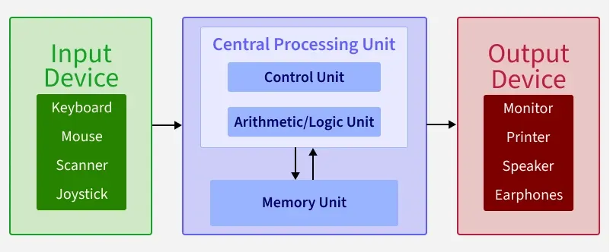

- Harvard Architecture:

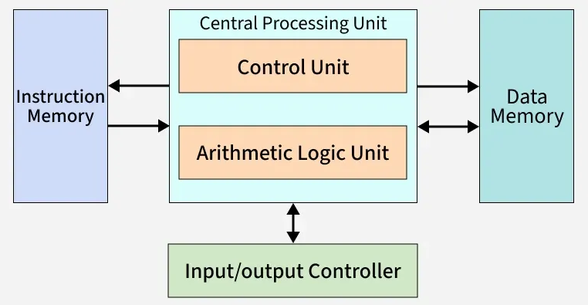

- Instruction Set Architecture (ISA):

1.2 PC Hardware Components

1.2.1 Motherboard: The motherboard which can also be called the nervous system of personal computer is a circuit board which connects all the hardware components in your PC. It determines what kind of CPU you can use, how much RAM you can have, etc. The CPU sits on the mother board slot called “Socket”. The brain of the mother board is called “Chipset” which controls the data flow between CPU, memory and peripherals.

1.2.2 Central Processing Unit (CPU): CPU is the brain of the computer. While other components handle memory and graphics, CPU performs arithmetic, logical and control operations.
CPU contains following core components:
- Arithmetic Logic Unit (ALU): This performs all mathematical operations (addition, subtraction, multiplication and division) and logical operations (AND, OR, NOT).
- Control Unit (CU): It is also called as “Manager”. It fetches instructions from memory, decodes them into command and directs other components what to do.
- Registers: This is fastest form of memory exist in your system. It has small capacity and hold data the CPU is currently working on.
- Cache (L1/L2/L3): It is a small amount of high speed memory which fills the gap between fast processors and slower RAM.

1.2.3 ROM/RAM
1.2.4 Storage
1.2.5 Graphical Processing Unit (GPU)
- VRAM
1.2.6 Power Supply Unit
1.2.7 Thermal Management
1.2.8 Peripheral and Connectivity
1.2.9 Maintenance and Diagnostics

