Mavzu: CSS orqali matn va bloklarni bezash
Ishdan maqsad:
ushbu laboratoriya ishining maqsadi — CSS (Cascading Style Sheets) yordamida matn va blok elementlarini bezash usullarini o‘rganish, shrift, rang, fon, chegaralar, soya va animatsiya xossalari bilan amaliy ishlash ko‘nikmalarini shakllantirishdan iborat.

Nazariy qism:
CSS — veb-sahifalarning tashqi ko‘rinishi va dizaynini boshqaruvchi stil tili. HTML faqat tuzilma beradi, CSS esa go‘zallik, tartib va harakat qo‘shadi.

Matn bezash xossalari (to‘liq ro‘yxat)
Xossa | Tavsif | Misol
color | Matn rangi | color: #333;
font-family | Shrift turi | font-family: 'Roboto', sans-serif;
font-size | Shrift o‘lchami | font-size: 1.2rem;
font-weight | Qalinlik | font-weight: 700;
text-align | Joylashuv | text-align: justify;
text-decoration | Chiziqlar | text-decoration: underline;
text-shadow | Matn soyasi | text-shadow: 2px 2px 5px rgba(0,0,0,0.3);
text-transform | Katta/kichik harf | text-transform: capitalize;
letter-spacing | Harflar orasidagi bo‘shliq | letter-spacing: 1px;
line-height | Qator balandligi | line-height: 1.8;

Blok bezash xossalari
Xossa | Tavsif | Misol
background | Fon (rang + rasm) | background: linear-gradient(...);
border | Chegara | border: 3px dashed #ff6b6b;
border-radius | Burchak yumaloqlash | border-radius: 20px;
box-shadow | Blok soyasi | box-shadow: 0 10px 20px rgba(0,0,0,0.15);
padding | Ichki bo‘shliq | padding: 25px;
margin | Tashqi bo‘shliq | margin: 40px auto;
width / max-width | Kenglik | max-width: 800px;
display | Element turi | display: flex;
transition | Silliq o‘tish | transition: all 0.4s ease;

Amaliy qism:
Quyidagi kod misolida CSS yordamida matn va bloklarni bezash amalga oshirilgan:
<!DOCTYPE html>
<html lang="uz">
<head>
<meta charset="UTF-8">
<meta name="viewport" content="width=device-width, initial-scale=1.0">
<title>CSS Bezaklari | Zamonaviy Dizayn</title>
<link rel="stylesheet" href="style.css">
<link href="https://fonts.googleapis.com/css2?family=Roboto:wght@400;500;700&display=swap" rel="stylesheet">
</head>
<body>

<header>
<h1 class="sarlavha">CSS orqali matn va bloklarni bezash</h1>
<p class="subtitle">Zamonaviy veb-dizayn asoslari</p>
</header>

<main class="container">
<section class="card">
<h2 class="card-title">CSS imkoniyatlari</h2>
<p class="card-text">
CSS yordamida biz matn rangini, shriftini, fon gradientini o‘zgartirishimiz,
elementlarga <strong>soya</strong>, <strong>yumaloq burchaklar</strong>,
<strong>animatsiyalar</strong> va <em>interaktivlik</em> qo‘shishimiz mumkin.
</p>
<ul class="features">
<li>🌈 Gradient fonlar</li>
<li>Soya va yorqinlik</li>
<li> Hover animatsiyalari</li>
<li>Responsive dizayn</li>
</ul>
</section>

<div class="button-group">
<button class="btn btn-primary">Boshlash</button>
<button class="btn btn-secondary">Ko‘proq bilish</button>
</div>
</main>

<footer>
<p> 2025 CSS Laboratoriya ishi. Barcha huquqlar himoyalangan.</p>
</footer>

</body>
</html>
CSS kodi (style.css):
* {
margin: 0;
padding: 0;
box-sizing: border-box;
}

body {
font-family: 'Roboto', Arial, sans-serif;
background: linear-gradient(135deg, #667eea 0%, #764ba2 100%);
color: #333;
line-height: 1.7;
min-height: 100vh;
display: flex;
flex-direction: column;
}

/* Sarlavha */
header {
text-align: center;
padding: 40px 20px;
color: white;
}

.sarlavha {
font-size: 2.8rem;
font-weight: 700;
text-transform: uppercase;
letter-spacing: 2px;
text-shadow: 3px 3px 8px rgba(0,0,0,0.4);
margin-bottom: 10px;
animation: fadeInDown 1s ease-out;
}

.subtitle {
font-size: 1.3rem;
opacity: 0.9;
font-weight: 300;
animation: fadeInUp 1.2s ease-out;
}

/* Asosiy konteyner */
.container {
flex: 1;
display: flex;
flex-direction: column;
align-items: center;
padding: 20px;
max-width: 900px;
margin: 0 auto;
width: 100%;
}

/* Karta */
.card {
background: white;
border-radius: 20px;
padding: 30px;
margin: 20px 0;
box-shadow: 0 15px 35px rgba(0,0,0,0.1);
transition: all 0.4s ease;
animation: slideUp 0.8s ease-out;
width: 100%;
}

.card:hover {
transform: translateY(-10px);
box-shadow: 0 20px 40px rgba(0,0,0,0.15);
}

.card-title {
color: #5a67d8;
font-size: 1.8rem;
margin-bottom: 15px;
text-align: center;
position: relative;
}

.card-title::after {
content: '';
width: 60px;
height: 4px;
background: #667eea;
display: block;
margin: 10px auto;
border-radius: 2px;
}

.card-text {
font-size: 1.1rem;
color: #4a5568;
margin-bottom: 20px;
text-align: justify;
}

.features {
list-style: none;
display: grid;
grid-template-columns: repeat(auto-fit, minmax(200px, 1fr));
gap: 12px;
margin-top: 20px;
}

.features li {
background: #f7fafc;
padding: 12px;
border-radius: 12px;
font-weight: 500;
color: #2d3748;
border-left: 4px solid #667eea;
transition: all 0.3s ease;
}

.features li:hover {
background: #edf2f7;
transform: translateX(5px);
border-left-color: #764ba2;
}

/* Tugmalar */
.button-group {
display: flex;
gap: 15px;
margin: 30px 0;
flex-wrap: wrap;
justify-content: center;
}

.btn {
padding: 14px 28px;
font-size: 1.1rem;
font-weight: 600;
border: none;
border-radius: 50px;
cursor: pointer;
transition: all 0.4s cubic-bezier(0.4, 0, 0.2, 1);
min-width: 140px;
position: relative;
overflow: hidden;
}

.btn::before {
content: '';
position: absolute;
top: 0; left: 0;
width: 100%; height: 100%;
background: rgba(255,255,255,0.2);
transform: translateX(-100%);
transition: transform 0.6s;
}

.btn:hover::before {
transform: translateX(100%);
}

.btn-primary {
background: linear-gradient(45deg, #667eea, #764ba2);
color: white;
box-shadow: 0 8px 20px rgba(102, 126, 234, 0.4);
}

.btn-primary:hover {
transform: translateY(-3px) scale(1.05);
box-shadow: 0 15px 30px rgba(102, 126, 234, 0.5);
}

.btn-secondary {
background: white;
color: #667eea;
border: 2px solid #667eea;
}

.btn-secondary:hover {
background: #667eea;
color: white;
transform: translateY(-3px) scale(1.05);
}

/* Footer */
footer {
text-align: center;
padding: 25px;
color: rgba(255,255,255,0.8);
font-size: 0.9rem;
background: rgba(0,0,0,0.1);
}

/* Animatsiyalar */
@keyframes fadeInDown {
from { opacity: 0; transform: translateY(-30px); }
to { opacity: 1; transform: translateY(0); }
}

@keyframes fadeInUp {
from { opacity: 0; transform: translateY(30px); }
to { opacity: 1; transform: translateY(0); }
}

@keyframes slideUp {
from { opacity: 0; transform: translateY(50px); }
to { opacity: 1; transform: translateY(0); }
}

/* Responsive */
@media (max-width: 768px) {
.sarlavha { font-size: 2.2rem; }
.card { padding: 20px; }
.features { grid-template-columns: 1fr; }
.button-group { flex-direction: column; align-items: center; }
.btn { width: 80%; }
}
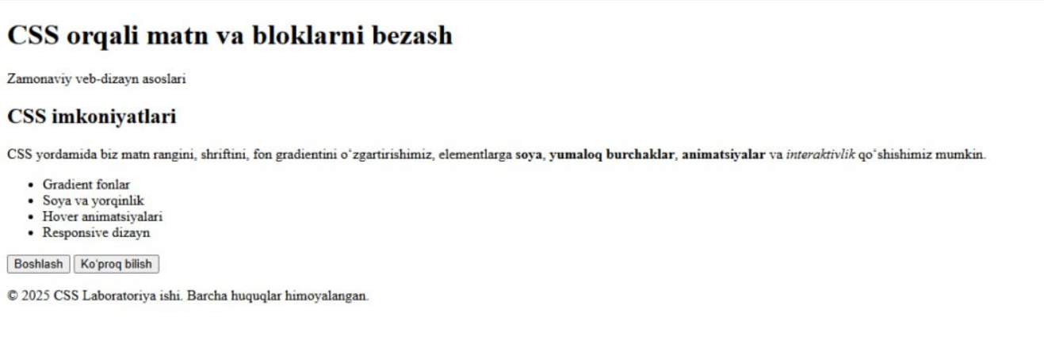

Xulosa:
Ushbu laboratoriya ishini bajarish davomida men CSS orqali matn va blok elementlarini bezash usullarini amalda qo‘llashni o‘rgandim. Matn rangini, shriftini, fon rangini, chegara va soyani boshqarish orqali veb-sahifani chiroyli va zamonaviy qilish mumkinligini bilib oldim. Shuningdek, hover va transition xossalari yordamida elementlarga interaktivlik berish usullarini ham o‘rgandim. Natijada, CSS yordamida veb-sahifaning tashqi ko‘rinishini foydalanuvchiga qulay va jozibador holga keltirish mumkinligini tushundim.
- Matn stilizatsiyasi — text-shadow, letter-spacing, line-height orqali o‘qish qulayligini oshirish.
- Blok dizayni — border-radius, box-shadow, gradient fonlar orqali zamonaviy ko‘rinish.
- Interaktivlik — transition, transform, hover orqali foydalanuvchi tajribasini yaxshilash.
- Animatsiyalar — @keyframes yordamida sahifa elementlarini "jonlantirish".
- Responsive dizayn — @media query orqali mobil qurilmalarga moslashuv.
- Kod tuzilishi — BEMga yaqin, tushunarli klass nomlari, izohlar va optimallashtirish.

