6-Lobaratoriya.PHP orqali CRUD (Create, Read, Update, Delete) amallarini bajarish

Ishdan maqsad
- PHP va MySQL yordamida ma’lumotlar bazasi bilan ishlashni o‘rganish
- CRUD (Create, Read, Update, Delete) amallarini amalda bajarish
- HTML forma orqali ma’lumotlarni kiritish va qayta ishlash
- Ma’lumotlar bazasidagi yozuvlarni chiqarish, tahrirlash va o‘chirish

Kerakli dasturiy vositalar
- XAMPP / OpenServer / Denwer
- PHP 7.x yoki yuqori
- MySQL
- Brauzer (Chrome, Edge va h.k.)
- Kod muharriri (VS Code, Sublime va boshqalar)

Nazariy qism
PHP va MySQL haqida tushuncha
PHP — bu server tomonida ishlaydigan dasturlash tili bo‘lib, u dinamik veb-sahifalar yaratishda keng qo‘llaniladi. PHP yordamida foydalanuvchi tomonidan kiritilgan ma’lumotlar qayta ishlanadi va natija brauzerga chiqariladi.
MySQL esa ma’lumotlar bazasini boshqarish tizimi (MBBT) bo‘lib, u ma’lumotlarni saqlash, izlash, yangilash va o‘chirish imkonini beradi. PHP va MySQL birgalikda ishlaganda kuchli veb-ilovalar yaratish mumkin.
Ma’lumotlar bazasi bilan ishlash
Ma’lumotlar bazasi — bu tartiblangan ma’lumotlar to‘plami. Har bir ma’lumot jadval (table) ko‘rinishida saqlanadi. Jadval ustunlar (columns) va qatorlardan (rows) iborat bo‘ladi.
CRUD tushunchasi
CRUD – bu ma’lumotlar bazasida bajariladigan 4 asosiy amal:
Amal | Tavsif
Create | Yangi ma’lumot qo‘shish
Read | Ma’lumotlarni o‘qish (ko‘rish)
Update | Ma’lumotni tahrirlash
Delete | Ma’lumotni o‘chirish

1-qadam: Ma’lumotlar bazasini yaratish
phpMyAdmin orqali quyidagi SQL so‘rovni bajaring:
CREATE DATABASE talaba_db;
USE talaba_db;
CREATE TABLE talabalar (
id INT AUTO_INCREMENT PRIMARY KEY,
ism VARCHAR(50) NOT NULL,
familiya VARCHAR(50) NOT NULL,
yosh INT NOT NULL
);

2-qadam: Loyihaning fayl tuzilmasi
crud/
│
├── db.php
├── index.php
├── add.php
├── edit.php
├── delete.php

3-qadam: Ma’lumotlar bazasiga ulanish (db.php)
<?php
$conn = new mysqli("localhost", "root", "", "talaba_db");
if ($conn->connect_error) {
die("Ulanishda xatolik: " . $conn->connect_error);
}
?>

4-qadam: CREATE – Ma’lumot qo‘shish (add.php)
<?php
include 'db.php';
if(isset($_POST['submit'])){
$ism = $_POST['ism'];
$familiya = $_POST['familiya'];
$yosh = $_POST['yosh'];
$sql = "INSERT INTO talabalar (ism, familiya, yosh)
VALUES ('$ism', '$familiya', '$yosh')";
$conn->query($sql);
header("Location: index.php");
}
?>
<form method="POST">
Ism: <input type="text" name="ism"><br>
Familiya: <input type="text" name="familiya"><br>
Yosh: <input type="number" name="yosh"><br>
<button type="submit" name="submit">Saqlash</button>
</form>

5-qadam: READ – Ma’lumotlarni chiqarish (index.php)
<?php include 'db.php'; ?>
<a href="add.php">Yangi talaba qo‘shish</a>
<table border="1">
<tr>
<th>ID</th>
<th>Ism</th>
<th>Familiya</th>
<th>Yosh</th>
<th>Amallar</th>
</tr>
<?php
$result = $conn->query("SELECT * FROM talabalar");
while($row = $result->fetch_assoc()){
echo "<tr>
<td>{$row['id']}</td>
<td>{$row['ism']}</td>
<td>{$row['familiya']}</td>
<td>{$row['yosh']}</td>
<td>
<a href='edit.php?id={$row['id']}'>Tahrirlash</a>
<a href='delete.php?id={$row['id']}'>O‘chirish</a>
</td>
</tr>";
}
?>
</table>

6-qadam: UPDATE – Ma’lumotni tahrirlash (edit.php)
<?php
include 'db.php';
$id = $_GET['id'];
$result = $conn->query("SELECT * FROM talabalar WHERE id=$id");
$row = $result->fetch_assoc();
if(isset($_POST['update'])){
$ism = $_POST['ism'];
$familiya = $_POST['familiya'];
$yosh = $_POST['yosh'];
$conn->query("UPDATE talabalar
SET ism='$ism', familiya='$familiya', yosh='$yosh'
WHERE id=$id");
header("Location: index.php");
}
?>
<form method="POST">
Ism: <input type="text" name="ism" value="<?php echo $row['ism']; ?>"><br>
Familiya: <input type="text" name="familiya" value="<?php echo $row['familiya']; ?>"><br>
Yosh: <input type="number" name="yosh" value="<?php echo $row['yosh']; ?>"><br>
<button type="submit" name="update">Yangilash</button>
</form>

7-qadam: DELETE – Ma’lumotni o‘chirish (delete.php)
<?php
include 'db.php';
$id = $_GET['id'];
$conn->query("DELETE FROM talabalar WHERE id=$id");
header("Location: index.php");
?>
5. TOPSHIRIQ: “Mehmonxona Rezervatsiya”
Database: hotel_reservation_db
Jadval: guest_bookings
Ustunlar:
- booking_id
- guest_identity
- passport_reference
- room_code
- arrival_date
- departure_date
- payment_mode
- booking_status
Kodi:
<?php
$conn = new mysqli("localhost", "root", "", "hotel_reservation_db");

if ($conn->connect_error) {
die("Xatolik: " . $conn->connect_error);
}

// DELETE
if(isset($_GET['delete'])){
$id = $_GET['delete'];
$conn->query("DELETE FROM guest_bookings WHERE booking_id=$id");
}

// ADD
if(isset($_POST['add'])){
$conn->query("INSERT INTO guest_bookings
(guest_identity, passport_reference, room_code, arrival_date, departure_date, payment_mode, booking_status)
VALUES
('{$_POST['guest_identity']}', '{$_POST['passport_reference']}', '{$_POST['room_code']}', '{$_POST['arrival_date']}', '{$_POST['departure_date']}', '{$_POST['payment_mode']}', '{$_POST['booking_status']}')");
}

// UPDATE
if(isset($_POST['update'])){
$id = $_POST['id'];
$conn->query("UPDATE guest_bookings SET
guest_identity='{$_POST['guest_identity']}',
passport_reference='{$_POST['passport_reference']}',
room_code='{$_POST['room_code']}',
arrival_date='{$_POST['arrival_date']}',
departure_date='{$_POST['departure_date']}',
payment_mode='{$_POST['payment_mode']}',
booking_status='{$_POST['booking_status']}'
WHERE booking_id=$id");
}

// EDIT DATA
$editData = null;
if(isset($_GET['edit'])){
$id = $_GET['edit'];
$res = $conn->query("SELECT * FROM guest_bookings WHERE booking_id=$id");
$editData = $res->fetch_assoc();
}
?>

<!DOCTYPE html>
<html>
<head>
<title>Hotel CRUD</title>

<!-- Bootstrap -->
<link href="https://cdn.jsdelivr.net/npm/bootstrap@5.3.0/dist/css/bootstrap.min.css" rel="stylesheet">

<style>
body {
background: linear-gradient(120deg, #74ebd5, #9face6);
}
.card {
border-radius: 15px;
}
h2 {
font-weight: bold;
}
</style>
</head>

<body>

<div class="container mt-5">

<div class="card shadow p-4">
<h2 class="text-center mb-4">🏨 Mehmonxona rezervatsiya</h2>

<form method="POST" class="row g-3">
<input type="hidden" name="id" value="<?= $editData['booking_id'] ?? '' ?>">

<div class="col-md-6">
<input type="text" name="guest_identity" class="form-control" placeholder="Ism" value="<?= $editData['guest_identity'] ?? '' ?>" required>
</div>

<div class="col-md-6">
<input type="text" name="passport_reference" class="form-control" placeholder="Passport" value="<?= $editData['passport_reference'] ?? '' ?>" required>
</div>

<div class="col-md-4">
<input type="text" name="room_code" class="form-control" placeholder="Xona" value="<?= $editData['room_code'] ?? '' ?>" required>
</div>

<div class="col-md-4">
<input type="date" name="arrival_date" class="form-control" value="<?= $editData['arrival_date'] ?? '' ?>" required>
</div>

<div class="col-md-4">
<input type="date" name="departure_date" class="form-control" value="<?= $editData['departure_date'] ?? '' ?>" required>
</div>

<div class="col-md-6">
<input type="text" name="payment_mode" class="form-control" placeholder="To‘lov turi" value="<?= $editData['payment_mode'] ?? '' ?>">
</div>

<div class="col-md-6">
<input type="text" name="booking_status" class="form-control" placeholder="Status" value="<?= $editData['booking_status'] ?? '' ?>">
</div>

<div class="col-12 text-center">
<?php if($editData): ?>
<button class="btn btn-warning px-4" name="update">Yangilash</button>
<?php else: ?>
<button class="btn btn-success px-4" name="add">Saqlash</button>
<?php endif; ?>
</div>
</form>
</div>

<div class="card shadow p-4 mt-4">
<h4 class="mb-3">📋 Bronlar ro‘yxati</h4>

<table class="table table-striped table-hover">
<thead class="table-dark">
<tr>
<th>ID</th>
<th>Ism</th>
<th>Passport</th>
<th>Xona</th>
<th>Kelish</th>
<th>Ketish</th>
<th>To‘lov</th>
<th>Status</th>
<th>Amallar</th>
</tr>
</thead>

<tbody>
<?php
$result = $conn->query("SELECT * FROM guest_bookings");

while($row = $result->fetch_assoc()){
echo "<tr>
<td>{$row['booking_id']}</td>
<td>{$row['guest_identity']}</td>
<td>{$row['passport_reference']}</td>
<td>{$row['room_code']}</td>
<td>{$row['arrival_date']}</td>
<td>{$row['departure_date']}</td>
<td>{$row['payment_mode']}</td>
<td>{$row['booking_status']}</td>
<td>
<a href='?edit={$row['booking_id']}' class='btn btn-sm btn-primary'>Edit</a>
<a href='?delete={$row['booking_id']}' class='btn btn-sm btn-danger'>Delete</a>
</td>
</tr>";
}
?>
</tbody>
</table>
</div>

</div>

</body>
</html>

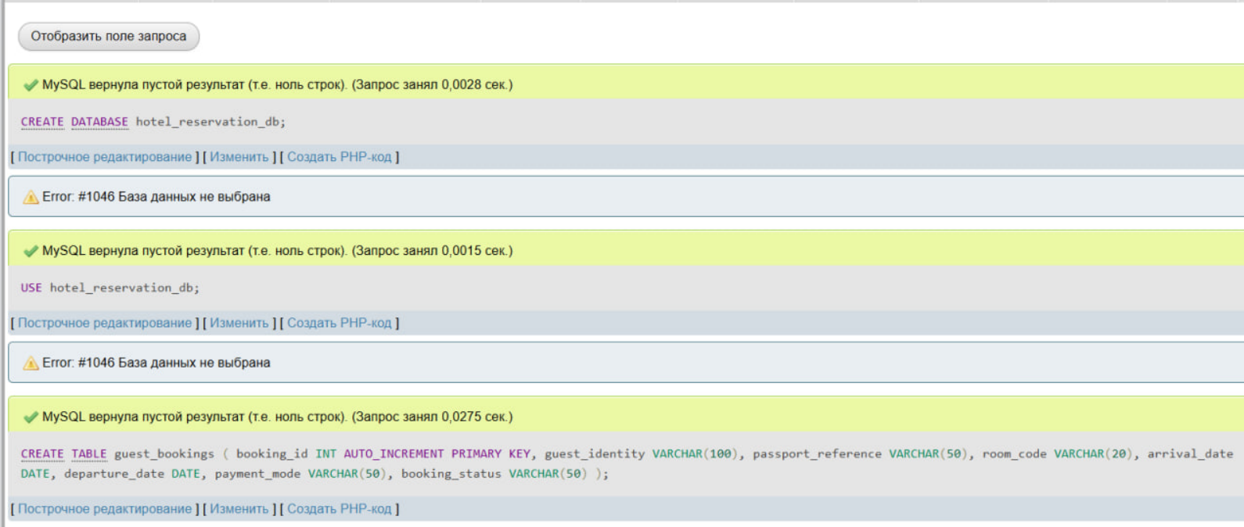
Natija:
http://localhost/hotel/index.php

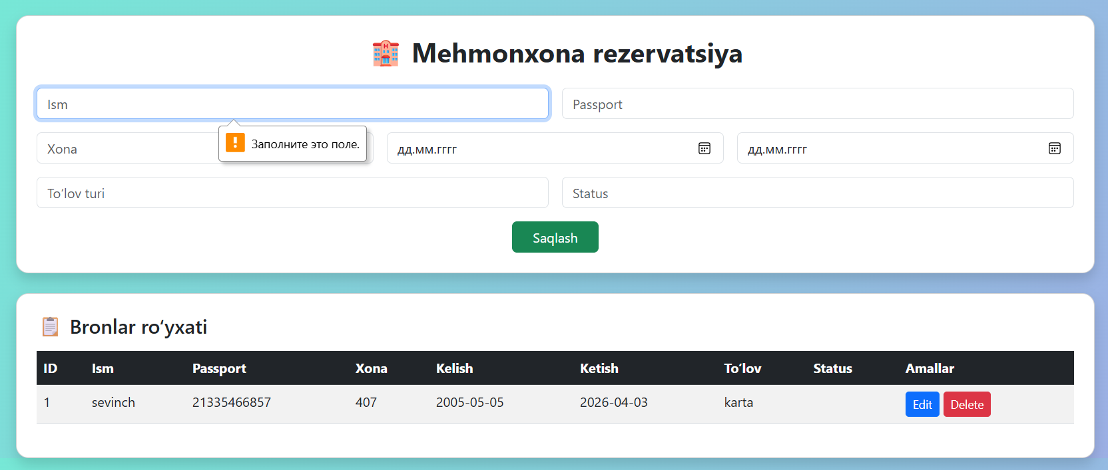
XULOSA
Ushbu laboratoriya ishida PHP va MySQL yordamida mehmonxona rezervatsiya tizimi yaratildi. Ish jarayonida ma’lumotlar bazasi bilan ishlash, jadval yaratish va unga ulanish amaliy tarzda bajarildi. Shuningdek, CRUD (Create, Read, Update, Delete) amallari to‘liq o‘zlashtirildi.
Dastur orqali foydalanuvchi yangi bron qo‘shishi, mavjud ma’lumotlarni ko‘rishi, ularni tahrirlashi va o‘chirishi mumkin bo‘ldi. HTML forma va PHP integratsiyasi orqali ma’lumotlarni qabul qilish va qayta ishlash jarayoni o‘rganildi.
Natijada, zamonaviy va qulay interfeysga ega bo‘lgan oddiy veb-ilova yaratildi. Ushbu laboratoriya ishi orqali talabaning veb dasturlash va ma’lumotlar bazasi bilan ishlash bo‘yicha amaliy ko‘nikmalari yanada mustahkamlandi.

