# Edris Safari

## DSC680 Project1, Milestone2

Abstract

Provide software-built tools to assist in making better analysis of stocks and their behavior

Project White Paper

Stock Market Analysis

# Business Problem

Predicting stock behavior has been and continues to be complex. Even more so in the modern world with disparate events that affect the market. This is a challenge for both investors and financial advisors. Investors and financial advisors are well versed in stock market trading based on fundamentals and other market indicators. However, market volatilities can pose challenges to even the most knowledgeable trader. Augmenting the knowledge with additional tools would equip investors with more ammunition to make better and more accurate investment decisions.

# Background/History

The traditional financial advisors use company fundamentals to gauge the performance of stocks. Fundamentals are metrics that measure the financial health of the company. Metrics such as cash flow, return on assets, debt, R&D investment, earning per share, company estimates, their “Generally Acceptable Accounting Practices”, and many more. However, stocks have shown themselves to have healthy books, but have not traded well in the market and that their stock price fluctuation doesn’t reflect the health of the company. Often time, other stimuli affect the stock price. While some stimuli are not predictable, the variation in the stock price over time may reveal more insight into the stock behavior.

Technical indicators enable investors to use pattern-based signals that are revealed when historical data is taken into consideration. A simple example of a technical indicator is the moving average. The moving average is the mean value of price of stock over a period. A 20-day moving average is the average stock price for the past 20 days. In the picture below the chart shows the moving average and the daily closing price. Note that the closing price is above the moving average which is an indication of the strength of the stock.

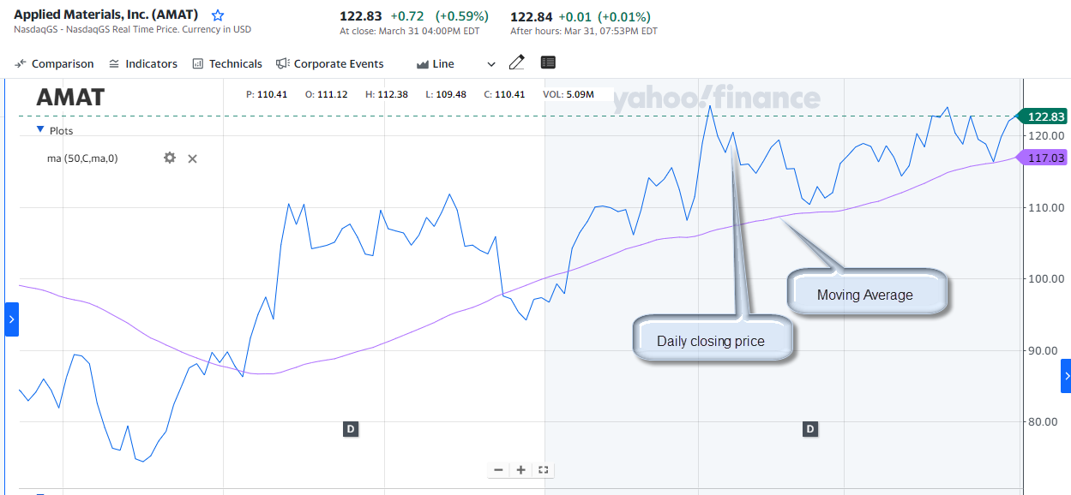

The goal of this project is to provide tools to “visualize” stock behavior over time, and predict stock price along with metrics to grade the prediction.

# Data Explanation

For this phase of the project, we will use traditional stock parameters. This dataset will have.

## Datasets

The data that we will use in this project will be historical data for individual stocks. We will have a set of static data that we can use initially, and then connect our application to yahoo fiancé to get “live” data. The static dataset was obtained from Kaggle.

There are over 7000 text files, with comma-separated values for Date, Open, High, Low, Close, Volume, and OpenInt. OpenInt is the number of options or future contracts that are open and its impact on price fluctuations will not be examined in this project. We will use the other parameters in calculating the technical indicators.

The dataset from yfinance will have values for Date, Open, High, Low, Close, Adjusted Close, and Volume.

## Data Preparation

Both Datasets will be augmented with a column for label. Label is extracted from the filename. For example, file name mcd.us.txt will be converted to a table with column Label having the value of ‘MCD”. We will then add columns for the following technical indicators. They are described in more detail in the Methods and Analysis sections.

RSI_14D: 14-day Relative Strength Index

BB_Upper_Band, BB_Middle_Band, BB_Lower_Band: Upper,Middle, and lower Bollinger Bands

Arron_Oscillator: Oscillator based on daily high/lows shows the strength of the trend.

PVT: Price Volume Trend

AB_Upper_Band, AB_Middle_Band, AB_Lower_Band: Upper, Middle, and lower Acceleration Bands. These are bands around a 20-day simple moving average.

## Data Management

# Methods

We will use Python as the primary programming language. We will use Matplotlib, Seaborn, Keras, Pandas, yfinance and other necessary libraries. We will show technical indicators for individual stocks. We apply an AI model in Neural networks to predict the price of a given stock and show graphs and metrics to show confidence and accuracy of the prediction.

# Analysis

# Conclusion

We showed that technical indicators help investors make more accurate decisions about buying or selling stocks. They also help in the timing of the transaction, and also the price target. Combined with fundamentals of the stock, and other factors such as interest rate, consumer confidence, overall health of the economy (both nationally and globally) and other external factors, investors of today can make educated and low risk decisions.

# Assumptions

# Limitations

# Challenges

Challenges and issues that we could face in this project must be considered and addressed. This is part of risk assessment that all projects must go through. The table below lists the risks and their mitigation.

|  |  |
| --- | --- |
| Risk | Mitigation |
| Data Quality | Ensure data quality by performing a preliminary analysis |
| Data Security | Ensure data is secure both incoming and outgoing. Enable/utilize security measures. |
| Data Availability | Ensure data is available without interruption or delay that may affect the performance of the analysis |
| Technical Challenges | Enforce fault tolerance, redundancy, connection integrity |
| Ethical Violations | Ensure procedures are put in place that will reduce and remove risk of ethical violations by all parties involved. |

# Future Uses & Product Roadmap

The following improvements will be put on the roadmap.

## Graphical User Interface

A graphical user interface to allow users select stocks, get different graphs and anamysis.

## Additional technical indicators

Add more technical indicators as the product matures

## Other algorithms

Research and Implement new ML algorithms.

## Dataset

Augment data set with additional parameters the gauge the market fluctuation better.

# Recommendations

# Implementation Plan

To implement this project, we will perform the following tasks:

1. Gather and prepare dataset.
2. Prepare Design Document.
3. Code, and test
4. Present
5. Deploy

# Ethical Assessment

Based on the ethical considerations we listed in our proposal; we have taken the following measures to address them.

Data privacy: Work with the legal team to ensure that the data collected is obtained in a legal and ethical manner. We will also work with the IT team to ensure that personal information for clients as well as employees are safe and secure.

Bias and fairness: Provide appropriate training about ethics involved in this field to people involved in all aspects of the product.

Transparency: Work with engineering to ensure that the data sources, analysis methods, and findings are transparent and easily understandable to all stakeholders.

Security: We will work with IT on security issues and data privacy as mentioned above.

Informed consent: Work with legal team to make sure that legal documents are in place to align with the customers on topics requiring consent.

Impact on society: Perform a thorough evaluation of the results, perform risk analysis, measure accuracy, and any metrics that can help ascertain minimal negative impact.

Questions and Answers

## Q: What is technical analysis?

## Q: What is machine learning?

## Q: How do graphics help?

## Q: Is technical analysis better than fundamentals?

## Q: Are there other models or algorithms that can be used

## Q: Are there other technical indicators?

## Q: Can variables other than open, close, high, low be used, if so name 2-3.

## Q. What are recurrent neural networks?

## Q. Explain LSTM algorithm.

## Q.

# References

1. 7 Technical Indicators to Build a Trading Toolkit <https://www.investopedia.com/top-7-technical-analysis-tools-4773275>
2. François Chollet. Deep Learning with Python (Kindle Locations 1504-1508). Manning Publications Co.. Kindle Edition.
3. What are Stock Fundamentals? <https://www.investopedia.com/articles/fundamental/03/022603.asp#:~:text=Stock%20fundamentals%20are%20key%20metrics,perceived%20value%20of%20a%20stock>
4. Technical Indicators Mathematical Description

<https://docs.anychart.com/Stock_Charts/Technical_Indicators/Mathematical_Description>

1. Understanding Indicators in Technical Analysis - <https://www.fidelity.com/bin-public/060_www_fidelity_com/documents/learning-center/Understanding-Indicators-TA.pdf>
2. Using Technical Indicators to Develop Trading Strategies <https://www.investopedia.com/articles/trading/11/indicators-and-strategies-explained.asp>
3. Technical Indicator: Definition, Analyst Uses, Types and Examples <https://www.investopedia.com/terms/t/technicalindicator.asp>
4. Project Proposal-Project1_Milestone1_EdrisSafari.pdf