edris safari

DSC680 Project1, Milestone1

Abstract

Provide software-built tools to assist in making better analysis of stocks and their behavior

Project White Paper

Stock Market Analysis

Contents

Business Problem 2

Background/History 2

Data Explanation 3

Datasets 3

Data Preparation 3

Data Management 4

Methods 4

Analysis 4

Technical Indicators 4

RNN Model 6

Conclusion 8

Assumptions 9

Limitations 9

Challenges 9

Future Uses & Product Roadmap 9

Additional technical indicators 9

New Model 9

Graphical User Interface 10

Other algorithms. 10

Dataset 10

Recommendations 10

Implementation Plan 10

Ethical Assessment 10

References 11

# Business Problem

Predicting stock behavior has been and continues to be complex. Even more so in the modern world with disparate events that affect the market. This is a challenge for both investors and financial advisors. Investors and financial advisors are well versed in stock market trading based on fundamentals and other market indicators. However, market volatilities can pose challenges to even the most knowledgeable trader. Augmenting the knowledge with additional tools would equip investors with more ammunition to make better and more accurate investment decisions.

# Background/History

The traditional financial advisors use company fundamentals to gauge the performance of stocks. Fundamentals are metrics that measure the financial health of the company. Metrics such as cash flow, return on assets, debt, R&D investment, earning per share, company estimates, their “Generally Acceptable Accounting Practices”, and many more. However, stocks have shown themselves to have healthy books, but have not traded well in the market and that their stock price fluctuation doesn’t reflect the health of the company. Often time, other stimuli affect the stock price. While some stimuli are not predictable, the variation in the stock price over time may reveal more insight into the stock behavior.

Technical indicators enable investors to use pattern-based signals that are revealed when historical data is taken into consideration. A simple example of a technical indicator is the moving average. The moving average is the mean value of price of stock over a period. A 20-day moving average is the average stock price for the past 20 days. In the picture below the chart shows the moving average and the daily closing price. Note that the closing price is above the moving average which is an indication of the strength of the stock.

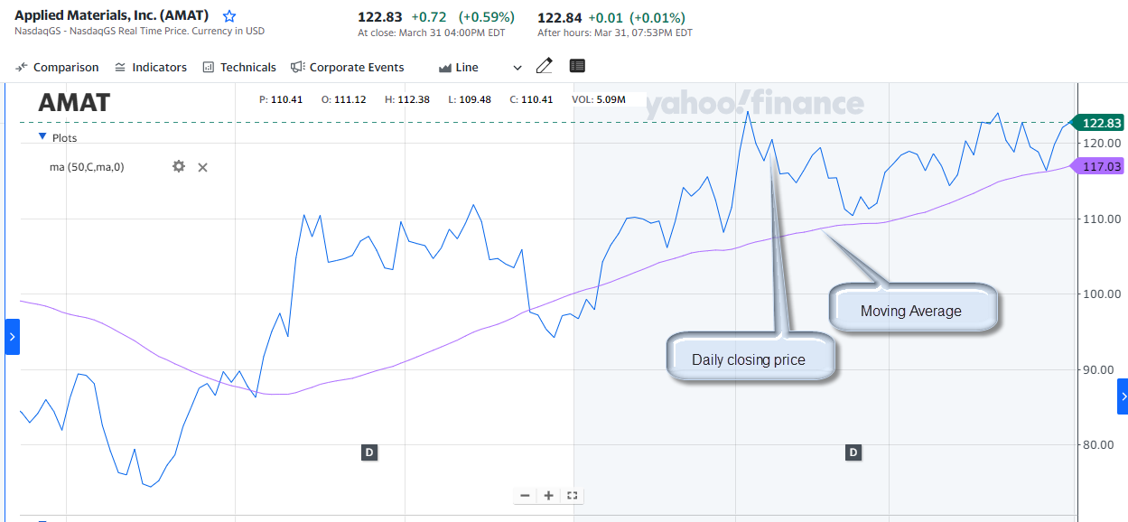

The goal of this project is to provide tools to “visualize” stock behavior over time, and predict stock price along with metrics to grade the prediction.

# Data Explanation

For this phase of the project, we will use traditional stock parameters. This dataset will have.

## Datasets

The data that we will use in this project will be historical data for individual stocks. We will have a set of static data that we can use initially, and then connect our application to yahoo fiancé to get “live” data. The static dataset was obtained from Kaggle.

There are over 7000 text files, with comma-separated values for Date, Open, High, Low, Close, Volume, and OpenInt. OpenInt is the number of options or future contracts that are open and its impact on price fluctuations will not be examined in this project. We will use the other parameters in calculating the technical indicators.

The dataset from yfinance will have values for Date, Open, High, Low, Close, Adjusted Close, and Volume.

## Data Preparation

Both Datasets will be augmented with a column for label. Label is extracted from the filename. For example, file name mcd.us.txt will be converted to a table with column Label having the value of ‘MCD”. We will then add columns for the following technical indicators. They are described in more detail in the Methods and Analysis sections.

RSI_14D: 14-day Relative Strength Index

BB_Upper_Band, BB_Middle_Band, BB_Lower_Band: Upper,Middle, and lower Bollinger Bands

Arron_Oscillator: Oscillator based on daily high/lows shows the strength of the trend.

PVT: Price Volume Trend

AB_Upper_Band, AB_Middle_Band, AB_Lower_Band: Upper, Middle, and lower Acceleration Bands. These are bands around a 20-day simple moving average.

## Data Management

# Methods

We will use Python as the primary programming language. We will use Matplotlib, Seaborn, Keras, Pandas, yfinance and other necessary libraries. We will show technical indicators for individual stocks. We apply an AI model in Neural networks to predict the price of a given stock and show graphs and metrics to show confidence and accuracy of the prediction.

# Analysis

## Technical Indicators

Technical indicators are intrinsically pattern-based because they are based on time. They are signals that are produced by the price, volume, and other parameters. Shown graphically, these signals will show spike, declines, gradual/sharp decrease, or gradual/sharp increase, etc. These visuals will help technical analysist predict future price movements.

We created 5 technical indicators. The Bollinger band indicator is a popular one. Shown below, the black line is the 30-day average closing price of the stock, and the gray area is the band range. The upper part of this gray area is the 30-day average plus 3 standard deviations, and low part of the gray area in the average minus 3 standard deviation. The wider the band, the more volatile the stock is.

Relative Strength Index or RSI, measures speed and magnitude of a stock’s most recent price changes (up or down). This will help evaluate whether a stock is overvalued (don’t buy) or undervalued(buy). Shown below, the stock for AMAT was overvalued in 2016,2017 and undervalued since 2021-22.

Aroon Oscillators are technical indicators that are used to identify the strength and direction of a trend. The indicator consists of two lines: the Aroon-Up and the Aroon-Down. The Aroon-Up measures the number of periods since the highest high, while the Aroon-Down measures the number of periods since the lowest low. When the Aroon-Up is above the Aroon-Down, it indicates an uptrend, while when the Aroon-Down is above the Aroon-Up, it indicates a downtrend. Shown below, AMT is trending downward.

Acceleration Bands are technical indicators that use volatility to identify potential price trends in the market. The indicator consists of three lines: the upper band, the lower band, and the centerline. The upper and lower bands are based on the standard deviation of the price from the centerline, while the centerline is typically a moving average. Shown below, when the price touches or crosses the upper band, it indicates that the trend is losing its momentum and due for a reversal.

## RNN Model

We used a RNN model and used two LSTM layers(shown below). LSTM is suitable for time series dataset. We used the closing price in the training data set to predict closing price in a test dataset.

The graph below shows the result. The disparity in the green and orange line shows the accuracy of the model.

Shown below, the disparity seems quite wide and persistent.

Using a different approach, we came up with this result:

No noticeable difference was found.

# Conclusion

We showed that technical indicators help investors make more accurate decisions about buying or selling stocks. They also help with the timing of the transaction, and the price target. Combined with fundamentals of the stock, and other factors such as interest rate, consumer confidence, overall health of the economy (both nationally and globally) and other external factors, investors of today can make educated and low risk decisions.

# Assumptions

We must assume that the investors are knowledgeable about the interpretation of the technical indicators, but not necessarily about machine learning. The machine learning aspect of this project is mainly the responsibility of the developers and data scientists.

# Limitations

One major limiting factor to this project is data quality. We must ensure that the quality of data is monitored and always maintained. Other limiting factor that we must be aware of is time to market constraint. Model and calculation accuracy is also a limitation that cannot be overlooked.

# Challenges

Challenges and issues that we could face in this project must be considered and addressed. This is part of risk assessment that all projects must go through. The table below lists the risks and their mitigation.

|  |  |
| --- | --- |
| Risk | Mitigation |
| Data Quality | Ensure data quality by performing a preliminary analysis |
| Data Security | Ensure data is secure both incoming and outgoing. Enable/utilize security measures. |
| Data Availability | Ensure data is available without interruption or delay that may affect the performance of the analysis |
| Technical Challenges | Enforce fault tolerance, redundancy, connection integrity |
| Ethical Violations | Ensure procedures are put in place that will reduce and remove risk of ethical violations by all parties involved. |

# Future Uses & Product Roadmap

The following improvements will be put on the roadmap.

## Additional technical indicators

These technical inidcators can be added to the portfolio:

1. Stochastic Oscillator(%K and %D)
2. Chaikin Money Flow
3. Parabolic SAR
4. Price Rate of Change
5. Volume Weighted Average Price

## New Model

Research and create classification model to predict up or down. Other RNN models and more advanced LSTM model can also help improve our portfolio,

## Graphical User Interface

A graphical user interface to allow users to select stocks, select graphs of different types (i.e., RSI, PVT, BBs, etc.) and be able to view the data daily, monthly, yearly, etc. The GUI will have to be web based and accessible by authorized personnel.

## Other algorithms.

Research and Implement new ML algorithms.

## Dataset

Augment data set with additional parameters to gauge the market fluctuation better.

# Recommendations

Market research at any level is an important asset. We recommend that the results of all the analysis done be used as a basis for future market analysis. This will also help in improvement of the process of stock analysis.

# Implementation Plan

To implement this project, we will perform the following main tasks:

1. Gather and prepare dataset.
2. Prepare Design Document.
3. Code, and test
4. Present
5. Deploy

# Ethical Assessment

Based on the ethical considerations we listed in our proposal; we have taken the following measures to address them.

Data privacy: Work with the legal team to ensure that the data collected is obtained in a legal and ethical manner. We will also work with the IT team to ensure that personal information for clients as well as employees is safe and secure.

Bias and fairness: Provide appropriate training about ethics involved in this field to people involved in all aspects of the product.

Transparency: Work with engineering to ensure that the data sources, analysis methods, and findings are transparent and easily understandable to all stakeholders.

Security: We will work with IT on security issues and data privacy as mentioned above.

Informed consent: Work with legal team to make sure that legal documents are in place to align with the customers on topics requiring consent.

Impact on society: Perform a thorough evaluation of the results, perform risk analysis, measure accuracy, and any metrics that can help ascertain minimal negative impact.

Questions and Answers

Q: What is technical analysis?

Q: What is machine learning?

Q: How do graphics help?

Q: Is technical analysis better than fundamentals?

Q: Are there other models or algorithms that can be used

Q: Are there other technical indicators?

Q: Can variables other than open, close, high, low be used, if so name 2-3.

Q. What are recurrent neural networks?

Q. Explain LSTM algorithm.

Q. Can use of ML adversely affect the stock market trading?

# References

1. 7 Technical Indicators to Build a Trading Toolkit <https://www.investopedia.com/top-7-technical-analysis-tools-4773275>
2. François Chollet. Deep Learning with Python (Kindle Locations 1504-1508). Manning Publications Co.. Kindle Edition.
3. What are Stock Fundamentals? <https://www.investopedia.com/articles/fundamental/03/022603.asp#:~:text=Stock%20fundamentals%20are%20key%20metrics,perceived%20value%20of%20a%20stock>
4. Technical Indicators Mathematical Description

<https://docs.anychart.com/Stock_Charts/Technical_Indicators/Mathematical_Description>

1. Understanding Indicators in Technical Analysis - <https://www.fidelity.com/bin-public/060_www_fidelity_com/documents/learning-center/Understanding-Indicators-TA.pdf>
2. Using Technical Indicators to Develop Trading Strategies <https://www.investopedia.com/articles/trading/11/indicators-and-strategies-explained.asp>
3. Technical Indicator: Definition, Analyst Uses, Types and Examples <https://www.investopedia.com/terms/t/technicalindicator.asp>
4. The basics of Bollinger Bands https://www.investopedia.com/articles/technical/102201.asp
5. Project Proposal-Project1_Milestone1_EdrisSafari.pdf