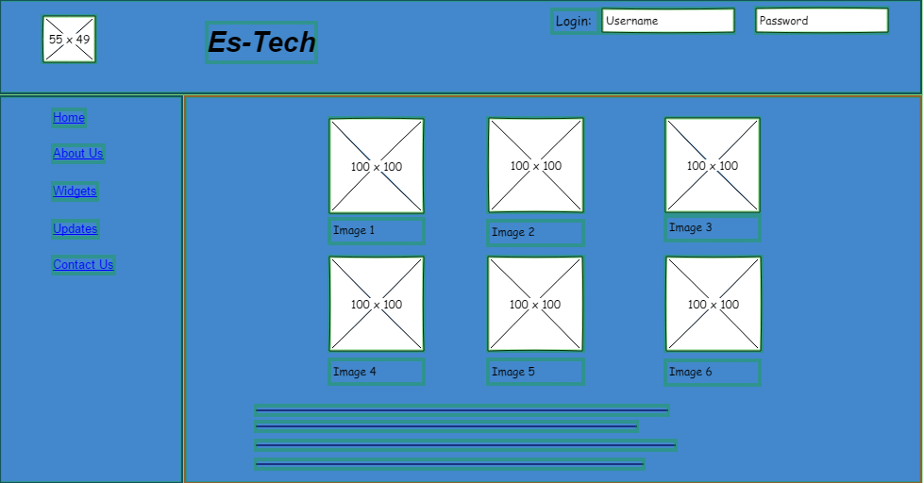

On the left is the sidebar, Above that directly will be the logo (sorry for the colors so early didn’t want it to look bland). Name of website in the header. Login for returning users on the right at the top in the header. The main content will include images of the newest technology along with its name and a few other pieces of information the item displayed. And will have a brief description (the lines below the images) that will include updates, news and the newest information regarding items the made the homepage.