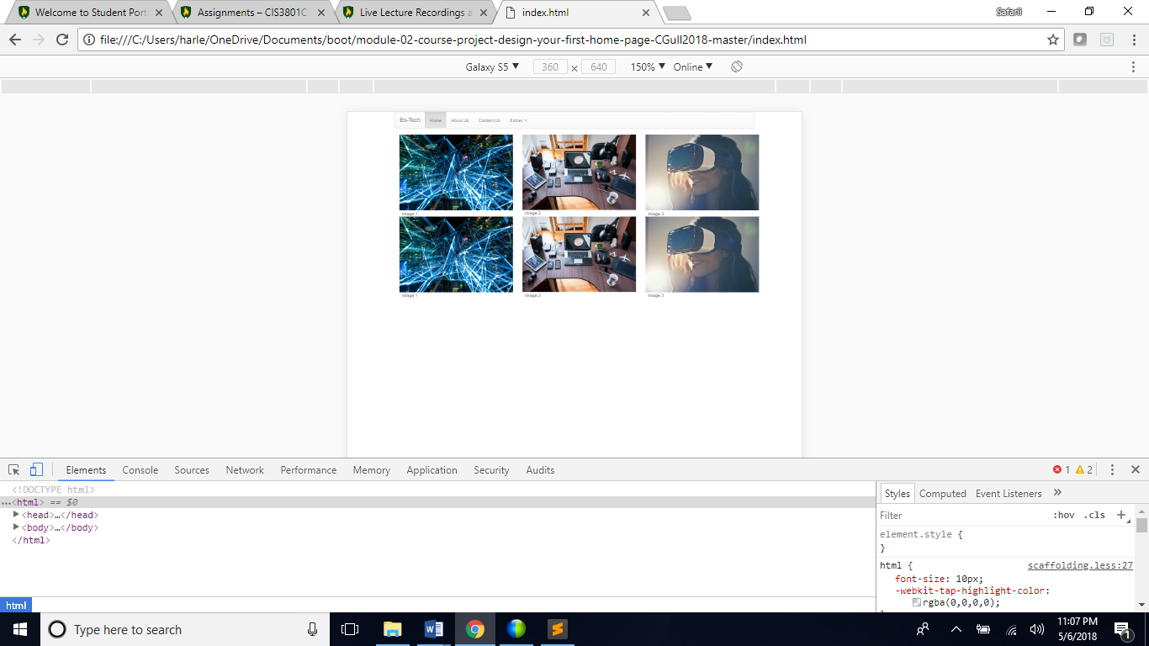

On the Galaxy S5 This is the visual that is received Nothing is affected too much with the content Everything seems to fit smoothly.

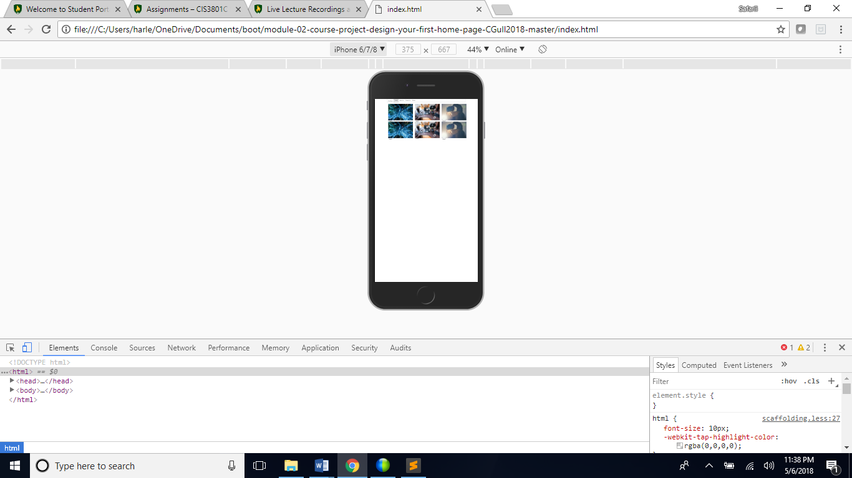

The iphone 6/7 shows a different view slightly as the items seem to be closer to the edge of the frame. The iphone’s screen is slightly smaller which may cause this but a fix to this is typically a built in CSS webkit.

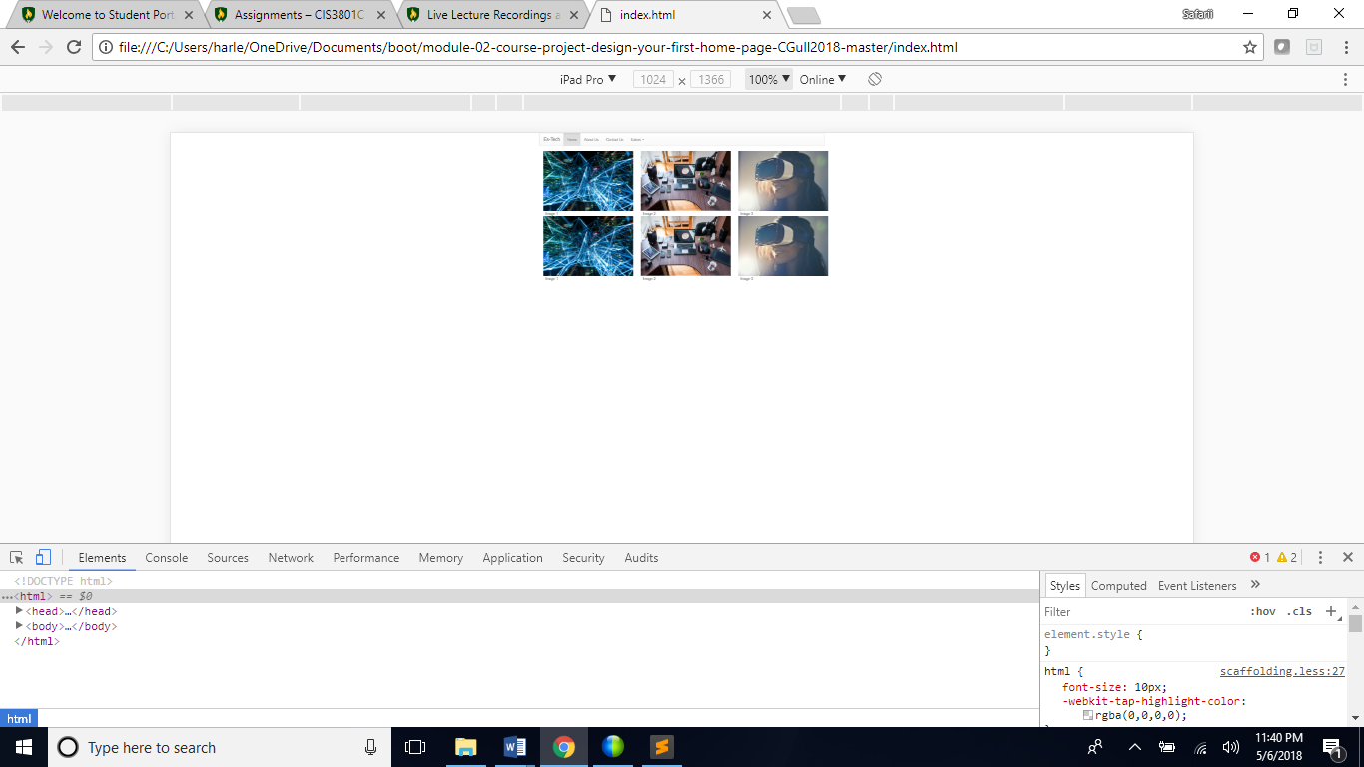

The ipad pro also gives an interesting point of view. It’s screen is so big it provides a ton of white space which is technically bad because of the extra unnecessary scrolling that will be performed while browsing.