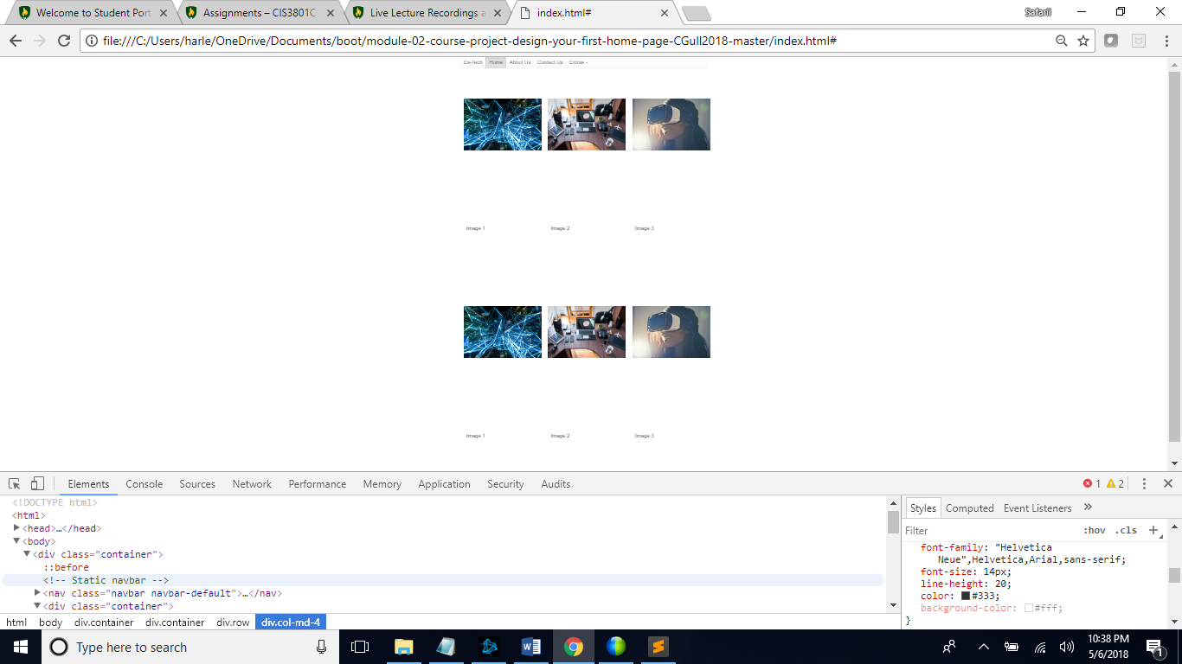

In this screen shot I used an example of increasing line height which I thought I could use to manipulate spacing, but it was cause a big error for users because of the unreasonable amount of spacing. I used a bit of an extreme circumstance, but this I how it would look with 20 pixels of space.

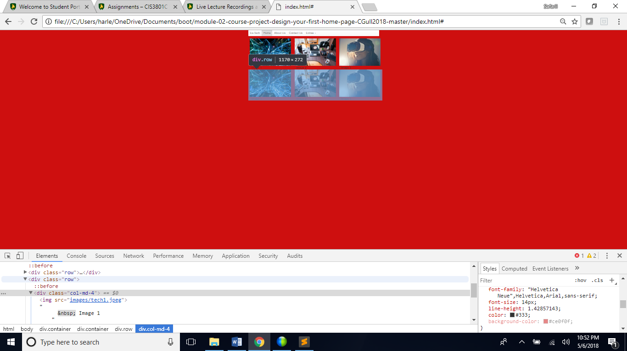

This CSS change is obvious I’ve been testing a few other colors but going along with UX that we’ve discussed in previous lectures this color is neither satisfying nor correlating. This color does not blend well with the pictures nor navigation.

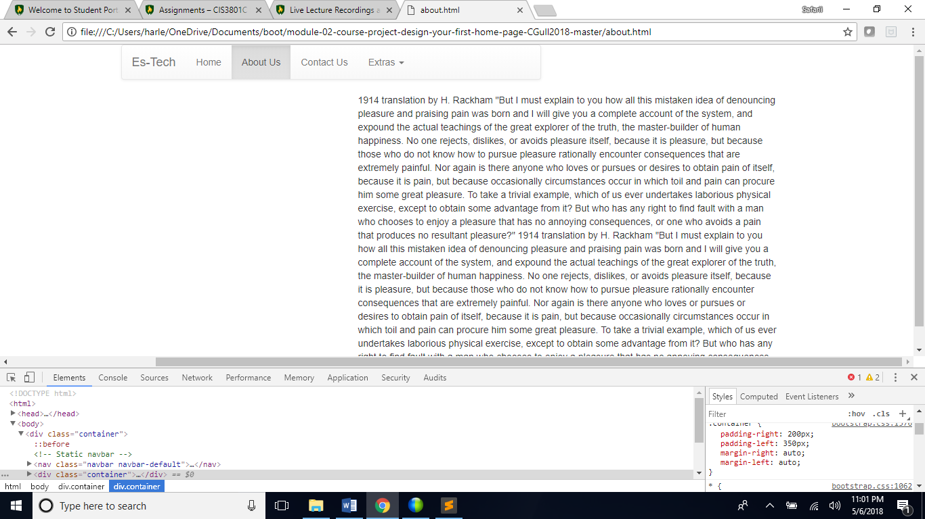

I picked at the left and right margins, and this can be the cause of some dysfunction they were majorly increased, but sometimes spacing outside of text is an issue to make things better for readability using the margins to create space sometimes is useful.