* Engagement Rate=(Total Engagements (Likes + Comments + Shares)​/Total Reach )×100

معدل التفاعل=(عدد الأشخاص الذين رأوا المنشور\إجمالي التفاعلات​)×100

=*100(1437/15419)

=9.3%

mobile marketing

email marketing

add whatsapp button and automatic message? نبعت رسايل للناس في حالة العروض او المسابقة عايزين نعملها for collecting data

**insights and recommendations:**

**Mobile Marketing Recommendations:**

### **.Have a Mobile-Friendly Website**

Make sure your lab’s website is responsive and easy to navigate on smartphones. It should include

About us, our team

List of tests and services

Google Maps location

WhatsApp contact button, facebook page and instagram

### **Use SMS Marketing**

Build a database of your customers' phone numbers

contract with SMS service provider (e.g., mobily.ws, SMS Misr, Bulk sms Egypt), or use application as excel for sending messages

create short and clear messages for:

Promotions and offers

Appointment reminders

Follow-ups and health tips

greetings during holidays or special occasions

Send at appropriate time

Track your performance

SMS open and click rates

### **Activate WhatsApp Business**

Use WhatsApp Business to

Send automated welcome messages

Respond to frequently asked questions

Show a catalog of your lab’s services

Display your WhatsApp number clearly on your website, social media, and printed materials

**Email Marketing recommendations:**

#### **Build a Strong Email List**

Use a subscription form on the official website and social media  
 "Subscribe for exclusive discounts and free health tips."

Use a tool like Linktree to add multiple links to your bio.In the main link in your bio, place a link that leads to the subscription page or registration form.

Collect emails from patients when registering at the lab.

use Mailchimp

Segment the Audience, Send personalized content to each segment to increase engagement

### **Email Automation**

#### **Examples:**

* **Welcome Sequence**: Triggered when a client subscribes.
* **Reminder Flow**: After 3 months of the last test.
* **Follow-up**: After receiving the results, ask for feedback.

Analyze Performance

* Open rate
* Click rate
* Unsubscribe rate

insights of content overview before managing facebook page:

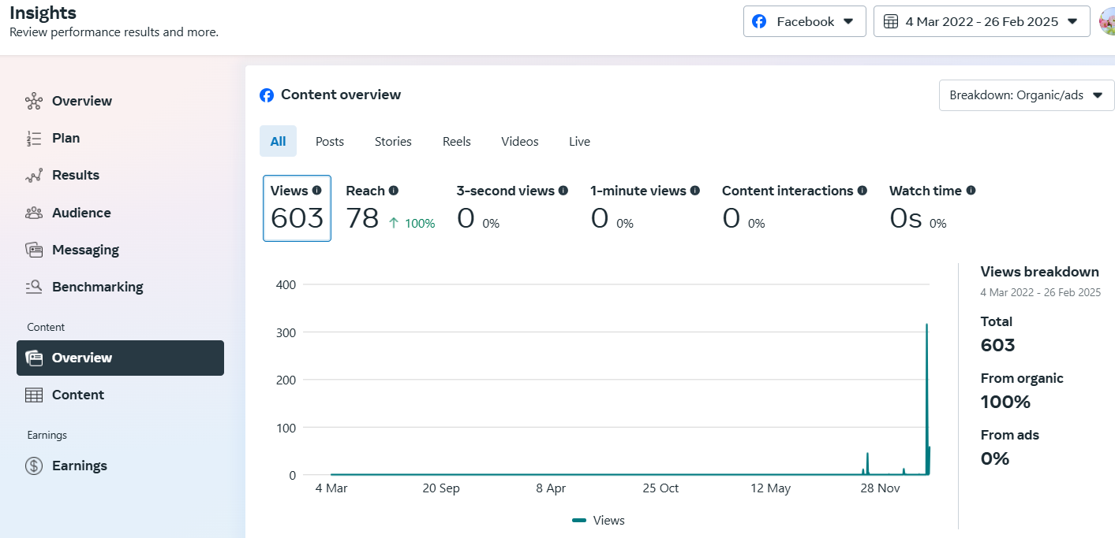

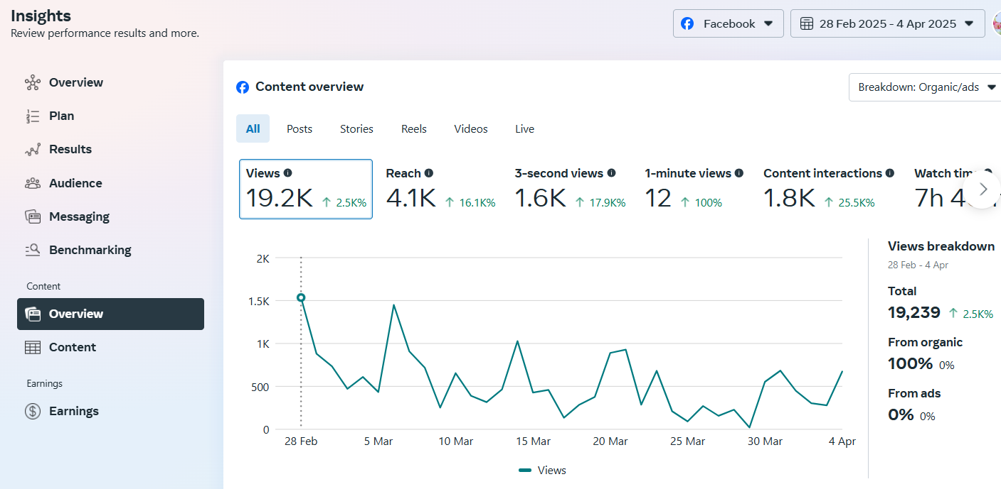

insights of content overview after managing facebook page:

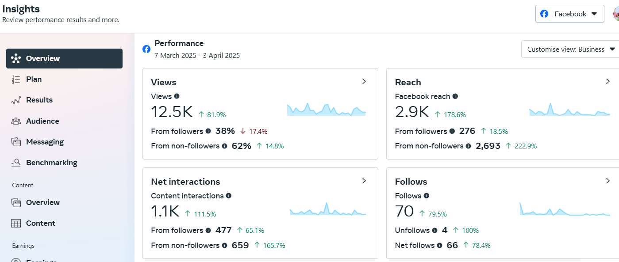

over view insights:

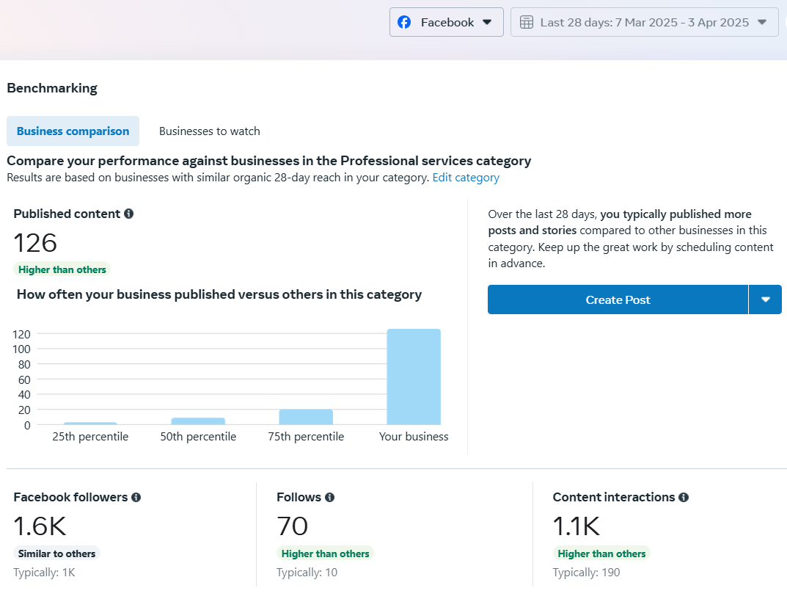

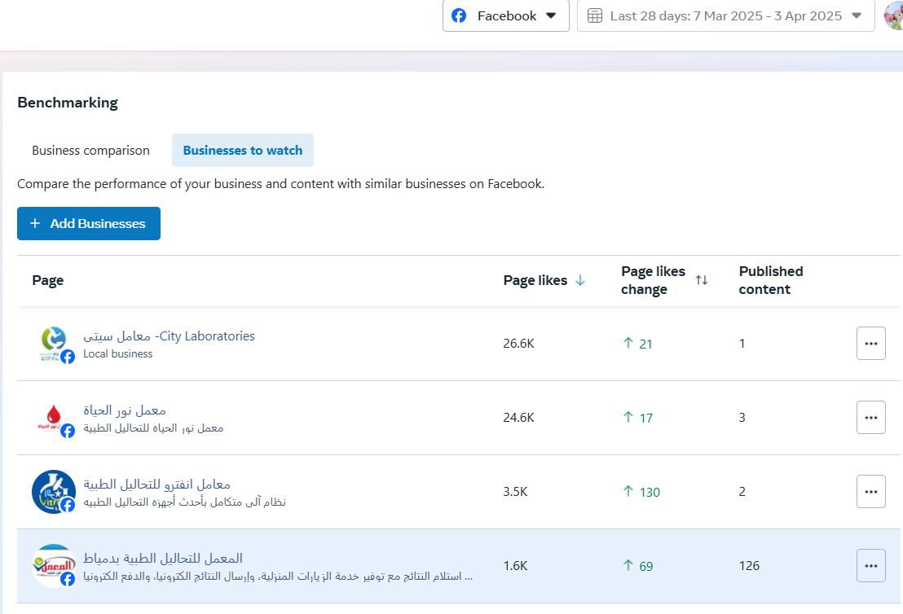

highest reach: (المسابقة)

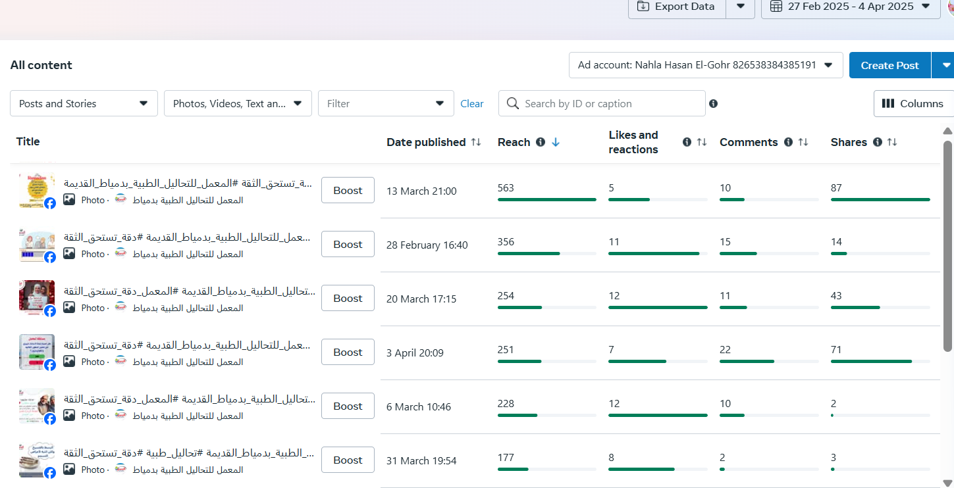

highest likes and interactions

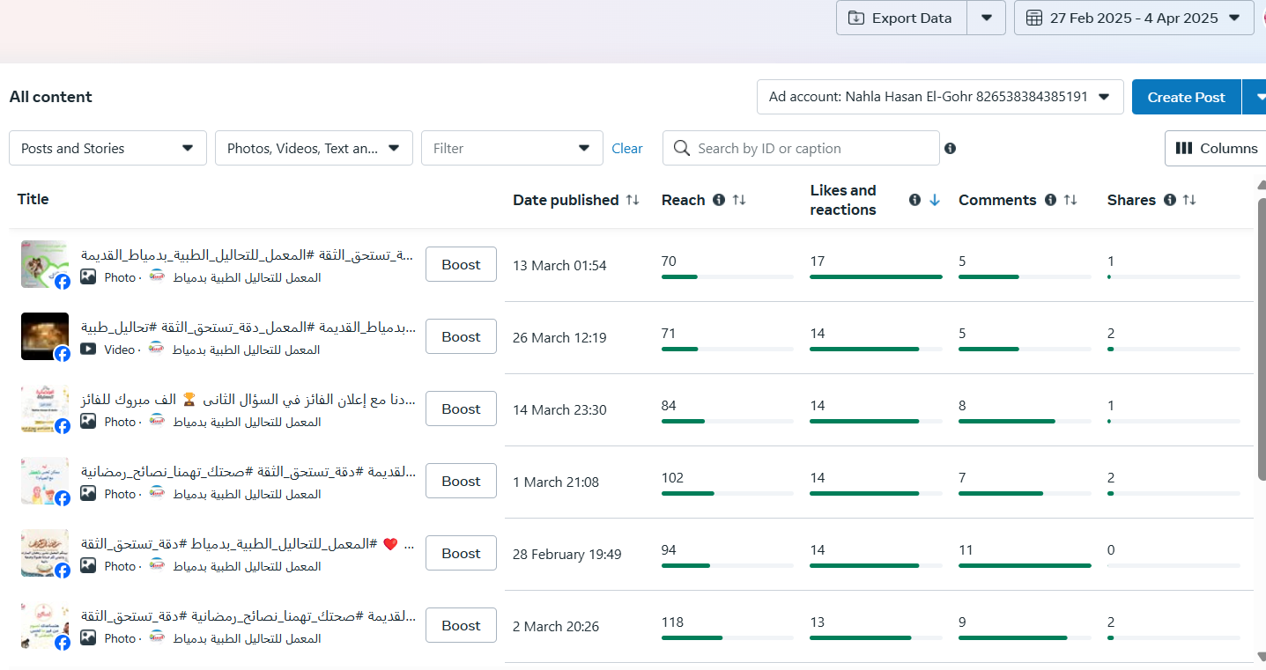

highest comments

highest comments: ( المسابقة)

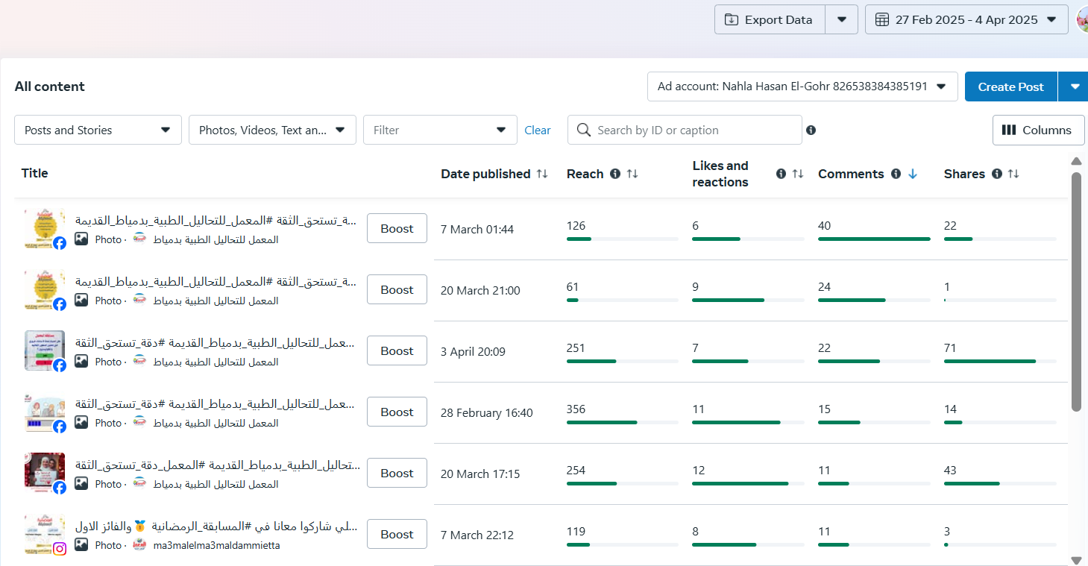

highest watch time: (Reels)

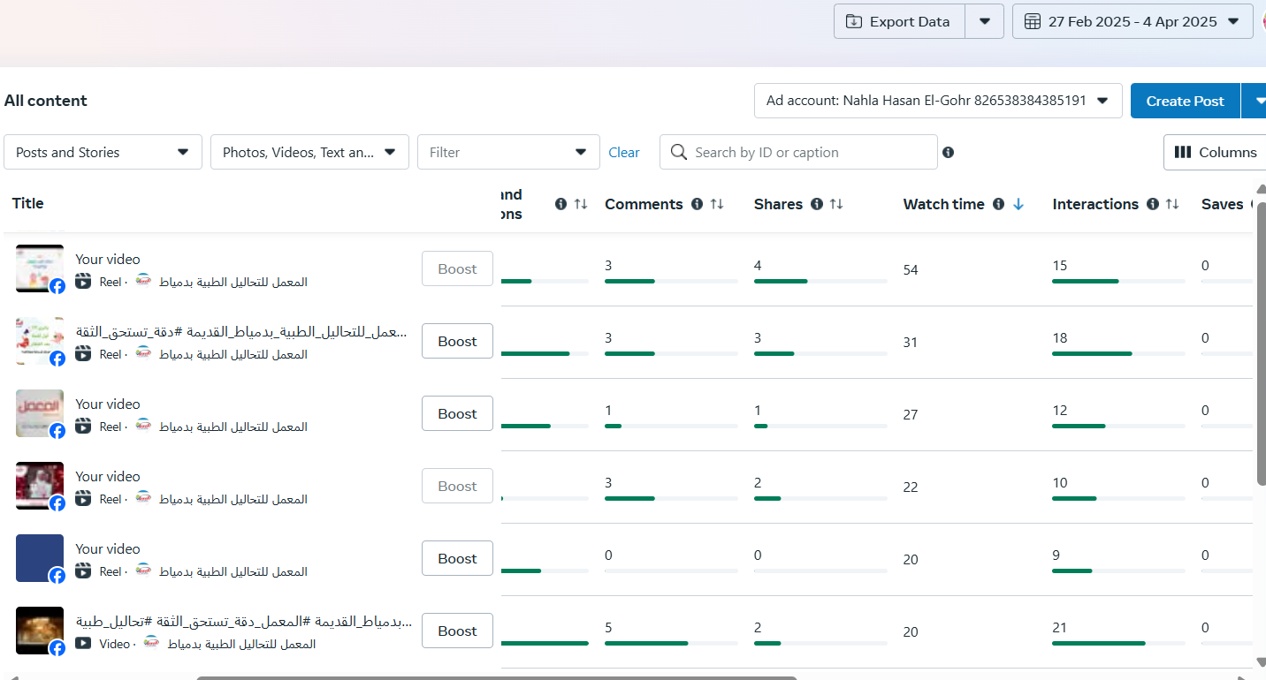

highest view: ( pinned post)

highest view: ( pinned post)

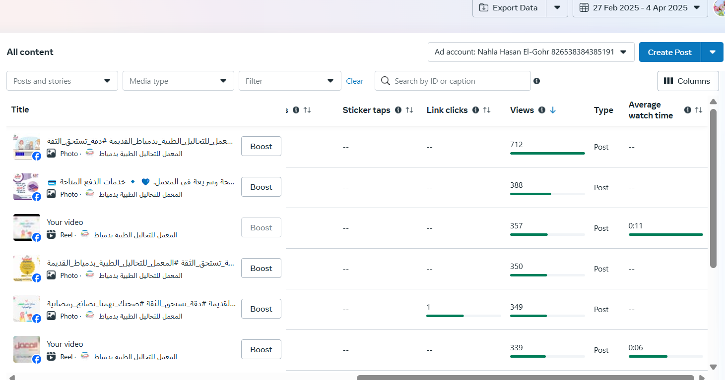

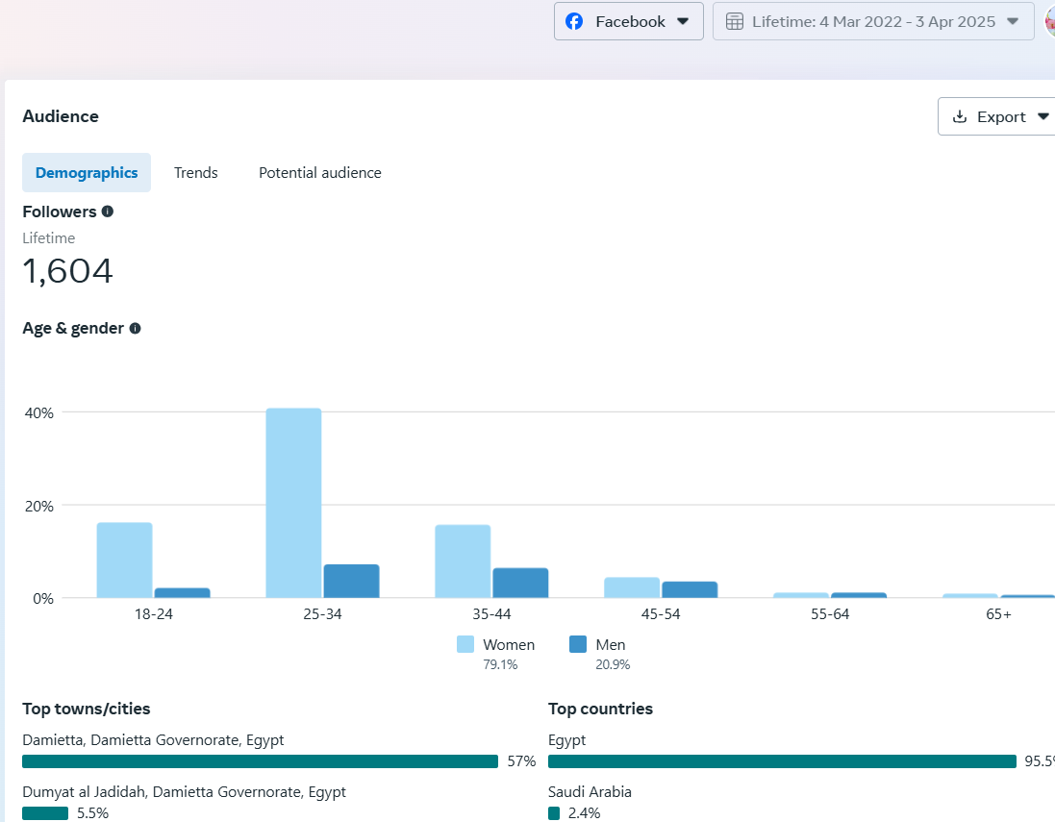

our audience:

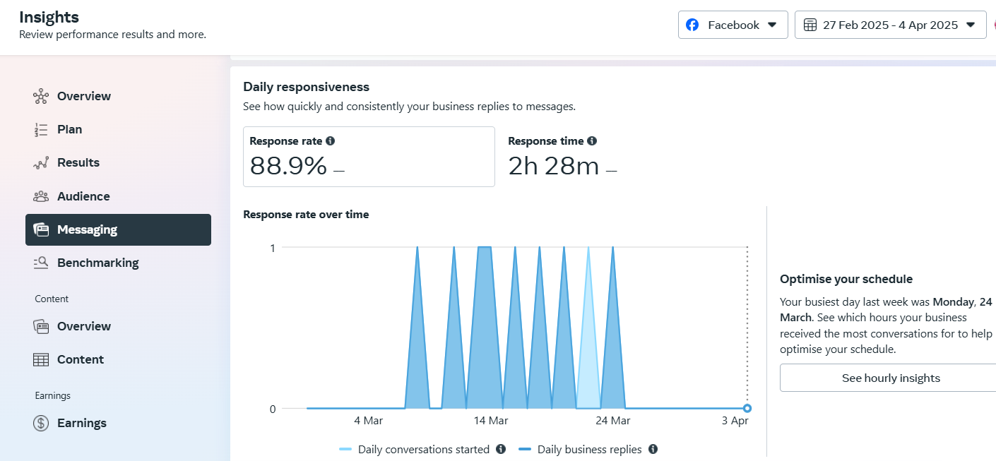

instagram overview:

