

American International University-Bangladesh (AIUB)  
**Department of Computer Science  
Faculty of Science &Technology (FST)  
Spring 21 22**

**Automated Toll Management System**

Software Requirement Engineering

Sec: **B**

Project submitted

By

*Rahman, Md Sadman (18-38832-3)*

*Bhuiyan, Niaz Rahman (18-38770-3)*

*Islam, Hasan Sanjary (19-39589-1)*

*Hossain, Shafayat (18-38863-3)*

1. **PROBLEM DOMAIN**
   1. **Background to the Problem**

Travelling via toll plaza is an extra hassle for the travelers. A recent study analyses current reasons for congestion. The delay and queue are mainly due to two different charging methods namely known as ‘Manual Toll Collection (MTC)’ and ‘Electronic Toll Collection (ETC)’. In an Electronic Toll Collection, the user has to pay the fee using their credit card which is also time consuming. All the lanes are having mixed lane system that is both MTC and ETC vehicles pass through the same lane. Toll booth capacity and type of toll service have influence on traffic operation and the efficiency of the toll plaza. The vehicles need to halt and pay the toll which cause time delay and may also cause traffic jam. Most of the people prefer to work in Dhaka and as a result, they travel to their hometown whenever possible. The transport most people use has to pass through multiple toll plazas to get to the desired destination. Trucks transport commodities from one district to the next in our country. They can be seen in lines waiting to pay tolls to cross bridges. They spend hours at a time in the same place, waiting in lines. As a result, the goods are damaged while being transported. Raw materials are more likely to be damaged, resulting in significant losses for many businesses. Toll plazas also require continuous man power to operate as the tolls have to be manually collected. This causes significant delay and also human errors.

* 1. **Solution to the Problem**

This problem can be solved by using an automated online payment system. In this system whenever any vehicle approaches the toll plaza, the laser detector detects the vehicle. Then it will check if the vehicle’s RFID (Radio-frequency identification) tag is activated or not. If the chip is activated then it will check user’s information from the database and deduct balance from the car owner’s account automatically. When the tag is inactive or the tag is not found the laser will trigger the camera and the camera will take two photos, one on the rear number plate and another of the back name-plate. Then according to the registered number plate, a mail will be sent to the respective owner for paying the money within certain amount of time to avoid fine. Using this RFID tag, both time consumption is decreased and extra security measures are ensured. In this way, people don’t have to stop at the toll gate even if they don’t have registered for a RFID tag. Authority can still collect the fee from the unregistered users. This will completely remove any kind of traffic congestion at the toll gate. If a registered vehicle is stolen, the user can report the theft, and all toll plazas will be notified if that vehicle goes through. If the car goes through a toll plaza, local authorities will be notified of the vehicle's last known location, allowing them to monitor and locate it.

There are software which can do these task only if the vehicle is registered and it has RFID tag on the windshield. If the vehicle is unregistered then the owner has to manually pay the toll fee. But the difference between our system and the existing system is that our system will detect the vehicle owner even if the vehicle is unregistered to our system and send a mail to the respective owner informing him to pay the fee in time to avoid fines.

1. **SOLUTION DESCRIPTION**
   1. **System Features**

Our system contains vehicle’s RFID (Radio-frequency identification) tag and at times when the tag is inactive or not discovered the laser activates the camera, which takes two photos: one of the rear vehicle number plate and the other of the back nameplate. Then, based on the registration number plate an email will be sent to the owner, requesting payment within a specific time period to avoid a fine.

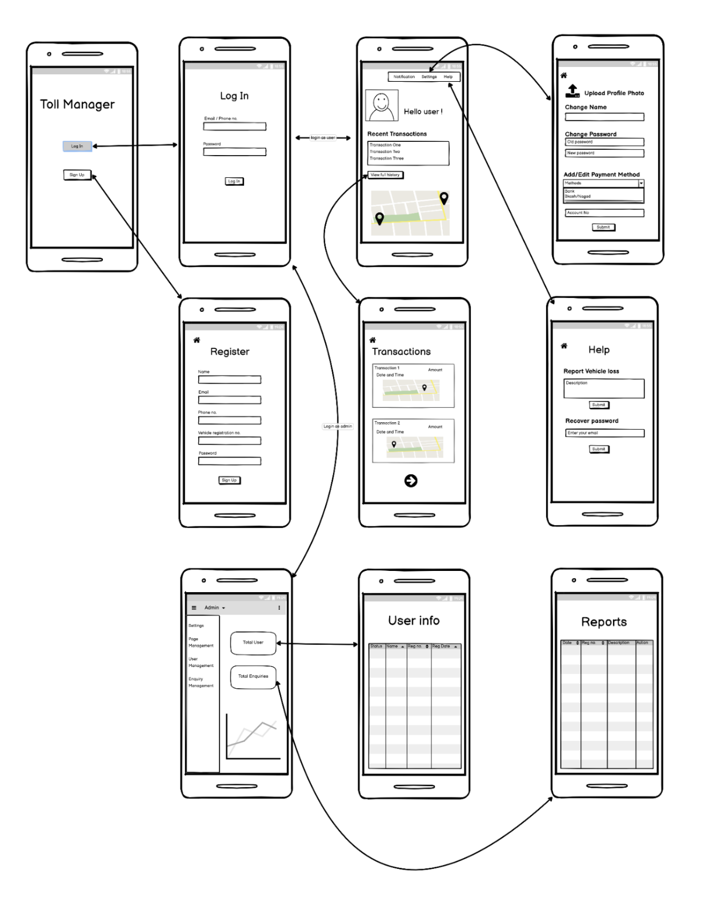

Figure 1: - Prototype Design [1]

**Admin Features**

* **Sign In**

Admin can login to their system

* **Access to User Information**

Admin can access to user information’s if required

* **Change User Information**

Information can be edited by Admin if required

* **View total inquiries/reports**

If suppose users send any inquiry or reports, then admin can check those and take necessary measurements.

* **Respond to User Reports**

After getting any report or inquiry from user’s, admin can respond to those as well

* **Tracking Vehicles**

With the help of this system admin can keep tracks of the vehicles in queue and can store any problematic case into their system database.

* **Remove Users**

Admin can remove any user and if required they can also take legal steps

**User Features**

* **Registration**

Users will have to register to our system first when they decide to use our system

* **Login**

After successfully registering to our system, User’s will have to login to use our software

* **Checking Notification**

Here User’s will get notification when they pass through the toll plaza and will also get notifications about their financial transactions required in toll

* **Edit/Update Information**

If User’s need to update/edit any information in their profile, they will be able to do so as well

* **Change Password**

Users can change password if they need to and during that time old password will be required as well for safety purpose.

* **Recover Password**

If any of our user faces a situation where they have forgotten their password, then they could be retrieved through SMS and email verification.

* **Add Payment Method**

There will be three payment methods which users can use. First comes Bank Account transaction where users will be able to directly transfer from their respective bank accounts.

Second option will be online payment gateways like Bkash, Nagad, Upay and Rocket. Simultaneously users can remove any previously selected payment method.

Lastly is the credit/debit card option where users will be able to pay through their cards like Mastercard, Visa or any local bank cards.

* **Viewing Recent Transactions**

Users will be able track their recent transactions for example their history of how much they have spent on toll plaza till now, then they can view their transactions within a fixed timeline. Then in which of the toll plazas they have already visited and how much have been spend on each of them can also be traced. It also incorporates the net deduction of how much was spend and what is the current balance.

* **Report Vehicle Loss**

If suppose a vehicle gets missing or disappears then they could be reported to our system and then authority will take necessary actions required. With this feature vehicles could be tracked and can be returned to the original owner safely.

* 1. **UML Diagrams**

**Use Case Diagram:**

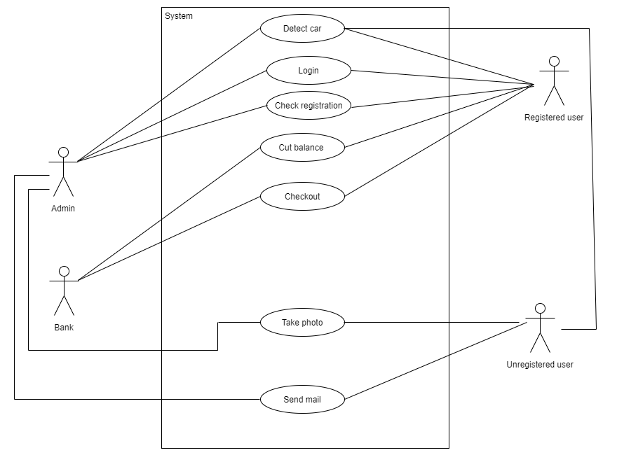

Figure 2: - Use Case Diagram [2]

Here, when a registered car passes through the toll plaza the system detects the car and checks registration and cuts balance from the users account. This can be monitored by the admin. The bank will be responsible for deducting balance from the user’s account and checkout. When an unregistered user passes through the sensor detects the car and a photo is taken of the number plate and an email is sent to the respective owner to pay the fees in time to avoid fines.

**Class Diagram:**

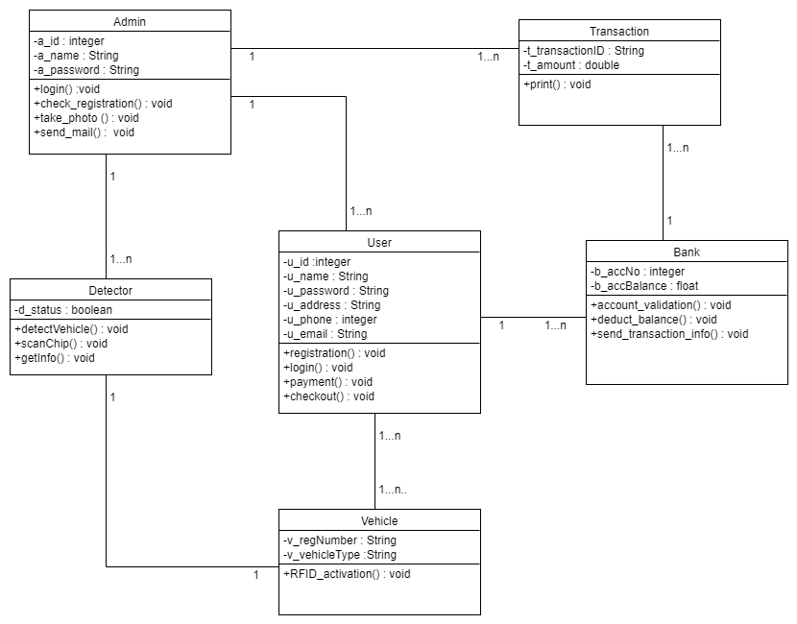

Figure 3: - Class Diagram [2]

Here in the Class diagram, there are a total of six classes. They are Admin, User, Detector, Vehicle, Bank, Transaction. There is one to many relations between admin and user as well as the detector and transaction, one to many relations between user and bank, many to many relation between user and vehicle and one to one relation between detector and vehicle.

**State Diagram:**

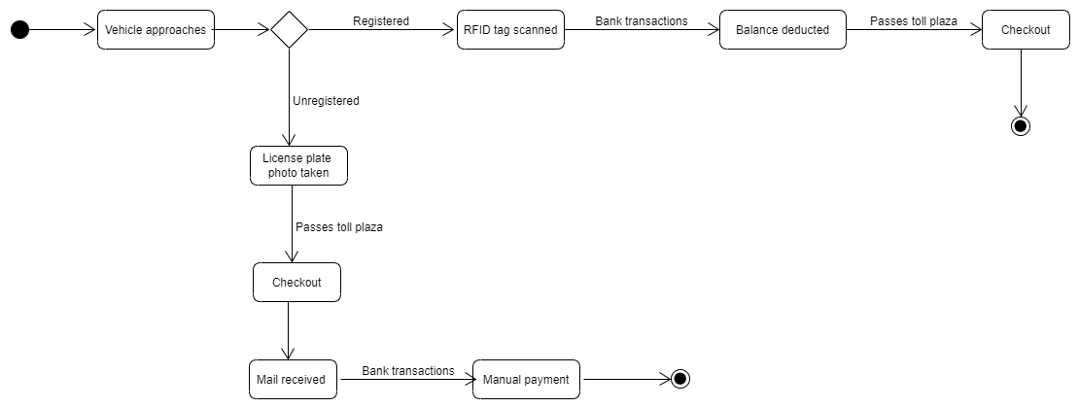

Figure 4: - State Diagram [2]

Here we can see a total of eight states. At first the vehicle approaches and if the vehicle is registered the balance is deducted from the owner’s account after the RFID tag is scanned. If the vehicle is unregistered a photo is taken of the license plate and an email is sent to the owner of the vehicle to pay the fees in due time to manually.

**Sequence Diagram:**

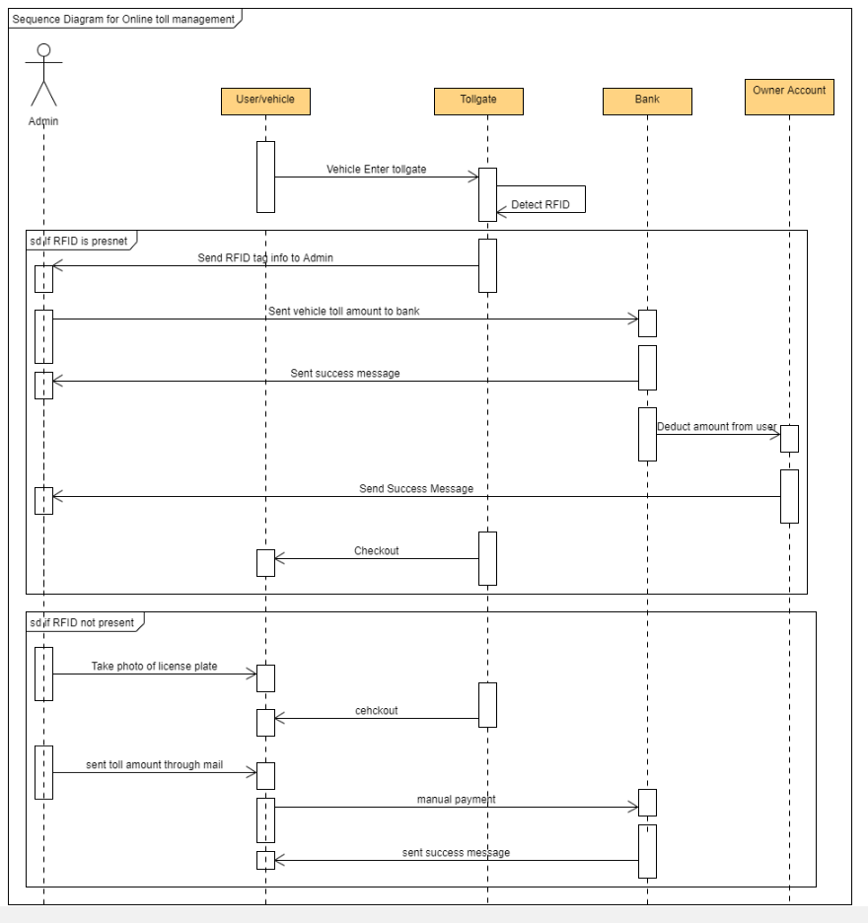

Figure 5: - Sequence Diagram [2]

In this sequence diagram a registered car passes through the toll plaza the system detects the car and checks registration and cuts balance from the user’s account. This can be monitored by the admin. The bank will be responsible for deducting balance from the user’s account and checkout. When an unregistered user passes through the sensor detects the car and a photo is taken of the number plate and an email is sent to the respective owner to pay the fees in time to avoid fines. So, the owner of the unregistered vehicle can pass through but has to make payment manually. Then a success message will be sent to inform about the successful payment.

1. **Social Impact**

As our country is making progress and getting closer to be a developed country, the activity and number of vehicles on the road have increased significantly in the last two decades. Bangladesh is a land of river and there are many bridges connecting one district to another. Most of the people are not familiarized with the automated toll collection system as this technology is much newer to our region. If Manual Toll Collection system is replaced with our Automated Toll Collection system, people will get to know the benefits of it as it will save a lot of valuable time. People in Bangladesh spends a big amount of time in traffic when giving tolls. But in our system the registered user’s RFID will be scanned automatically after detecting the vehicle with a laser sensor. It will be completely hassle free and the toll fee will be automatically deducted from the user’s account.

As the technology is still new, even an unregistered vehicle can pass through without giving toll manually. In this case, the vehicle license plate will be captured using a camera. After searching in the BRTA database for the vehicle owner, an email will be sent automatically to him informing him to pay the fee within a time limit to avoid fines. In this way the car owners will eventually register for the automated toll management system.

In our country goods are transferred with trucks from one district to another. They can be seen standing in lines for giving tolls to cross bridges. Some time they spend hours at the same spot waiting is queues. As a result, the goods get damaged on the way. Raw goods get damaged more and many businesses face huge losses. Our system will help to completely eliminate this problem and crossing bridges and toll plazas will be just like crossing a normal road for the people as they don’t have to stop anywhere to give toll fees. No man power will be need to run the toll plaza so there will be no human errors and delay.

Another features which will be very beneficial for the users is the stolen vehicle tracking system. If a registered vehicle gets stolen, the user can report the loss and all the toll plazas will be alerted if that specific vehicle passes. If the vehicle passes through any toll plaza, local authorities will be informed of the last known location to track and find out the stolen vehicle. This feature will be very helpful for the registered users.

.

1. **Project Estimation**

The total amount of time required to develop the software is estimated to be around 15 weeks. We have divided the project works according to our development plan.

|  |  |
| --- | --- |
| **Weeks** | **Task** |
| Week 1 | Requirement Gathering |
| Week 2 | Project Planning |
| Week 3 | Team selection and Scheduling |
| Week 4 | Analysis and Risk Management |
| Week 5 | Specification Analysis and Time Estimation |
| Week 6 | Design and Development [1] |
| Week 7 | Design and Development [2] |
| Week 8 | Design and Development [3] |
| Week 9 | Design and Development [4] |
| Week 10 | Quality Testing [1] |
| Week 11 | Quality Testing [2] |
| Week 12 | Quality Testing [3] |
| Week 13 | Quality Testing [4] |
| Week 14 | Maintenance and Delivery |
| Week 15 | Maintenance and Delivery |

Table 1: - Assigned Tasks for Each Week

In the team, we need a total of six main personnel who will be directly involved with the development. The business analyst will be in charge of evaluating past and current business data with the primary goal of improving decision-making process. The senior developer will be in charge of the developer team. UX designer has to design user interface of the software. And lastly the back-end and front-end developers will be developing the front-end and back-end of the software. The estimated work hour per day and hourly rates are given below:

|  |  |  |  |
| --- | --- | --- | --- |
| **Team Member** | **Total Number** | **Hour/Day** | **Hourly Rate** |
| Business Analyst | 1 | 6 | 900/- |
| Senior Developer | 2 | 6 | 800/- |
| UX Designer | 2 | 4 | 850/- |
| Front-end Developer | 3 | 3 | 750/- |
| Back-end Developer | 3 | 3 | 750/- |
| Quality Tester | 2 | 5 | 750/- |

Table 2: - Employee List with Working Hour

Estimated Monthly Cost for Development = 856000/-

Esti­mated Total Project Cost = 2996000/-

1. **Project Schedule**

Figure : - Gantt Chart [3]

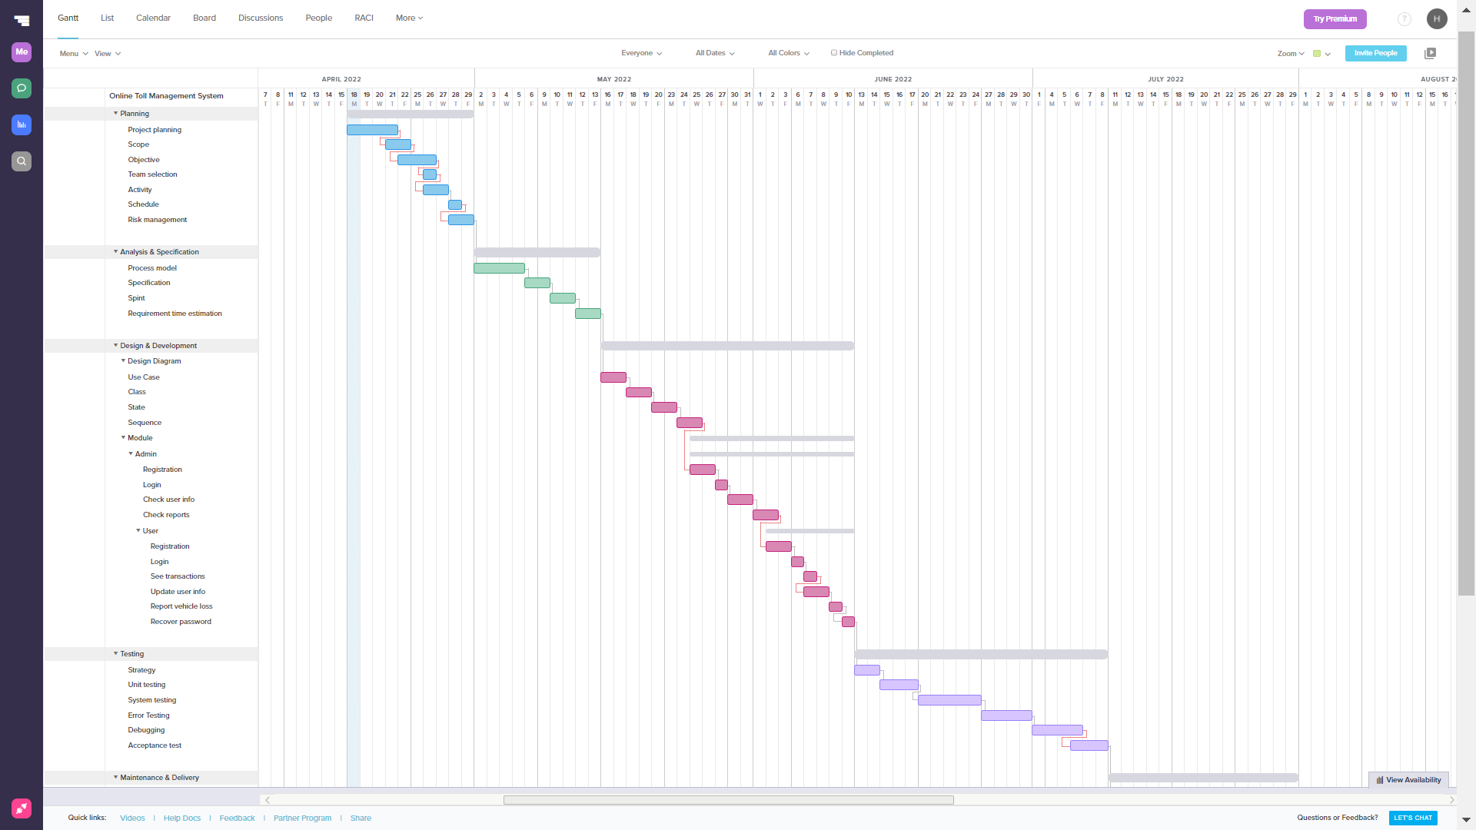

1. **Development Plan**

We will begin by gathering the project requirements of our software from our customers and listen to various stakeholders. Then we will analyze the requirements and prioritize them and eventually make a baseline requirement of our software which must be fulfilled in development process. Our designing team will then be starting designing the UML diagrams and make a proper prototype of what should be implemented during development. Documenting the requirements and finally make an SRS document will be our primary goal before reaching the development phase. Afterwards developers of our team will to commence the development part. When the development phase completes, quality assurance team will be testing the beta version of our software and may advice developers for further improvement or if any mistakes are made then that will be mended. Below are some key phases of our development road map.

* **Elicitation:**

In this phase we will be sitting and brainstorming with the related government ministries like road and transport ministry. Listen to all of their requirements without any opinion or prioritization. This process will continue for one week and then we begin analysing, prioritizing and share opinion and advice about what could make out toll system robust. If any requirement came out to be not useful then it can be disregarded and if any requirement seem to be suitable by us, we will suggest them to designated government ministries.

* **Documentation:**

After collecting requirements our designing team will begin to make the UML diagrams like Use Case diagram, Class diagram, State diagram, Sequence diagram, Activity and E-R diagram. These will be some of the diagrams required in order for developers to start building the software. Documenting the baseline of our software requirements will be an important aspect for further developing, testing and much more. Documentation process will be taking two weeks period.

* **Developing/Coding:**

Our development team constitutes of eight members which is why we will split our team members into half and they will work on shifts. Among eight of them three programmers will be specifically designated for extreme programming. During extreme coding while one member will be coding other two members will be looking at the code and if any mistakes or suggestions found then they will provide or correct them. After every three hours cycle another programmer will sit down and start to code and these will be repeated back and forth. Our target to complete the development of the system will be in four weeks.

* **Testing:**

Testing will be a vital stage for us as during testing our Quality Assurance team will come at work. There are five members at our Quality Assurance team. Each member will be assigned different functions to test. We will divide our testing into three different parts which are mentioned as follows: -

1. Functional Testing:

In this part we test the main functionalities of our system. Various tests will be conducted here e.g. Unit Testing, Integration Testing, Smoke and UAT (User Acceptance Testing)

1. Non-Functional Testing:

In non-functional testing our QA team will test extensively Performance of the system to Endurance, to Load, Usability and Scalability

1. Maintenance Testing:

Maintenance testing will be another crucial testing where two specific tests will be conducted. One is regression testing and another is maintenance.

So, testing of our software will be taking around four week.

* **Releasing:**

During the release of our software, the first release will make is the beta version where before users using it our internal team, stakeholders and designated government bodies will have the first in hand experience. From there a feedback will come for further changes or improvements. After a certain period of understanding and coping up with it we will release the user version.

* **Manuals/Guidelines:**

In this part of documentation, we will be providing guidelines and manuals for how to use our system to Government ministries, general public users and other stakeholders. Leaflets, pamphlets and other visual materials will be given to them as well for usage convenience.

1. **Change Management Plan**

In our change management plan, we have made it in a very systematic manner. When any government or ministry body will be proposing us a change, we would not directly go for granting that change or improvement. Business analyst of our team will first hear those requests from stakeholders and then make an impact analysis of the change. While doing impact analysis Business Analyst will have to consider all the possible implications e.g. how much time will be required to allocate for the task and would it hamper the releasing date, how much will it cost and also do we have enough man power to make a change request in a short notice and vice versa.

There will be a Change Control Board in our company comprising members from each sector like marketing, finance, HR, programmer and etc. Each representative from each department will make the CCB which abbreviates Change Control Body. Our business analyst will make a report out of impact analysis and submit it to the CCB. CCB then will make the decision of whether to grant the change request or to reject or to defer it for further iteration. If any changes are made then we will keep track of those changes for safety and future release purpose. Proper documentations will be made for keeping the track of changes and also versions of the system made after an iteration.

1. **Marketing Plan**

* **Advertisement:**   
  Advertising is a good way to spread our works as it will help to amplify our marketing and will help us to reach the right audience with positive, targeted messaging that will convert potential customers into paying customers. Advertisement can be done through many platforms. They can be print media, radios, televisions and many more. There are many screen billboards which can display videos. We can show a demonstration video of our system through it. It will catch people’s attention and also buyers.
* **Social Media:**  
  Social media allows marketers to connect and engage potential customers. Facebook, Instagram, YouTube and other social media platforms offer paid promotions which includes sponsored posts to appear on people’s newsfeed. This will allow to reach general people and they will get to know about the new technology and the importance of it in their daily life. As we also provide services to international buyers, people from different countries are also our target. Social media provided very convenient service to reach other country’s people and let them get to know the specialty of our software.
* **Search Engine Optimization:**   
  Search Engine Optimization or SEO is crucial because it will make our company’s website more visible and that means more traffic and more opportunities to convert prospects into customers. This means that whenever someone searches for anything related to our service, our website will pop up on their search list. Search engines such as: Google, Bing, Yahoo, Baidu, AskDotCom are popular among many more search engines.
* **Public Relation (PR):**  
  Public Relations Increases Brand Credibility. Goodwill and communication between the company and the consumer are promoted through public relations. Customer relationships are strengthened by good public relations. So, to preserve a good image is very important. Maintaining good public relation can be done by proper after sale services, promotional offers and many more. As our company’s developed software’s future will rely on the customer’s feedback, we have to maintain good public relation.
* **Sponsoring Events:**  
  Sponsorships will help our software to increase its credibility, improve its public image and build prestige. We can sponsor many local events which will gain us people’s reach and let them get familiar to our newly developed software. Maintaining a good position and to be known by general people is very important to gain trust. Public demonstration of the software is also very important which can be done by sponsoring events. This will increase our brand value significantly.

1. **Cost and Profit Analysis**

**Cost Analysis:**

|  |  |  |  |
| --- | --- | --- | --- |
| **Team Member** | **Total Number** | **Hour/Day** | **Hourly Rate** |
| Business Analyst | 1 | 6 | 900/- |
| Senior Developer | 2 | 6 | 800/- |
| UX Designer | 2 | 4 | 850/- |
| Front-end Developer | 3 | 3 | 750/- |
| Back-end Developer | 3 | 3 | 750/- |
| Quality Tester | 2 | 5 | 750/- |

Table 3: - Employee Cost Table

Estimated Monthly Development Cost: 856000/-

Estimated Total Project Development Cost: 2996000/-

Annual Marketing Cost:

* Advertisement: 110000/-
* Social Media Sponsored Post: 50000/-
* Search Engine Optimization (SEO): 150000/-
* Sponsored Events: 300000/-

Annual Office Rent and other Cost:

* Rent: 500000/-
* Utility Bills: 100000/-
* Maintenance: 120000/-

So, in total the cost is 4326000/- in one year including software development.

**Total Earnings:**

Our customers are toll management companies. They will be buying our service and they have to make payment in monthly basis. Within one year, we are expecting to sell our software to at least 250 clients. For each month they have to pay us 20000/- BDT to continue our service.

So, in one-year total earning from our software will be: 20000 X 250 X 12 = 60000000 BDT

**Profit Analysis:**

After one year of releasing our software, the total cost will be 4326000/-

And total earning will be around 60000000/-

So total profit after 1 year: (60000000-4326000) = 55674000 BDT

In the above descriptions we have tried to illustrate what will be our yearly expenses then a sample amount of what will be the total earning. We also have mentioned of what will be our yearly net profit.

In the upcoming days our plan is to double the number of our users. In second year of our software company our goal is to decrease the monthly rates, however, it will depend on the local market conditions and the number of users subscribed at our company.

After we expedite our software business, we have a goal to attract global customers around the world. On that instance we might increase our expenses for global customers initially and afterwards if we make an impactful development, we will minimize them to decent rates so that we achieve a competitive market.

In order to reach there initially the rates for international customers will be similar to that of local customers but in future we might change them as to minimize our profit and loss. We will also differentiate expense and costs in region wise as currency rates are different in various continents.

**References:**

[1] Balsamiq, “Balsamiq. Rapid, effective and fun wireframing software. | Balsamiq,” *Balsamiq.com*, 2019. <https://balsamiq.com/>

[2] Lucidchart, “Online Diagram Software & Visual Solution | Lucidchart,” *Lucidchart*, 2017. <https://www.lucidchart.com/pages/>

[3] “Trello,” *@trello*, 2014. <https://trello.com/>

[4] Development Department (itsd.aiub.edu), AIUB Software. “SRS Template | American International University-Bangladesh (AIUB).” *Home | AIUB*, www.aiub.edu, 10 Apr. 2001, www.aiub.edu.

‌

‌

‌