make sure that you have read and following the install instructions on the following website
https://chain.com/docs/core/get-started/install
Make sure that docker is installed

Step up your account
- docker run -it -p 1999:1999 chaincore/developer
- open http://localhost:1999
make sure to note your client ID and copy that whole line and paste that to login. example is below
client:51a05ff4e1ed18074dcaf11b53d90ddcd8cef83917d97b272442207cf0b00b83
use your own client log to login

Once login to dashboard, you can either set up your own chain core network or join the foundery chain core.
You will need the following below to login to the foundery chain.
Generator URL: http://13.95.95.38:1999
network access key: Gabe:5e28b4d28125e91908226d31417eb5f6ca82cf869bd492bd45a6cdfa3f7ba21d
Blockchain ID: 0b5924c85dac6f14576c9adfc88bf38154f02830163680158d4abc5d1da9680a

Once login foundery dashboard. it is best to set up an account. This is done by doing the following steps
Setting up Accounts
- Click on the side bar tab “Accountss”. Once there click on the “+ New account”
- Enter the name of the account you want to use in “Alias” then click submit.
- Click on “Submit” once done
Note you can select how many Keys and Quorum you would like to use. You can also add tags but we will skip that for this tutorial.
Below will have a practical example of what is entered in each step.
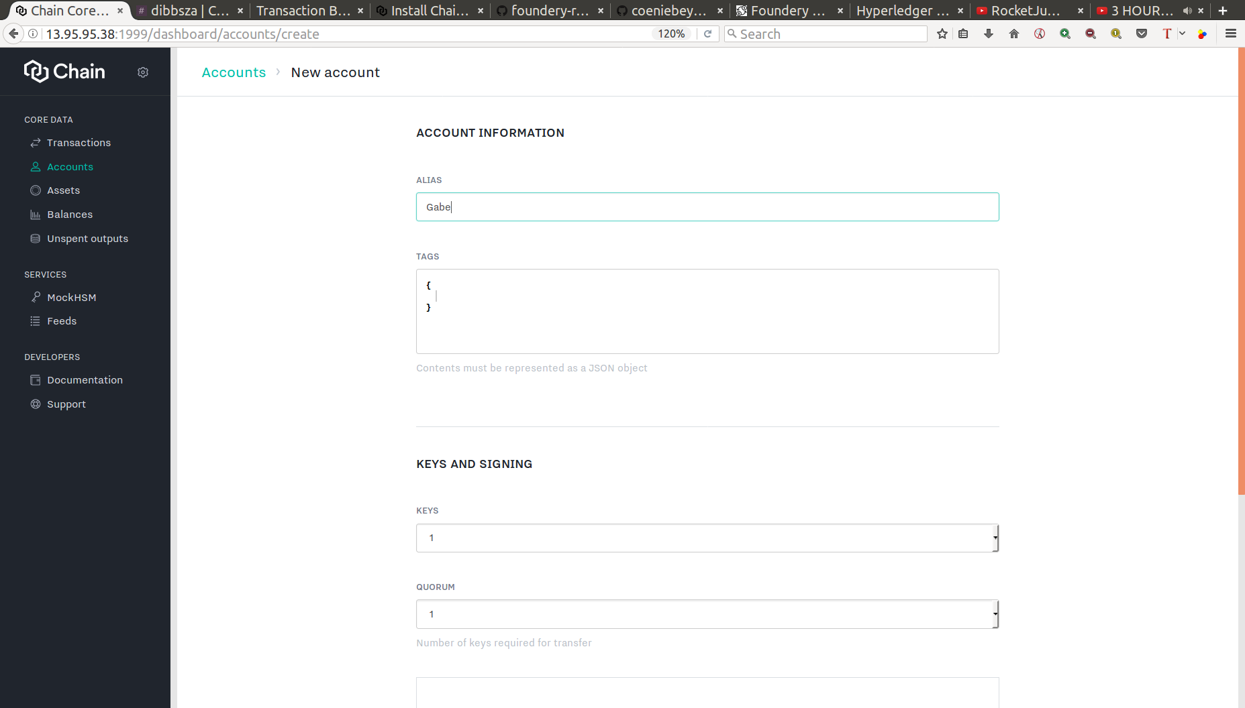

Setting up Assets
- Click on the side bar tab “Assets”. Once there click on the “+ New assets”
- Enter the name of the asset you want to use in “Alias” then click submit.
- Click on “Submit” once done
Note you can select how many Keys and Quorum you would like to use. You can also add tags and definition but we will skip that for this tutorial.
Below will have a practical example of what is entered in each step.
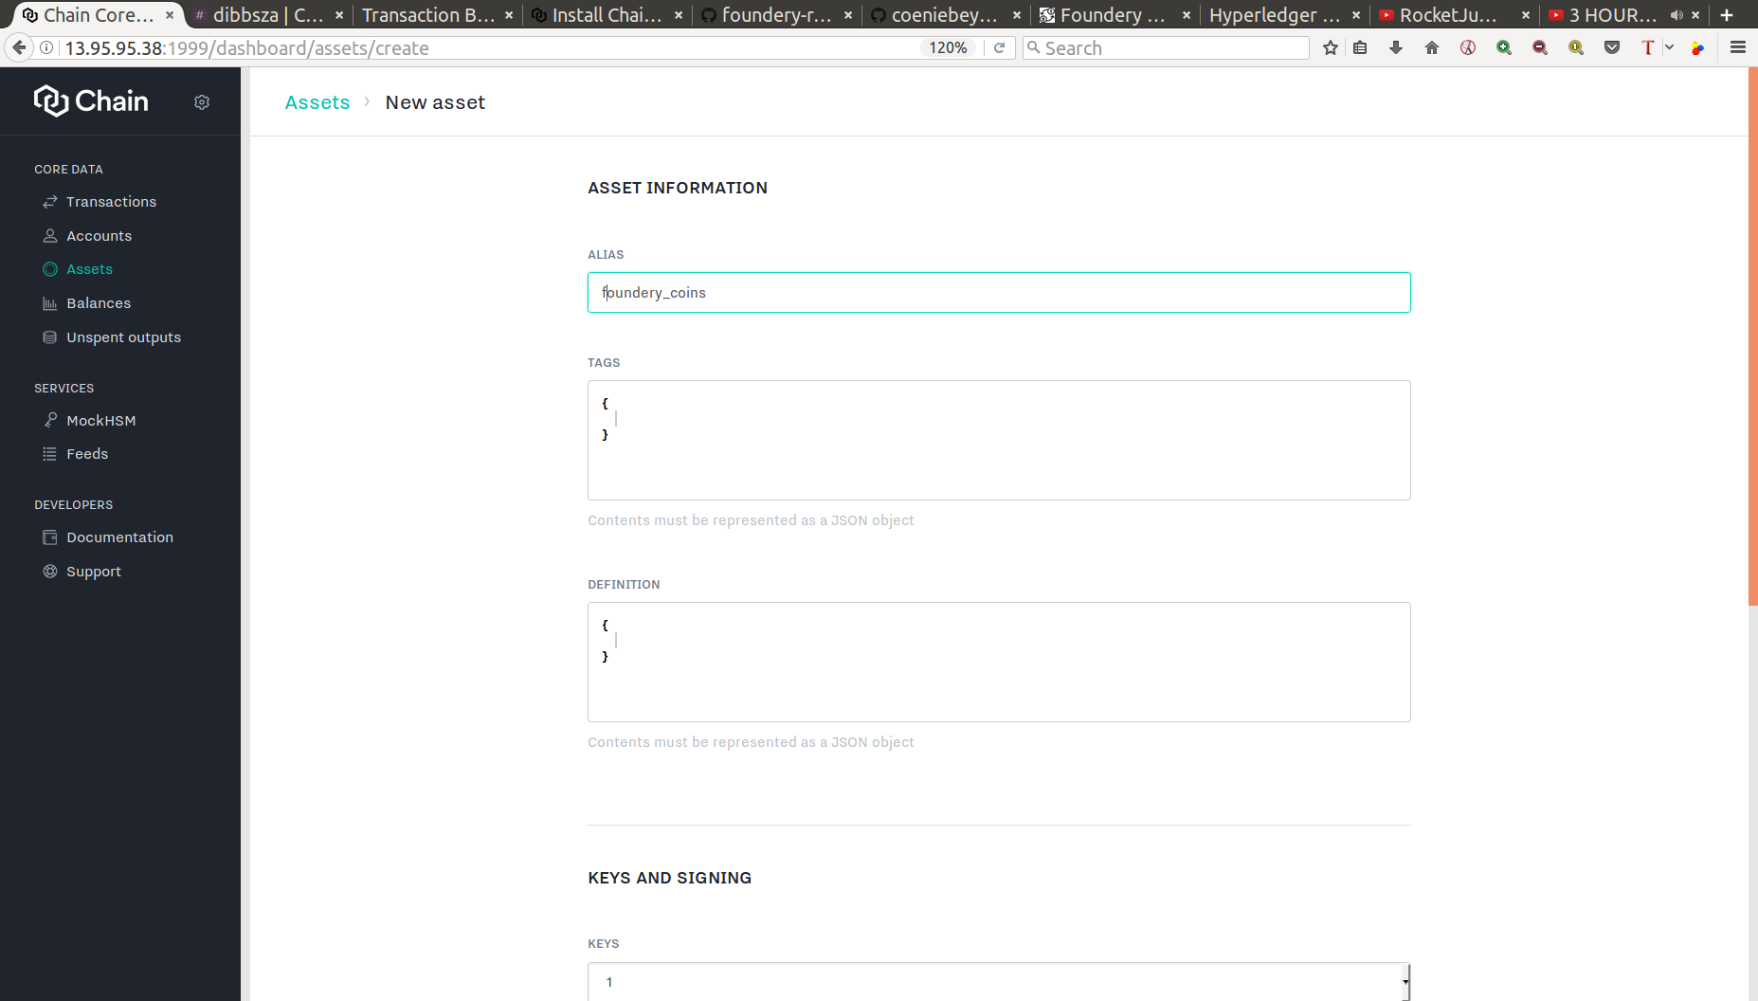

Addind funds to your asset.
- Click on the side bar tab “Transactions”. Once there click on the “+ New transaction”
- Click on “+ Add action” and select “Issue”
- Enter the name of the asset alias you want to use to add funds to
- followed by the amount
- Click on “+ Add action” and select “Control with account”
- Enter the name of the account alias you want to add funds to.
- Enter the name of the asset alias you want to use to add funds to,
- followed by the amount
- Click on “Submit transaction” once done
Note you can select “ Add reference data” to each action but we will skip that for this tutorial.
Below will have a practical example of what is entered in each step.
- Click on the side bar tab “Transactions”. Once there click on the “+ New transaction”
- Click on “+ Add action” and select “Issue”
- foundery_coins
- 10000
- Click on “+ Add action” and select “Control with account”
- Gabe
- foundery_coins
- 10000
- Click on “Submit transaction” once done
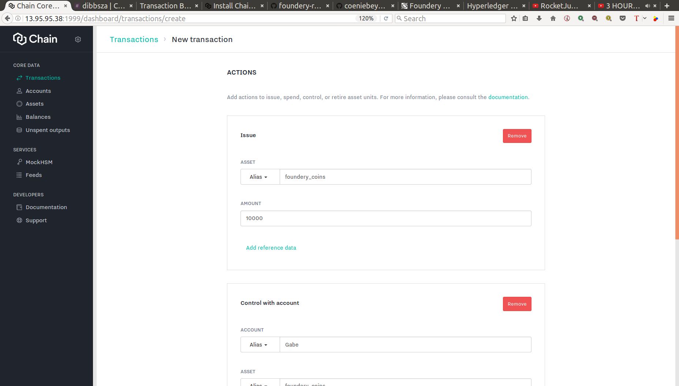
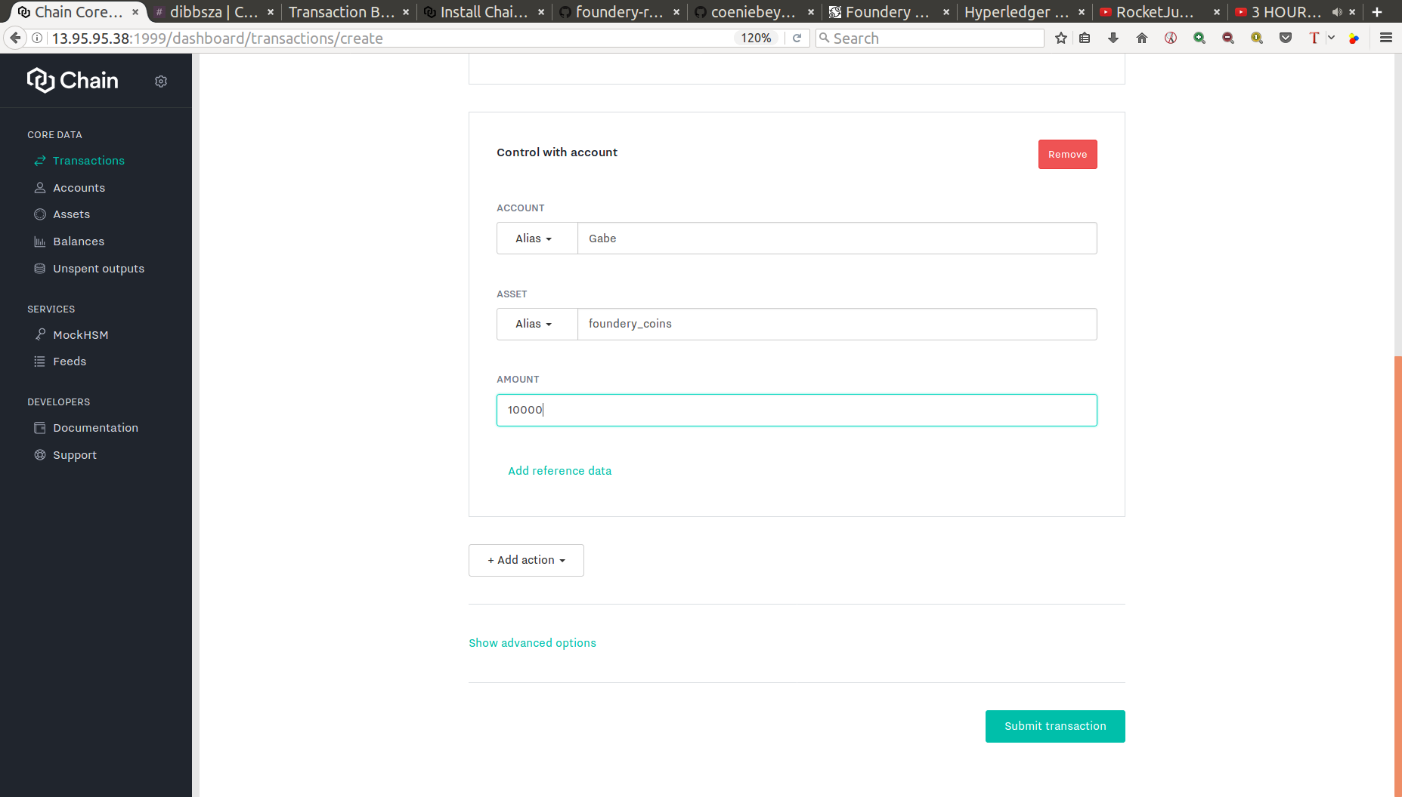

Create a control program
- Click on the “Accounts” side bar tab on the left side
- Click on the view details within the same row as the Account Alias name on the right of Account ID
- Click on the “Create control program” at the top right corner
- Copy that code to the clip board and paste it somewhere (notepad) where you will use it in future.
Below will have a practical example of what is entered in each step.
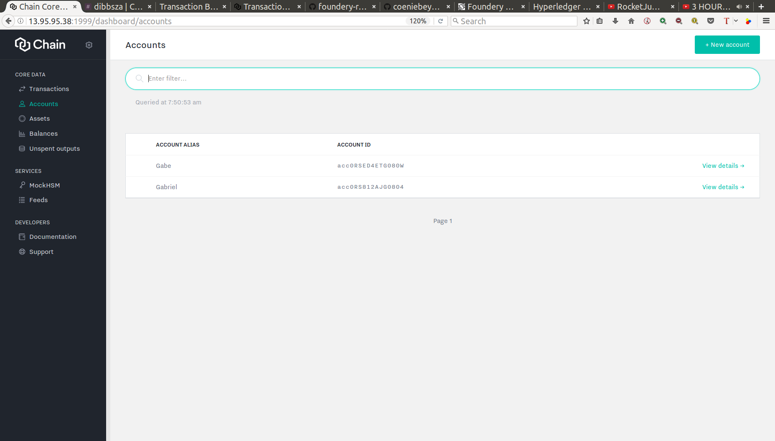
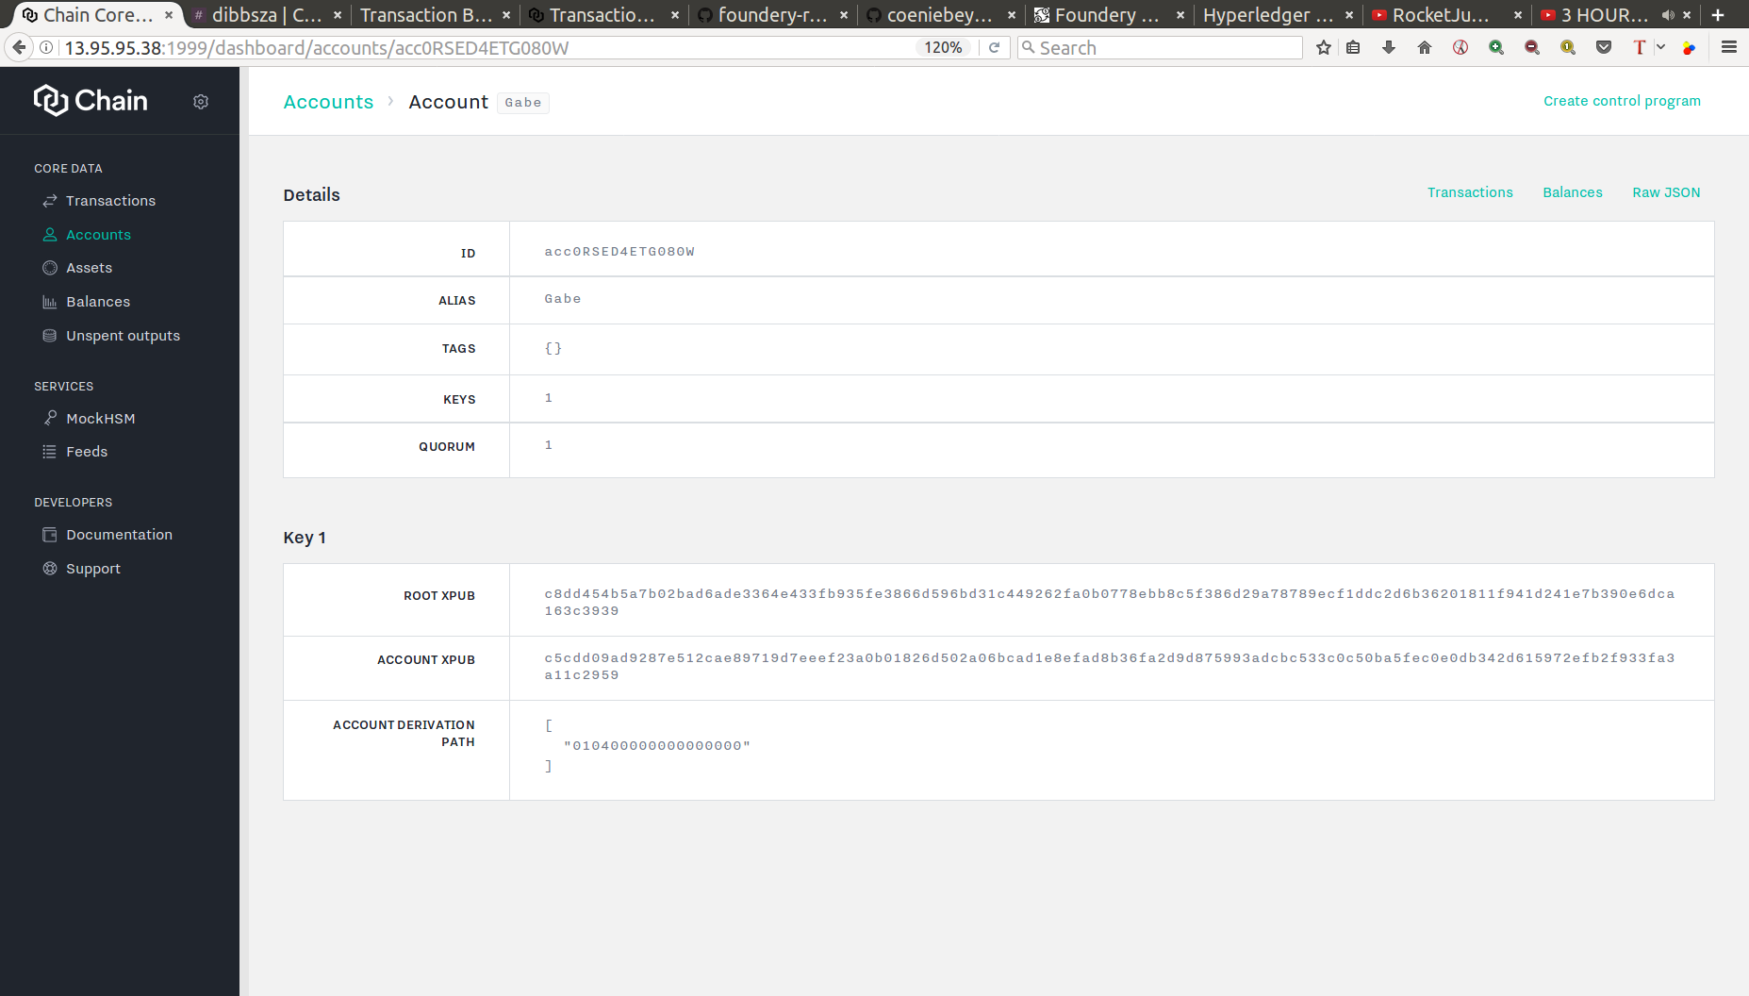

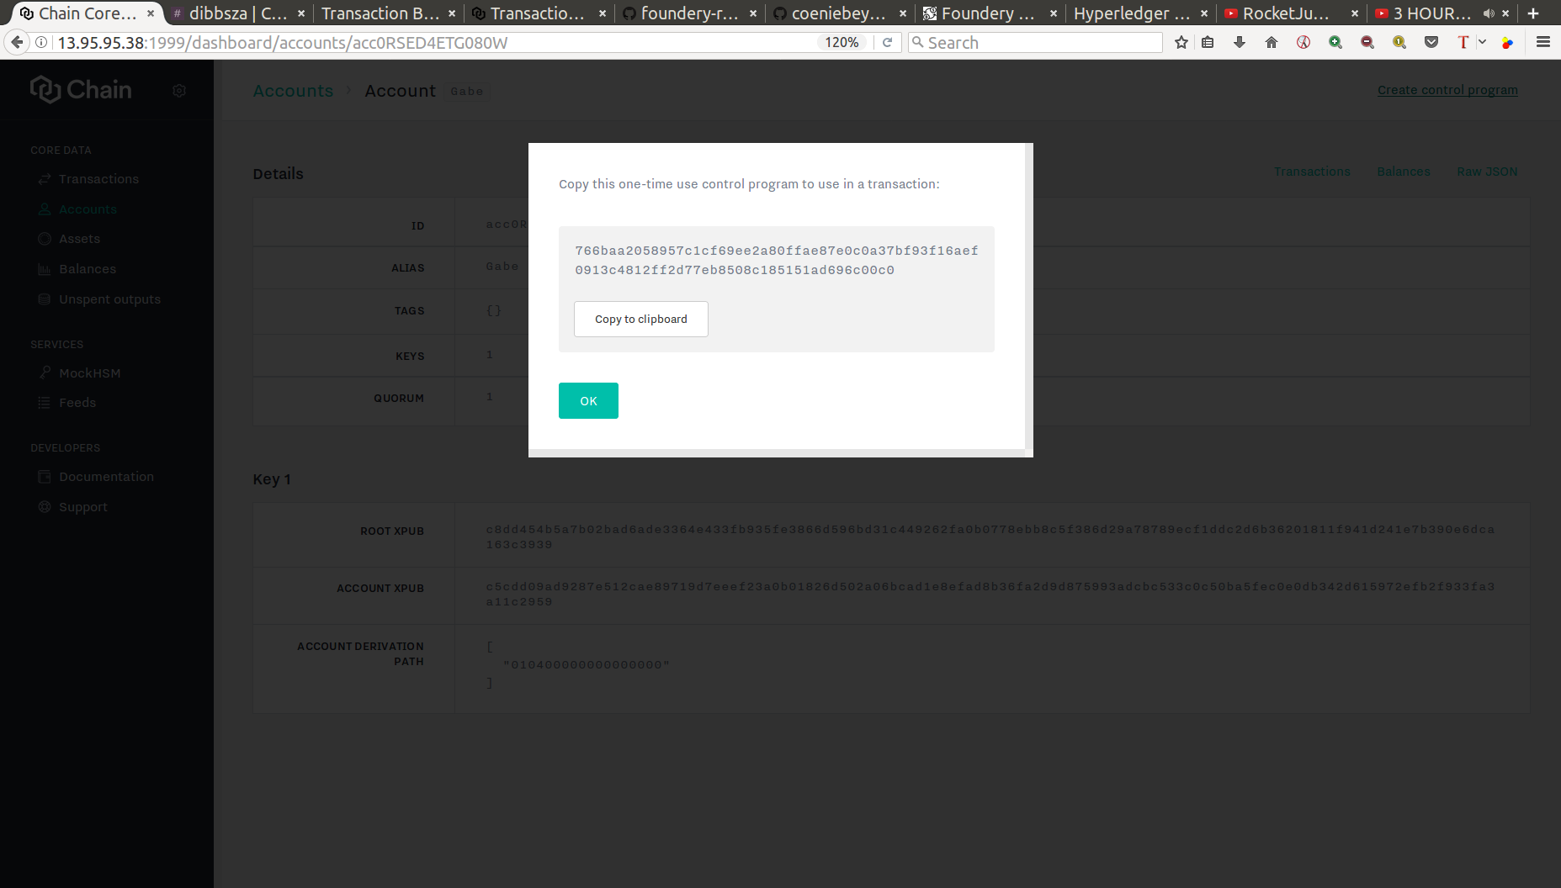
Using the control program just created to trade with other people.
Ask for the other persons conrtol program.
To send them your asset do the following.
- Click on the side bar tab “Transactions”. Once there click on the “+ New transaction”
- Click on “+ Add action” and select “Spend from account”
- Enter the name of the account alias you want to send the asset from.
- Enter the name of the asset alias you want to send
- followed by the amount
- Click on “+ Add action” and select “Control with program”
- Enter the Control Program that you get from the other person.
- Enter the name of the asset alias entered in step 4
- followed by the amount
- Click on “Submit transaction” once done
Below will have a practical example of what is entered in each step.
