https://www.youtube.com/watch?v=bGqS0f4Utn4&list=PLhW3qG5bs-L_ZCOA4zNPSoGbnVQ-rp_dG&index=8

https://www.youtube.com/watch?v=bGqS0f4Utn4&list=PLhW3qG5bs-L_ZCOA4zNPSoGbnVQ-rp_dG&index=8

git init

git add .

git commit -m "added help world"

git remote add origin https://github.com/safdar23/helloworld.git

git push -u origin master

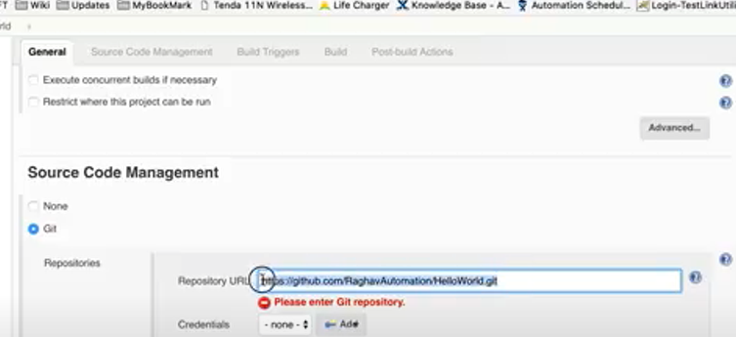

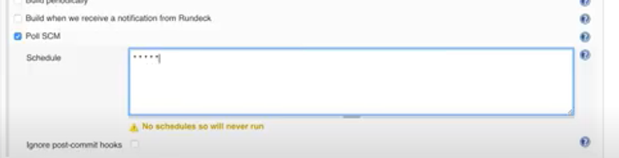

Create a new file in the pojetc folder

C:\Users\szaman\OneDrive - Capgemini\Desktop\java Project 1>dir > readme.txt

C:\Users\szaman\OneDrive - Capgemini\Desktop\java Project 1>git status

On branch master

Your branch is up to date with 'origin/master'.

Untracked files:

(use "git add <file>..." to include in what will be committed)

readme.txt

nothing added to commit but untracked files present (use "git add" to track)

C:\Users\szaman\OneDrive - Capgemini\Desktop\java Project 1>git add .

git commit -m "added read me.txt"

git push -u origin master

