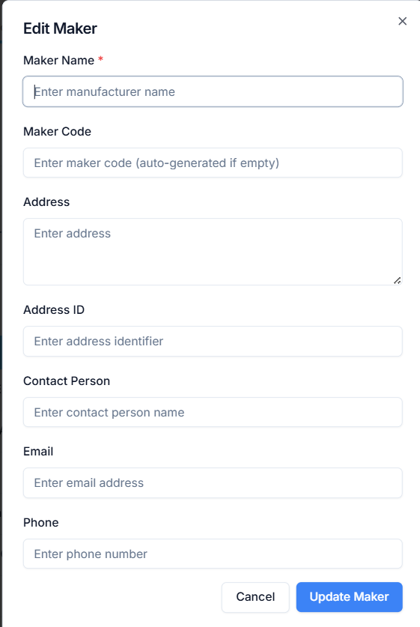
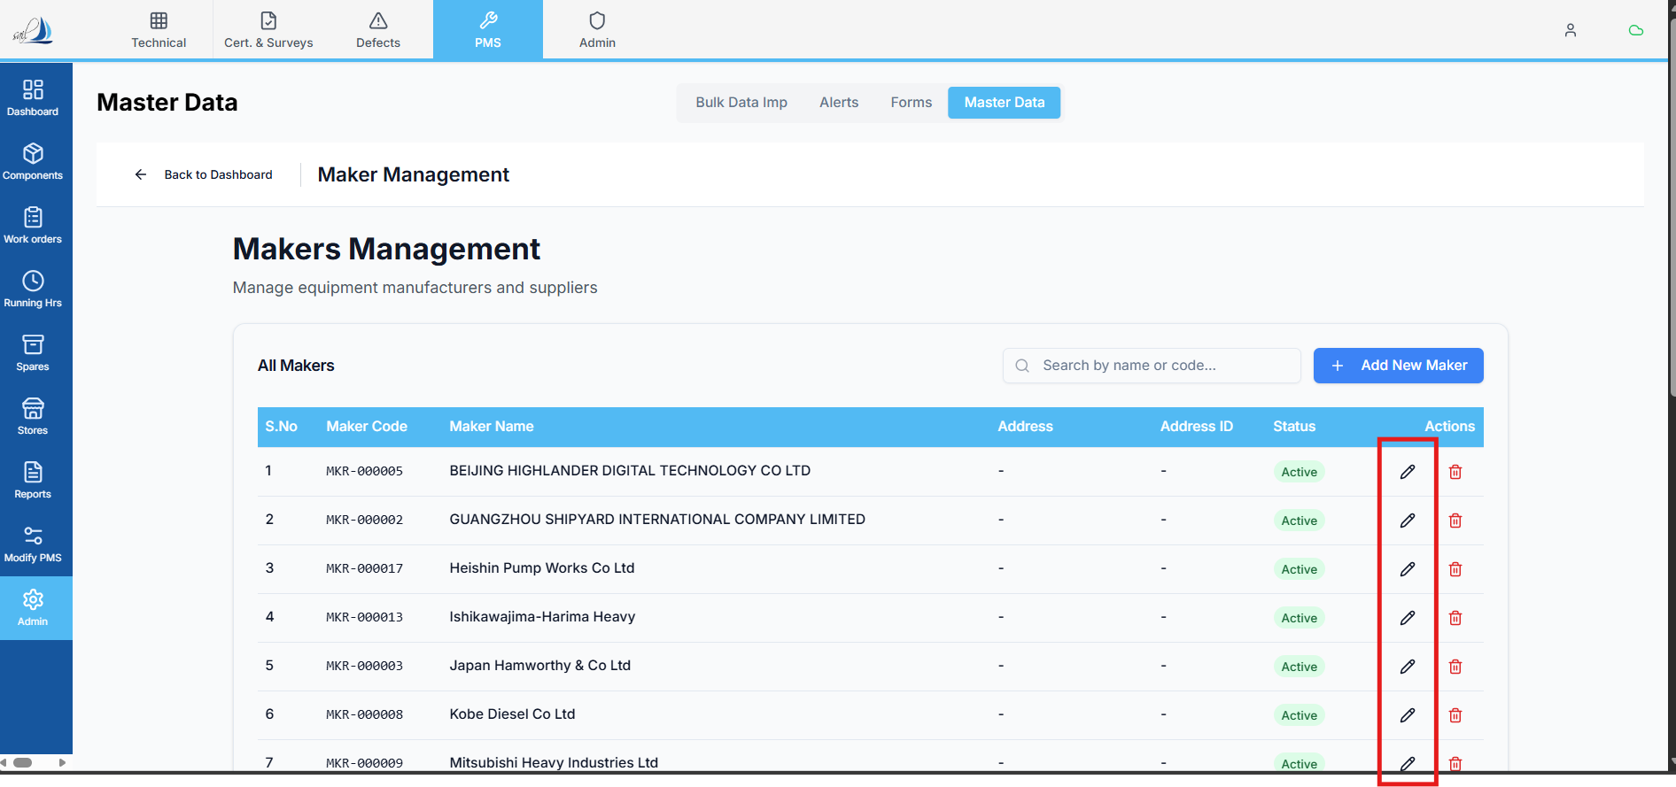
Raplit Prompt
Title: Fleet → Maker Management Screen – Edit Button Opens Blank Screen (Analysis & Correction Plan)
Purpose
Analyse the issue in the Maker Management screen where clicking the Edit button opens a blank Edit Maker screen instead of loading the selected Maker’s data.
This prompt requires a detailed root-cause analysis and a clear, safe plan to correct the issue without impacting any other functionality.

Problem Statement
Current behavior:
- User clicks Edit on a Maker record in Maker Management.
- Edit Maker screen opens.
- All fields are blank / empty.
Expected behavior:
- Edit Maker screen should load and display the selected Maker’s existing data.

Analysis Scope
1. Edit Button Interaction Analysis
Analyse and document:
- How the Edit button is wired:
  - OnClick handler
  - Navigation / routing logic
- What identifier is passed on Edit:
  - Maker ID
  - Maker Code
  - Any other key
- Whether the identifier is:
  - Missing
  - Undefined
  - Incorrect
  - Not aligned with backend expectations

2. Edit Screen Initialization Analysis
Analyse the Edit Maker screen:
- How the screen determines edit vs create mode
- How initial form state is created
- Whether:
  - Edit mode API is called
  - Form state is overwritten with empty defaults
- Whether the screen:
  - Expects route params that are not provided
  - Expects state from navigation that is missing

3. Data Fetching & API Analysis
Analyse the backend interaction:
- Which API is supposed to fetch Maker details for edit
- Whether that API is:
  - Never called
  - Called with wrong parameters
  - Returning empty or null data
- Whether the API:
  - Queries maker_list table
  - Queries a different makers table
- Whether the response structure matches frontend expectations

4. Table & Data Consistency Analysis
Analyse:
- Which table the Maker Management list is reading from
- Which table the Edit Maker screen is reading from
- Whether there is a mismatch between:
  - List source vs Edit source
  - Identifier used in list vs identifier expected in edit
- Whether recently imported Makers behave differently from manually created ones

5. Root Cause Identification
Based on the above, clearly identify:
- Why the Edit screen opens blank
- Whether the issue is due to:
  - Missing navigation data
  - Incorrect API call
  - Wrong table mapping
  - Incorrect form initialization
  - Edit/Create mode confusion

Correction Plan (To-Be)
6. Correct Edit Flow Definition
Define the correct flow:
Maker Management List
→ Edit Click (with Maker identifier)
→ Edit Maker Screen (edit mode)
→ Fetch Maker details
→ Populate form with existing data

7. Detailed Fix Plan
Provide a step-by-step plan to:
- Ensure the correct Maker identifier is passed on Edit
- Ensure the Edit screen:
  - Detects edit mode correctly
  - Calls the correct backend API
- Ensure the API:
  - Fetches data from maker_list table
  - Returns all required fields
- Ensure the form:
  - Binds returned data correctly
  - Does not reset to empty defaults after load

Scope & Safety Constraints (Mandatory)
- Do not change or affect:
  - Other master screens
  - Bulk upload flows
  - Create Maker functionality
- Do not refactor shared components
- Fix must be isolated to Edit Maker behavior
- No UI or backend changes beyond what is required
- Analysis first, plan only (no code in this prompt)

Expected Outcome
After this analysis and plan:
- Root cause of blank Edit Maker screen is clearly identified
- A safe, minimal-impact correction plan is defined
- Edit functionality correctly loads Maker data
- No other Fleet or PMS functionality is affected

