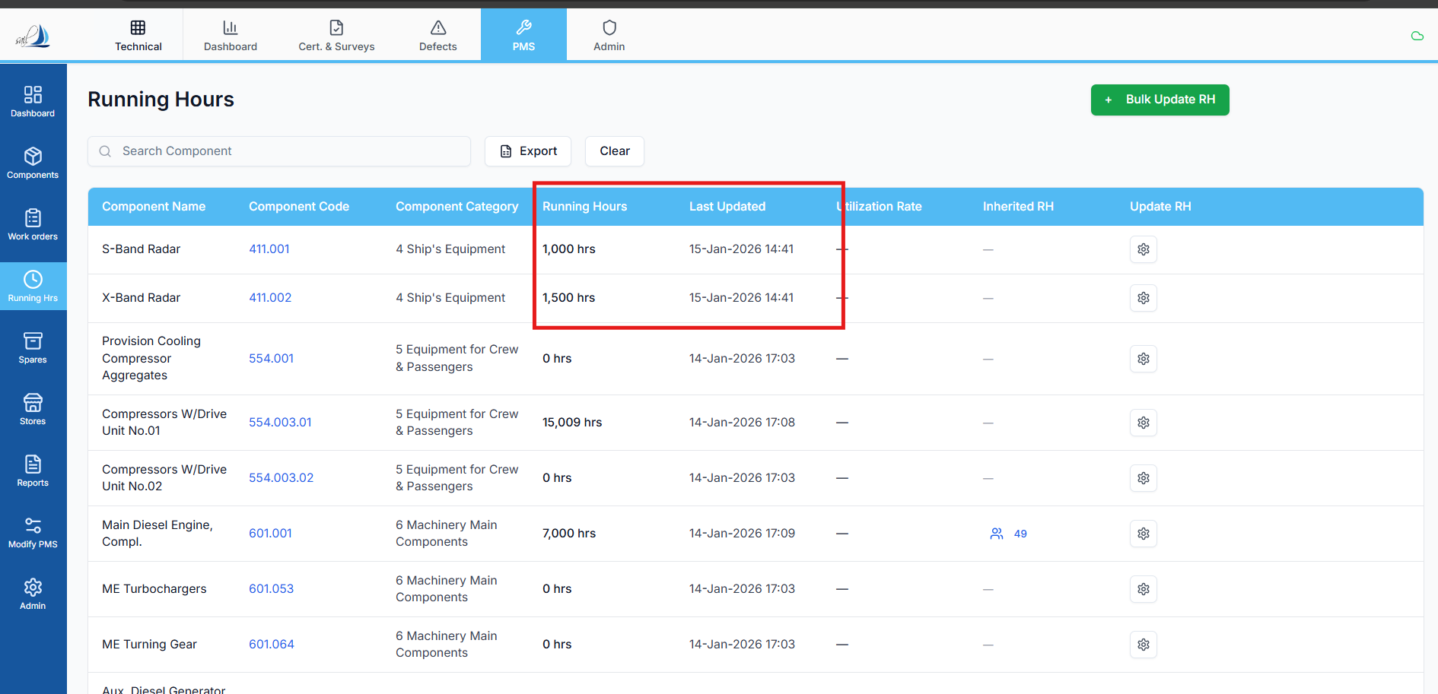

Replit Analysis & Fix Prompt — Running Hours “Last Updated” Date Binding Issue
Context
There is an issue in the Running Hours table UI screen where the “Last Updated” column is displaying an incorrect date.
This problem impacts user trust and audit accuracy, especially when backdated or future-dated running hour updates are applied.

❌ Current Incorrect Behavior
- The Running Hours UI table binds the “Last Updated” column using:
- component.rh_master_updated_at
- This column represents:
  - The timestamp when PMS internally updated the RH master record
  - Not the date selected by the user in the Update Running Hours screen
As a result:
The highlighted “Last Updated” dates show the PMS update timestamp instead of the user-selected running hour update date.

✅ Expected Correct Behavior
- The “Last Updated” column in the Running Hours UI must display:
- component.last_updated
- This column represents:
  - The actual date selected by the user in the Update RH screen
  - The business-effective date for running hour changes
Specifically:
The date shown must match the date chosen in the Update RH screen, not the system update timestamp.

🧠 Analysis Required (Before Fix)
Replit must:
- Trace the data source used for:
  - Running Hours UI table
  - “Last Updated” column binding
- Explain:
  - Why rh_master_updated_at was originally chosen
  - Whether it was intended for system-level auditing rather than UI display
- Confirm:
  - That component.last_updated is already being populated correctly during RH updates

🛠️ Fix Requirements (Strict)
Replit must:
- Replace the UI binding only:
  - From rh_master_updated_at
  - To last_updated
- Ensure:
  - No changes to RH calculation logic
  - No changes to RH inheritance logic
  - No changes to audit or system timestamps
- Apply the fix:
  - Only to the Running Hours table UI
  - Without altering backend persistence behavior

🚫 What Must NOT Be Changed
- ❌ RH master calculation logic
- ❌ Inherited / Master RH source logic
- ❌ Work order RH update flow
- ❌ Database schema or column meanings
- ❌ PMS internal audit timestamps

