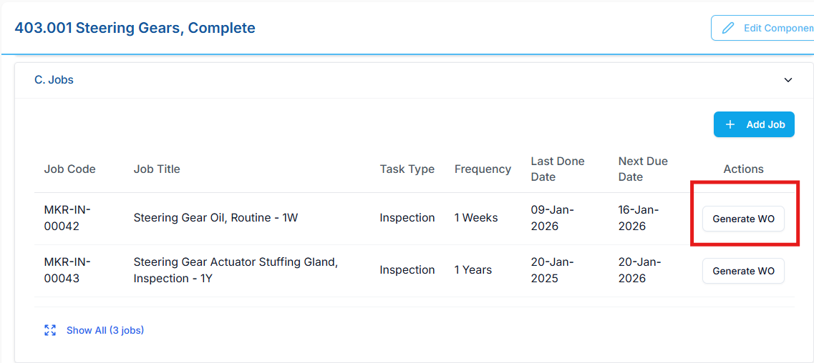

Replit Fix Prompt — Change Work Order Number Format (Generate WO from Component → Section C → Job)
Context
- This change applies only to Generate Work Order functionality triggered from:
  - Component Sub-Module
  - Section C → Job
- Existing logic for:
  - Planned work orders
  - Unplanned work orders
  - Planner-generated work orders
  - Bulk creation
  - Other entry points
must remain untouched

🎯 Current Behavior (Incorrect)
When generating a work order from Component → Section C → Job, the work order number is currently generated as:
MKR-IN-00041.WO-2026-001
This format is not aligned with business rules for job-based work order generation.

✅ Required Work Order Number Format
For Generate Work Order from Job (Section C), the work order number must follow exactly this format:
{job_no}-{component_code}-{year}-{auto_increment_number}
Example:
MKR-IN-00041-702.005.01-2026-001

🔒 Uniqueness Rules
- Auto-increment number must be:
  - Sequential
  - Scoped per vessel
  - Scoped per year
- Uniqueness must be enforced without changing:
  - Existing numbering logic for other work order sources

🛠️ Fix Requirements (Strict)
Replit must:
- Identify the Generate Work Order from Job flow in:
  - Component → Section C → Job
- Override only the work order number generation logic for this flow
- Replace:
- MKR-IN-00041.WO-2026-001
with:
{job_no}-{component_code}-{year}-{auto_increment}
- Ensure:
  - job_no is taken from the Job record
  - component_code belongs to the selected component
  - year is derived from work order creation date
- Preserve:
  - Existing validations
  - Approval flow
  - Frequency logic
  - Work order type behavior

🚫 What Must NOT Be Changed
- ❌ Planned work order numbering logic
- ❌ Unplanned work order numbering logic
- ❌ Planner or scheduler logic
- ❌ Database schema
- ❌ Any shared utility unless conditionally scoped

📄 Expected Output from Replit
Replit must provide:
- Confirmation of:
  - Where the conditional logic was applied
- Confirmation that:
  - The new format is applied only for job-initiated work orders
- Assurance that:
  - No regression is introduced in other work order creation flows

