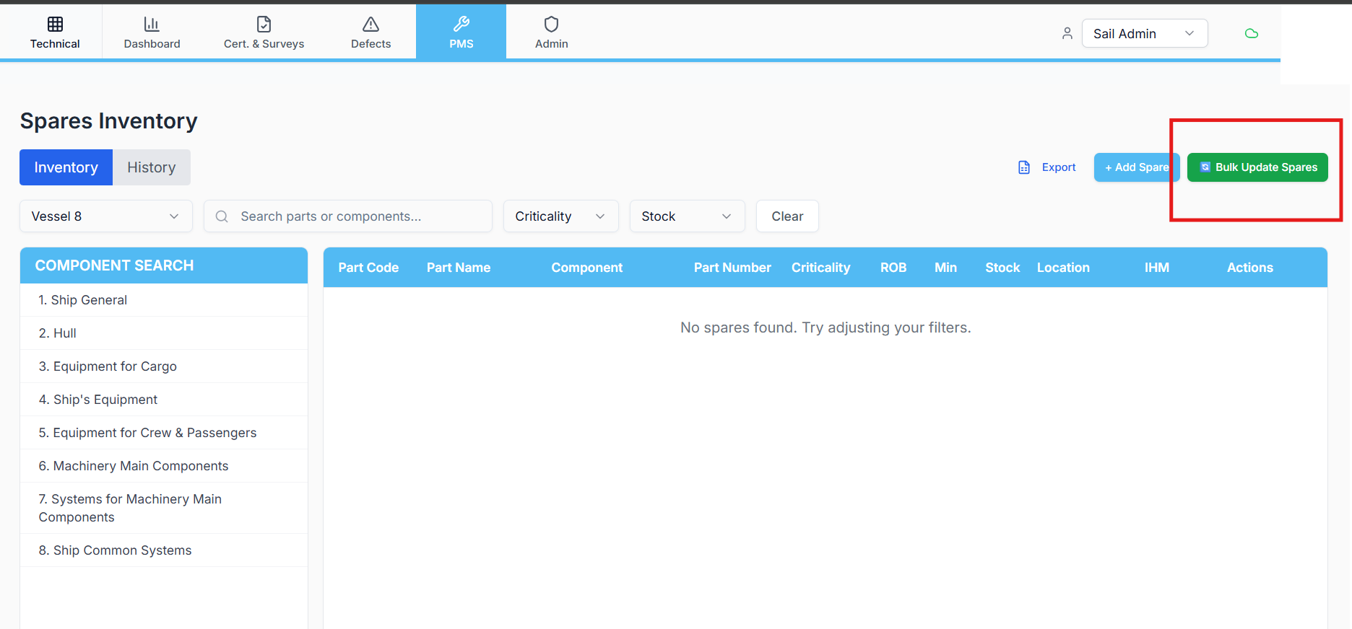
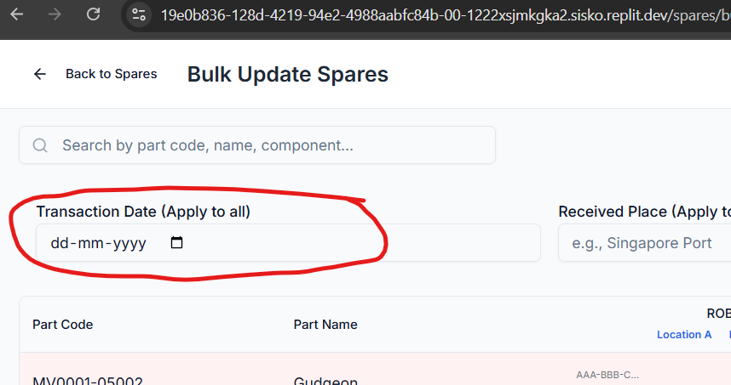
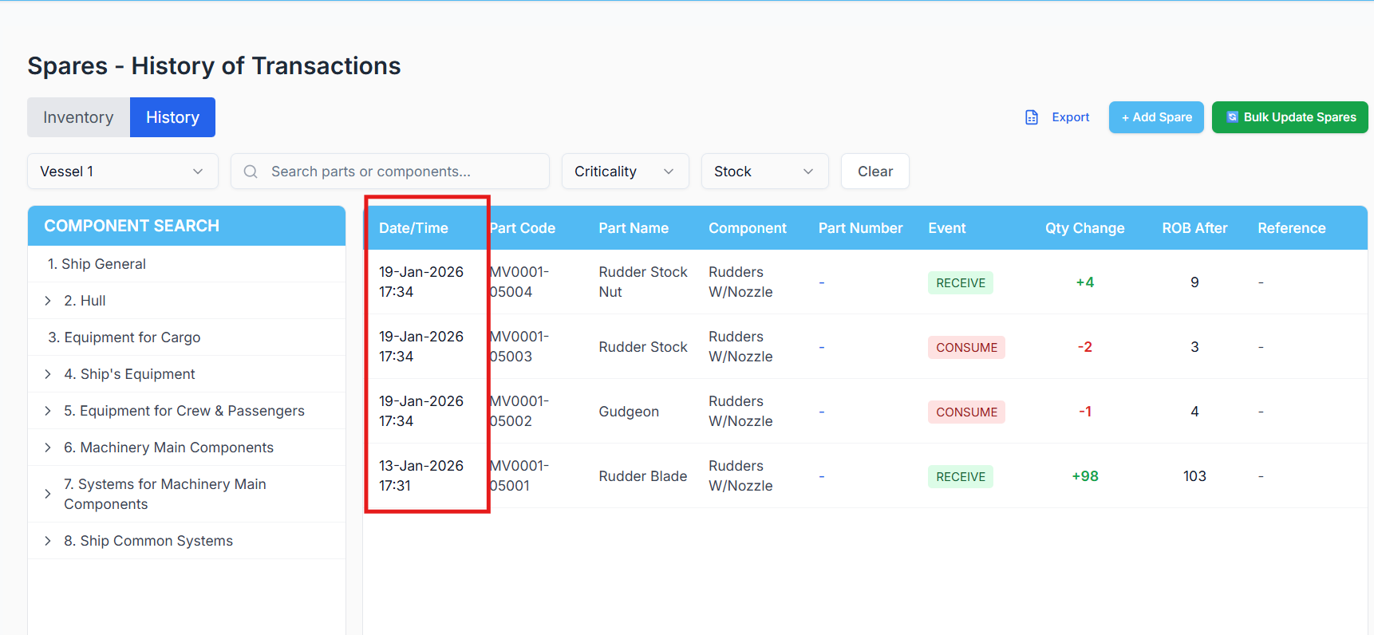
Replit Prompt — Fix Date Handling for Spares Bulk Update (Bulk Update Button Only)
Context
In the Spares module, when spares are updated using the Bulk Update button, the system is expected to:
- Identify that the update originated from Bulk Update
- Save and display dates based on the user-selected date
- Correctly populate date_local in spares_history
However, this is not working correctly.
(Refer to the attached images for UI flow and expected behavior.)

❌ Current Incorrect Behavior
- When spares are updated using the Bulk Update button:
  - The system uses the timestamp column
  - It shows the current system time
- The selected date is:
  - Not correctly saved into spares_history.date_local
- This issue occurs for both:
  - event_type = "CONSUME"
  - event_type = "RECIEVE"

✅ Expected Correct Behavior
When the update is triggered only via the Bulk Update button:
- A flag must be used to identify:
  - This update originated from Bulk Update
- In this case:
  - spares_history.date_local must be populated using the date selected in the UI
  - This date_local value must be used for:
    - Saving history
    - Displaying dates in the UI
- The timestamp column must not override the selected date in this flow

🧠 Analysis Required (Before Fix)
Replit must analyse:
- Bulk Update Flow
  - How the Bulk Update button triggers the backend
  - Whether the payload includes the selected date
- Identification Logic
  - How updates are currently differentiated (single update vs bulk update)
  - Why no flag is currently enforcing Bulk Update–specific logic
- Date Handling
  - Where timestamp is being applied
  - Why date_local is ignored or overwritten
Replit must clearly explain why the current logic always falls back to timestamp.

🛠️ Fix Requirements (Strict)
Replit must:
- Introduce a clear flag (e.g. isBulkUpdate = true) that:
  - Is set only when the Bulk Update button is used
- Update the Bulk Update spares method so that:
  - When this flag is present:
    - spares_history.date_local is set from the selected UI date
    - timestamp is not used for display or logic
- Apply this logic only for:
  - Bulk Update button flow
- Ensure correct handling for both:
  - event_type = "CONSUME"
  - event_type = "RECIEVE"

🧪 Testing Requirements (Mandatory)
After applying the fix, Replit must:
- Perform Bulk Update for spares with:
  - A past date
  - Today’s date
- Verify:
  - spares_history.date_local matches the selected date
  - UI displays the correct date
- Confirm:
  - Single spare updates (non-bulk) remain unchanged
  - No regression in spares history listing

🚫 What Must NOT Be Changed
- ❌ Existing table structure
- ❌ Timestamp column behavior for non-bulk updates
- ❌ Business logic for stock calculation
- ❌ Single update spares flow

📄 Final Deliverable from Replit
Replit must provide:
- Root cause explanation
- Description of the Bulk Update–specific fix
- Confirmation that:
  - date_local is now correctly saved and displayed
  - The fix applies only to Bulk Update button usage

🔐 Authoritative Rule
When spares are updated via Bulk Update, user-selected date (date_local) must take precedence over system timestamp.

