1. B. Edit Function not working for Running Hours and Condition Monitoring Part.
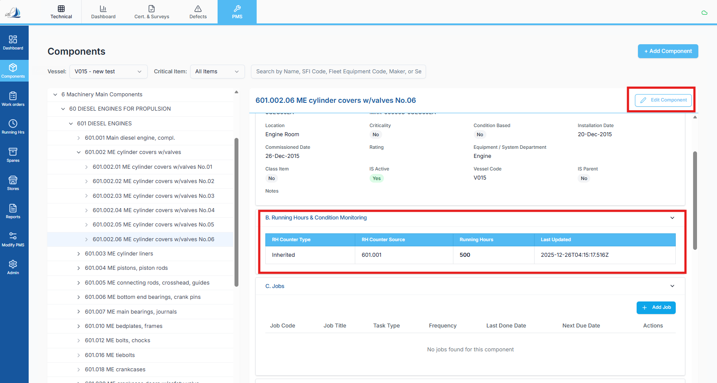

2. Add a Filter for Counter also. There no direct filter for counter jobs only, Weekly, Monthly and Yearly filters are available.
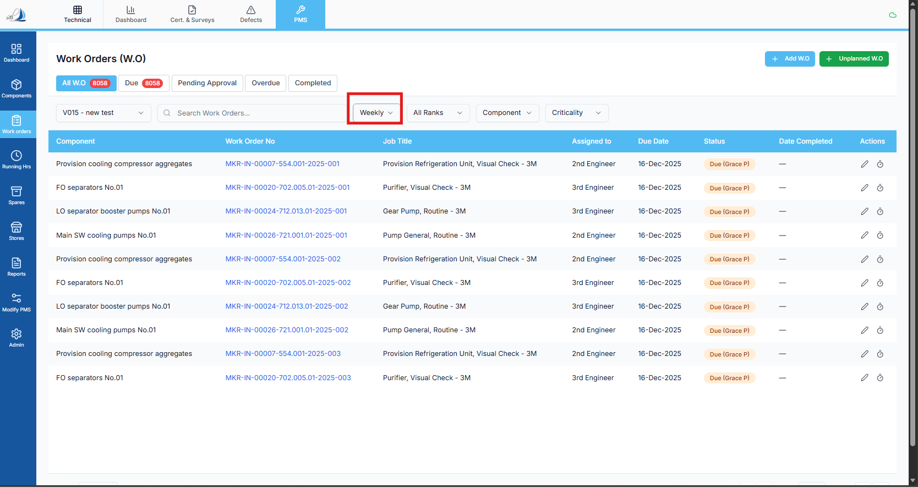

3. +Add Component Function Not working.
4. Work Orders: When I try to open any WO from this screen, the details page does not open for the selected work order.
5. WO has been saved but its showing in the pending for approval sections.
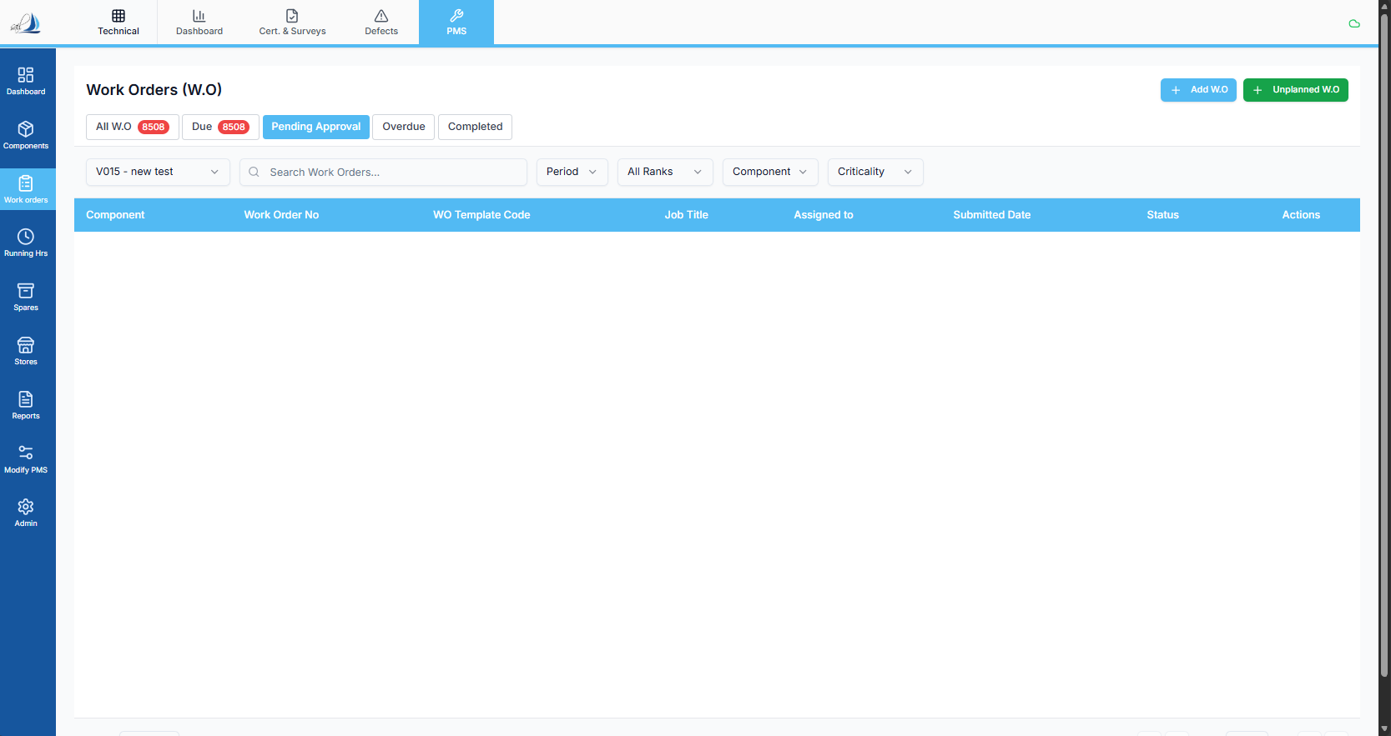

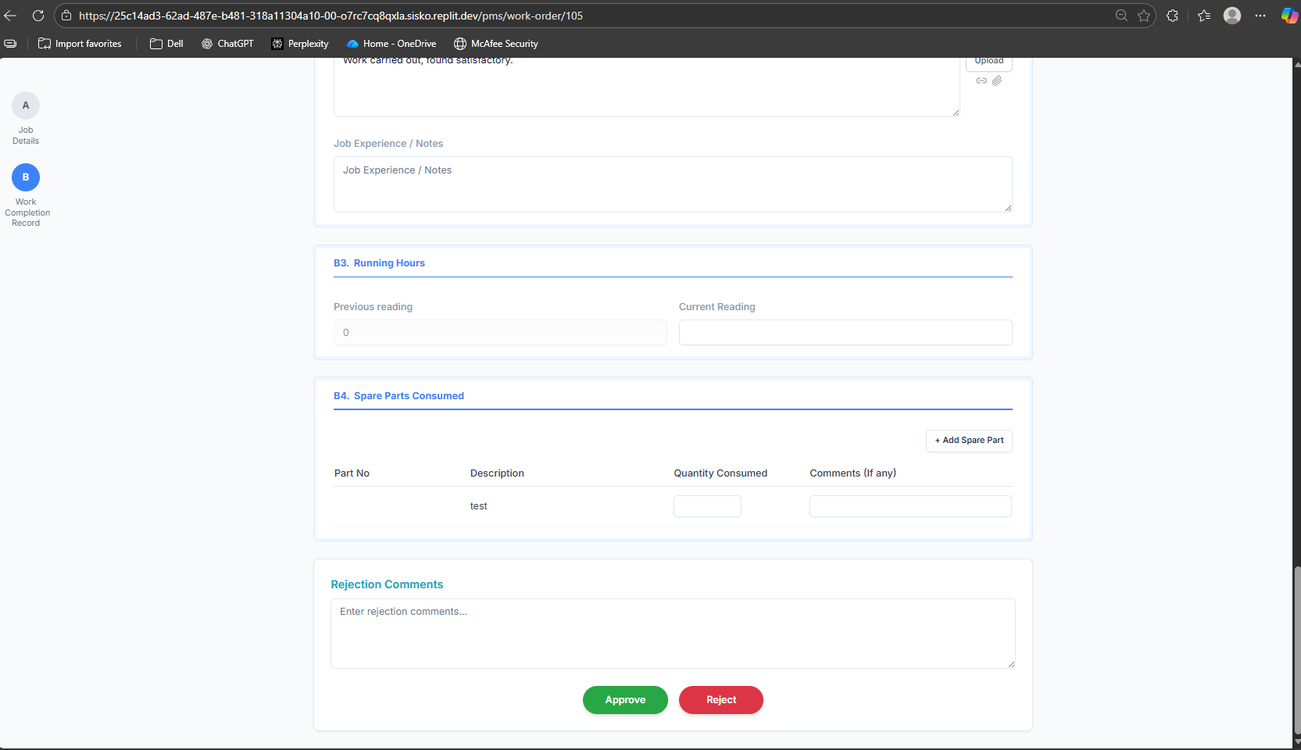

6. Spares Edit:
Need Change the Spares Edit Pop up.
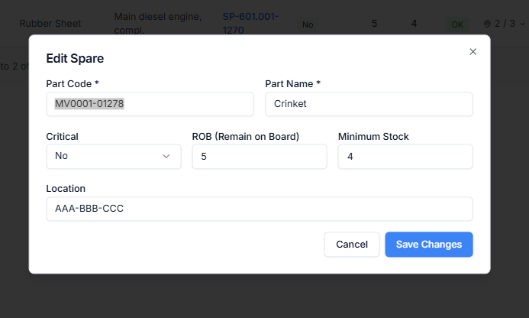

7. Remove the Consume / receive Option from action and change the delete Icon.

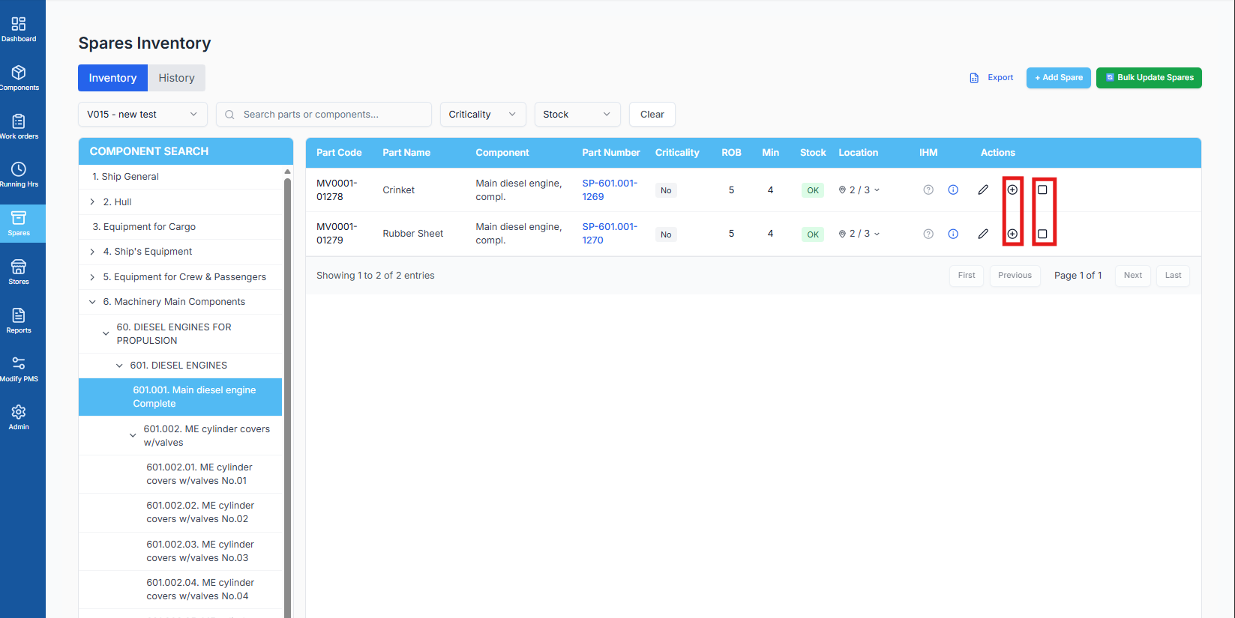

8. While updating running hour if we don’t add the date it should show us the error and it should not save the data. For RH date is also essential.
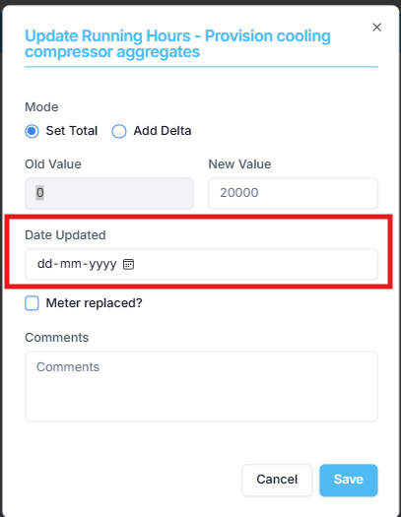

10. After completing the WO the Maintenance history is not getting updated in the components – D Section.
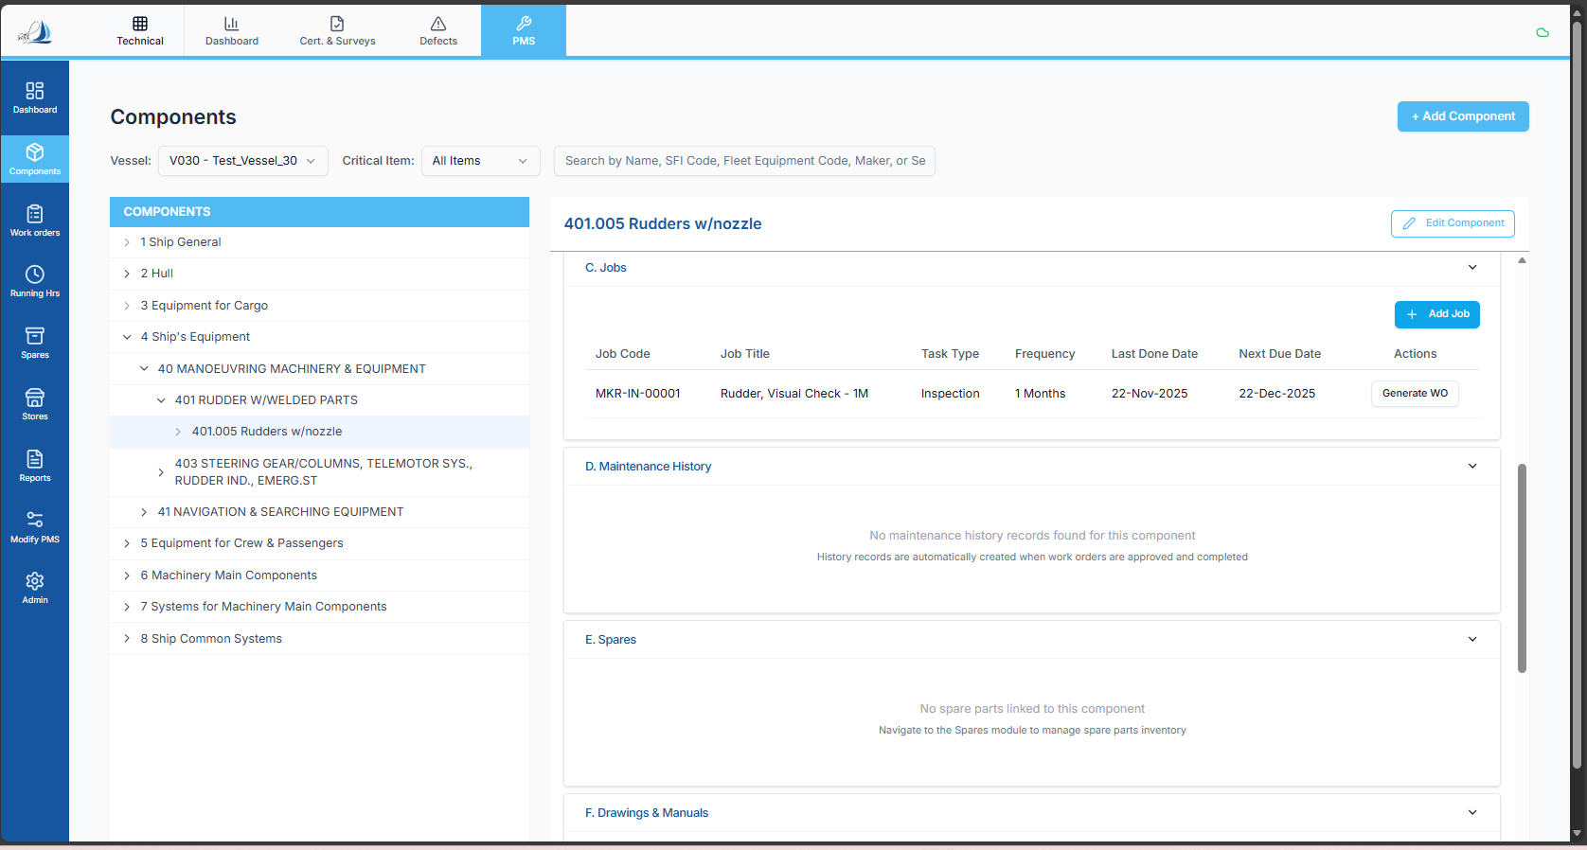

11. After Completing the WO the Same job getting triggered again for same date.
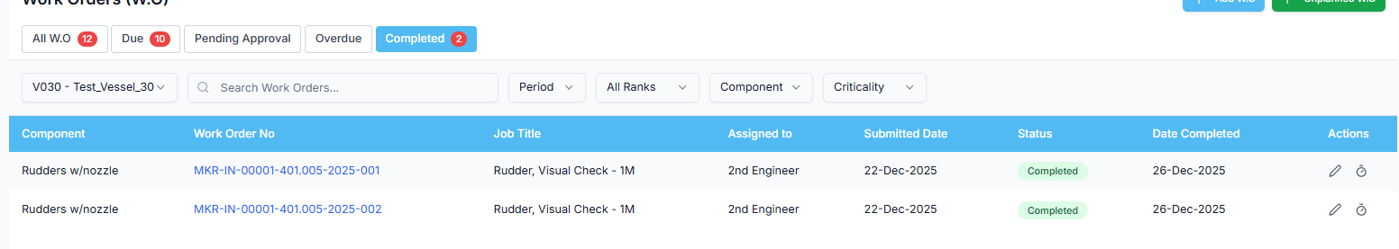
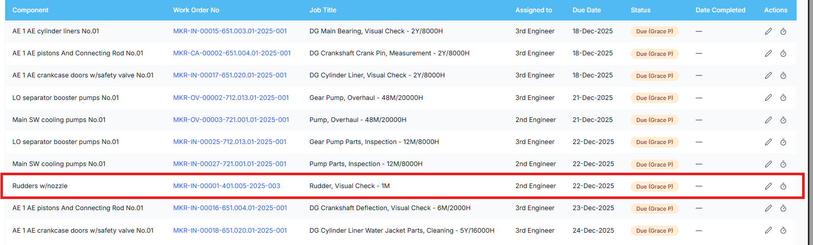

12. Counter based jobs are not auto generating.
13. After Importing the spares the Part Number column should take the data from import sheet but now its getting auto generated.
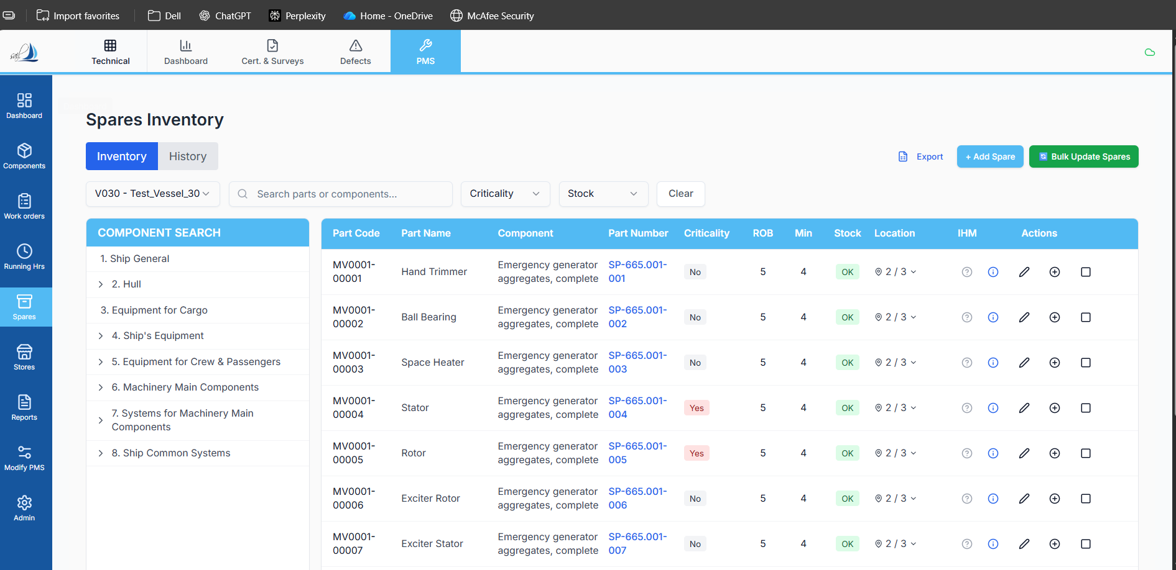

14. Similar for Location A and Location B Columns also it has to fetch the data from the import sheet but its not fetching.

