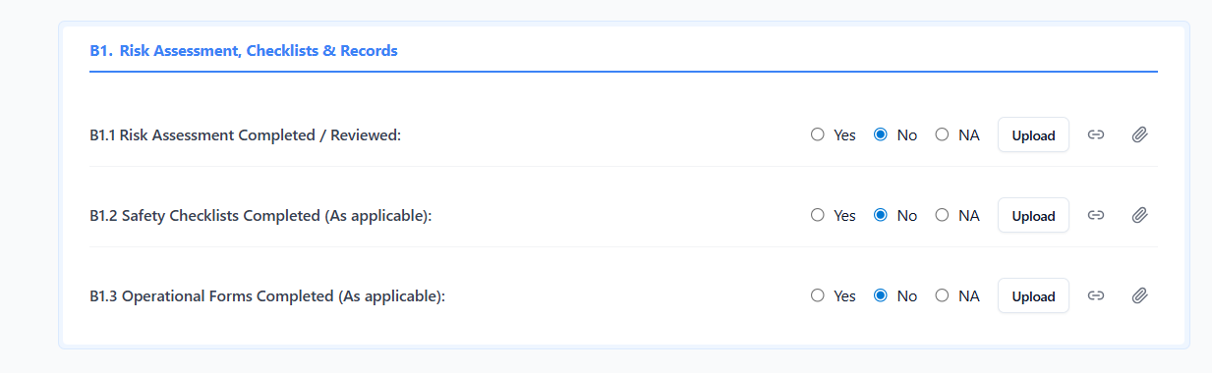

Prompt for Replit
Create a phase-wise implementation plan to build file upload functionality for the Work Order section shown in the attached UI.
Scope
- Only Work Order upload section
- This is for production-ready implementation
What to Analyse & Provide
1. Upload Flow Design
- Explain how the upload will work end-to-end:
  - UI → API → Service → Storage → DB
- Identify whether upload is:
  - Single file or multiple files
  - Per work order or per work order execution
2. Database Design
- Specify:
  - Which table(s) will store uploaded file metadata
  - Required columns (uuid, work_order_uuid, file_name, file_type, size, path, created_at, etc.)
- Mention whether:
  - Files are stored on disk, object storage, or both
  - Only metadata is stored in DB
3. Compression Requirement
- While uploading:
  - Files must be compressed to 5–10 MB
- Explain:
  - Where compression happens (frontend vs backend)
  - Libraries/tools to use
  - Validation if file exceeds max size after compression
4. Backend Implementation Plan
- APIs required (endpoint names, methods)
- Controller / service responsibilities
- Validation (file type, size, security)
- Error handling
- Cleanup strategy on failure
5. Environment Handling
Explain how upload works in:
- Local development
- Deployed DEV server
Include:
- Path configuration differences
- Environment variables
- Folder creation strategy
- Permissions handling
6. Best Practices (Mandatory)
- Use UUIDs for references
- Prevent path traversal attacks
- File type whitelisting
- Max file count and size limits
- Transaction safety (DB + file consistency)
- Logging and audit support
- Future scalability considerations
Output Requirements
- Provide the response in clear steps / phases
- No assumptions — explain actual implementation
- Do not write code unless required for explanation
- Keep it aligned with current backend architecture

