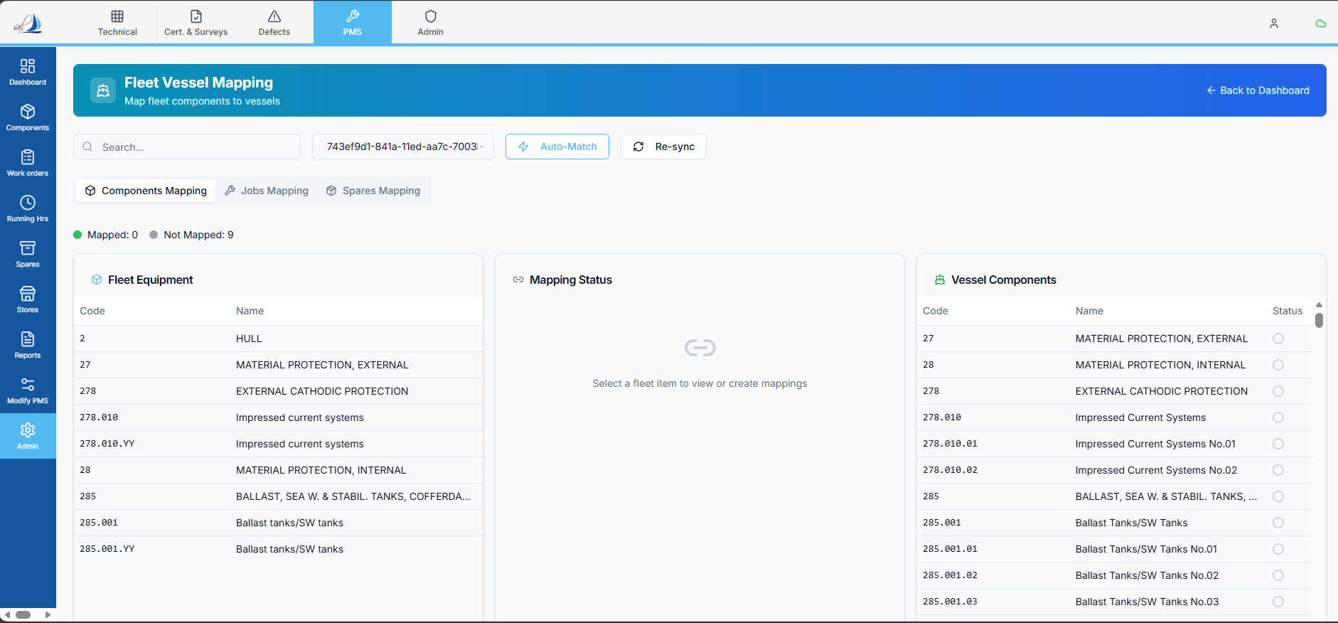

Fleet ↔ Vessel Component Mapping – Functional Requirement
1. UI Layout & Structure
The Fleet Vessel Mapping screen should be divided into three sections:
- Left Section – Fleet Equipment Tree View
- Middle Section – Mapping Status Panel
- Right Section – Vessel Component Tree View
Layout Ratio
- Left Section: 40%
- Middle Section: 20%
- Right Section: 40%

2. Data Display Requirements
Fleet Equipment Tree View (Left Side)
Each node should display:
- Fleet Equipment Code
- Fleet Equipment Name
Vessel Component Tree View (Right Side)
Each node should display:
- Component Code
- Component Name
- Component Status

3. Mapping Logic – Frontend Flow
Initial Load
- Data should load without any automatic linkage.
- Mapping must be performed manually or through Auto Match.

Auto Match Functionality
When the Auto Match button is clicked:
A popup window should open with the following functionality:
- Load all Vessel Components.
- Match vessel components using:
  - Fleet Equipment Code from Component Table
  - Fleet Equipment Code from Fleet Equipment Table

Auto Match Status Indication
- If a match is found:
  - Status should be marked as Matched
  - Highlight in Green
- If no match is found:
  - Status should be marked as No Match
  - Highlight in Red

Create Mapping Action
When the user clicks Create Mapping:
- The system should create linkage between:
  - Fleet Equipment
  - Vessel Component
- After mapping, the system should generate a detailed summary, including:
  - Successfully Linked Components
  - Components Not Linked
  - Reason for Non-Linking (if applicable)

4. Vessel Component Eligibility Rules
Mapping should only be allowed for vessel components where:
- IS Parent = No
If:
- IS Parent = Yes
  - That component must be excluded from Fleet mapping.

5. Mapping Visual Behaviour
Fleet → Vessel Selection
When a Fleet Equipment is selected:
- Linked Vessel Component should be:
  - Highlighted in Green
  - Status shown as Matched
- Fleet Equipment should also be highlighted.

Vessel → Fleet Selection
When a Vessel Component is selected:
- Linked Fleet Equipment should be:
  - Highlighted in Green
  - Status shown as Matched

6. Backend Mapping Logic
Component linkage must be stored using:
- fleet_equipment_uuid
- component_uuid
These two fields should be used as the primary reference keys for maintaining mapping relationships.

7. Validation Rules
- Mapping must not allow duplicate linkage.
- Only eligible components should be mapped.
- Mapping changes must be transaction-safe.

Here's my detailed analysis of the Fleet Vessel Component Mapping feature:
What Already Exists
Database schema - We already have:
- fleet_components table (fleet equipment master data with UUID, parent hierarchy, equipment codes)
- fleet_component_mapping table (links fleet equipment code + vessel code + component code)
- fleet_vessel_mapping table (links fleet equipment to vessels)
- components table with isParent, fleetEquipmentCode, vesselCode fields
Backend APIs - Existing routes in fleetAdmin.ts:
- CRUD for fleet-component-mappings (GET/POST/DELETE)
- CRUD for fleet-vessel-mappings (GET/POST/DELETE)
- Filtering by equipment code and vessel code
Existing Page - FleetVesselMapping.tsx (742 lines) already has:
- A 3-column layout (Fleet Equipment / Mapping Status / Vessel Components)
- Tabs for Components, Jobs, Spares mapping
- Auto-Match button and Re-sync button
- Vessel selector dropdown
- Status badges (Mapped / Not Mapped)
Gap Analysis vs. Requirements
The existing page is close but needs significant rework to match the screenshot and spec:
- Left panel: Currently uses a flat table. Needs to become a tree view with parent-child hierarchy using parentFleetEquipmentCode.
- Right panel: Currently shows vessel components in a flat table. Needs a tree view with Code, Name, and Status (radio-style selection indicators visible in screenshot).
- Auto-Match popup: Current auto-match runs inline. Needs a dedicated popup dialog showing all vessel components with green (Matched) / red (No Match) highlighting, then a "Create Mapping" action that produces a summary.
- Selection/highlighting behavior: When selecting a fleet item, linked vessel components should highlight green. And vice versa.
- Backend mapping logic: Spec requires mapping using fleet_equipment_uuid + component_uuid (UUID-based). Current schema uses string codes (fleet_equipment_code + component_code). This may need a schema migration to add UUID reference columns.
- Eligibility filter: Only components with isParent = false should be eligible for mapping on the vessel side.
- Validation: No duplicate linkage, transaction-safe operations (largely handled by existing unique constraints).
Key Technical Decisions Needed
- Schema change: The spec says to use fleet_equipment_uuid + component_uuid as keys. The current fleet_component_mapping table uses string codes. We'd need to either add UUID columns via migration or adapt the spec to use the existing code-based approach (which already works).
- Tree view component: Both left and right panels need a collapsible tree view built from parent-child relationships.
- Scope: This is a full page rewrite of FleetVesselMapping.tsx, not a minor edit.

