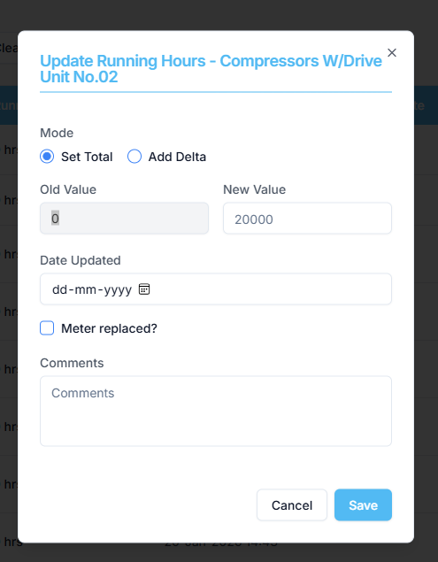

Raplit Analysis Prompt – Running Hour Meter Replacement (Without New Table)
Context
Module: PMS → Component → Running Hours
Screen: Running Hour Meter
Purpose: Handle meter replacement correctly without resetting running hours.

Problem Statement
Currently, when a running hour meter is replaced, the system may reset the running hours to zero. This causes:
- Incorrect total running hours
- Wrong PMS maintenance scheduling
- Loss of historic meter information
Running hours must remain continuous and cumulative, even after meter replacement.

Key Rule
- Do NOT create any new table
- Use the existing running hour table only

Minimal Database Change
In the existing running hour table, add only the following columns:
- meter_replaced_date (DATE, nullable)
- meter_replaced_last_rh (NUMERIC, nullable)
No other schema changes are allowed.

Functional Flow
1. Meter Replaced Mode
- Introduce a Meter Replaced action for running hour meters only
- This is a logical mode, not a new workflow

2. Meter Replaced Popup
When Meter Replaced is selected, show a popup with mandatory fields:
- Old Meter Latest RH
- Meter Replaced Date
On save:
- Save Old Meter RH → meter_replaced_last_rh
- Save Replacement Date → meter_replaced_date

3. Running Hour Entry After Replacement
After replacement:
- Replace Set Total with Added Set Total
- UI must display:
  - Old Value (read-only) → meter_replaced_last_rh
  - New Value → current meter reading

4. Running Hours Calculation Logic
Total Running Hours =
meter_replaced_last_rh + current_meter_rh
Example
- Old Meter RH: 20,000
- New Meter RH entered: 100
- Total Running Hours shown: 20,100
This value must:
- Display in Running Hours column
- Be used for PMS job calculations

5. History & Audit Visibility
- Meter replacement details must be visible in the Running Hours screen
- Values must be read-only after save
- No separate history table is allowed

Validation Rules
- Old Meter RH and Replacement Date are mandatory
- Saving must be blocked if either value is missing

🚫 Strict Non-Impact Constraint
This change must NOT affect:
❌ Existing running hour logic for non-replaced meters
❌ PMS scheduling logic
❌ Maintenance counters or thresholds
❌ Historical running hour data
❌ Any other module, screen, API, or calculation
❌ Existing workflows unrelated to meter replacement
Only the Meter Replaced scenario is in scope.

Expected Result
- Running hours remain cumulative
- Meter replacements are fully traceable
- PMS schedules remain accurate
- No regression in existing functionality

