Audit Module User Manual

Table of Contents
1.1 Dashboard 5
1.1.1 Filters 6
1.1.1.1 All Vessel / My Vessel 6
1.1.1.2 Filter 6
1.1.2 Summary 7
1.1.2.1 Operational: 7
1.1.2.1.1 Inspections in Range 7
1.1.2.1.2 Open Reports 8
1.1.2.1.3 Submission of Operator Comments (Sire/CDI) & CAP (Audits) 9
1.1.2.2 Management 10
1.1.2.2.1 KPI External Inspections 10
1.1.2.2.2 KPI Internal Inspections 11
1.1.2.2.3 Average Findings – Periodic Analysis 12
1.1.2.2.4 Vessel / Group Analysis 13
1.1.2.2.5 Watchlist 13
1.1.3 Overview 14
1.1.3.1 Change of Inspection Type 14
1.1.3.1.1 Summary 14
1.1.3.1.2 KPI 15
1.1.3.1.3 Risk 15
1.1.3.1.4 Watchlist 15
1.1.3.1.5 Periodic Analysis 16
1.1.3.1.6 Vessel / Group Analysis 17
1.1.3.1.7 Finding Analysis 18
1.1.3.1.8 Top Repeated Findings 19
1.1.3.1.9 Inspection Analysis 20
1.1.3.1.9.1 Oil Major 20
1.1.3.1.9.2 Insp. Vs. Obs. 21
1.2 Planning 22
1.2.1 Opening Screen 23
1.2.2 Planning Sub Module Opening Screen 23
1.2.3 Planning 24
1.2.3.1 How to Select Inspection Type 24
1.2.3.2 How to View Last Three Inspection of Vessel 25
1.2.3.3 How to View and Select Vessel Inspection Interval 26
1.2.3.4 How to Edit, Delete and Create Planning 28
1.2.3.5 How to Initiate An Inspection 30
1.2.4 Timeline 32
1.2.4.1 How to View Timeline 32
1.2.4.2 How to Select the Inspection 33
1.2.4.3 How to View Reminders 33
1.2.4.4 How to View Legends and Next Due Status 34
1.2.5 CALENDAR 35
1.2.5.1 How to View Calendar 35
1.2.6 Reminders 36
1.2.6.1 How to View Reminders 36
1.2.6.2 How to Create a Reminder 37
1.3 Preparation 38
1.3.1 OPENING SCREEN 39
1.3.1.1 How To Create A New Preparation 39
1.3.1.2 Information Available On Preparation Main Screen 41
1.3.1.3 Edit Existing Preparation 42
1.3.1.4 Delete Existing Preparation 43
1.3.2 CHECKLIST 44
1.3.2.1 How To View Checklist Summary 44
1.3.2.2 How To Enter The Checklist 45
1.3.3 CHECKLIST FUNCTIONS 47
1.3.3.1 How To Apply Filters 47
1.3.3.2 How To Apply Search Function 48
1.3.3.3 How To Change Checklist Chapters 49
1.3.3.4 How To Fill The Checklist 49
1.3.3.4.1 Binary Response Type 49
1.3.3.4.2 Graduated Response Type 49
1.3.3.4.3 How to add Attachment 50
1.3.3.4.4 How to Delete Attachments 52
1.3.3.4.5 Additional comments 53
1.3.3.5 How To See Additional Information Related To A Particular Question 54
1.3.3.6 How To Use Chat Function 57
1.3.3.7 How To Save A Questionnaire 57
1.3.3.8 How To Return To the Main Preparation Screen 57
1.3.3.9 HOW TO USE VIEW FUNCTION 57
1.3.4 PRE-INSPECTION QUESTIONNAIRE (PIQ) 60
1.3.4.1 How To View/Edit PIQ 60
1.3.4.2 How To Answer The PIQ 60
1.3.4.3 How To Change Chapters In PIQ 61
1.3.4.4 How To Save A Questionnaire 61
1.3.4.5 How To Return To the Main Preparation Screen 61
1.3.5 ONLINE & SEMI ONLINE MODE 62
1.3.5.1 Online Mode 62
1.3.5.2 Semi Online Mode 63
1.3.5.3 Exporting Data 65
1.4 Request / Assign 66
1.4.1 Opening Screen 67
1.4.2 On Entering Request/Assign Sub Module 67
1.4.3 Request/Assign Records Table 69
1.5 Inspectors 70
1.5.1 Opening Screen 71
1.5.2 Add New Inspector 71
1.5.3 View Past Observation of an Inspector 72
1.5.4 View / Add / Edit Auditor Name 73
1.6 History 74
1.6.1 Opening Screen 75
1.6.2 Filters 75
1.6.2.1 All Vessel / My Vessel 75
1.6.2.2 History / Request 75
1.6.2.3 Filter 76
1.6.3 Change Inspection Type 76
1.6.4 How to Add New Inspection Record 77
1.6.5 How to edit / View an existing inspection 79
1.6.6 How to Edit / Delete Inspections in Requested Stage 80
1.7 Fleet Sharing 82
1.7.1 Fleet sharing office Side 83
1.7.1.1 Opening Screen 83
1.7.1.2 HOW TO CREATE NEW FLEET SHARING 83
1.7.1.3 HOW TO VIEW AND CHECK CONFIRMATION STATUS OF FLEET SHARING 85
1.7.2 Fleet Sharing Vessl Side 86
1.7.2.1 HOW TO CHECK OFFICE ENTRIES 86
1.7.2.2 DETAILS TO BE UPDATED BY THE VESSEL 86
1.1 HOW TO SUBMIT FLEET SHARING ACTIONS 87
1.8 Reports 88
1.8.1 General View of Report 89
1.8.1.1 Filters 89
1.8.1.1.1 Time Period Filter 89
1.8.1.1.2 General filter 89
1.8.1.1.3 Advanced Filter 90
1.8.1.2 Consolidated Reports 92
1.8.1.2.1 All Inspection Summary 92
1.8.1.2.2 All Inspections Overview 92
1.8.1.2.3 Inspections Comparison 93
1.8.1.3 General Inspection Report 94
1.9 Admin 96
1.9.1 Opening Screen 97
1.9.1.1 Admin Section Options 97
1.9.1.1.1 Vessel Management 97
1.9.1.1.2 Custom Data field Management 98
1.9.1.1.3 Fleet 98
1.9.1.1.4 Additional Group 99
1.9.1.1.5 Vessel Owner 99
1.9.1.1.6 Port 100
1.9.1.1.7 User Management 100
1.9.1.1.8 Access Control 101
1.9.1.1.9 KPI Configuration 101
1.9.1.1.10 Oil Major 102

- Dashboard

  - Filters

All Vessel / My Vessel
- All Vessel:
- Shows data for all the vessels available in the organization.
- My Vessel:
- Shows data for all the vessels assigned to the specific user.
- Please refer to the below image for your reference
- You can toggle between All Vessel / My Vessel
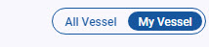

Filter
- By clicking on Filter, you can select any one of the filter options as per your preference and select Apply.
- To remove filters, click on clear.
- Data will reflect based on filters you apply.
- Please refer to the below image for your reference
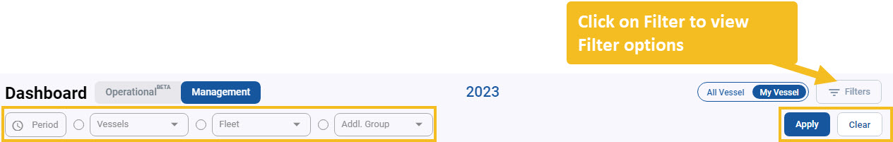

  - Summary

Operational:
      - Inspections in Range
- The tabular data shows inspections in range with regards to the next due interval set in planning section for different inspection types.
- For eg. If you set next due interval for Sire Inspection type as +6 Months from last inspection date it will show you the Reminder date / Days to go & Planned Date (From Planning Section)
- The tabular data will start displaying data here when Days to go is within 2 months range of Reminder date, or if no Reminder date set, then as per Planned Date.
- Days to Go will be highlighted: in ‘Green’ colour in between 31 - 60 days, in ‘Orange’ colour when 30 days or less & in ‘Red’ colour when overdue.
- Please refer to the below image for your reference
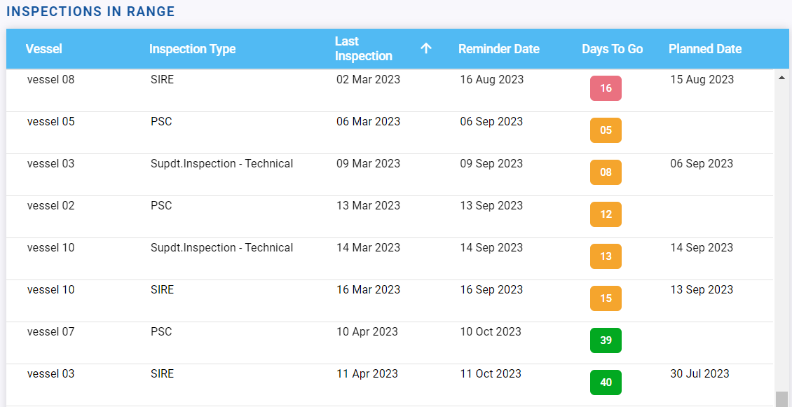

      - Open Reports
- The tabular data shows a list of open reports / findings for all the inspection types.
- In case of all inspections type with VIQ 7 version or RISQ version, Open Findings ‘Due Next 7D’ & ‘Overdue’ will be as per due date set in data entry form.
- In case of Sire, Sire trial inspections with Sire2.0 version & RISQ inspections, Open Findings ‘Due Next 7D’ & ‘Overdue’ will be as per Action due date set in data entry form (in case of multiple actions then as per the due date of the one which is closest).
- For Findings with due date 7 days or less, will be highlighted in orange colour & displayed under column ‘Due Next 7D’ & for Overdue, will be highlighted in red colour & displayed under column ‘Overdue’.
- Please refer to the image below for your reference.
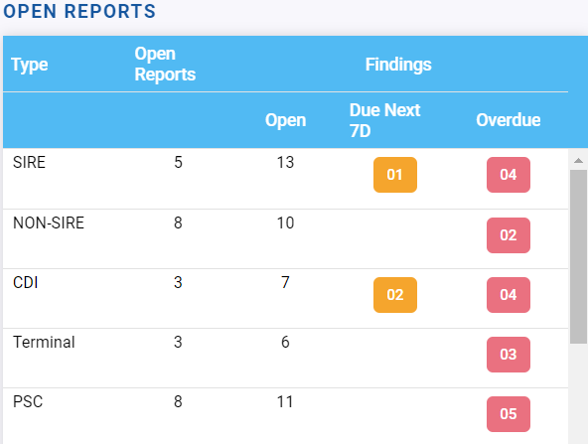

      - Submission of Operator Comments (Sire/CDI) & CAP (Audits)
- The tabular data shows the due date to enter operator comment / CAPA for Sire, CDI & Internal Audit inspection type.
- The tabular data will start displaying data here when user puts the observation details in the data entry form.
- Days to go will be displayed when user puts the Report received date in the data entry form & will be colour coded as per Report received date.
- Days to Go will be highlighted: in ‘Green’ colour in between 14-8 days, in ‘Yellow’ colour in between 7-4 days, in ‘Orange’ colour when 3 days or less & in ‘Red’ colour when overdue.
- Please refer to the image below for your reference.
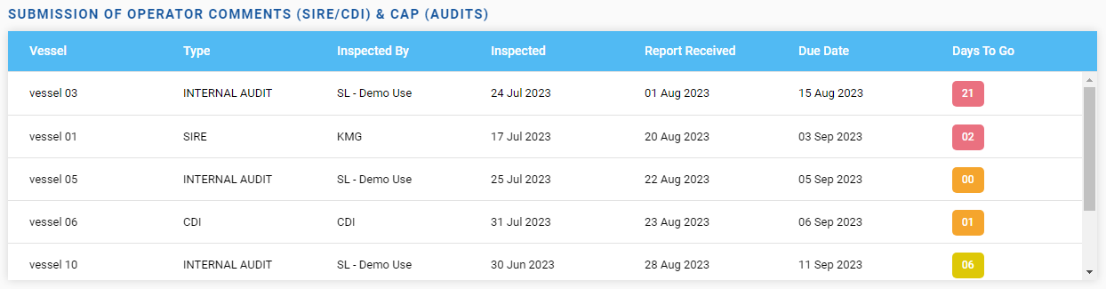

Management
      - KPI External Inspections
- This represents graphical interpretation of KPI for external inspection types.
- You can set KPI value for different inspection types from “Admin Section”.
- Click on the desired KPI graph to generate the pop-up which will display the related data for the concerned vessels.
- Please refer to the image below for your reference.
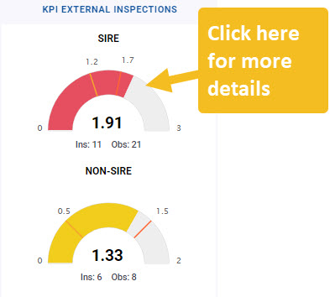
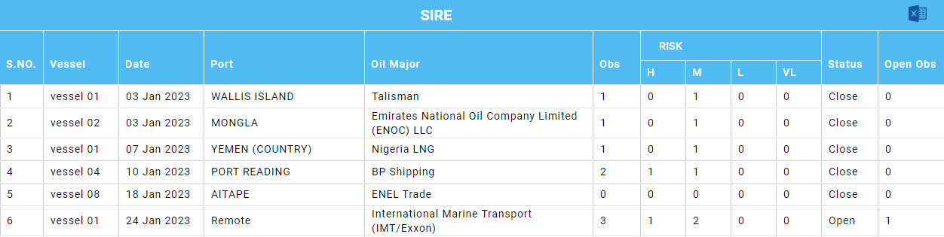
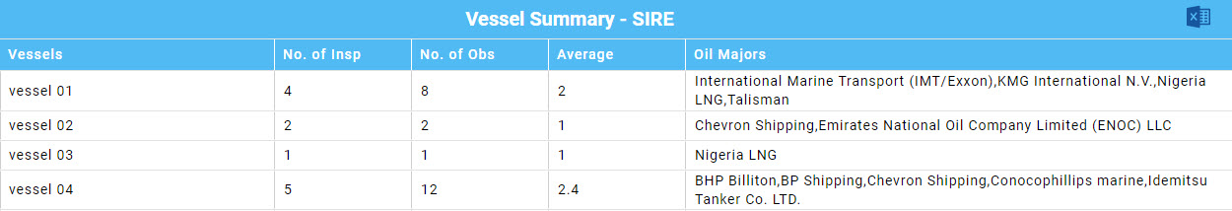
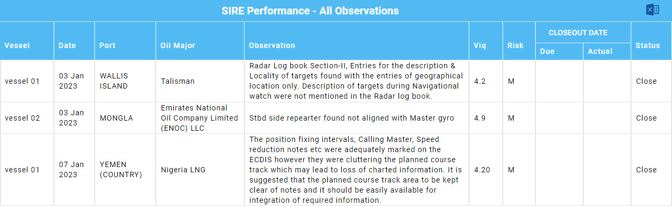
      - KPI Internal Inspections
- This represents graphical interpretation of KPI for internal inspection types.
- You can set KPI value for different inspection types from “Admin Section”.
- Click on the desired KPI graph to generate the pop-up which will display the related data for the concerned vessels.
- Please refer to the image below for your reference.
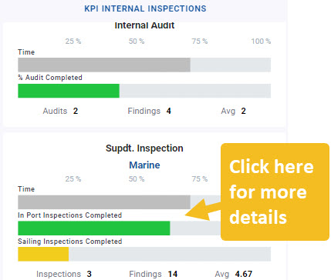
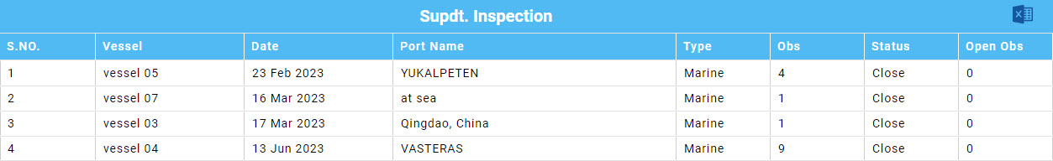
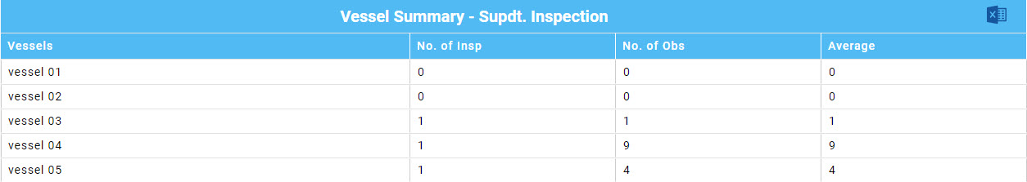
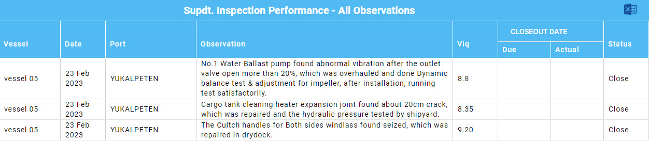
      - Average Findings – Periodic Analysis
- This represents graphical interpretation of Average findings for SIRE / Non-Sire / CDI / PSC / Terminal.
- You can Toggle between Yearly / Quarterly & Monthly options to as per your preference.
- Please refer to the image below for your reference.

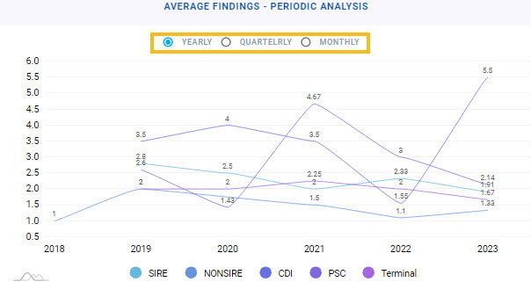

      - Vessel / Group Analysis
- This represents graphical interpretation of Vessel / Group analysis.
- Data is calculated based on KPI set in admin section.
- You can Toggle between Fleet Group / Additional Group / Owners & Vessels options to as per your preference.
- Please refer to the image below for your reference.
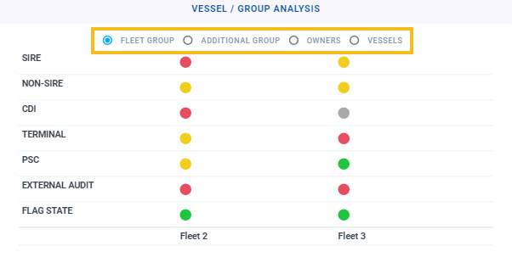
      - Watchlist
- This represents graphical interpretation of Watchlist Data.
- Data is calculated based on KPI set in admin section.
- Please refer to the image below for your reference.

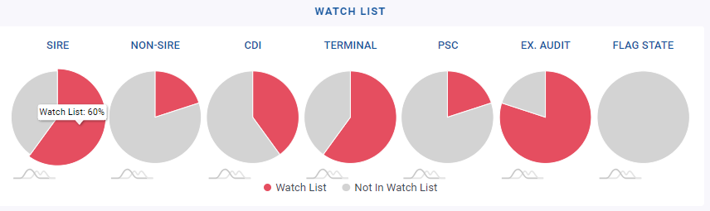

  - Overview

Change of Inspection Type
- To change inspection type, click on the dropdown and select inspection type for which you need analysis.
- Please refer to the image below for your reference.
- The below data can change depending upon the inspection type you select.
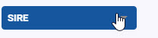
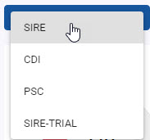

      - Summary
- After selecting the inspection type, you can see the summary of the inspection as shown in the image below.
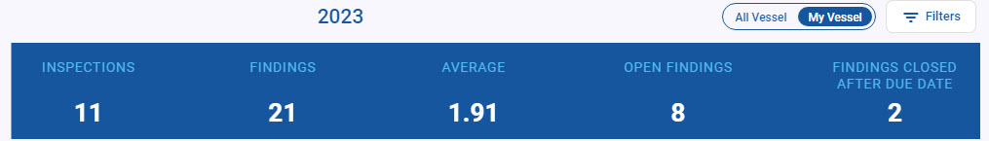

      - KPI
- KPI data can be seen as shown in the image below for the selected inspection type.
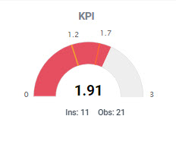

      - Risk
- Risk data can be seen as shown in the image below for the selected inspection type.
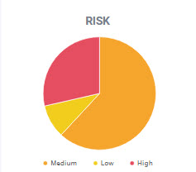
      - Watchlist
- Watchlist data can be seen as shown in the image below for the selected inspection type.
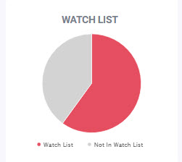

      - Periodic Analysis
- Periodic Analysis data can be seen as shown in the image below for the selected inspection type.
- You can toggle between different options as per your preference as highlighted in below image.
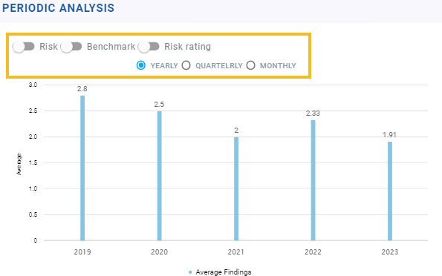

      - Vessel / Group Analysis
- Vessel / Group analysis data can be seen as shown in the image below for the selected inspection type.
- You can toggle between different options as per your preference as highlighted in below image.
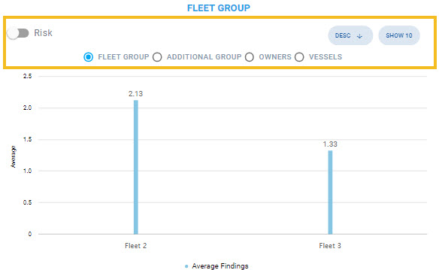

      - Finding Analysis
- Finding analysis data can be seen as shown in the image below for the selected inspection type.
- You can toggle between different options as per your preference as highlighted in below image.
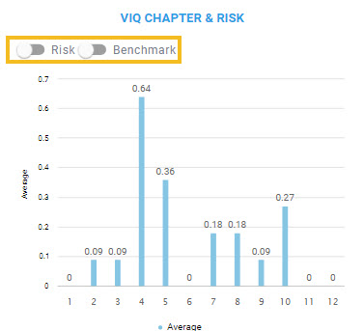

      - Top Repeated Findings
- Top Repeated Finding analysis data can be seen as shown in the image below for the selected inspection type.
- You can toggle between different options as per your preference as highlighted in below image.
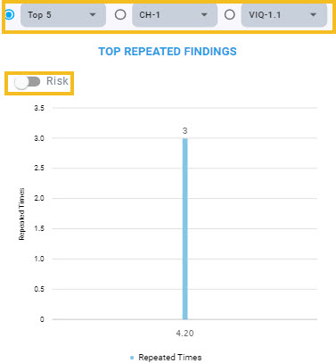

      - Inspection Analysis
        - Oil Major
- Oil Major data can be seen as shown in the image below for the selected inspection type.
- You can toggle between different options as per your preference as highlighted in below image.
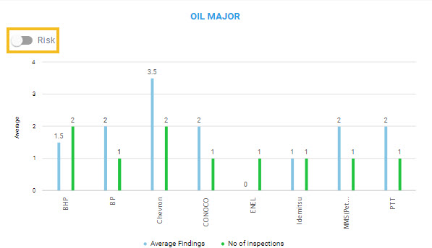

        - Insp. Vs. Obs.
- Insp. Vs. Obs. data can be seen as shown in the image below for the selected inspection type.
