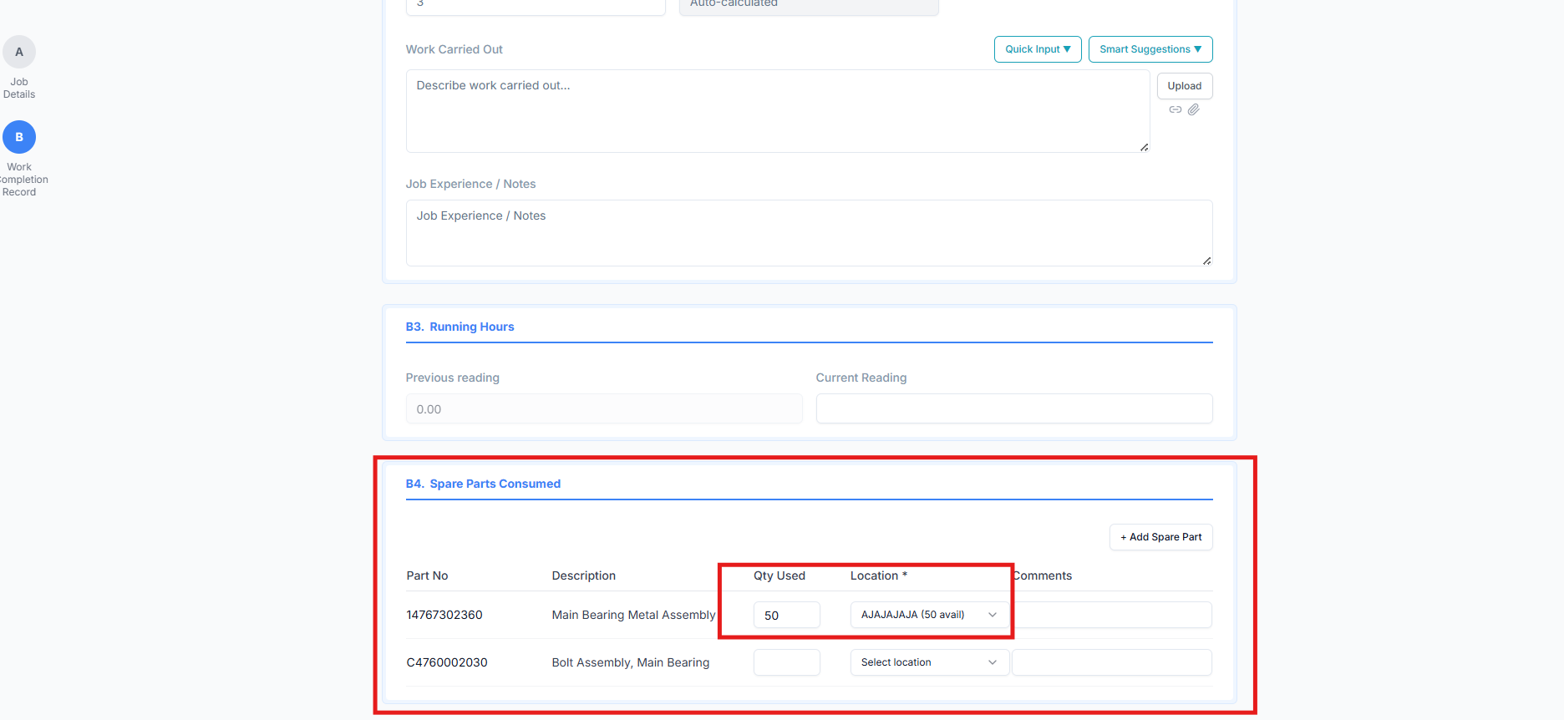
Work Order form

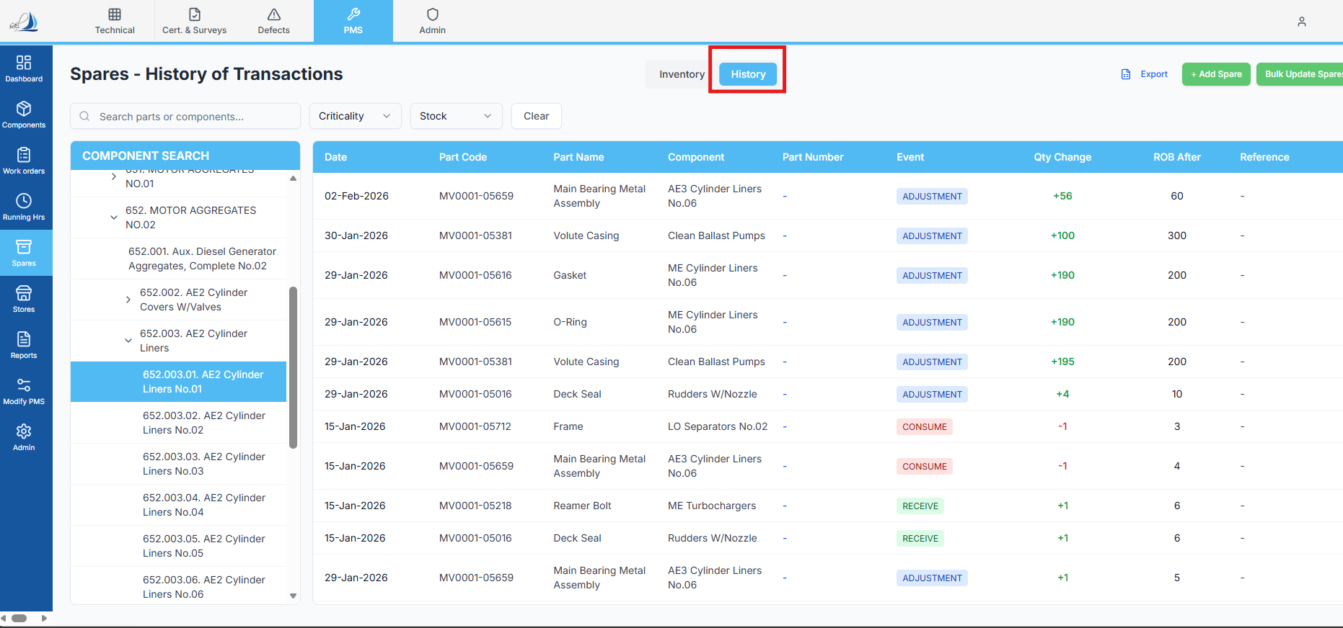
Raplit Analysis Prompt – Spares History Not Updating from Work Order Consumption

Context
In Work Order Form → B4. Spare Parts Consumed, spare parts are selected, quantity is entered, and the Work Order is approved.
This approval results in an inventory transaction (spare consumption).
However, the Inventory History / Spares History screen is not showing any entry for this consumption.

Expected Design (Correct Behaviour)
✅ When a spare part is consumed from Work Order (B4)
✅ And the Work Order is approved
➡ A corresponding record must be inserted into spares_history table
➡ This record must appear in the Spares History section

Current Issue
- Spare quantity may be deducted (or attempted to be deducted)
- But no history record is saved
- Spares History UI remains empty for Work Order–based consumption

Scope of Analysis (STRICT)
Analyse ONLY:
- Work Order Form
- B4 – Spare Parts Consumed
- Work Order Approval flow
- Inventory History / Spares History logic
🚫 Do NOT analyse or modify:
- Spare Master creation
- Purchase / GRN / Issue modules
- Other inventory transaction sources
- UI layout or unrelated business logic

Analysis Required
1. Inventory Transaction Trigger Analysis
- Identify:
  - What inventory-related logic is executed on Work Order Approval
- Verify:
  - Whether any code path attempts to create a spares_history record
- Confirm:
  - If Work Order consumption is treated as a valid inventory transaction or not

2. spares_history Table Usage Verification
Analyse:
- What operations currently write to spares_history
- Whether:
  - Only Purchase / GRN flows write to it
  - Work Order consumption flow is missing entirely
Confirm whether:
- spares_history insert logic is:
  - Not implemented
  - Implemented but not triggered
  - Triggered but failing due to missing data

3. Data Mapping Analysis (Work Order → Spares History)
Verify whether the following details are available at approval time:
- part_code
- spare name
- quantity used
- location
- transaction type (Consumption / Issue)
- reference number (Work Order No)
- transaction date
Identify which of these are:
- Missing
- Not passed
- Not mapped

4. UI Display Analysis – Spares History
Confirm:
- From which table the Spares History UI reads data
- Whether it correctly reads from:
  - spares_history
- Whether filtering is applied that could hide Work Order entries

Why History Is Not Saving (Root Cause Analysis)
Clearly identify:
- Whether:
  - No history insert logic exists for Work Order consumption
  - Approval flow skips inventory history creation
  - Required fields for spares_history are not available at runtime

Corrective Plan (Analysis Only)
Provide a clear corrective plan, covering:
- At what point the spares_history record should be created
→ On Work Order Approval.
- What minimum fields must be stored in spares_history
- How to classify the transaction:
  - Transaction Type: Consumption
  - Source: Work Order
- How to ensure:
  - One history entry per consumed spare line
  - No duplicate entries on re-approval or edit
- How the Spares History UI will correctly display the record

Expected Output
The analysis should clearly state:
- Why spares history is not saving today
- What logic is missing or broken
- What exact correction is required
- Confirmation that once fixed:
  - History will save correctly
  - History will display in Spares History screen

