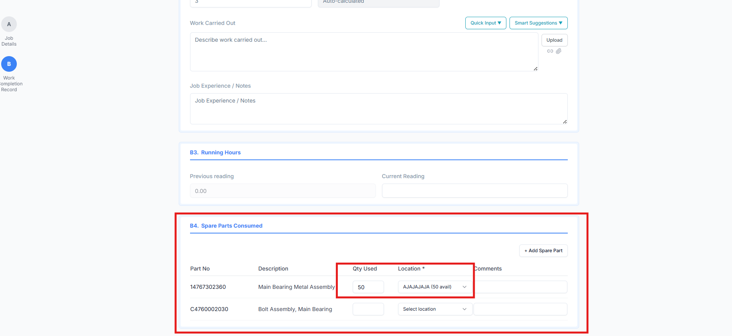

Raplit Analysis Prompt – Work Order Form: B4 Spare Parts Consumed – Inventory Deduction on Approval

Context
In Work Order Form → B4. Spare Parts Consumed, users:
- Select a Spare Part
- Select a Location
- Enter Quantity Used
- Save and later Approve the Work Order
Currently, the used quantity is not updating correctly, or it is unclear where the quantity is being updated after consumption.

Key Questions for Analysis
- Are spare parts in B4 fetched directly from the spares table?
- When quantity is entered in B4, is it:
  - Updated in the spares table, or
  - Stored in some other table?
- If it is not updating the spares table:
  - Which table is storing the consumed quantity?
- Why is the quantity not deducting correctly for the selected location?
- What is the correct and reliable inventory flow?
- How can this be fixed so it works correctly every time?

Correct Design Expectation (Authoritative)
✅ Spare parts in B4 must be fetched from the spares table
✅ Spare identification must be based on:
- part_code
✅ Inventory is location-wise
✅ Important Rule
Quantity must NOT be deducted at Save
Quantity must be deducted only when the Work Order is Approved

Expected Correct Inventory Flow
- Before Approval
  - Quantity entered in B4 is only recorded
  - No deduction from spares table
- On Work Order Approval
  - System must:
    - Identify spare using part_code
    - Identify selected location
    - Deduct Qty Used from the spares table
    - Deduction must be location-specific

Scope of Analysis (Strict)
Analyse ONLY:
- Work Order Form
- B4 – Spare Parts Consumed section
- Inventory update triggered by Work Order Approval
🚫 Do NOT analyse or modify:
- Spare Master screens
- Components / Fleet / Jobs modules
- Work Order numbering or status logic
- UI layout or field positions
- PMS scheduling logic

Analysis Breakdown
1. Spare Data Source Verification
- Confirm:
  - Whether B4 spares list is fetched from spares table
- Identify:
  - Which fields represent location and available quantity
  - How location-wise stock is structured

2. Consumption Data Storage Analysis
Trace where Qty Used is stored:
- On Work Order Save:
  - Is it stored in:
    - work_order_spares
    - spare_consumption
    - inventory_transaction
    - Or any other table?
- Confirm:
  - Whether spares table is untouched at this stage

3. Approval-Time Inventory Deduction Analysis
Analyse what happens on Work Order Approval:
- Is any deduction triggered?
- If yes:
  - From which table?
  - Is location respected?
- If no:
  - Why inventory is not updating

4. Location-wise Deduction Validation
Verify whether deduction logic:
- Uses part_code as reference
- Uses the selected location
- Correctly deducts quantity from:
  - The correct location record
- Identify issues such as:
  - No deduction on approval
  - Deduction from wrong location
  - Deduction happening multiple times
  - Deduction happening at save instead of approval

Root Cause Identification
Clearly identify:
- Where the current logic is broken
- Why the quantity is not updating properly
- Whether inventory logic is missing, incomplete, or incorrectly triggered

Corrective Method – Plan Required
Provide a detailed corrective plan covering:
- Which table should store spare consumption entries
- How and when spares table quantity should be updated
- Exact trigger point:
  - Work Order Approval
- How to ensure:
  - Location-wise accuracy
  - No double deduction
  - No premature deduction
- How UI should reflect updated quantity after approval

Expected Output
The analysis should clearly explain:
- Current storage behavior
- Why deduction is incorrect or missing
- What exact correction is required
- Confirmation that:
  - Deduction occurs only on approval
  - Other modules remain unaffected

