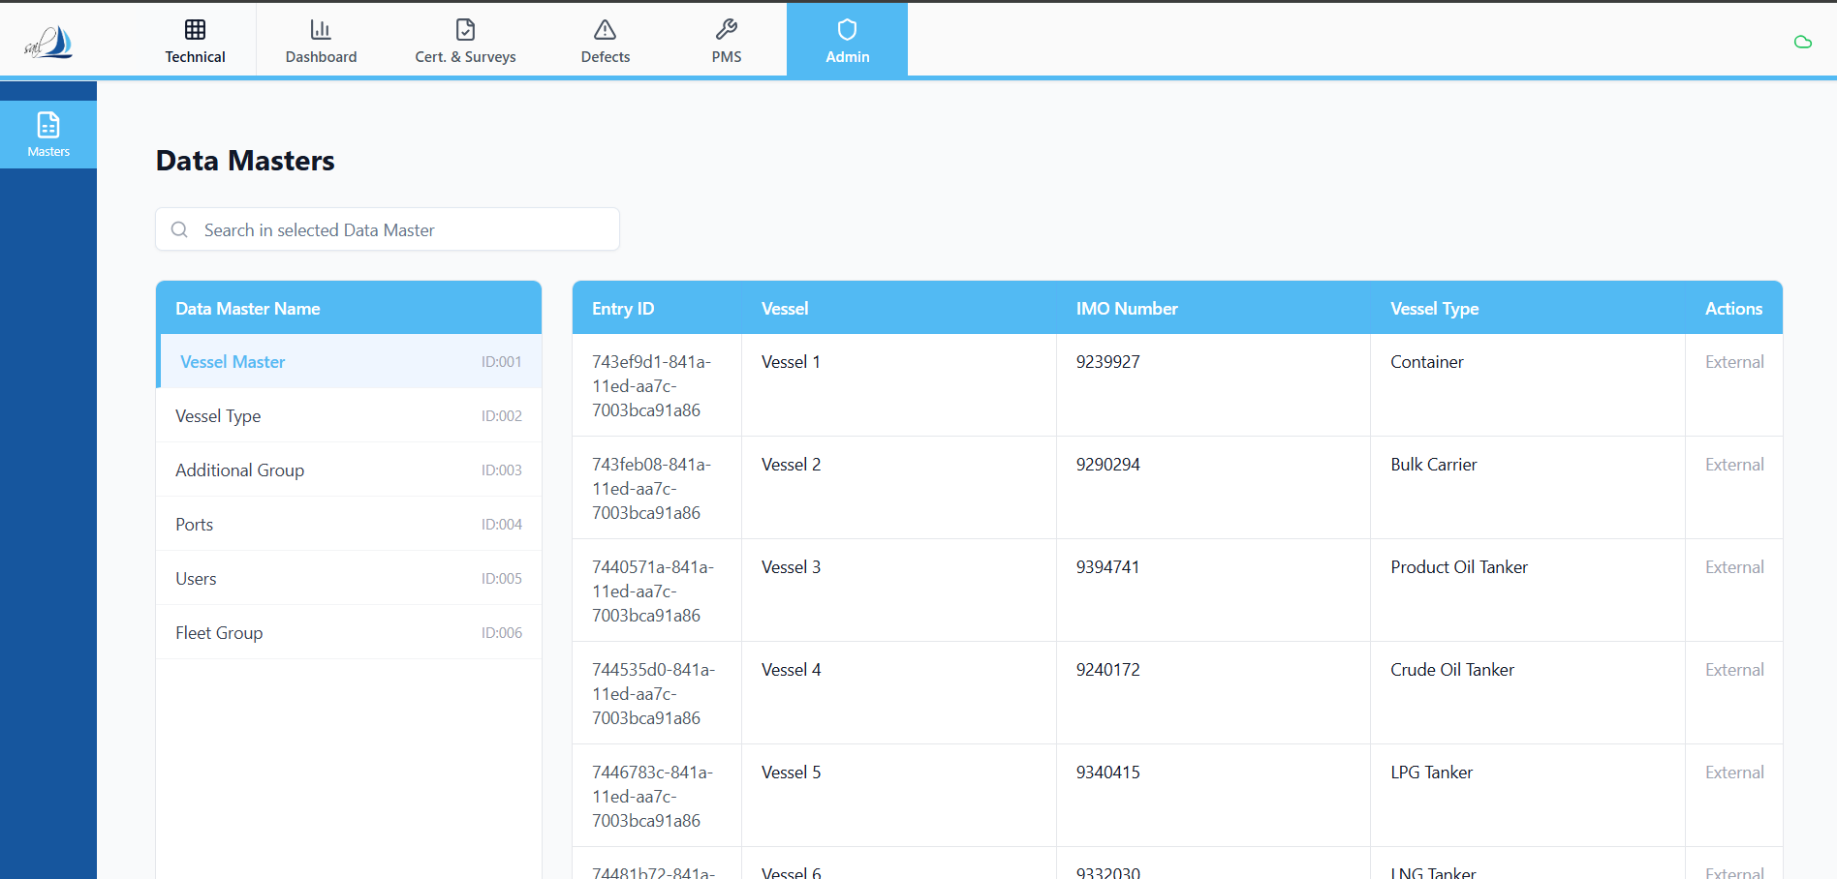

Prompt for Replit — “Sync All” Master Data Button (ANALYSIS & PLAN ONLY)
Context
In the Admin section, I want to add a “Sync All” button in right aligned properly.
This button’s responsibility will be to synchronize all master data shown in the Admin sidebar into the PMS system by creating or updating corresponding master tables.
⚠️ Do NOT implement anything yet. This task is planning and analysis only.

Core Requirements (Conceptual)
- The “Sync All” button should:
  - Iterate through all master data sources shown in the Admin sidebar
  - Create a corresponding master table for each dataset if it does not exist
  - Update existing records if the table already exists
- Identifier Rules (Very Important)
  - Entry Id from the master source must be saved as:
    - id (primary key) in each master table
  - No internal auto-generated IDs
  - All relationships must rely on this Entry Id
- Vessel Data Rule
  - Vessel data will now be sourced only from this master
  - All PMS modules must use:
    - Entry Id as vessel identifier
  - In future, other vessel types may be added using the same master structure
  - This design must remain extensible
- Non-Regression Rule
  - Existing functionality must remain fully intact
  - No breaking changes to:
    - Components
    - Jobs
    - Work orders
    - Running hours
    - Spares
    - Bulk uploads
  - This feature must be isolated and additive

Your Task — ANALYSIS & PLAN ONLY
1️⃣ Identify Scope of “Sync All”
- List each sidebar master section that will be included
- For each:
  - Source of data
  - Current usage (read-only vs persisted)
  - Target master table name

2️⃣ Master Table Strategy
For each master dataset, explain:
- Table structure (high-level, not SQL)
- Primary key (Entry Id)
- Update strategy:
  - Insert new records
  - Update existing records
  - Ignore removed records OR soft-delete (state assumption clearly)

3️⃣ Sync Flow Design (Step-by-Step)
Provide a step-by-step execution plan:
- What happens when user clicks “Sync All”
- Order of syncing (if any dependency exists)
- How failures are handled:
  - Partial failure
  - Retry strategy
- How progress / status should be reported

4️⃣ Data Integrity & Safety Checks
Explain how you will:
- Prevent accidental overwrites
- Ensure Entry Id consistency
- Avoid duplicate records
- Handle schema mismatches safely

5️⃣ Impact Analysis (Must Be Explicit)
For each area, state Yes / No impact and why:
- Existing PMS Admin screens
- Vessel dropdowns
- Bulk upload logic
- Job → Work order triggers
- Running hours logic
- Reporting / dashboards

6️⃣ Future-Proofing
Explain how this design:
- Allows new master datasets to be used without rewriting logic
- Keeps master sync logic independent of PMS business logic

Output Format Required
- A clear step-by-step plan
- Headings per section
- Explicit assumptions
- Explicit non-goals (what this will NOT touch)
❗Do not write code.
❗Do not change existing behavior.
❗Do not optimize anything beyond this scope.
Once the plan is approved, we will move to implement.

