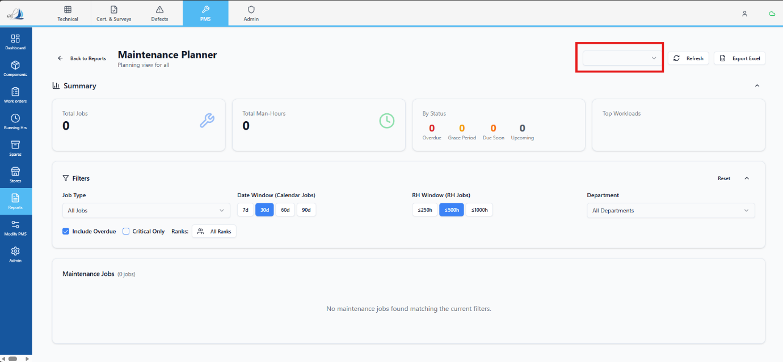
Replit Prompt – Fix Vessel Dropdown Fallback Logic (Location / Vessel Selection)
Objective
Analyse and fix the vessel dropdown data source logic used in the Vessel dropdown (as shown in the attached UI).

Current Behaviour
- The dropdown attempts to bind vessel data only from the internal vessels table via the technical API.
- When the vessels table is empty or returns no records, the dropdown remains empty.
- There is no fallback mechanism, even though a valid external master data API exists.

Required Behaviour (Correct Logic)
Implement a two-step data source resolution for the vessel dropdown:
- Primary Source (Preferred)
  - Fetch vessel data from the internal API:
  - /technical/api/vessels
  - If this API returns one or more vessels, use this data exclusively.
- Fallback Source (Only When Needed)
  - If the internal vessels API returns:
    - an empty array
    - or no usable vessel records
  - Then fetch vessel data from the external master API:
  - Use this external data only as a fallback, not in parallel.

Scope Constraints (Very Important)
- ❌ Do NOT change backend database structure
- ❌ Do NOT modify vessel sync logic
- ❌ Do NOT affect other dropdowns or modules
- ❌ Do NOT change permissions, roles, or filters
- ✅ Only update logic related to this vessel dropdown
- ✅ Ensure existing behaviour remains unchanged when vessel data already exists internally

