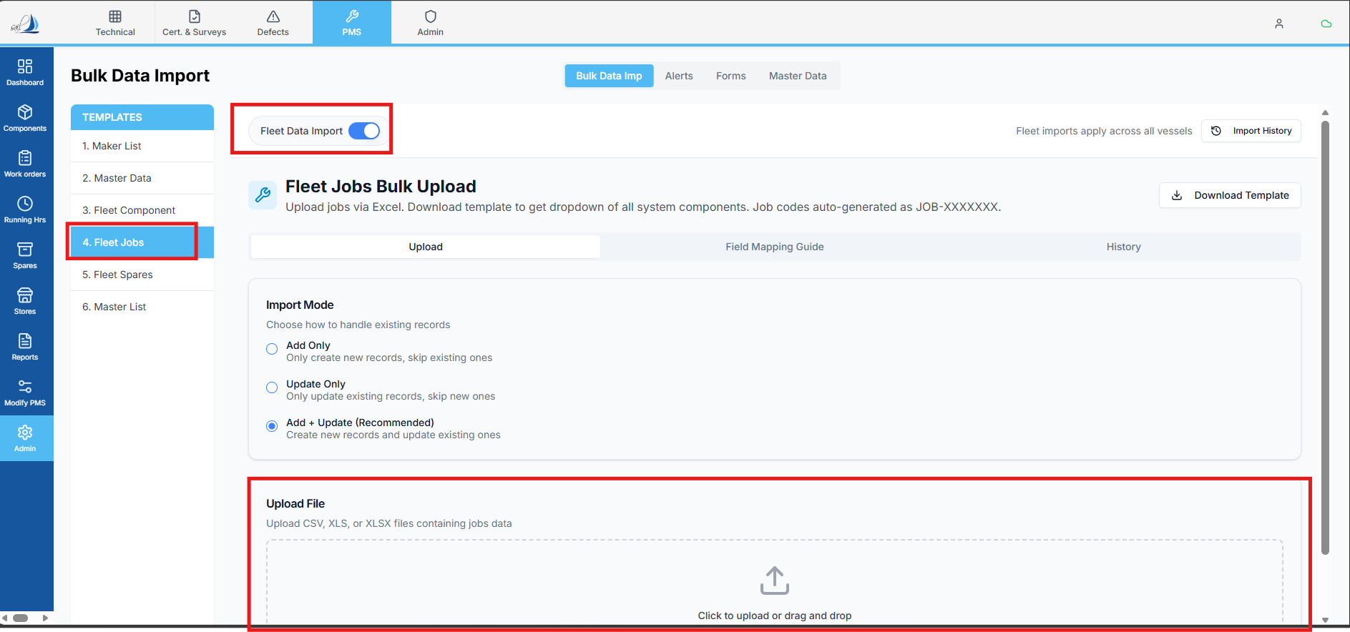

Raplit Analysis Prompt
Module: PMS → Admin → Bulk Data Import → Fleet Data Import → Fleet Jobs
Topic: Fleet Jobs Bulk Import – Table Creation & Data Storage Design

Context
In Bulk Data Import → Fleet Jobs, users upload an Excel sheet to bulk import Fleet Job master data.

Requirement Overview
- All Fleet Jobs bulk-imported data must be stored in a new table named fleet_jobs
- If the fleet_jobs table does not exist:
  - It must be created
- While creating the table:
  - Mandatory system columns (as previously defined for all new tables) must also be added
- The table must support all columns from the Fleet Jobs import sheet, with correct naming and required/optional classification

Fleet Jobs – Import Sheet to Table Mapping
Import Sheet Header Name | Table Column Name | Validation
Job Code | job_code | Required
Fleet Equipment Code | fleet_equipment_code | Required
Fleet Equipment Name | fleet_equipment_name | Required
WO Title | wo_title | Required
Maintenance Basis | maintenance_basis | Optional
Interval Value | interval_value | Optional
Unit | unit | Optional
Task Type | task_type | Required
Assigned To | assigned_to | Required
Approver | approver | Required
Job Priority | job_priority | Required
Class Related | class_related | Required
Brief Work Description | brief_work_description | Required
Department | department | Required
Criticality | criticality | Required
Is Active | is_active | Required
Required Spare Parts | required_spare_parts | Optional
Required Tools | required_tools | Optional
PPE Requirements | ppe_requirements | Optional
Permit Requirements | permit_requirements | Optional
Other Safety Requirements | other_safety_requirements | Optional

Analysis Questions (To Be Answered)
- Does a Fleet-level jobs table already exist under a different name?
- Where is Fleet Job bulk-import data currently being stored (if at all)?
- What mandatory system columns must be added to fleet_jobs based on global table standards?
- How is Fleet Jobs data different from Vessel Jobs data in the current architecture?
- How other Fleet master tables (e.g., Fleet Components) are designed and persisted?

Detailed Analysis Scope
1. Table Design Analysis
- Analyse existing Fleet master tables
- Identify:
  - Naming conventions
  - Primary identifiers
  - Mandatory system columns pattern
2. Bulk Import Flow Analysis
- Analyse Fleet Jobs bulk import pipeline:
  - Excel parsing
  - Dry run
  - Final import
- Identify the correct insertion point for fleet_jobs persistence
3. Validation Classification
- Analyse how:
  - Required vs Optional fields are enforced
  - Validation rules are applied during dry run
  - Get the validation rules from the Fleet Jobs – Import Sheet to Table Mapping.

Detailed Plan (Design-Level Only)
Step 1: fleet_jobs Table Definition
- Define table structure using:
  - Exact column names listed above
  - Mandatory system columns (as per standard)
- Ensure no schema conflict with existing tables
Step 2: Bulk Import Storage Alignment
- Ensure Fleet Jobs bulk import:
  - Persists data only into fleet_jobs
  - Does not reuse vessel-specific job tables
Step 3: Validation Alignment
- Required fields must be:
  - Enforced during dry run
  - Block import if missing
- Optional fields must allow nulls
Step 4: Post-Import Visibility (Analysis Only)
- Analyse where Fleet Jobs data should be visible post-import
- Ensure data source consistency

Expected Outcome
- A clearly defined fleet_jobs table
- Fleet Jobs bulk-imported data is persisted correctly
- Column names match import sheet headers (mapped format)
- Required and optional fields are correctly classified
- Fleet Jobs master data storage becomes standardized

Mandatory Constraints (Strict)
- ANALYSE & PLAN ONLY
- DO NOT implement logic
- DO NOT modify existing tables
- DO NOT impact vessel job imports
- DO NOT change UI
- DO NOT add validations beyond classification
- WAIT for explicit PROCEED instruction

