How to Acknowledge the Locked WO
- Click on the ‘Dashboard’ sub-sub module. (Ref Figure 1)
- Go to the ‘Operation’ tab. (Ref Figure 1)
- Click on the ‘WO Anomalies’ card. (Ref Figure 1)
- Click on the ‘Superintendent Notifications’. (Ref Figure 1)
3. Click on the ‘W.O Anomalies’ card.

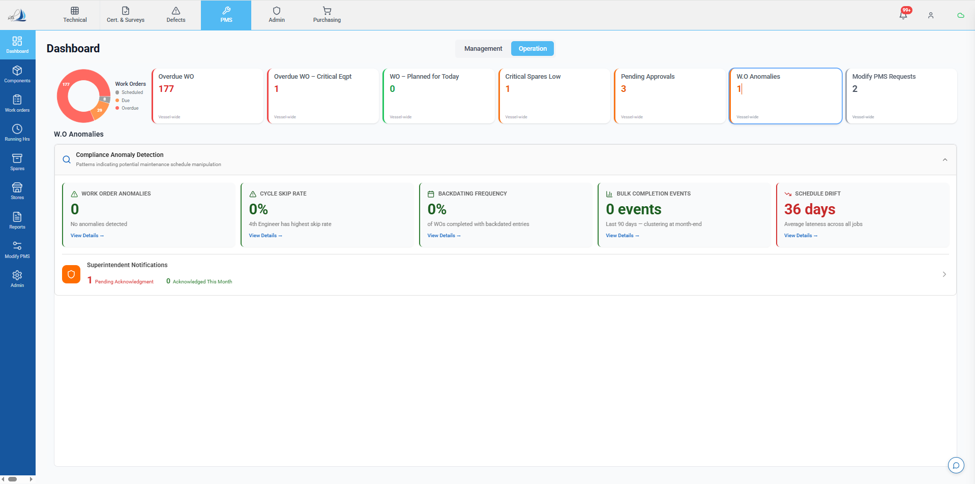
2. Click on the ‘Operation’ tab.
1. Click on the ‘Dashboard’.
4. Click on the ‘Superintendent Notification’.
Figure 1

- Upon clicking on the ‘Superintendent Notifications’ card, the screen below will appear. (Ref Figure 2)
- Click on the ‘Acknowledge’ button to unlock the WO. (Ref Figure 2)
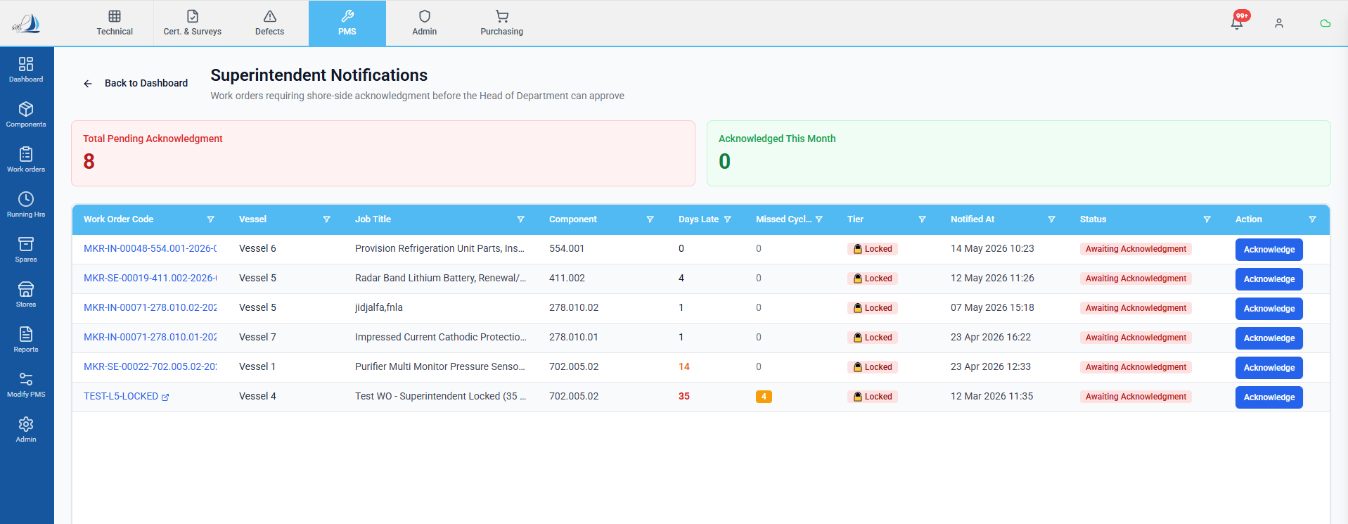
1. Click here to unlock the WO.
Figure 2
Note: For testing purposes, Vessel Users and Vessel Admins will also have the option to Acknowledge a locked Work Order.

This action is being provided only for the testing phase. In the live production environment, the Acknowledge option will be removed for Vessel Users and Vessel Admins.

Only the intended office-side users will be able to perform the required actions on locked Work Orders in the live system.

