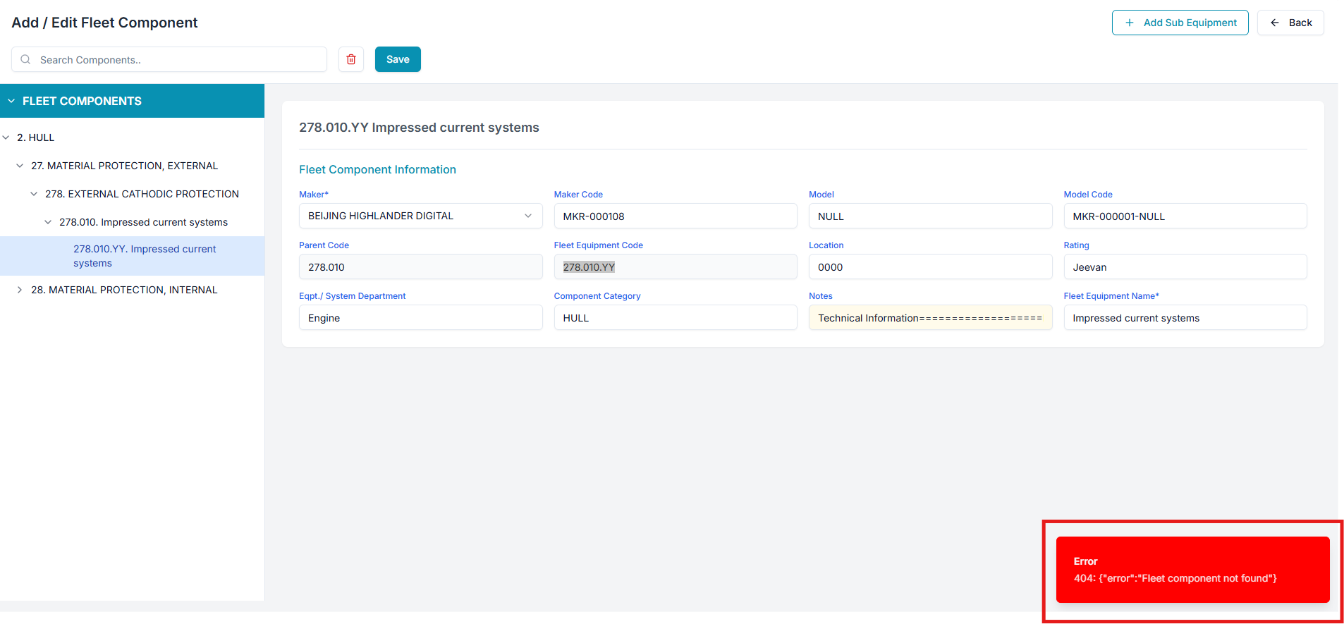

Raplit Analysis Prompt
Module: PMS → Admin → Master Data → Fleet Data → Fleet Components
Scope: Edit Fleet Component → Save Error
Issue Type: Data Save Failure (UI / Data Binding / API Mapping – Analysis Only)

Context
In the Fleet Components module:
- Users can open + Add / Edit Fleet Component
- Existing Fleet Component data is displayed correctly in Edit mode
- Users modify one or more fields
- When clicking Save, the system throws an error:
“Fleet Component Not Found”
As a result:
- Changes are not saved
- No update occurs in Fleet Components data
- User is blocked from editing Fleet Component master data

Observed Problem
- Edit screen loads successfully → indicates data fetch is working
- Save operation fails → indicates mismatch during update operation
- Error suggests the system cannot identify the Fleet Component record during save

Analysis Questions (To Be Answered)
- Why does the system throw “Fleet Component Not Found” during Save?
- What identifier is expected by the Save operation?
- Why is the identifier:
  - Missing?
  - Incorrect?
  - Not passed correctly from UI?
- Why does Edit mode allow data display but Save fails?
- Is the issue caused by:
  - UI state handling?
  - Incorrect key mapping?
  - Missing Fleet Component primary reference?
- Why is the existing Fleet Component record not being resolved during update?
- Is this an architectural issue in how Fleet Components are handled compared to Components?

Possible Root Cause Areas (Analysis Only)
1. Identifier Mapping Issue
- Fleet Component unique identifier may not be:
  - Loaded into UI state
  - Retained during Edit
  - Sent back during Save
- Save operation may be attempting:
  - Insert instead of Update
  - Update using an incorrect key (e.g., name/code instead of internal ID)
2. UI State Loss
- When switching to Edit mode:
  - Original Fleet Component reference may be lost
  - UI may only hold editable fields, not the record identity
3. API / Contract Expectation Mismatch
- Save API may expect:
  - Fleet Component ID
  - Parent Fleet Equipment Code
  - Composite key
- UI may be sending partial or mismatched payload
4. Fleet vs Component Design Gap
- Components module likely:
  - Has a stable edit/update flow
- Fleet Components module may:
  - Be partially reused
  - Miss update-specific handling

Why Data Is Not Saving
Based on the error behavior:
- The system cannot locate the target Fleet Component record during Save
- This implies:
  - Update request does not correctly identify the existing record
  - Backend treats it as “record does not exist”
- Hence the error “Fleet Component Not Found”

Detailed Resolution Plan (Design-Level Only)
1. Analyse Edit → Save Data Flow
- Trace how Fleet Component data is:
  - Loaded into Edit screen
  - Stored in UI state
  - Prepared for Save action
2. Identify Required Update Key
- Determine:
  - What unique reference the system uses to identify a Fleet Component
- Ensure:
  - Same reference is consistently used from load → edit → save
3. Align Edit and Save Context
- Ensure Edit screen:
  - Retains original Fleet Component identity
  - Does not overwrite or drop key fields during modification
4. Compare with Components Module
- Analyse how Components → Edit Component → Save works
- Identify:
  - What is missing or inconsistent in Fleet Components flow
- Use Components module as behavioral reference only
5. Improve Save Reliability (Conceptual)
- Ensure Save operation:
  - Clearly distinguishes between Create and Update
  - Always targets an existing Fleet Component when in Edit mode
6. Error Handling Clarity
- Review why “Fleet Component Not Found” is triggered
- Ensure the error reflects:
  - True absence of data
  - Not a misidentified update request

Is There a Better Way?
From an architectural perspective:
- Fleet Components Edit should:
  - Follow the same state + identity retention model as Components
- Update operations should:
  - Be tightly bound to a single authoritative Fleet Component reference
- UI should:
  - Never allow Save without a resolvable Fleet Component identity

Mandatory Constraints (Strict)
- ANALYSE & PLAN ONLY
- DO NOT implement logic
- DO NOT modify backend
- DO NOT change database schema
- DO NOT add validations
- DO NOT impact other modules
- DO NOT change Components module
- UI or flow changes, if required, must be limited to Fleet Components
- WAIT for explicit PROCEED instruction

