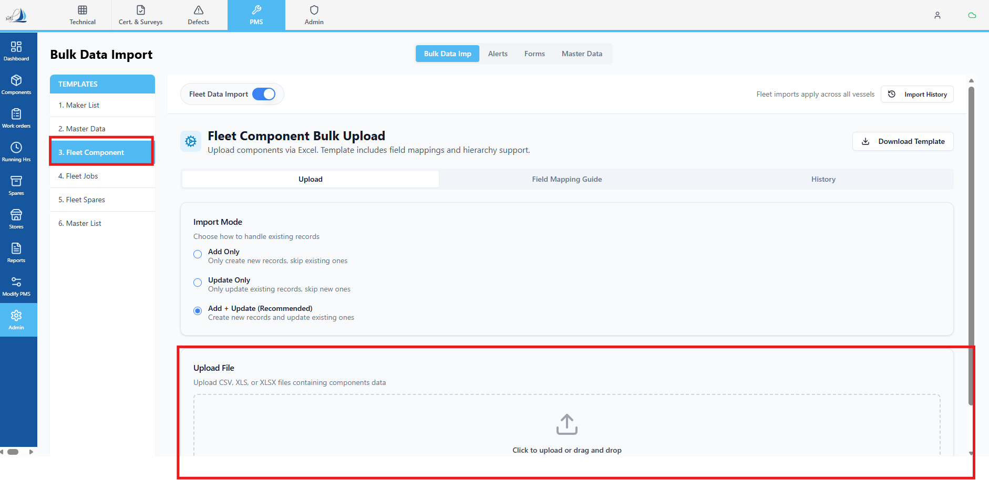

Raplit Analysis Prompt
Title: PMS Admin → Bulk Data Import → Fleet Data Import → Fleet Component
Mode: Analysis Only (No Implementation)

Context
In PMS → Admin → Bulk Data Import → Fleet Data Import → Fleet Component, users are allowed to bulk import Fleet Equipment / Component master data using a predefined Excel template.
This import is responsible for defining the Fleet Component master hierarchy, which is expected to be stored in a database table named fleet_components and displayed under:
Master Data → Fleet Data → Fleet Component

📥 Excel Import Template — Fixed Headers
The Fleet Component Excel template contains the following fixed headers.
These headers must be treated as authoritative and must exactly match the database column names.
Excel Column | Header Name
Column A | Parent Fleet Equipment Code
Column B | Fleet Equipment Code
Column C | Fleet Equipment Name
Column D | Component Category
Column E | Maker Name
Column F | Maker Code
Column G | Model
Column H | Model Code
Column I | Location
Column J | Rating
Column K | Eqpt / System Department
Column L | Notes

🎯 Post-Import Expectations (To Be Analysed)
After a successful import, the following must be true:
- Imported data is stored in a table named Fleet_Components
- Column names in Fleet_Components:
  - Must exactly match the Excel header names
  - Must also include mandatory system columns that were previously defined (to be identified during analysis)
- Imported records must be visible in:
  - Master Data → Fleet Data → Fleet Component

Analysis Objectives
1. Import Flow Analysis
Analyse the current Fleet Component bulk import flow and document:
- How the Excel file is processed
- How each Excel column is currently interpreted
- Whether the import logic:
  - Creates new records
  - Updates existing records
  - Handles hierarchy using Parent Fleet Equipment Code

2. Table & Schema Analysis
Analyse and document:
- Whether a table named Fleet_Components currently exists
- If it exists:
  - Current column structure
  - Whether column names match Excel headers
- If it does not exist:
  - Where the data is currently being stored (if anywhere)
- Identify mandatory system columns that must exist in addition to Excel headers (e.g. status, created date, etc.), without proposing changes

3. Data Visibility Analysis
Analyse:
- How data shown in Master Data → Fleet Data → Fleet Component is fetched
- Which table(s) are queried for this screen
- Whether imported Fleet Component data:
  - Is visible
  - Is partially visible
  - Is not visible at all
- Any mismatch between:
  - Import target table
  - Screen source table

4. Gap Identification
Identify and clearly document gaps between:
- Excel template headers
- Fleet_Components table structure
- Fleet Component master screen expectations
This includes:
- Missing columns
- Naming mismatches
- Structural inconsistencies
- Hierarchy interpretation issues

Deliverables from This Analysis
This analysis must produce:
- A clear understanding of the current import behavior
- Verification of the actual data storage location
- Confirmation of schema alignment or misalignment
- Identified gaps preventing correct storage or visibility
- A readiness baseline for a future PROCEED phase

Mandatory Constraints (Strict)
- ANALYSE ONLY
- DO NOT implement logic
- DO NOT change UI behavior
- DO NOT change existing schema
- DO NOT write validations
- DO NOT impact other bulk imports
- WAIT for explicit PROCEED instruction before any fix or implementation

