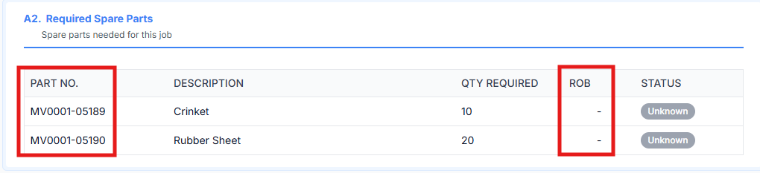
Raplit Analysis Prompt — Part No Empty Handling & ROB Fetch Issue
(Applicable ONLY When Part No is Blank / Empty / NULL)

Context
In the Jobs → A.2 / A.3 Required Spares section, spares are linked using Part Code.
An issue occurs only for those spare records where the Part No field is blank, empty, or NULL.
In this specific case:
- The Part No UI field
- And the ROB fetch logic
do not behave correctly.

🔒 Mandatory Constraints (Very Strict)
- ANALYSE ONLY
- DO NOT change any functionality
- DO NOT change any logic
- DO NOT modify UI
- DO NOT change APIs or database
- DO NOT affect any other PMS function
- This analysis applies ONLY to spares where Part No is blank / empty / NULL
❗Any behavior for spares with a valid Part No must remain completely unchanged.
❗Any fix must be applied only after explicit PROCEED instruction.

❌ Current Observed Behavior
(Only when Part No is blank / empty / NULL)
- Spare is linked using Part Code
- Part No is NULL / empty
- Result:
  - Part No UI handling is inconsistent
  - ROB is not fetched correctly in A.2 / Required Spares section

✅ Correct Rule (Strict & Limited Scope)
- Part Code is the primary and only reference key
- If Part No is blank / empty / NULL:
  - The Part No UI field must remain blank
  - ROB must still be fetched correctly from the Spares table using Part Code
- This rule:
  - Applies only to records where Part No is blank
  - Must not affect spares with valid Part No data

🧠 Analysis Required
Raplit must analyse and explain only within this limited scope:
1. Dependency Analysis
- Identify:
  - Where Part No is assumed to be mandatory
  - Why its absence blocks ROB retrieval
2. ROB Fetch Logic
- Trace:
  - How ROB is fetched for required spares
  - Which key is used in queries (Part Code vs Part No)
- Confirm:
  - Why Part Code alone is insufficient today
3. UI Binding Logic
- Analyse:
  - How Part No is populated
  - How null values are currently handled (or not handled)
4. Risk Isolation
- Confirm:
  - Changes required are fully isolated
  - No impact to:
    - Spares with Part No
    - Inventory
    - Other PMS modules

🛠️ Plan of Approach (NO Implementation)
Raplit must propose an approach to:
- Handle NULL / empty Part No safely
- Fetch ROB using Part Code
- Keep all existing flows unchanged
⚠️ Do NOT implement
⚠️ Do NOT refactor
⚠️ Only explain the approach

🚫 What Must NOT Be Changed
❌ Any spare with valid Part No
❌ Inventory logic
❌ Bulk import behavior
❌ UI layouts
❌ Validation rules
❌ Any other PMS functionality

