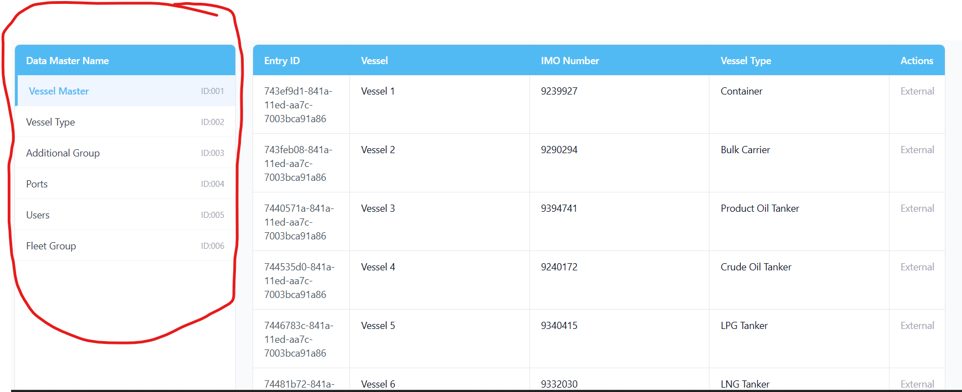

Prompt for Replit — “Sync All” Master Data (Corrected Scope & Behavior)
Context
The Admin → Data Masters screen displays master data coming from external APIs.
This UI already shows the authoritative data that must be persisted for PMS usage.
This task is to implement a “Sync All” button that saves exactly what is visible in this UI into database master tables.
This is a new implementation, not a migration and not a refactor of existing PMS logic.

🎯 Goal
When the user clicks “Sync All”:
- The system must immediately start syncing (NO confirmation dialog)
- Persist only the data currently shown in Admin → Data Masters UI
- Use Entry Id as the primary identifier everywhere
- Create or update master tables accordingly
- After completion, show a single success message

🧭 Scope — WHAT TO SYNC (STRICT)
Sync ONLY the master data sections visible in the left sidebar of Admin → Data Masters, and ONLY the columns visible in the right-hand grid.
Included Masters (from UI)
- Vessel Master
- Vessel Type
- Additional Group
- Ports
- Users
- Fleet Group
❌ Do NOT sync:
- Components
- Jobs
- Spares
- PMS Vessel Settings
- Any internal PMS / Fleet tables
- Any data not shown in this UI
Rule: If it is not visible in this UI, it must NOT be synced.

📥 Data Source (Important)
- Use the same external API responses already used to render the Data Masters UI
- Do NOT read from internal PMS tables
- Do NOT use Fleet Admin or PMS APIs as source
The UI response itself is the source of truth.

🗃️ Database Rules
Master Tables
- One master table per Data Master (no shadow or pms_* tables)
- Each table must store exactly the fields shown in the UI
Identifier Rule
- Entry Id from the external API must be saved as:
  - id (primary key)
  - vessel_code where applicable
  - Any reference fields already using vessel code
- Vessel Name = display only
- IMO Number = reference only
Persistence Behavior
- If record with Entry Id exists → UPDATE
- If record does not exist → INSERT
- Do NOT delete or soft-delete missing records

▶️ Sync Flow (No Confirmation Dialog)
- User clicks “Sync All”
- Sync starts immediately
- Each visible master is processed independently:
  - Fetch external API data
  - Upsert records by Entry Id
- After completion:
  - Show “Master data sync completed successfully”
  - Optionally show counts (inserted / updated)
❌ No confirmation popup
❌ No dependency graph
❌ No rollback UI
❌ No side effects on PMS logic

🧪 Safety & Constraints
- Do NOT modify existing PMS business logic
- Do NOT change existing module behavior
- Do NOT introduce new data sources
- Do NOT create parallel or shadow master tables
- Entry Id is mandatory — reject records without it

📌 Deliverable from You (Replit)
Before implementation, provide:
- A short analysis summary confirming your understanding of:
  - Scope
  - Data source
  - Storage behavior
- A step-by-step execution plan for Sync All
- Call out any ambiguity before proceeding
Do not implement until this analysis is confirmed.

✅ Expected End State
- Admin “Sync All” persists external master data shown in UI
- Entry Id is used consistently everywhere
- PMS modules will consume these masters in later phases
- No regression, no duplicate sources, no hidden logic

