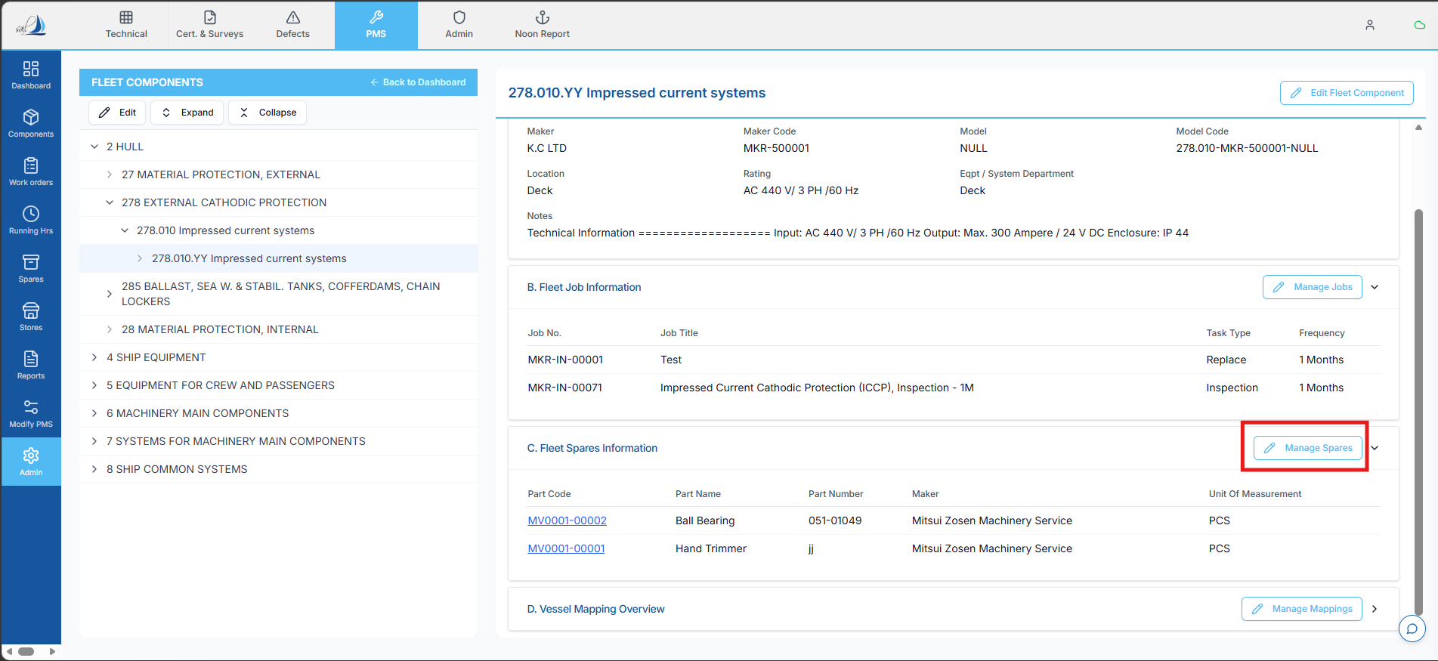
SS 1
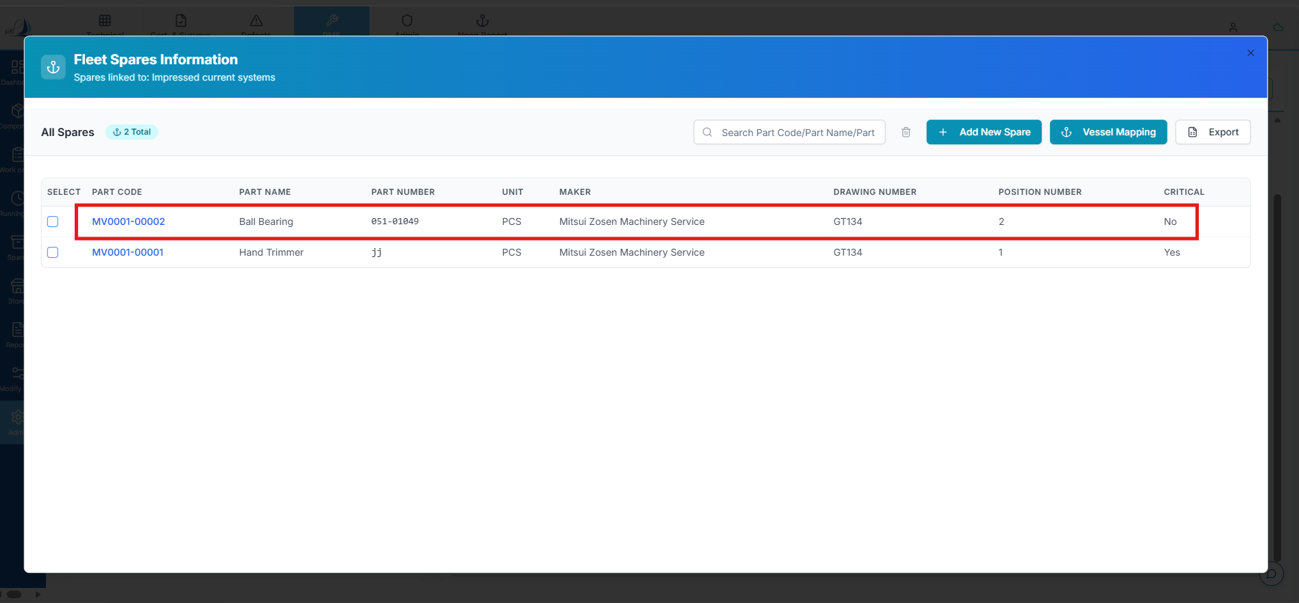
SS 2
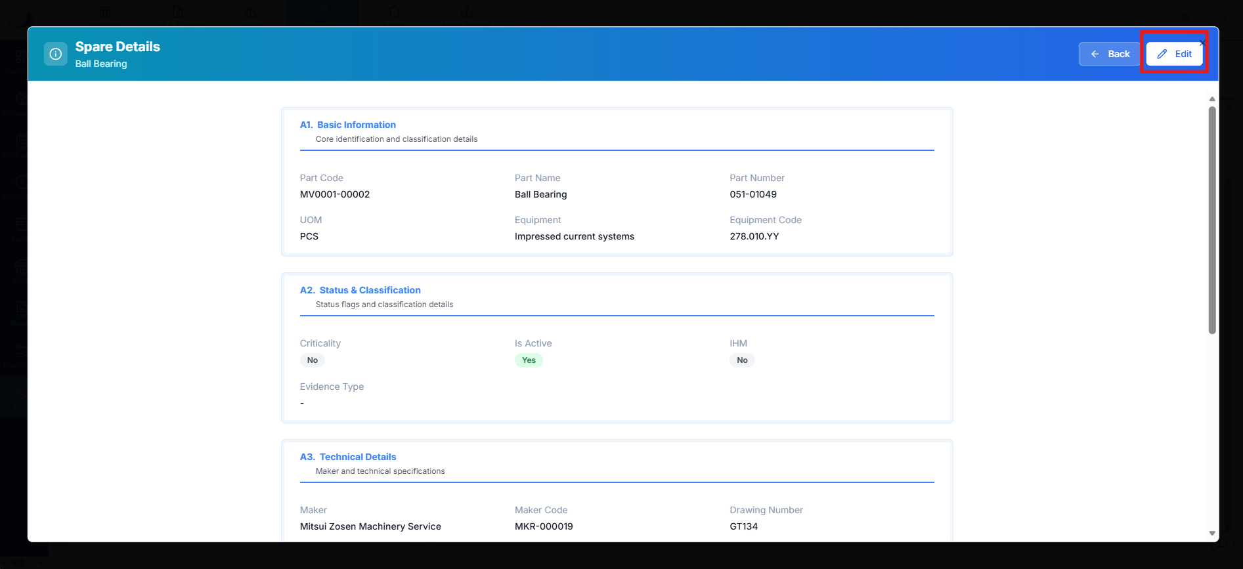
SS 3
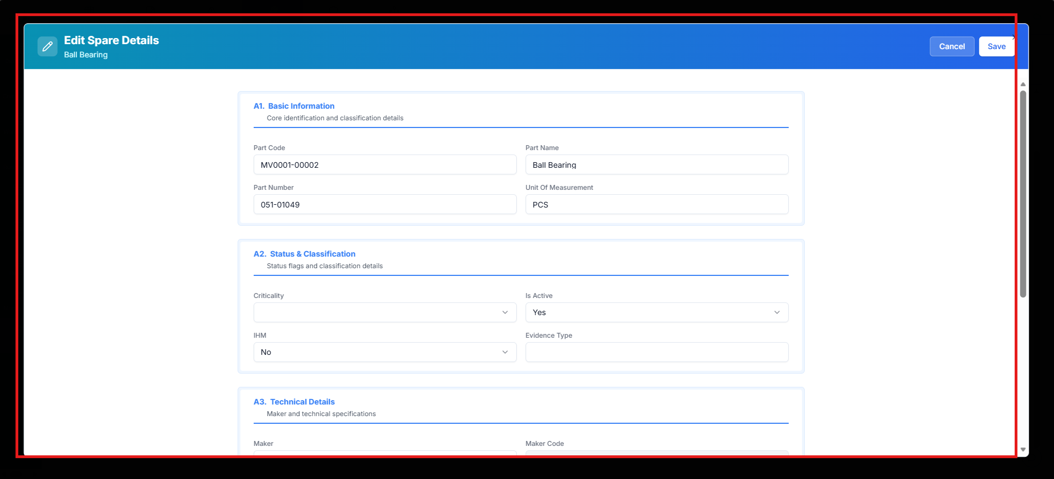
SS 4
TASK: ANALYSIS & FIX – EDIT SPARES DETAILS NOT SAVING + UI ALIGNMENT

Objective:

1. Perform **detailed root cause analysis** for why changes in **Edit Spares Details Popup (SS4)** are not saving
2. Provide **corrective implementation plan**
3. Align **SS4 UI** with reference screen (SS5) – ONLY styling (padding, colors, button size)
Path: Master Data → Fleet Data (SS1) → Manage Spares → Fleet Spares Information (SS2) → Select the Spare → Spares Details (SS3) → Edit Spares Details (SS4) Popup

--------------------------------------------------

1. Current Issue

• Changes made in **Edit Spares Details Popup (SS4)** are NOT reflecting after save
• No visible error but data is not persisted
• Indicates failure in save lifecycle

--------------------------------------------------

2. Root Cause Analysis

Investigate across all layers:

--------------------------------------------------

A. UI Layer Issues

Check:

• Is Save button triggering API call?
• Is form state updated before submit?
• Any JavaScript error blocking execution?

Common issue:

• JS errors can silently stop save execution :contentReference[oaicite:0]{index=0}

--------------------------------------------------

B. API / Payload Issue

Verify:

• Payload structure sent from UI
• Are updated fields included in request?
• Field names matching backend schema?

Common issue:

• Incorrect mapping → backend ignores update

--------------------------------------------------

C. Backend Save Logic

Check:

• API endpoint receiving request
• Update query execution

Possible issues:

• Update query not triggered
• Wrong WHERE condition (wrong ID used)
• Data overwritten by default values

--------------------------------------------------

D. ID / Reference Issue (CRITICAL)

Verify:

• Correct Spare ID passed?

Possible root cause:

• Popup loads correct data
• But save API uses:
- wrong spare_id
- null ID
- fleet_spare_id vs spare_id mismatch

--------------------------------------------------

E. State Management Issue

Check:

• Form uses:

- local state vs global state

Possible issue:

• UI updated but original object sent in API

--------------------------------------------------

F. Caching / Refresh Issue

Check:

• After save:

- Is fresh API called?
- Or old cached data shown?

Common issue:

• UI shows stale data due to cache :contentReference[oaicite:1]{index=1}

--------------------------------------------------

G. Database Layer Issue

Check:

• Is data actually updated in DB?

If YES → UI issue
If NO → backend issue

--------------------------------------------------

3. Most Probable Root Causes (Priority)

1. Wrong ID mapping (spare_id mismatch)
2. Payload not carrying updated values
3. Backend update condition failure
4. UI not refreshing after save
5. Silent JS/API error

--------------------------------------------------

4. Corrective Implementation Plan

A. UI Fix

• Ensure Save button:

- Triggers API
- Sends updated state

• Validate payload before sending

--------------------------------------------------

B. API Fix

• Validate incoming request:

- Correct spare_id
- All editable fields included

--------------------------------------------------

C. Backend Fix

• Ensure update query:

UPDATE spares
SET <fields>
WHERE spare_id = correct_id

• Add logging for update confirmation

--------------------------------------------------

D. Post-Save Refresh

• After successful save:

- Reload spare details API
- Update UI with latest data

--------------------------------------------------

E. Error Handling

• Show:

- Success message on save
- Error message if failure

--------------------------------------------------

5. Validation Plan

Test:

• Edit single field → save → verify
• Edit multiple fields → save → verify
• Refresh page → data persists
• Check DB directly

--------------------------------------------------

6. UI ALIGNMENT – SS4 (Edit Spares Details Popup)

⚠️ STRICT: Only styling changes allowed

--------------------------------------------------

A. Padding

• Increase internal padding to match SS5
• Uniform spacing between fields
• Equal margins inside popup
Colour Matching and should look similar colour
--------------------------------------------------

B. Colors

• Apply:

- Background color same as SS5
- Border color same
- Section header color same

--------------------------------------------------

C. Button Styling

• Match:

- Button color (primary blue)
- Button height
- Button width
- Border radius
- Font size

--------------------------------------------------

D. Layout Format

• Align:

- Field spacing
- Label alignment
- Section grouping

--------------------------------------------------

E. Popup Structure

• Center aligned
• Proper width (not stretched)
• Consistent header and footer spacing

--------------------------------------------------

7. Out of Scope

Do NOT change:

• Functionality
• Fields
• Buttons count
• Logic
• API behavior

--------------------------------------------------

Expected Result:

• Changes in Edit Spares Details are saved correctly
• Data persists after refresh
• No silent failure
• UI visually matches reference screen (SS5)
• Clean and consistent popup layout SS 5:
