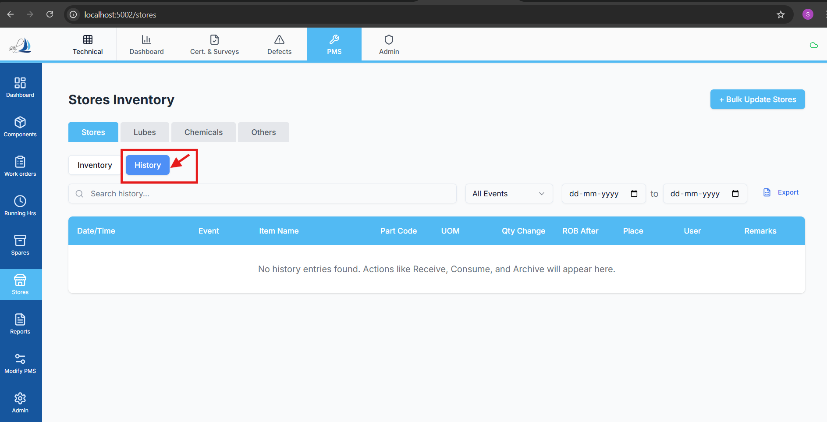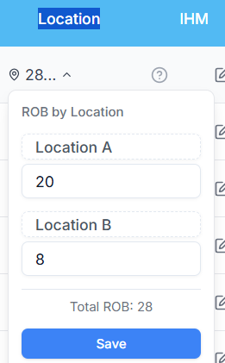

Replit Analysis Prompt — Stores Item ROB Location History Issue
Context & Constraints
- This analysis applies to the Stores module of PMS
- Replit must perform logical analysis only
- Do NOT provide code
- Focus on current functional behavior and data flow
- Vessel-wise data isolation must be respected at all times

🎯 Objective
Analyse the issue where Stores item history is not being shown or maintained when the ROB (Remaining On Board) location of an item is changed, even though the expected functionality is to preserve and display historical changes.

🔍 What Replit Must Analyse
- Current ROB Location Change Flow
  - Analyse how ROB location changes are currently handled
  - Identify whether the operation:
    - Overwrites the existing record
    - Replaces the previous location instead of preserving it
  - Determine if history creation is missing or bypassed
- History Tracking Expectations
  - Analyse the intended behavior for stores history:
    - What events should create a history record
    - Whether location change is treated as a state change or a full update
  - Identify mismatch between:
    - Business expectation
    - Actual logical flow
- Data Handling Gaps
  - Identify gaps such as:
    - Missing history trigger on location change
    - History being overwritten instead of appended
    - History linked incorrectly to the current record only
    - Vessel_ID or Item_Code not being respected while tracking history
- Vessel-wise Impact
  - Verify whether:
    - ROB history is incorrectly shared or mixed across vessels
    - History fetch logic ignores vessel scope
  - Identify if history appears missing due to incorrect filtering
- UI Binding vs Backend Logic
  - Analyse whether:
    - History is not created at all
    - History exists but is not fetched or bound to UI
  - Identify logical disconnects between:
    - Update operation
    - History retrieval logic

🚫 What Replit Must NOT Do
- ❌ Do NOT propose code changes
- ❌ Do NOT assume database structure
- ❌ Do NOT jump directly to fixes
- ❌ Do NOT ignore vessel-wise constraints

📄 Expected Output
Replit must provide:
- Clear explanation of current ROB location update behavior
- Identification of logical gaps causing missing history
- Root cause analysis (why history is not preserved)
- Pre-fix analysis summary explaining what must change logically
- Confirmation whether the issue is due to:
  - Update logic
  - History creation logic
  - Fetch/binding logic
  - Vessel-scoping issues

🧠 Final Instruction
Do NOT fix the issue immediately.
First, clearly explain what is happening now, why history is lost, and where the logic breaks.

