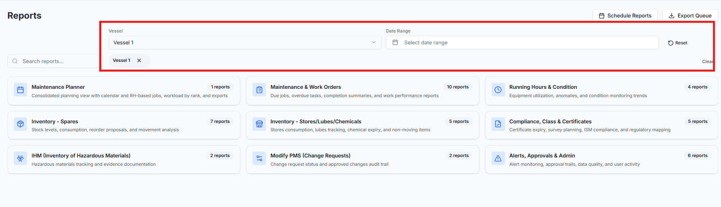
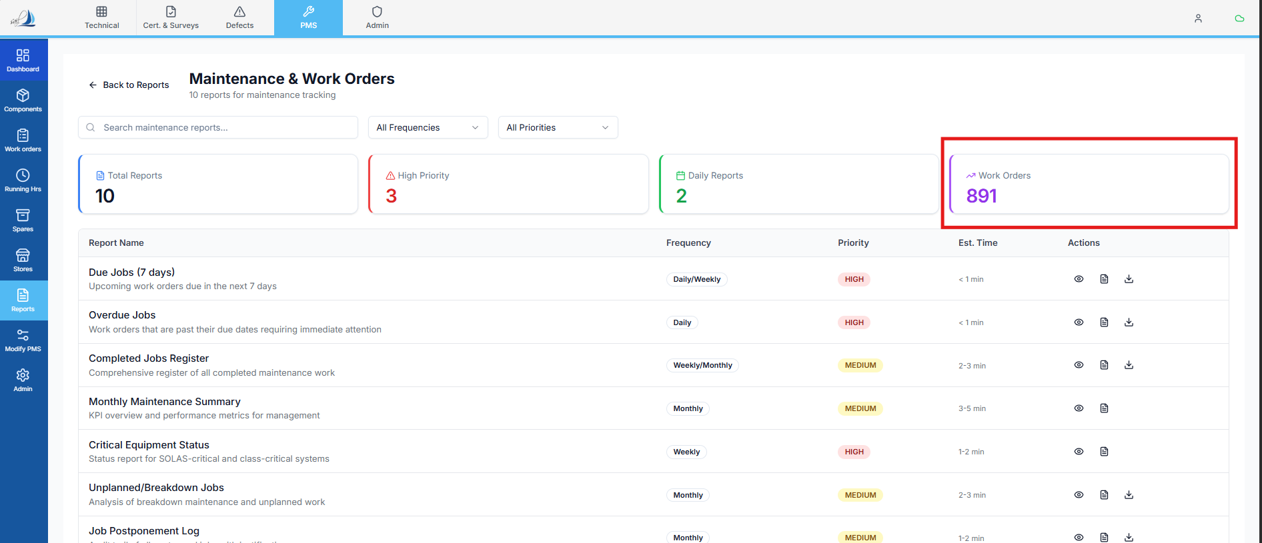

Raplit Analysis Prompt – Reports: Maintenance & Work Order (Vessel Filter Issue)
Module
Reports → Maintenance & Work Order → Work Order Reports

Problem Statement
When a vessel filter is selected in the Reports section and the user navigates to:
Reports → Maintenance & Work Order → Work Order
the system is currently displaying Work Order counts for all vessels, instead of showing only the Work Orders belonging to the selected vessel.

Authoritative Data Source
- All Work Order report data must be fetched ONLY from the work_order table
- The work_order table is the single source of truth for:
  - Work Order count
  - Vessel association
  - Report-level aggregation
No other table, cache, or derived dataset must be used for this report.

Key Questions to Analyse
- Current Behavior
- Is the Work Order report query reading data from the work_order table?
- Why is the report returning Work Orders for all vessels?
- Is the selected vessel filter:
  - Not passed to the backend?
  - Passed but not applied in the work_order query?
- Expected Behavior
- When a vessel is selected in the Reports filter:
  - Only Work Orders from the work_order table matching that vessel must be counted
- Aggregated (all-vessel) counts must appear only when “All Vessels” is selected

Scope of Analysis (Strict)
Analyse only:
- Reports module
- Maintenance & Work Order subsection
- Work Order reporting logic
- Queries on the work_order table
Do not analyse or modify:
- Work Order creation or approval
- PMS scheduling logic
- Maintenance Planner
- Any non-reporting module

Analysis Points to Cover
1. Vessel Filter Propagation
- Identify where the vessel filter is selected and stored
- Verify whether the selected vessel identifier:
  - Is passed to the Work Order report API
  - Is applied as a filter on the work_order table
2. Backend Query Validation
- Analyse the Work Order report query on work_order
- Confirm whether:
  - vessel_id / vessel_code condition exists
  - Or the query defaults to fetching all records
- Identify the exact reason the vessel constraint is missing or ignored
3. Aggregation Logic
- Validate how Work Order counts are calculated from the work_order table
- Check whether:
  - Counts are grouped correctly by vessel
  - Aggregation is applied without vessel filtering

Correct Method (Expected Design)
- Selected vessel filter must be:
  - Passed from Reports UI → API
  - Applied directly in the work_order table query
- Work Order counts must be:
  - Strictly vessel-specific
- All-vessel aggregation must occur only when no vessel filter or “All Vessels” is selected

Corrective Plan to Propose
- Identify where the vessel filter is lost or ignored
- Enforce vessel filtering at the work_order query level
- Ensure consistent behavior across:
  - UI filter
  - API parameters
  - Database query

🚫 Explicit Constraints
This change must NOT:
❌ Modify work_order data
❌ Change Work Order statuses or lifecycle
❌ Affect PMS scheduling logic
❌ Impact any non-reporting screen
❌ Introduce new tables or schemas

