Master:
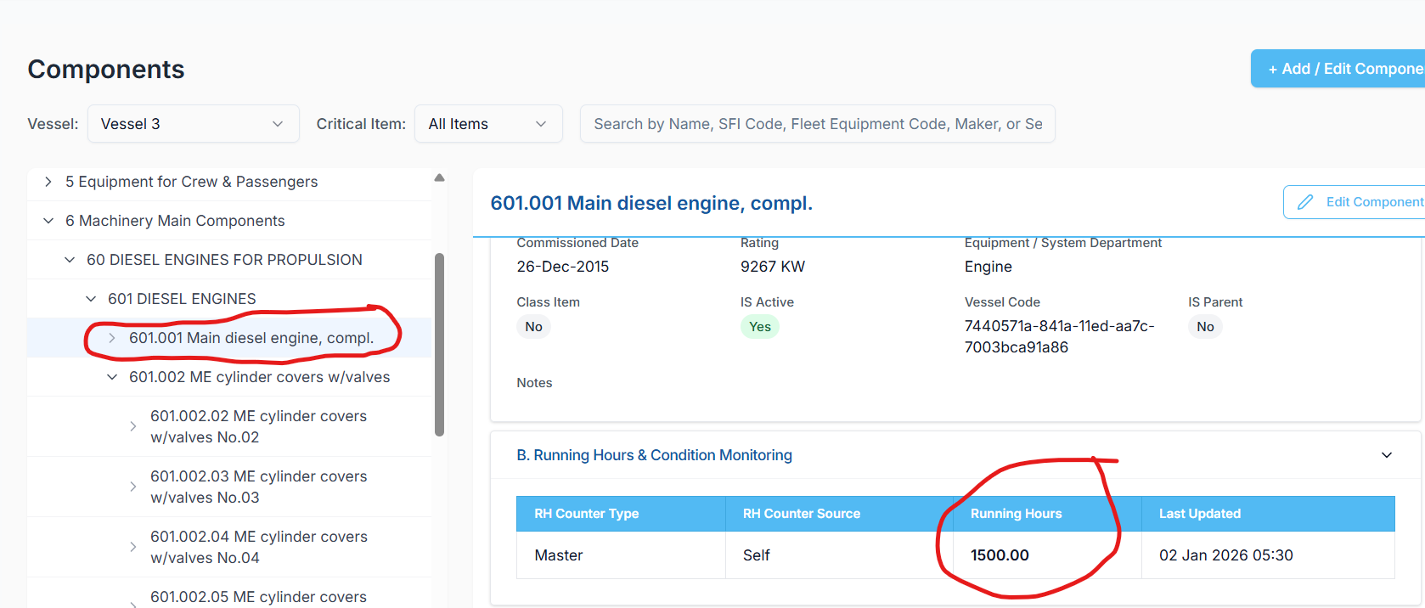

Inherited:
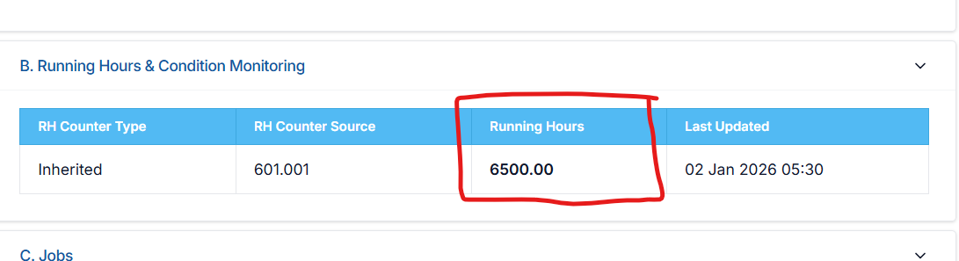

Prompt for Replit
Analyze the Running Hours calculation logic for Master and Inherited counters.
Context:
- Master Running Hours calculation is correct and is fetched vessel-wise and component-code-wise.
- Issue exists only for Inherited Running Hours.
Problem to analyze:
- For Inherited counters, running hours are currently being calculated by combining data from PMS settings across all vessels for the same component code.
- If the same component code exists in PMS settings for multiple vessels, their running hours are being summed and treated as a single value, which is incorrect.
Tasks:
- First, clearly explain what you understand from the above problem in your own words.
- Analyze the current fetching and calculation flow to identify:
  - Why vessel-level isolation is not applied
  - At what point PMS settings are causing cross-vessel aggregation
- Explain how data is ultimately being fetched today for inherited running hours.
Correct logic to enforce:
- If RH Counter Type = Inherited:
  - Running Hours must be taken only from the RH Counter Source
  - The value must be vessel-specific
  - No aggregation or summation across other vessels should occur, even if the same component code exists in PMS settings of other vessels
Constraints:
- Do not provide code
- Focus on logical analysis and correction
- Clearly describe the final, corrected data-fetching logic

