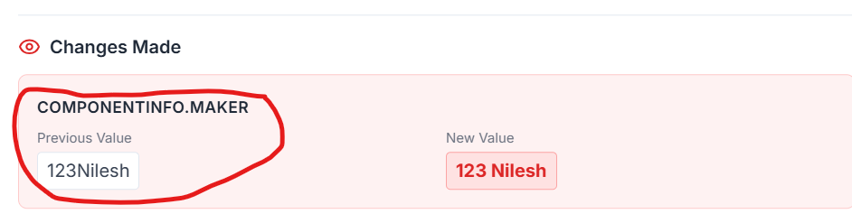

Prompt for Replit – Fix ONLY Incorrect oldValue Binding in Component Change Request Creation
Scope (Strict)
🚫 Do NOT change approval logic
🚫 Do NOT change apply logic
🚫 Do NOT change backend handlers
🚫 Do NOT change database schema
🚫 Do NOT refactor Change Request flow
✅ ONLY fix how oldValue is populated during Change Request creation from the Component section

Problem Statement
When creating a Change Request from the Component module, the oldValue shown in the popup and sent in the payload is incorrect.
Current Behavior (Wrong)
- oldValue is taken from proposedChangesJson.oldValue
- This value reflects the currently edited value, not the original one
- As a result, oldValue often equals newValue (or its trimmed variant)
Example of wrong behavior:
{
"field": "componentInfo.maker",
"oldValue": "123Nilesh",
"newValue": "123 Nilesh"
}

Required Behavior (Correct)
- oldValue must be fetched only from snapshotBeforeJson
- The value must be resolved using the field path provided in field
Example:
field: "componentInfo.maker"
Must resolve to:
snapshotBeforeJson.componentInfo.maker

Exact Logic to Implement
When building proposedChangesJson:
- Ignore proposedChangesJson.oldValue completely
- Resolve the field path against snapshotBeforeJson
- Populate:
  - oldValue ← value from snapshotBeforeJson
  - newValue ← edited value from the form
- If the field does not exist in snapshotBeforeJson:
  - Set oldValue = null
  - Do NOT fallback to edited or derived values

What NOT to Do
- Do NOT reuse or transform user-entered values for oldValue
- Do NOT trim, normalize, or mutate oldValue
- Do NOT modify how snapshotBeforeJson is captured
- Do NOT affect jobs, spares, stores, or any other module

Validation Example
Given:
- Snapshot:
{
"componentInfo": {
"maker": "ABC Corp"
}
}
- User edits maker to: "123 Nilesh"
Popup and payload must show:
{
"field": "componentInfo.maker",
"oldValue": "ABC Corp",
"newValue": "123 Nilesh"
}

Success Criteria
- oldValue always reflects the original persisted value
- newValue reflects only the user edit
- No other functionality is affected

