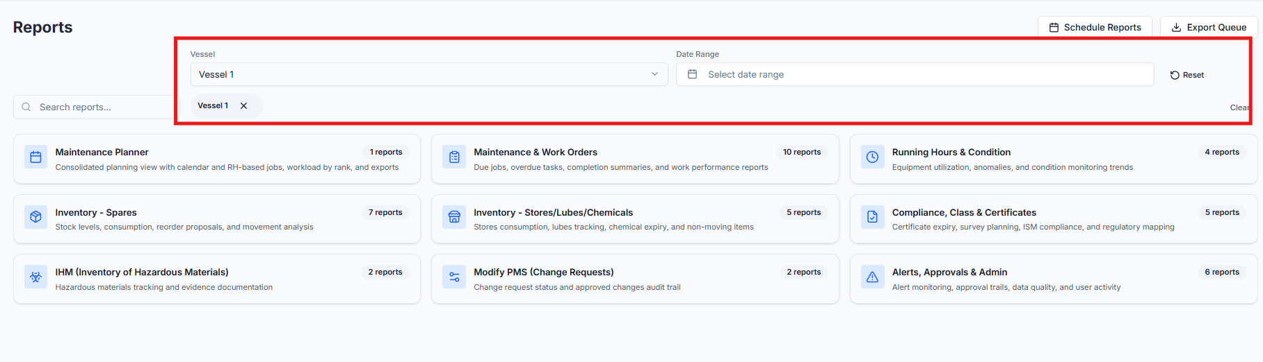
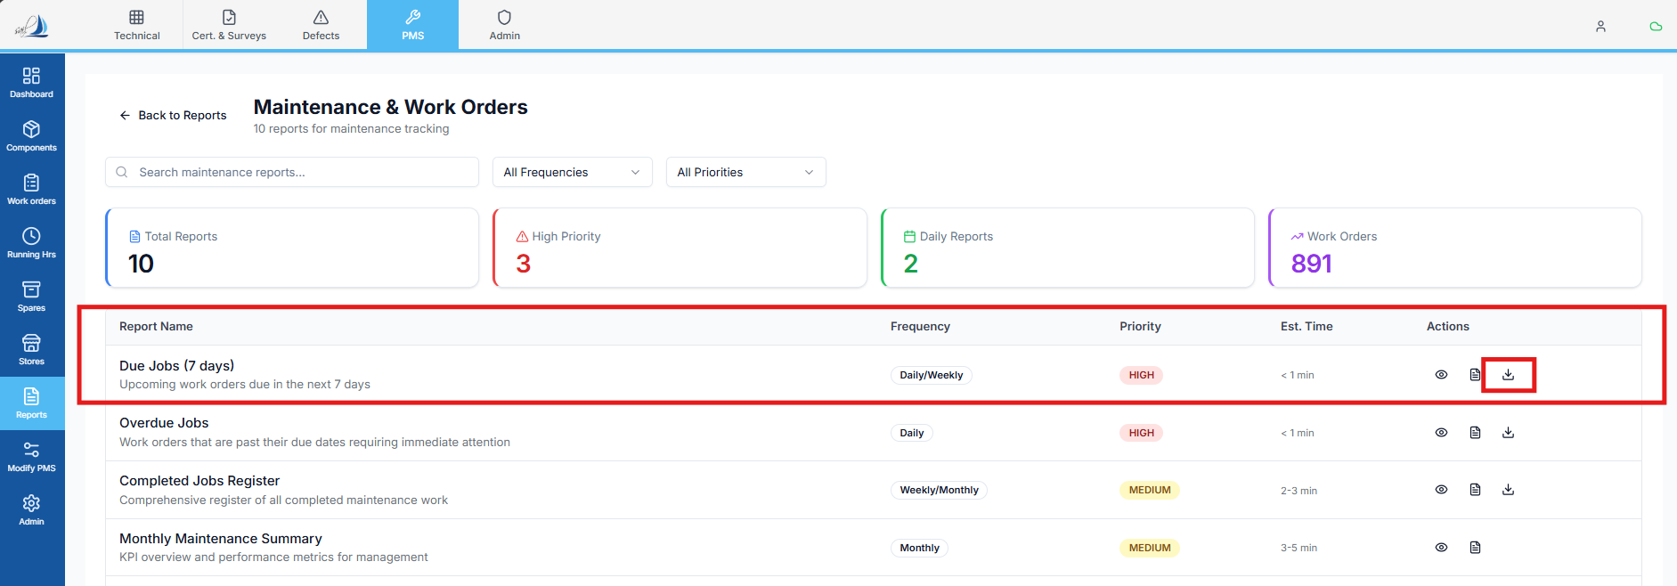

Raplit Analysis Prompt – Reports → Maintenance & Work Orders → Due Jobs (7 Days)

Context
In the Reports module, when a vessel is selected using the Vessel Filter, all reports under:
Reports → Maintenance & Work Orders
must operate strictly within the context of the selected vessel.
Currently, analysis is required for the Due Jobs (7 Days) report, specifically for the Excel download functionality.

Report Under Analysis
- Report Name: Due Jobs (7 Days)
- Module Path: Reports → Maintenance & Work Orders → Due Jobs (7 Days)

Expected Report Behaviour (Authoritative)

1. Vessel Context
- The report must consider only jobs related to the selected vessel
- Vessel context must be applied consistently at:
  - Reports vessel filter
  - Backend query
  - Excel export data

2. Date Range Logic
- Jobs must be filtered based on due date
- The date range is:
  - From: Today’s date
  - To: Today + 7 days
- Date filtering must be performed using:
  - due_date_snapshot column

3. Data Source
- Report must fetch data only from the work_order table
- No derived tables, cached data, or alternate sources must be used

Excel Download Requirement
When the Download button is clicked:
- An Excel file must be generated
- Data must be limited to the selected vessel
- Rows must represent individual work orders
- The export must include:
  - Jobs due within the next 7 days (based on due_date_snapshot)
  - AND
  - Jobs where status = 'Overdue', even if they fall outside the 7-day window

Status Inclusion Rule (Additional Condition)
For Excel export only:
Include work orders where either of the following is true:
(due_date_snapshot BETWEEN Today AND Today + 7 days)
OR
(status = 'Overdue')
This condition applies only to the Excel export logic.

Column Mapping (Mandatory)
SQL Table Column Name | Excel Column Name
component | Component Name
job_title | Job Title
assigned_to | Assigned To
due_date | Due Date
last_done_date_snapshot | Last Done Date
criticality | Criticality
status | Status

Scope of Analysis
Analyse only:
- Due Jobs (7 Days) report
- Vessel filter application
- Excel download logic
- work_order table query
- Date filtering using due_date_snapshot
- Status inclusion logic for Overdue jobs in export

Key Analysis Questions
- Vessel Filtering
  - How is the selected vessel passed to the Due Jobs report?
  - Is the vessel filter correctly applied to the work_order table query?
- Date & Status Filtering
  - Is due_date_snapshot used for 7-day filtering?
  - Are Overdue jobs explicitly included in the export logic?
  - Is the OR condition applied correctly?
- Excel Export Logic
  - Does the export use the correct combined filter (7-day due + overdue)?
  - Are all required columns mapped correctly from the work_order table?
- Data Accuracy
  - Are completed or cancelled jobs excluded if required?
  - Is status handling consistent with report intent?

🚫 Explicit Constraints
This analysis must NOT:
❌ Change any existing functionality
❌ Modify UI screens or buttons
❌ Alter report logic beyond analysis
❌ Change database schema or table structure
❌ Affect other reports or modules
This is strictly an analysis and planning exercise only.

Expected Output
- Clear explanation of:
  - How Due Jobs (7 Days) data is currently fetched
  - How vessel, date, and overdue status filters are applied
- Identification of:
  - Any gaps in vessel filtering
  - Any mismatch in export logic
- A step-by-step corrective plan to ensure:
  - Accurate vessel-specific data
  - Correct 7-day + overdue job inclusion
  - Proper Excel column mapping

