SPARES / INVENTORY / LOCATIONS / WO CONSUMPTION — LOCKED LOGIC
Implement Spares logic with these non-negotiable requirements:
A) CORE BEHAVIOR (ONE DATASET, MULTIPLE VIEWS)
- Spares uploaded via Excel must become visible in:
  - Components module → Section E (Component spares list)
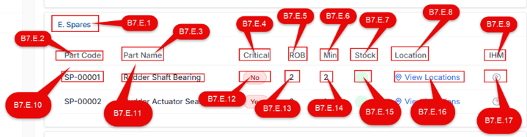
  - Spares module → Inventory tab
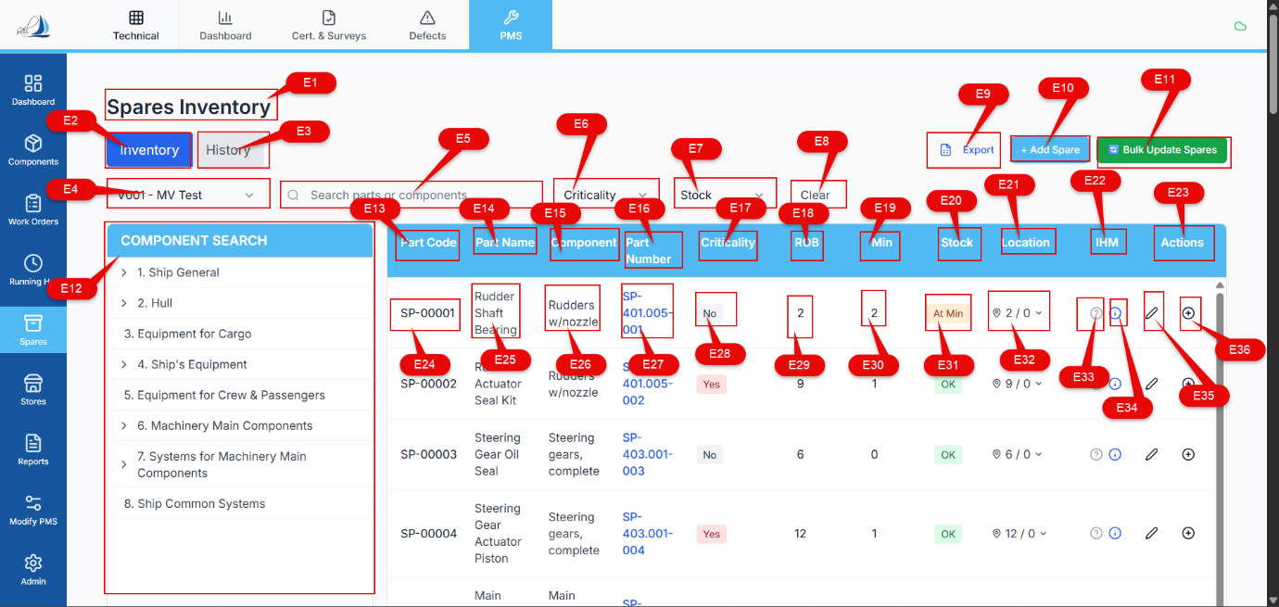
- These two screens must read from the same spare master dataset (no duplicates).

B) DATA MODEL (DB/JSON) — REQUIRED TABLES / FIELDS
B1) spares (spare master)
- spare_id (PK)
- vessel_id
- part_code (unique per vessel)
- part_name
- part_number (optional)
- uom (optional)
- min_stock (number, default 0)
- is_critical (boolean)
- is_active (boolean, default true)
- IHM fields:
  - ihm_presence (ENUM: YES/NO/UNKNOWN)
  - evidence_type (ENUM: NONE / DOC / CERT / MSDS / OTHER)
  - note (text optional)
- audit:
  - created_at, created_by, updated_at, updated_by
B2) components
Use existing components table, ensure it has:
- component_id (PK)
- vessel_id
- component_code (unique per vessel)
- component_name
B3) spare_component_links (MANY-TO-MANY — mandatory because same spare used by multiple components)
- link_id (PK)
- vessel_id
- spare_id (FK → spares)
- component_id (FK → components)
- linked_by, linked_at
Rules:
- A spare can link to multiple components.
- A component can link to multiple spares.
- Prevent duplicate link rows for same (spare_id, component_id).
B4) locations (location registry — needed for SIRE mapping)
- location_id (PK)
- vessel_id
- location_name (unique per vessel, trimmed + case-normalized)
- location_type (optional: STORE/LOCKER/BOX/etc.)
- created_at, created_by
B5) spare_location_stock (current stock per spare per location)
- sls_id (PK)
- vessel_id
- spare_id (FK)
- location_id (FK)
- qty (number, default 0)
Rules:
- unique(spare_id, location_id)
- qty must never go negative.
B6) inventory_transactions (single source of truth for history)
- txn_id (PK)
- vessel_id
- txn_datetime
- spare_id
- location_id (nullable only if txn is non-location specific; BUT for consume/receive you MUST set it)
- event_type ENUM:
  - RECEIVE
  - CONSUME
  - ADJUST_OPENING_BALANCE (for Excel opening stock)
  - ADJUST_CORRECTION (manual correction with reason + approval if you add later)
  - LINK_ONLY (optional, if you want to track linking separately; not required)
- qty_change (positive for receive, negative for consume)
- rob_total_before
- rob_total_after
- rob_location_before
- rob_location_after
- reference_type ENUM:
  - WORK_ORDER
  - MANUAL
  - EXCEL_IMPORT
- reference_id (e.g., WO number, import batch id)
- reference_note (free text)
- user_id

C) INVENTORY CALCULATIONS (FORMULAS)
For any spare:
- ROB_total = SUM(qty in spare_location_stock for that spare)
- Stock_status:
  - if ROB_total <= min_stock → “At Min”
  - else → “OK”
- No negative ROB anywhere:
  - For any consume: ensure location_qty >= consume_qty AND ROB_total >= consume_qty

D) EXCEL IMPORT RULES (BATCHED + AUDITED)
When spares are imported via Excel:
- Create/update spares records.
- Create component links using component_code in Excel:
  - Find component by component_code
  - Insert into spare_component_links
  - If component_code not found → import into “Unlinked Spares” state:
    - spare is created but link row is not created
    - show in UI with “Link Missing” indicator until user links manually
- For opening stock in Excel:
  - For each spare and each provided location/qty:
    - create/find locations.location_name
    - upsert spare_location_stock.qty
    - create inventory_transactions row with:
      - event_type = ADJUST_OPENING_BALANCE
      - reference_type = EXCEL_IMPORT
      - reference_id = import_batch_id
      - correct before/after snapshots

E) UI BEHAVIOR
E1) Components Module → Section E (Spare list under component)
- Display spares linked via spare_component_links
- Show key columns:

- Part Code,Part Name, Component Name, Part Number, Criticality, ROB, Min, Stock, Location (location A and Location B), IHM, Actions
- Clicking a spare opens “Spare Part Details” which opens a dialogue showing : Part Code, Fleet Equipment Code, Fleet Equipment Name, Component Code, Component Name, Part Name, Part Number, Unit of Measurement, Drawing Number, Position Number, Note, Specification, Maker, Maker Code, Manual Name, Page Number, Criticality, Total Rob, Location A, Location A ROB, Location B, Location B ROB, Minimum Stock, Is active, IHM, Evidence Type, Vessel Code
E2) Spares Module → Inventory Tab
- Search box + component-tree filter:
  - Tree selection filters spares by spare_component_links.component_id
- Table shows:
  - Part Code, Part Name, Component (display primary linked component or “Multi-linked”)
  - Part Number
  - Criticality
  - ROB_total
  - Min
  - Stock status
  - Location (show “A_qty / B_qty” style and dropdown editor)
  - IHM
  - Actions (edit/view/add transaction)
E3) Location editor
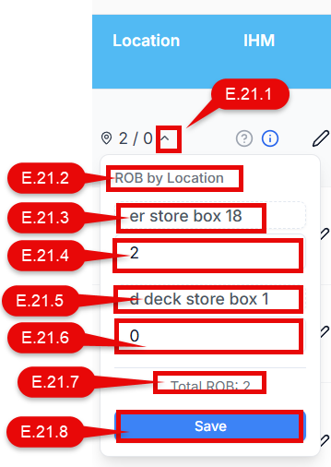
- A spare can have multiple locations, but UI may show two primary slots (A & B).
- User must be able to:
  - Edit location names (location registry) E.21.3 and E.21.5
  - Set qty per location E.21.4 AND E.21.6
- Backend must:
  - store location as location_id (not only text)
  - maintain spare_location_stock rows
  - allow building a report: “Which spares are stored in location X”
E4) Spares Module → History Tab
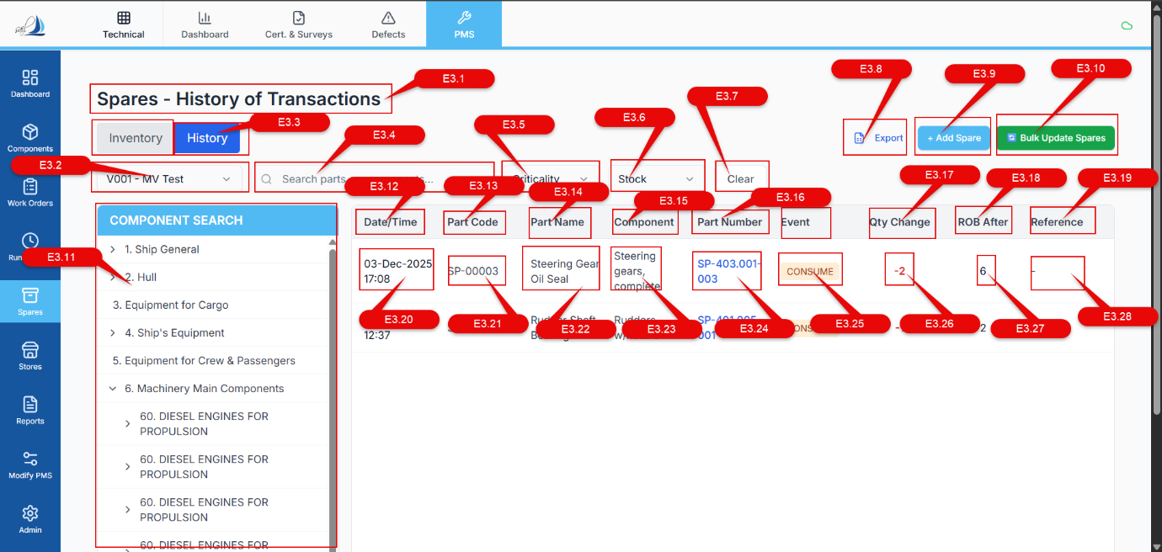
- History list reads from inventory_transactions
- Columns must include:
  - Date/Time
  - Part Code
  - Part Name
  - Component (can be derived by showing one linked component or “Multi-linked”)
  - Part Number
  - Event (CONSUME/RECEIVE/ADJUST…)
  - Qty Change
  - ROB After (total)
  - Reference (WO number / manual ref / import batch)
  - User (logged-in user who triggered txn)

F) WORK ORDER INTEGRATION (A2 IMMUTABLE + B4 CONSUMPTION)
F1) Job/Template spare list (BOM)
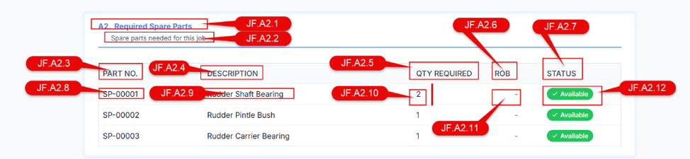
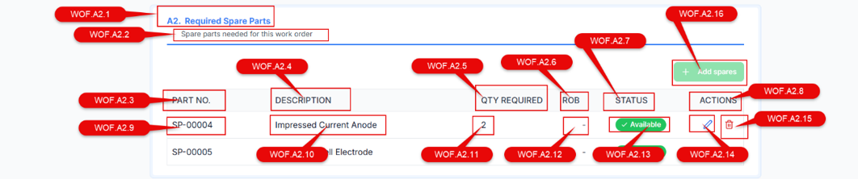
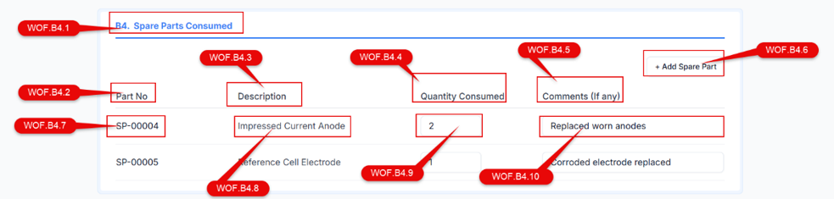
- A job template contains a list of required spares (immutable list)
- When WO is generated:
  - WO Section A2 shows the list read-only (immutable)
  - WO Section B4 shows same list but allows entering actual consumption
F2) Consumption must ask location (your rule)
- For each consumed spare line, user must select:
  - which location they consumed from (Location A / Location B or actual location names)
- No “auto deduction” across locations.
F3) No negative ROB (hard stop)
- If consume_qty > available qty at selected location → block submission with clear error.
- If total ROB insufficient → block.
F4) Posting consumption (real-time + history)
On WO consumption submit:
- For each line item:
  - validate availability at selected location
  - create inventory_transactions row with:
    - event_type = CONSUME
    - qty_change = -consume_qty
    - reference_type = WORK_ORDER
    - reference_id = wo_number
    - user_id = logged_in_user
    - capture before/after snapshots (total + location)
- Update spare_location_stock.qty immediately
- Refresh inventory UI + WO view in real time

G) MANUAL CONSUME/RECEIVE FROM SPARES MODULE
- User can do Consume/Receive directly from spares module.
- Must require:
  - location selection
  - qty
  - reference note
- Must create inventory_transactions with reference_type = MANUAL
- Must update spare_location_stock instantly
- Must show in History tab instantly

H) LOCATION RENAME / CHANGE RULE (CRITICAL FOR SIRE)
- Location names must be stored as location entities (locations table).
- If user changes a spare’s location name:
  - system must create/find the new location entity
  - move mapping in spare_location_stock accordingly
  - preserve historical transactions (history references location_id at the time of transaction)

I) REPORT REQUIREMENT (MANDATORY)
Provide backend query/view to list:
- For any location: which spares are stored there + qty
- For any spare: all locations + qty + total ROB

J) DATA INTEGRITY RULES (NON-NEGOTIABLE)
- No negative quantities in spare_location_stock
- Prevent duplicate open transactions logic issues by atomic update:
  - transaction insert + stock update must be in one atomic operation (or equivalent safe approach)
- Component linking must use component_code mapping; if not found, mark as unlinked and require manual linking.

