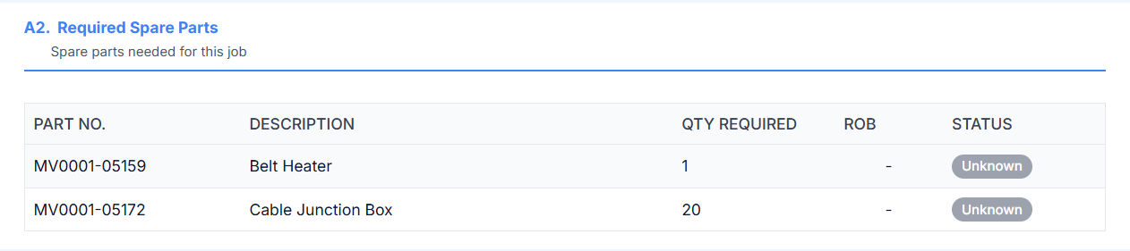

Analyse how you are binding data for this section for 554.001 component code and job code MKR-IN-00046.
As for this Part no is blank and there is ROB for this data and that is not showing on UI but even when there is no Part no it is showing a value in PART NO. section UI.
Anlyse and explain.

