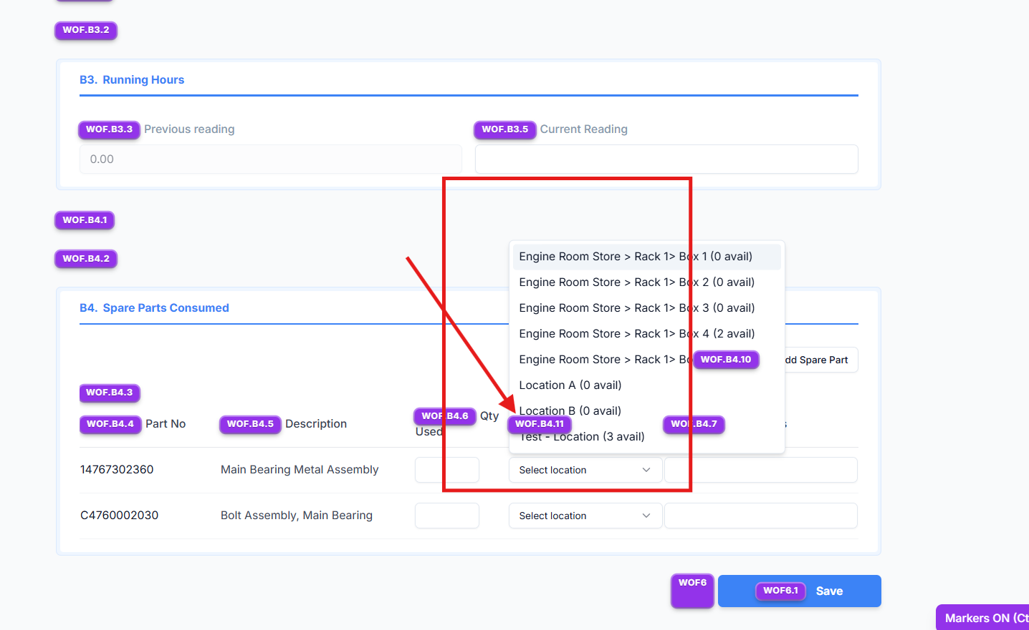

Replit Analysis Prompt – Work Order Form: Location & ROB Data
Analyse only the Location and ROB data handling inside the Work Order form, as shown in the attached reference.
This analysis must be strictly limited to the Work Order form section.
Do not analyse, modify, or reference any other module, screen, or business logic.

✅ Expected Data Fetching Logic (Authoritative)
For the Work Order form only, Location and ROB data must be fetched from Spares table using part_code, following this exact mapping:
Location Name Mapping
- location → Primary location name shown on the Work Order form
- location_2 → Secondary location name shown on the Work Order form
ROB Mapping
- rob_location_a → ROB value for location
- rob_location_b → ROB value for location_2
Frontend rules:
- ROB displayed for location must use rob_location_a
- ROB displayed for location_2 must use rob_location_b
- No summation, fallback, or cross-mapping is allowed

🔍 Scope of Analysis (Work Order Form Only)
1. Data Source Verification
- Identify how the Work Order form fetches:
  - Location
  - Location-wise ROB
- Verify whether this data is sourced directly via Spares using part_code
- Flag if any other API, cached object, or derived data is used.
2. Data Flow Trace
- Trace the exact flow only for Work Order form:
  - Backend response → API → Frontend binding
- Identify where:
  - location, location_2
  - rob_location_a, rob_location_b
are mapped and consumed.
3. Mapping Accuracy
- Validate that:
  - location ↔ rob_location_a
  - location_2 ↔ rob_location_b
- Detect any incorrect behaviour such as:
  - ROB being summed
  - ROB swapped between locations
  - One location overwriting another
4. UI Binding Behaviour
- Confirm how the Work Order form:
  - Displays multiple locations
  - Displays ROB per location
- Identify cases where:
  - Only one location appears when two exist
  - ROB value does not match the location
5. Edge Case Handling
Analyse behaviour when:
- Only location exists
- Only location_2 exists
- One location has zero ROB
- Both locations exist with different ROB values

🚫 Explicit Constraints
- Analyse Work Order form only
- Do not analyse Spares, Components, Fleet, or any other module
- Do not suggest schema changes
- Do not modify existing business logic outside Work Order form
- Analysis only – no implementation

📄 Expected Output
- Clear explanation of:
  - How Location and ROB are currently fetched in Work Order form
- Confirmation whether current logic matches the expected mapping
- Identification of:
  - Incorrect data source
  - Incorrect mapping
  - UI binding issues
- Final conclusion explaining:
  - Why the issue occurs
  - What logical correction is required only for Work Order form

