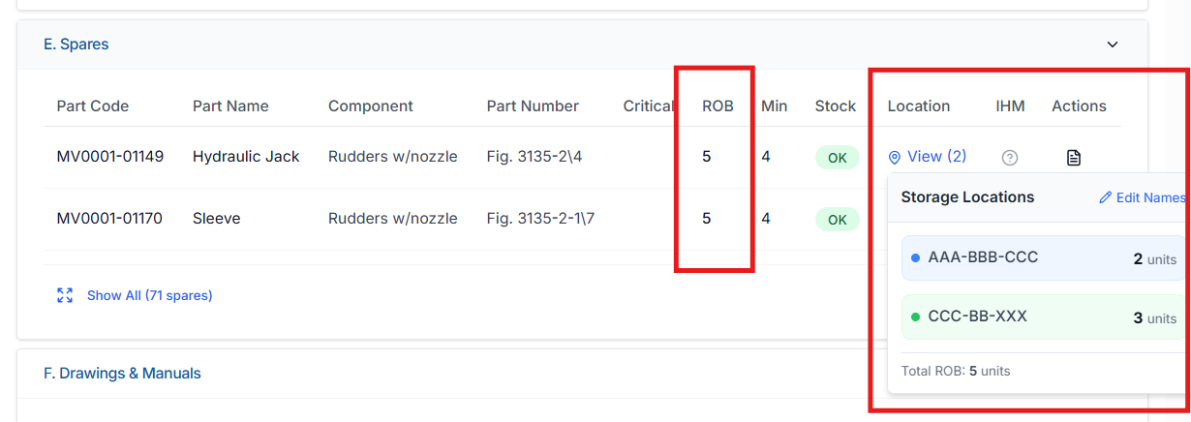

Prompt for Replit – Analyse ROB & Location Data Flow in Component Module (Spares Sync)
Context
In the Component → Spares section, the UI displays:
- ROB (Remain On Board) value in the main table
- Location-wise ROB split inside the Location popup (e.g., Location A / Location B with quantities)
Refer to the attached screenshot for UI reference.

Objective
Analyse from where and how ROB and Location data are being fetched, and explain how this data is logically related to Spares and why it must remain synchronized.
This is an analysis-only task.
❌ Do not modify or fix code yet.

Analysis Required
1. ROB Value (Main Table)
Explain:
- Which API / backend method provides the ROB value shown in the Component → Spares table
- Whether this ROB is:
  - Calculated dynamically
  - Aggregated from location-wise stock
  - Stored directly on a spare-related entity
- Which identifiers are used to fetch ROB:
  - part_code
  - component_id
  - vessel_id
- Whether ROB is sourced:
  - Directly from spares
  - From a derived inventory/stock summary
  - From a cached or pre-aggregated structure

2. Location-wise ROB (Popup View)
Explain:
- Which API(s) are called when clicking Location → View
- What data structure provides:
  - Location names
  - Quantity per location
- Whether this data comes from:
  - Spare history
  - Store/location mapping
  - Inventory ledger
  - Static/master data
- How Total ROB in popup is calculated and whether it is derived or stored

3. Relationship Between Component → Spares and Spares Module
Explain your understanding of:
- How Component → Spares data is linked to the main Spares module
- Whether both screens use:
  - The same source of truth
  - Different APIs but same underlying data
- How part_code acts as the binding key across:
  - Component spares list
  - Spare inventory
  - Location-wise stock

4. Synchronization Expectations (Conceptual)
Without proposing fixes, explain:
- Why ROB and location quantities must always be in sync with Spares
- What kind of operations should affect both:
  - Spare consumption via work order
  - Bulk update
  - Manual ROB adjustment
- What inconsistencies may occur if:
  - Component module uses derived data
  - Spares module uses stored data
  - Location data is fetched from a different source

5. Gaps & Risks (Analysis Only)
Identify:
- Any places where ROB and location data could diverge
- Any use of:
  - Static location names
  - Cached responses
  - Non–vessel-scoped data
- Any assumptions in current logic that could break synchronization

Constraints
- ❌ Do not change logic
- ❌ Do not propose fixes yet
- ❌ Do not refactor APIs
- ✅ Explain current data flow clearly
- ✅ Explain conceptual relationship between Component → Spares and Spares inventory

Output Expectation
Provide:
- Clear explanation of ROB source
- Clear explanation of location-wise stock source
- Relationship diagram (conceptual, text-based)
- Identified risks or mismatches

