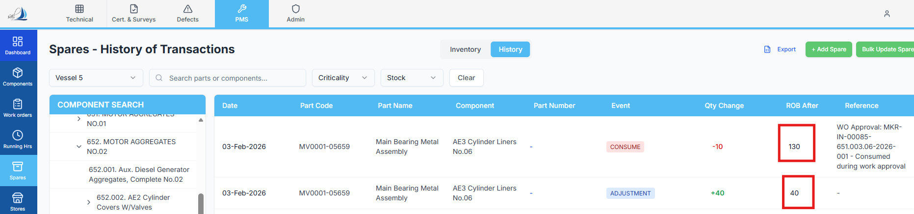

Raplit Analysis Prompt – Spares History: Incorrect “ROB After” Value (Part Code Based)

Context
When spare consumption is done through Work Order Form → B4. Spare Parts Consumed,
and the Work Order is approved:
- A history entry is correctly created in the Spares History tab
- All fields are correct except the “ROB After” value
- Spare identification is done using Part Code

Observed Issue
Example from the attached reference:
- Part Code ROB (Before): 40
- Quantity Consumed during Work Order Approval: 10
- Expected ROB After: 30
- Actual ROB After shown: 130 ❌
This clearly indicates a wrong calculation or wrong data source used for ROB After.

Expected Correct Behaviour (Authoritative)
- ROB After = ROB Before – Quantity Consumed
- ROB must be:
  - Part Code–specific
  - Location-specific
- No addition, summation, fallback, or cross-location logic is allowed

Scope of Analysis (VERY STRICT)
Analyse ONLY:
- Spares History logic
- ROB After field calculation and display
🚫 Do NOT analyse or change:
- Spare master logic
- ROB Before logic
- Inventory deduction logic
- Work Order logic
- UI layout or any other Spares History columns
- Any other modules or tables

Analysis Required
1. Data Source Analysis – ROB After
Identify:
- From where ROB After is currently fetched:
  - spares table (post-deduction)?
  - spares_history table?
  - aggregated ROB across locations?
  - cached or stale value?
Confirm whether ROB After is incorrectly:
- Added instead of deducted
- Read from the wrong column
- Summed across multiple locations
- Captured before inventory deduction

2. Part Code & Location Mapping Validation
Verify whether:
- ROB After calculation uses:
  - Part Code as the primary reference
  - Selected location from B4 section
- Ensure:
  - No global ROB
  - No cross-location overwrite

3. Sequence & Timing Analysis
Analyse the execution order:
- Inventory deduction occurs
- History entry is created
Confirm whether:
- History is written before inventory update (incorrect)
- History is written after inventory update (correct)

4. Error Pattern Verification
Check specifically for:
- ROB After = ROB Before + Qty Used
- Using total ROB for the Part Code
- Using opening stock instead of closing stock
- Duplicate deduction or duplicate read

Root Cause Identification
Clearly explain:
- Why ROB After = 130 instead of 30
- Which logic or data source is incorrect

Corrective Method (Analysis Only)
Provide a focused corrective plan, covering:
- Correct data source
→ Location-wise ROB after deduction, filtered by Part Code
- Correct formula
→ ROB After = ROB Before – Qty Consumed
- Correct timing
→ Capture ROB After only after inventory update
- Safeguards
  - Prevent aggregation across locations
  - Prevent reuse of stale/global ROB values
  - One history entry per Part Code per location per approval

Expected Output
The analysis must clearly state:
- Why ROB After is incorrect
- What exact correction is required
- Confirmation that:
  - Only ROB After will be affected
  - No other logic or module will change

