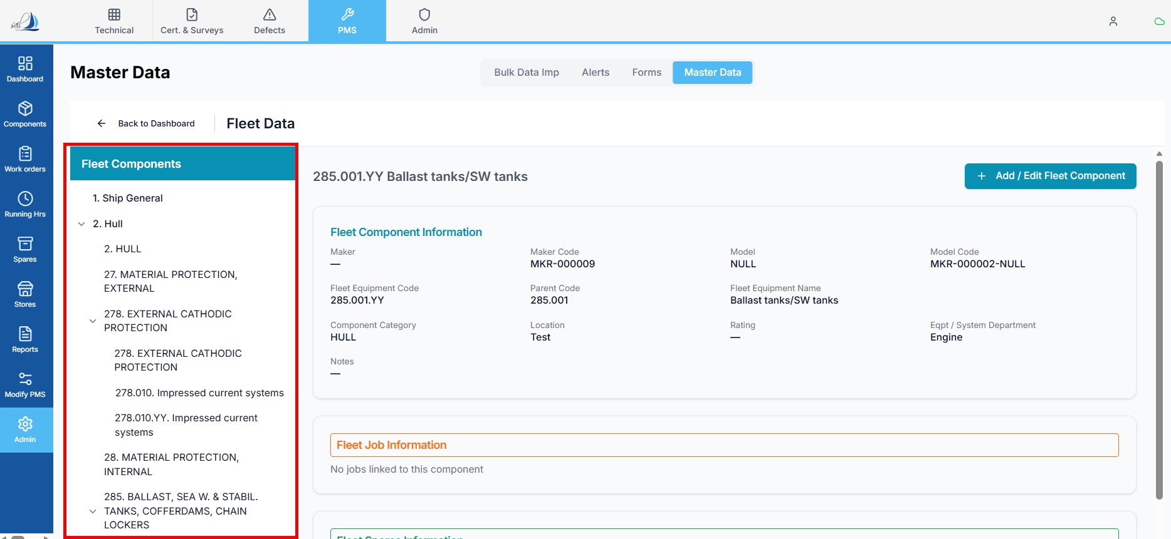
Fleet Components Tree View
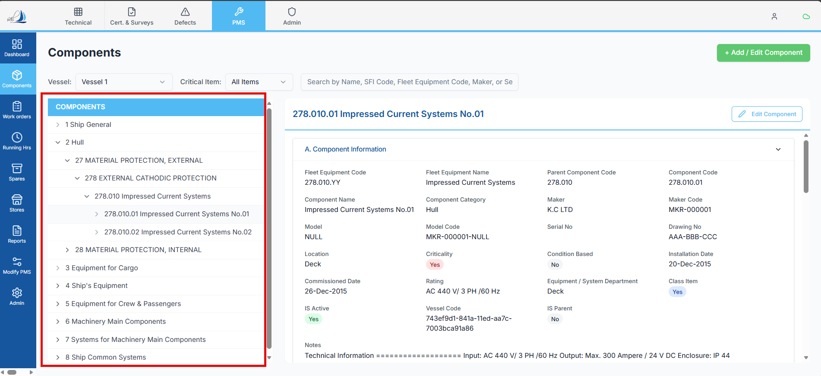
Components Tree View

Raplit UI Analysis Prompt
Title: Fleet Components Tree View UI – Align with Components Tree View UI
Mode: UI Analysis & UI Alignment Plan Only

Context
In Master Data → Fleet Data → Fleet Component, the Fleet Components are displayed in a tree view hierarchy.
There is an existing Components Tree View UI elsewhere in the system that represents the approved and standard visual pattern for hierarchical component display.
The requirement is to make the Fleet Components Tree View UI visually and structurally identical to the existing Components Tree View UI.

Objective
Analyse the current Fleet Components Tree View UI and define a clear UI-only plan to align it exactly with the Components Tree View UI, without changing:
- Functionality
- Data flow
- Business logic
- API behavior

UI Analysis Scope
1. Reference UI Analysis – Components Tree View
Analyse and document the Components Tree View UI in terms of:
- Tree structure and indentation
- Expand / collapse behavior
- Node icons (parent vs child)
- Row layout and spacing
- Typography (font size, weight)
- Action icon placement (if any)
- Selection / hover states
- Visual indicators (lines, arrows, chevrons)
This UI will be treated as the gold standard.

2. Current Fleet Components Tree View UI Analysis
Analyse the existing Fleet Components Tree View UI and document:
- Current tree layout and hierarchy display
- Differences in indentation or nesting
- Differences in icons or expand/collapse indicators
- Row height, padding, and spacing
- Font styles and alignment
- Any missing or extra UI elements compared to Components Tree View

3. UI Difference Identification
Clearly list UI-level differences only, such as:
- Visual structure mismatches
- Styling inconsistencies
- Interaction pattern differences (expand/collapse visuals)
- Alignment or spacing deviations
No functional or data differences should be analysed.

Planned UI Alignment (To-Be)
4. UI Standardization Plan
Define a UI-only plan where:
- Fleet Components Tree View:
  - Uses the same tree layout
  - Uses the same indentation rules
  - Uses the same icons and indicators
  - Uses the same row styling and spacing
- The visual behavior is indistinguishable from Components Tree View UI

5. UI Reuse / Consistency Plan
Analyse and propose (UI-only):
- Whether the same UI component can be reused
- Or the same CSS / style tokens can be applied
- Or the same UI configuration can be mirrored
(No refactoring or logic changes—analysis and plan only.)

Constraints (Strict & Mandatory)
- UI only
- Do NOT change any logic
- Do NOT change API calls
- Do NOT change data structure
- Do NOT impact tree behavior logic
- Do NOT affect other screens
- No implementation in this prompt

Expected Outcome
After this analysis:
- All visual and structural differences are clearly identified
- A precise UI alignment plan exists
- Fleet Components Tree View UI can be made identical to Components Tree View UI
- Zero risk to functionality, data, or other modules

