PMS Data Review

Findings Report — Component Sheet
Prepared for: Safe Lanes Team | Status: Action Required

1. Component Code Format — Non-Compliance
The component code format is not yet aligned with the agreed-upon requirements, as previously discussed during our call. Kindly note the following guidelines:

• Each unique component must be assigned a unique 7-digit code.
• A 10-digit code should only be used when a component has a fitted quantity of 2 or more, with a running number appended to create the structure.

Example 1: Incorrect coding structure identified.
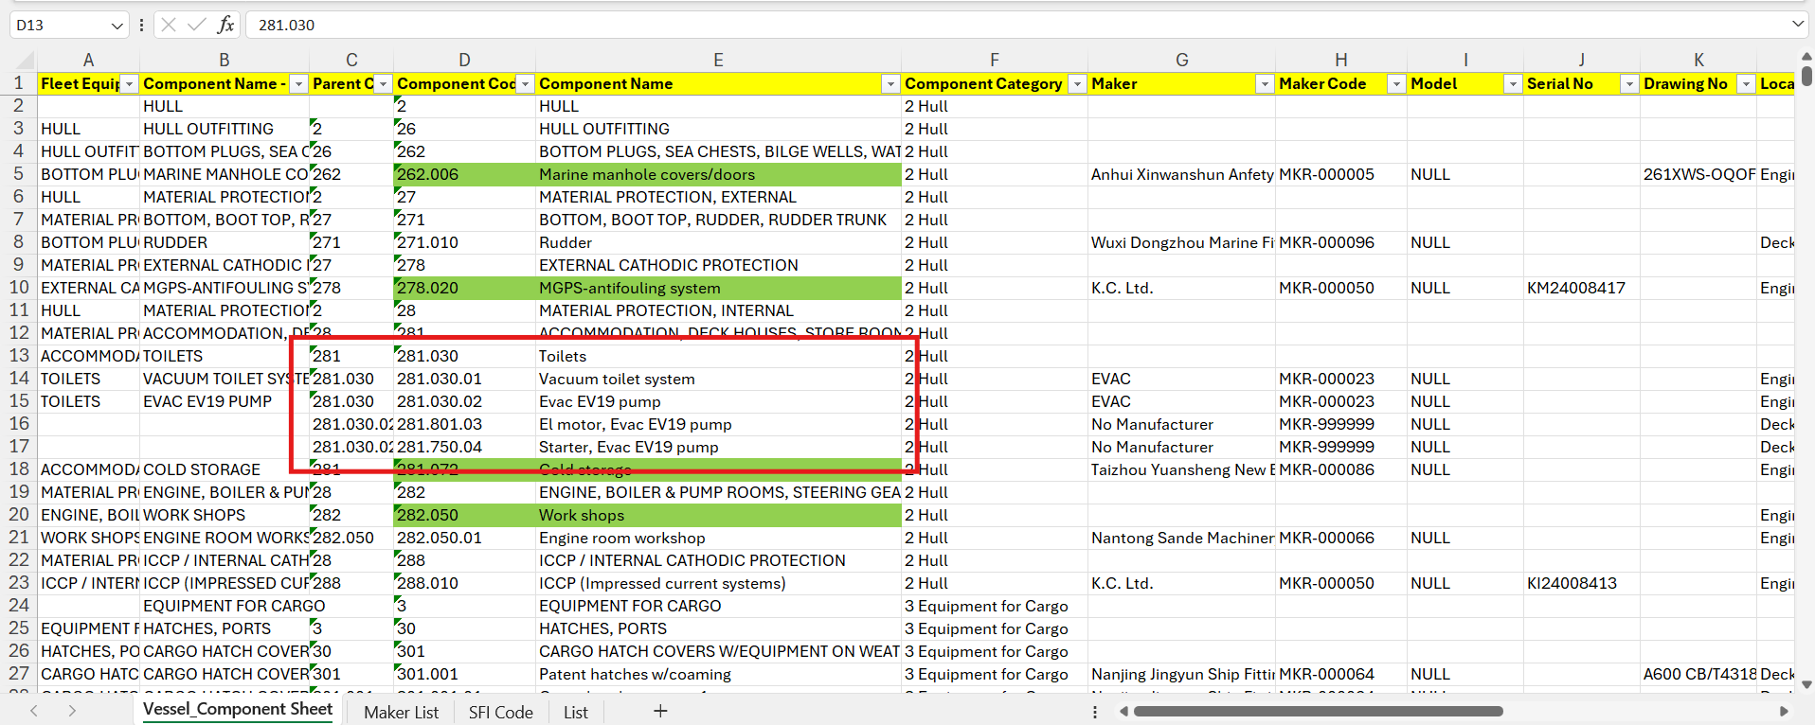
Correct Method for Highlighted Components:
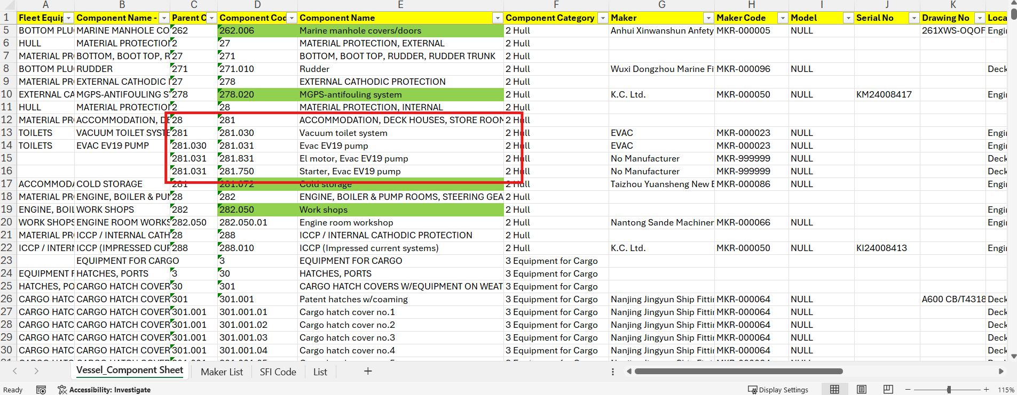

Example 2: Clarification is requested on whether the highlighted component belongs to the Cargo side or the Engine Room side, as this impacts the correct code assignment.
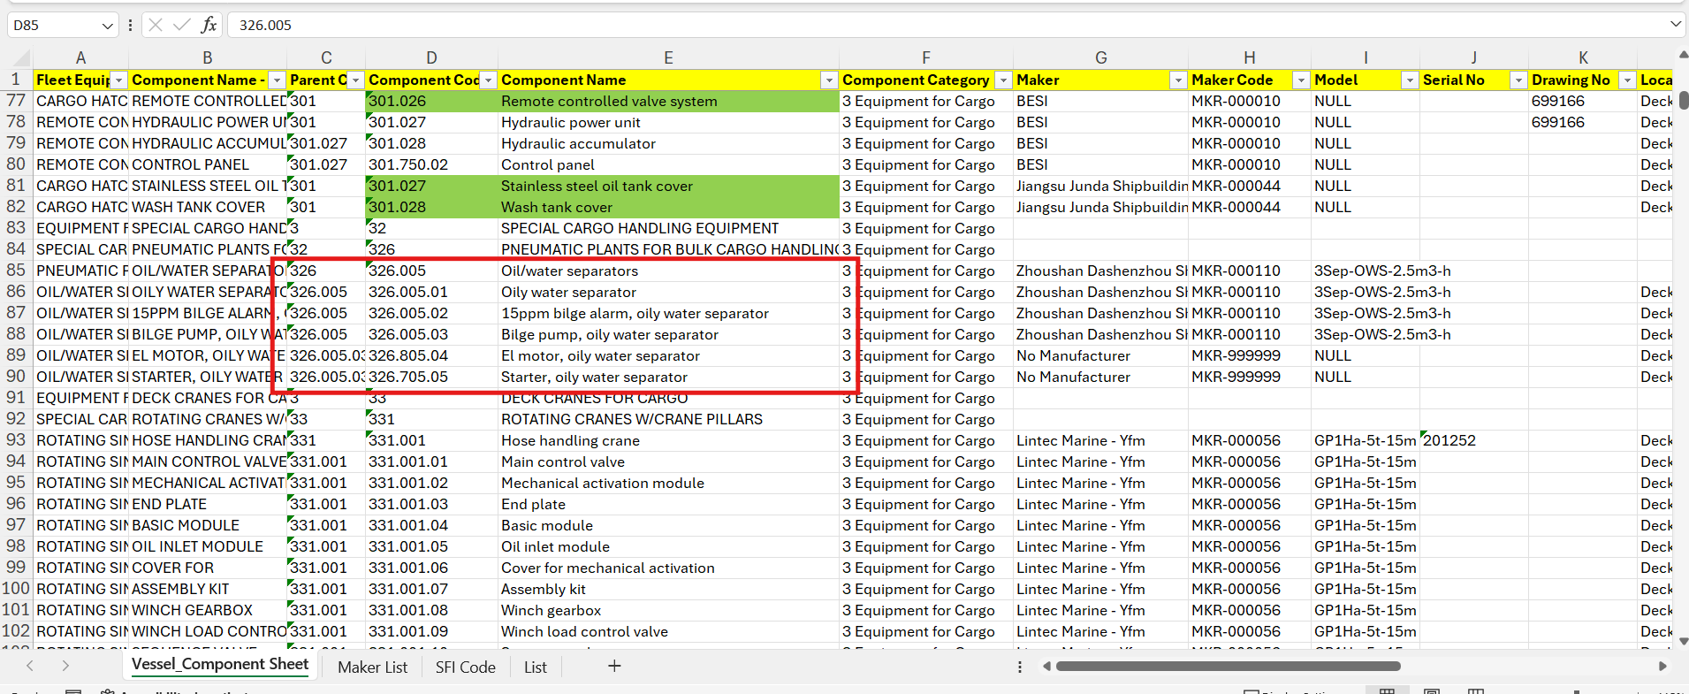
Correct Method for Highlighted Components:
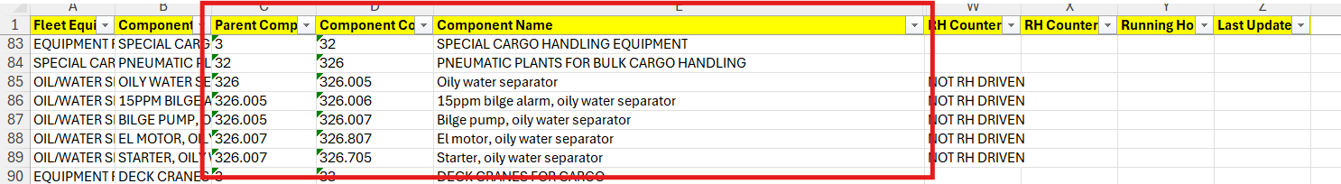

Note: The agreed-upon coding format has not been followed in several areas across the component sheet. Sample references are provided in Examples 1, 2, and 3.

Example 3: Additional instances of non-compliant coding format identified.
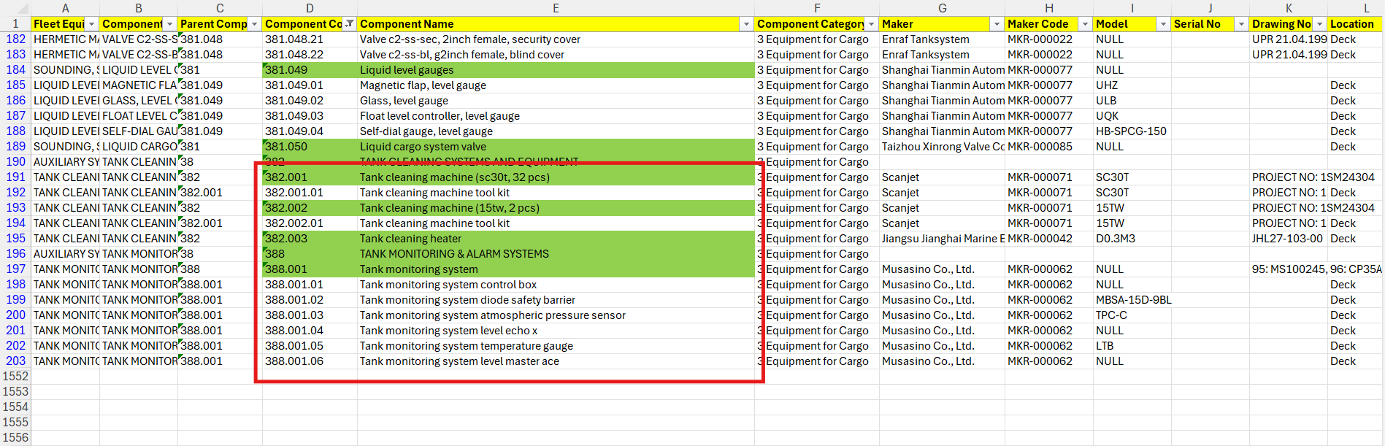
Correct Method for Highlighted Components:
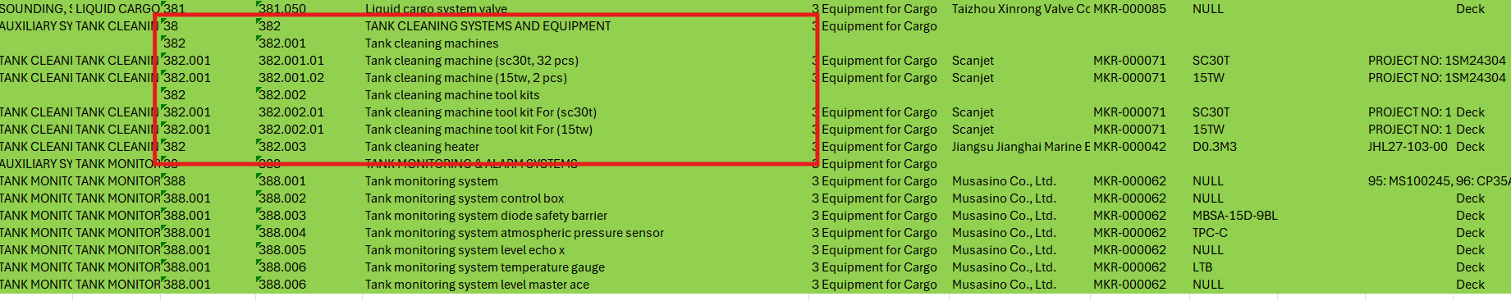

2. Incorrect Maker and Model Assignments
We have identified instances where incorrect maker and model details have been assigned to components.

Example 4: The 15 PPM Bilge Alarm and Bilge Pump have separate makers and models. However, it has been observed that their models have been incorrectly assigned the same values as the Oily Water Separator. We kindly request this to be reviewed and corrected.
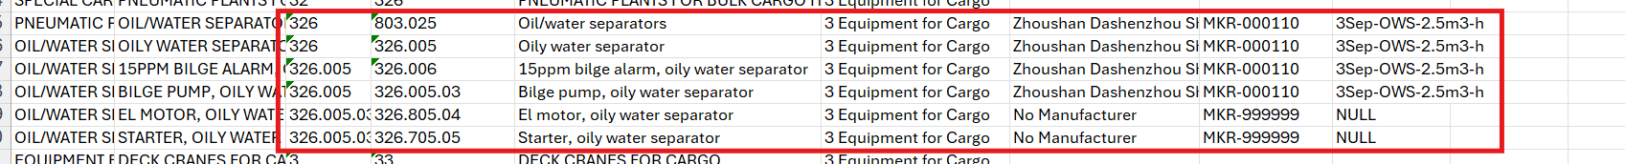

3. Incorrect Component Location Entries
For certain components, the location information has been entered incorrectly. We request the team to review and update the following:

Example 5:
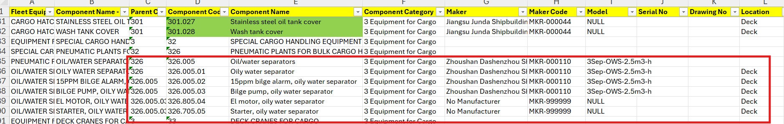
Example 6:
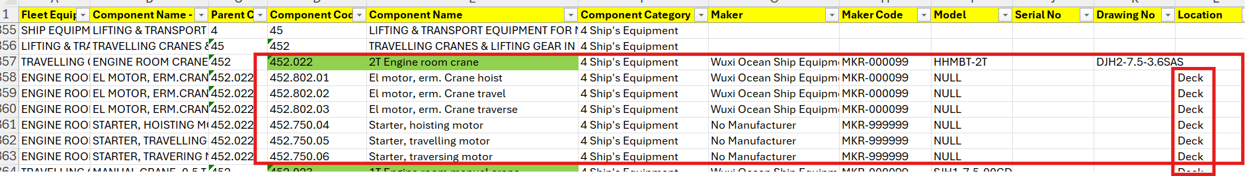
Example 7:

4. Electric Motor Coding Format — Non-Compliance
The suggested coding format for electric motors has not been followed for several components. We request the team to standardize these entries as per the agreed format.

Example 8:
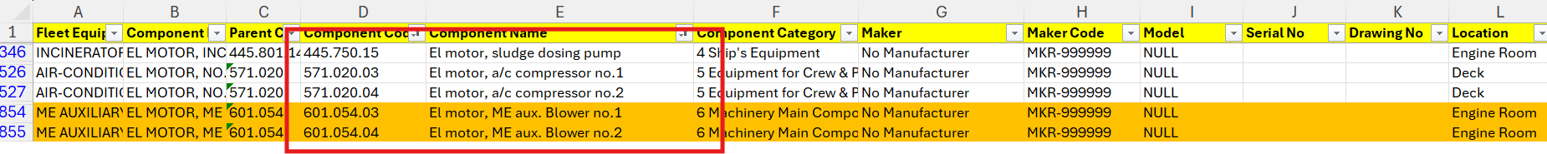

5. Incorrect Parent Code Assignments
For certain components, parent codes have not been assigned correctly. Proper parent-child hierarchy is essential for accurate PMS structure.

Example 9:
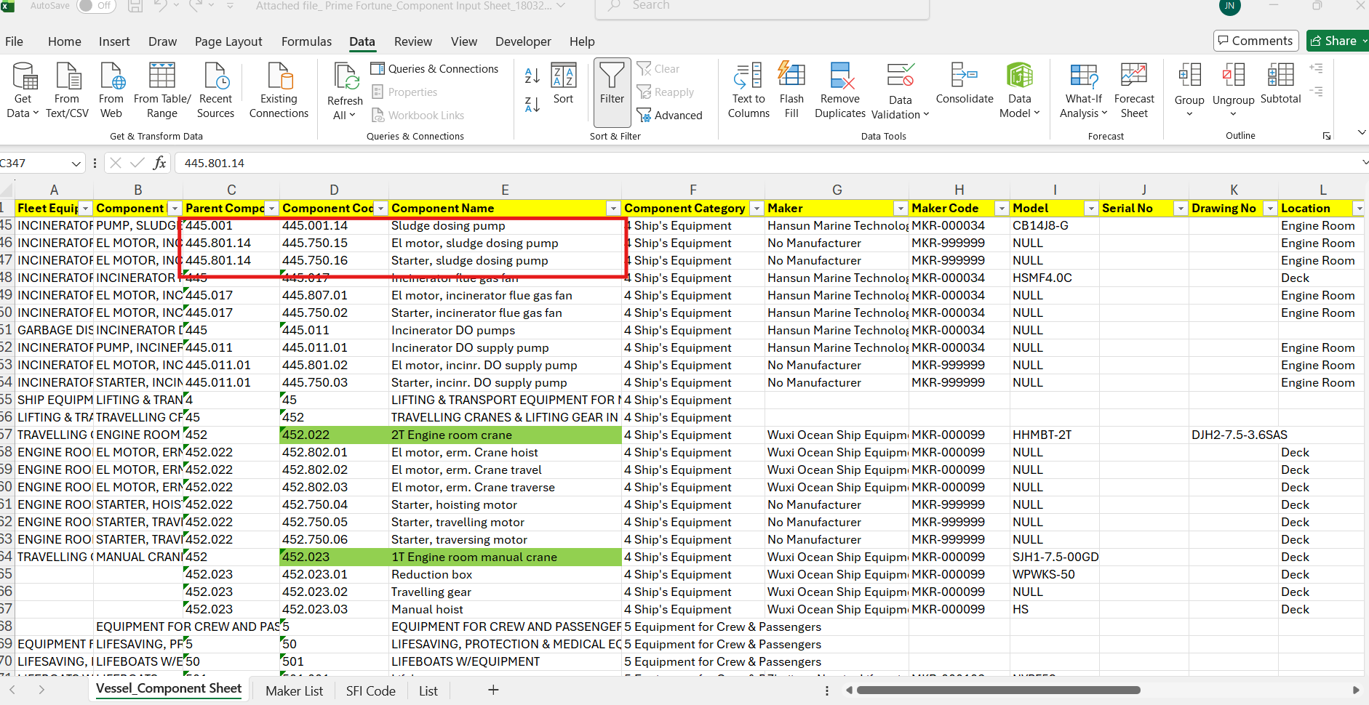
Example 10:
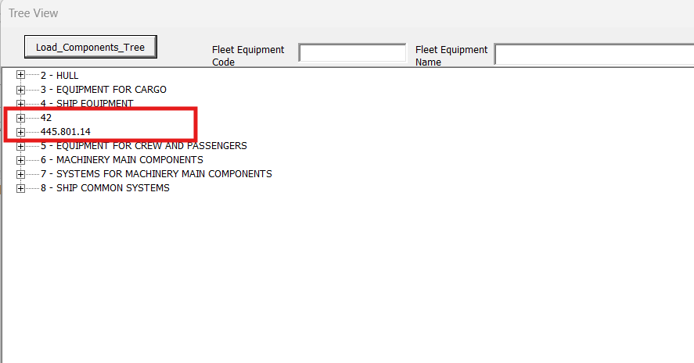

6. Unnecessary Component Entries — Clarification Required
Within the Main Engine and Purifiers component structures, we have noticed that several small-scale components, parts, and tools have been created that do not have any associated planned maintenance or spares.
We kindly request clarification on the rationale for creating these components, as their inclusion may add unnecessary complexity to the maintenance structure.

Example 11:
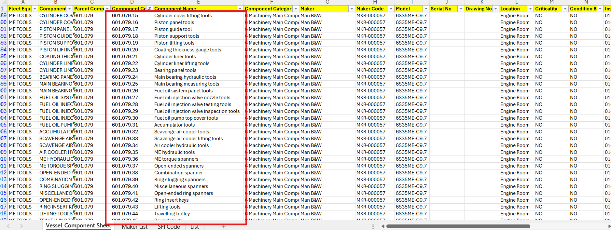
Example 12:
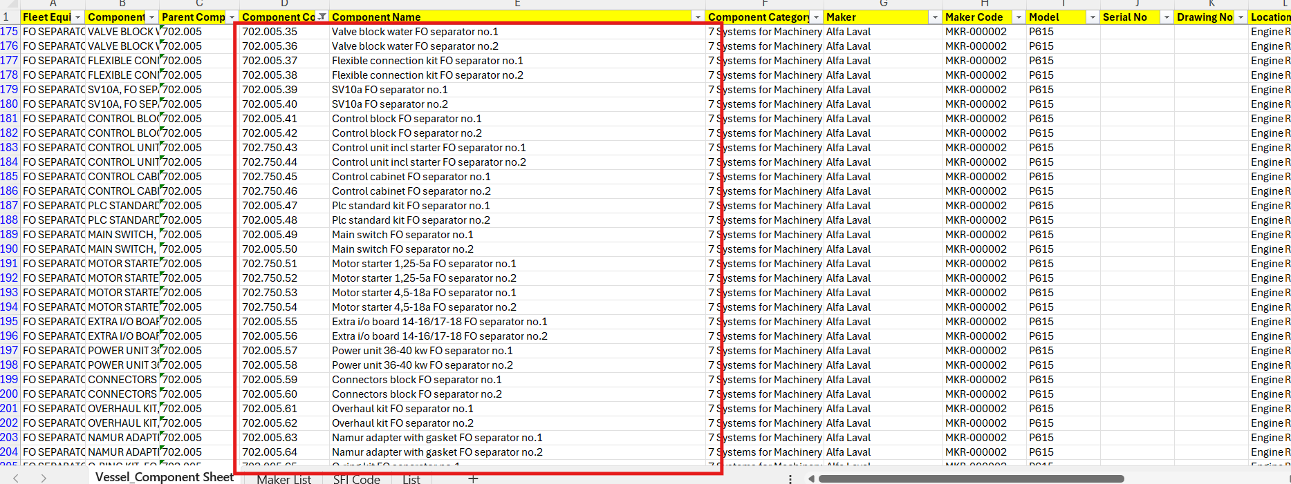

7. Missing Tank Details — 2 Series
We have observed that tank details have not been created under the 2 Series component structure. We kindly request the team to provide the capacity plan and update the tank details accordingly.

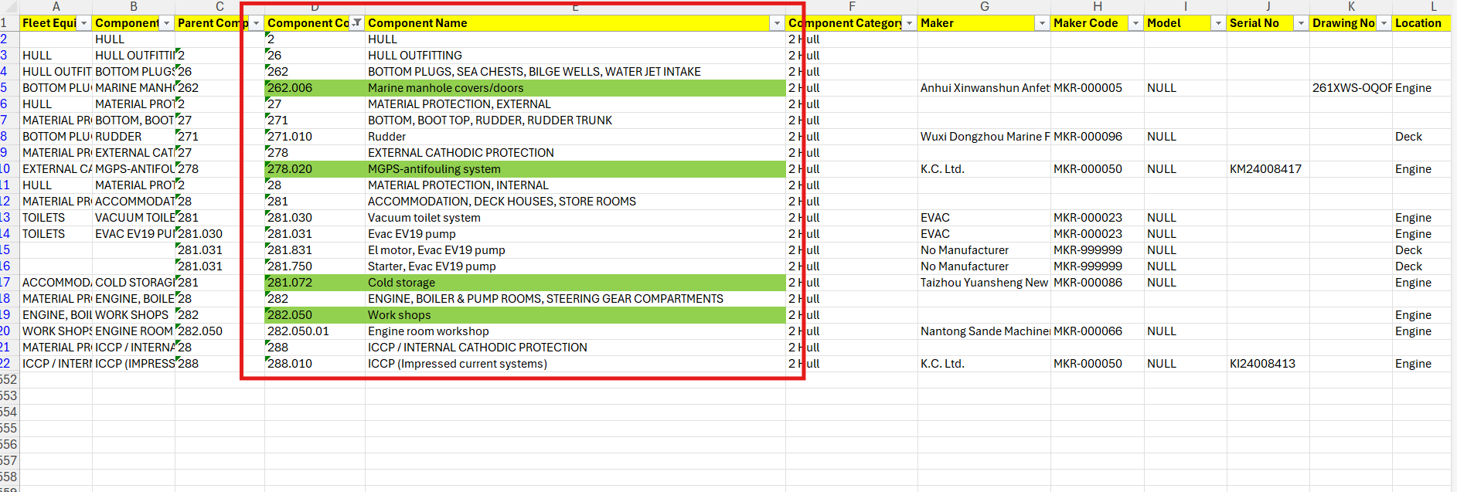

8. Running Hours Inheritance — Clarification Required
Clarification is required regarding the Main Engine Turbocharger (T/C) and Auxiliary Blowers Running Hours (RH):

• Should the RH be inherited from the Main Engine, or
• Should they maintain their own separate RH counters?

Example 13:
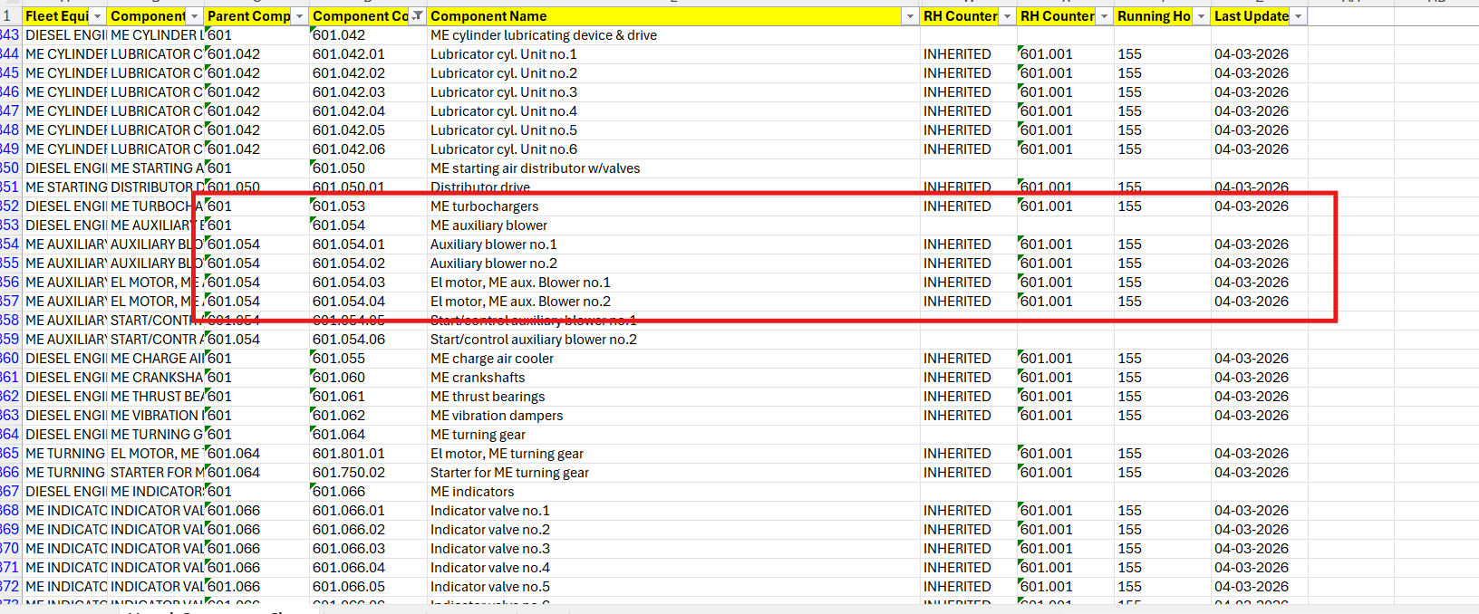

Summary of Actions Required

# | Finding | Action Required
1 | Component code format non-compliance | Correct coding as per agreed 7-digit / 10-digit format
2 | Incorrect maker/model assignments | Review and update maker/model for affected components
3 | Incorrect component locations | Review and correct location entries
4 | Electric motor coding non-compliance | Standardize to agreed coding format
5 | Incorrect parent codes | Review and correct parent-child hierarchy
6 | Unnecessary components without maintenance/spares | Provide clarification or remove
7 | Missing tank details (2 Series) | Provide capacity plan and update accordingly
8 | T/C and Aux Blower RH inheritance | Confirm whether inherited or independent

We appreciate the team's efforts and look forward to the necessary corrections at the earliest convenience. Please feel free to reach out should any further clarification be required.

