Component Sheet
- The component code format is still not aligning with the requirements, which were also discussed during our call.
- Each unique component should have a unique 7-digit code.
- If a component has a fitted quantity of 2 or more, only then should it be assigned a 10-digit code, using a running number to create the structure.
Example 1:
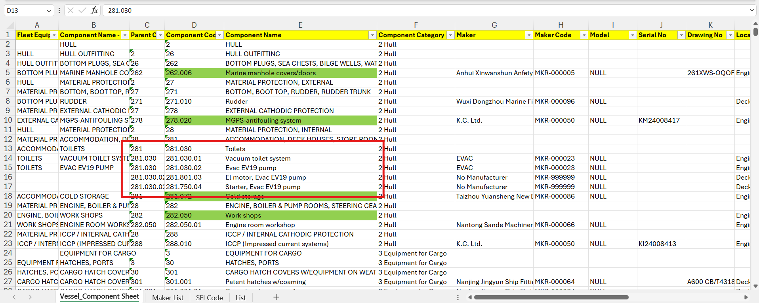

Correct Method for Highlighted Components: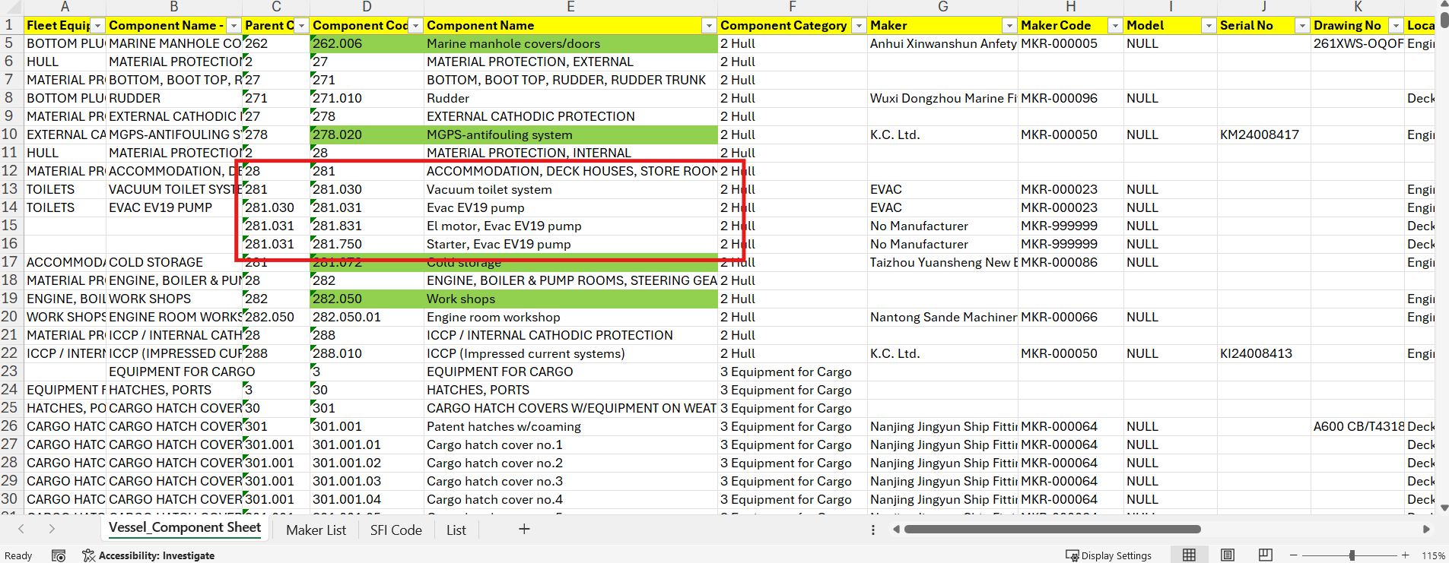

Example 2: Clarification is required on whether the highlighted component belongs to the cargo side or the engine room side.
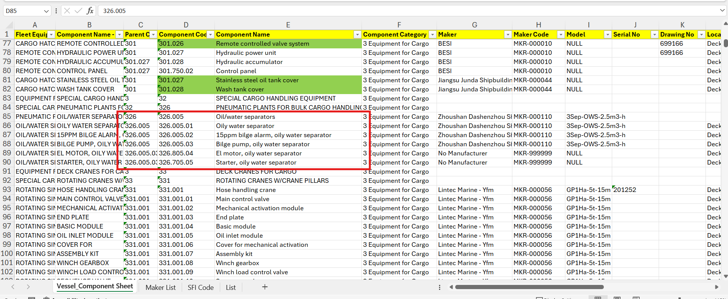
Correct Method for Highlighted Components:
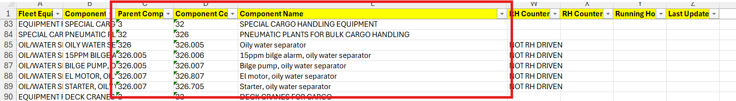
Note: The discussed coding format has not been followed in several areas. Sample examples are attached as Example 1 and Example 2.

Example 3:
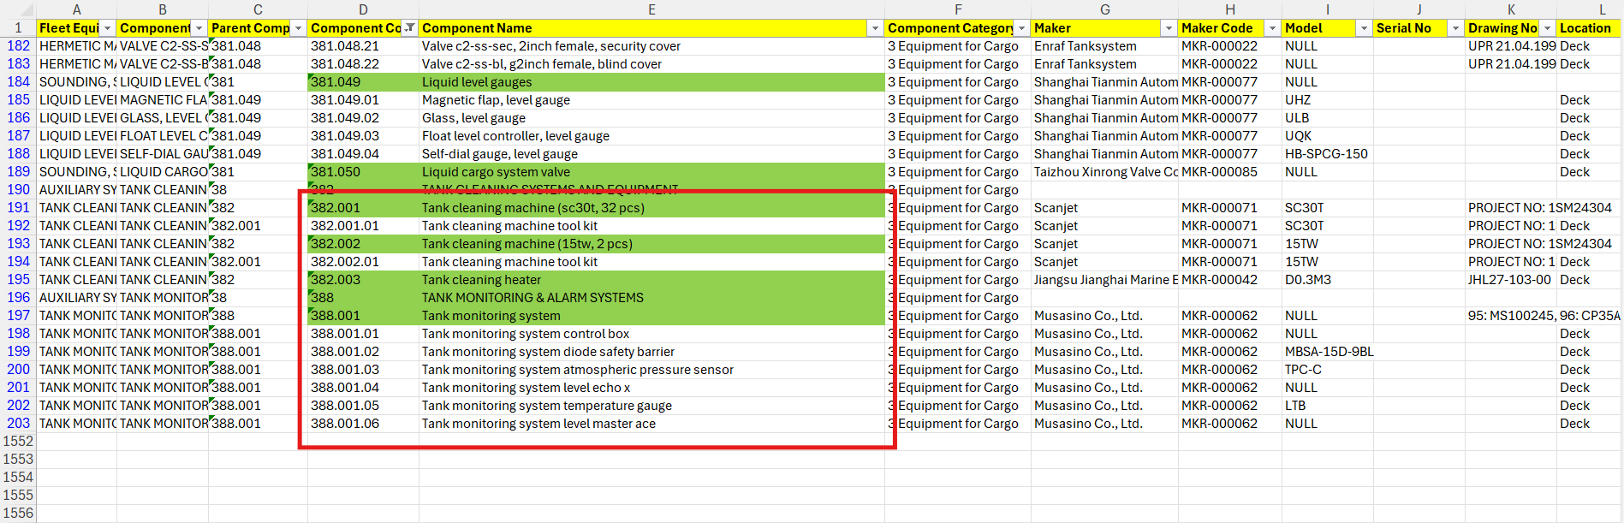

Correct Method for Highlighted Components:
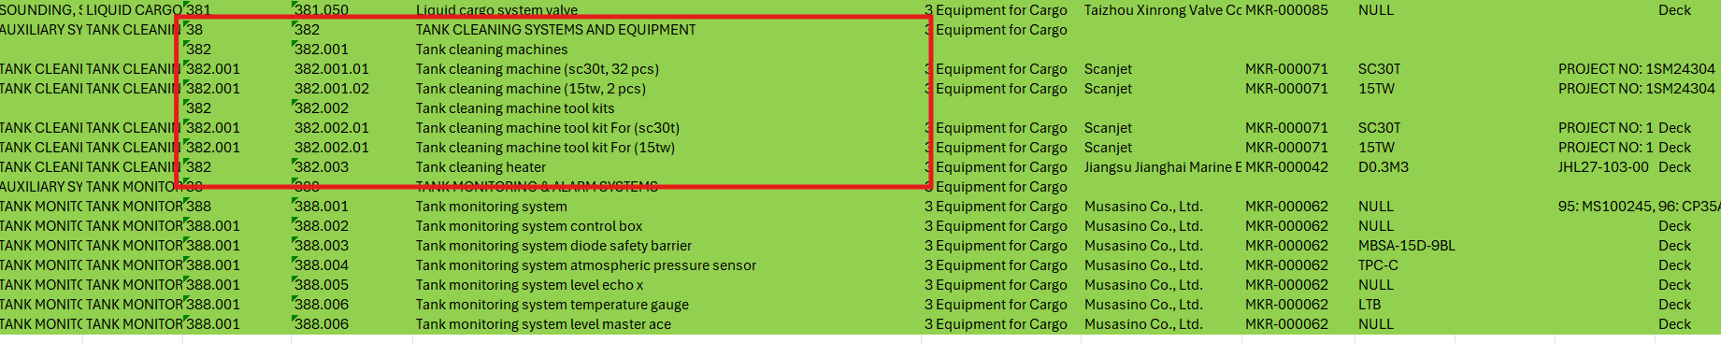

- Wrong maker and model has been assigned for few components.
Example 4:
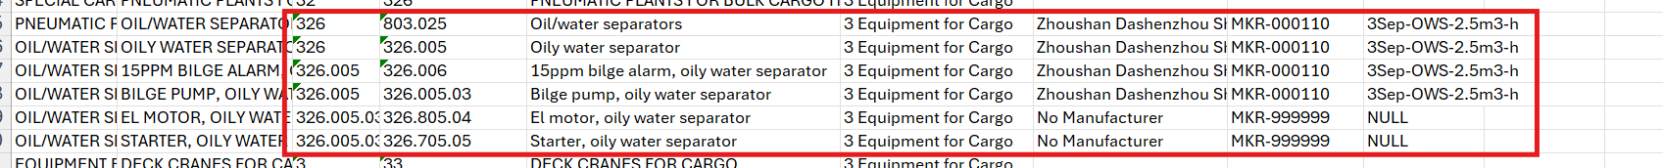
- The 15 ppm bilge alarm and bilge pump have separate makers and models. However, we have observed that the model has been assigned the same as the oily water separator.

- For few components the component location has been added wrong.
Example 5:
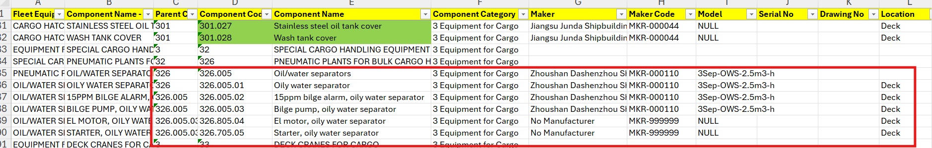
Example 6:
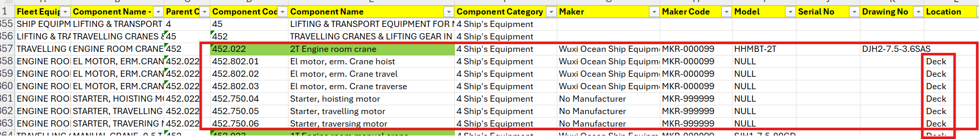
Example 7:

- For a few components, the suggested electric motor coding format has not been followed.
Example 8:
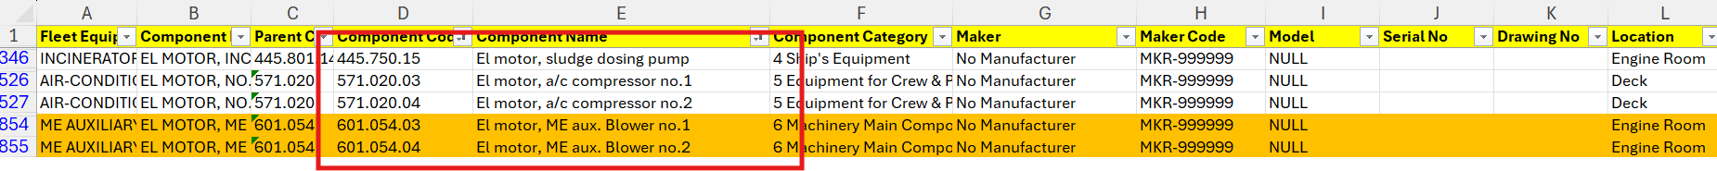

- For a few components, the parent codes have not been assigned properly.
Example 9:
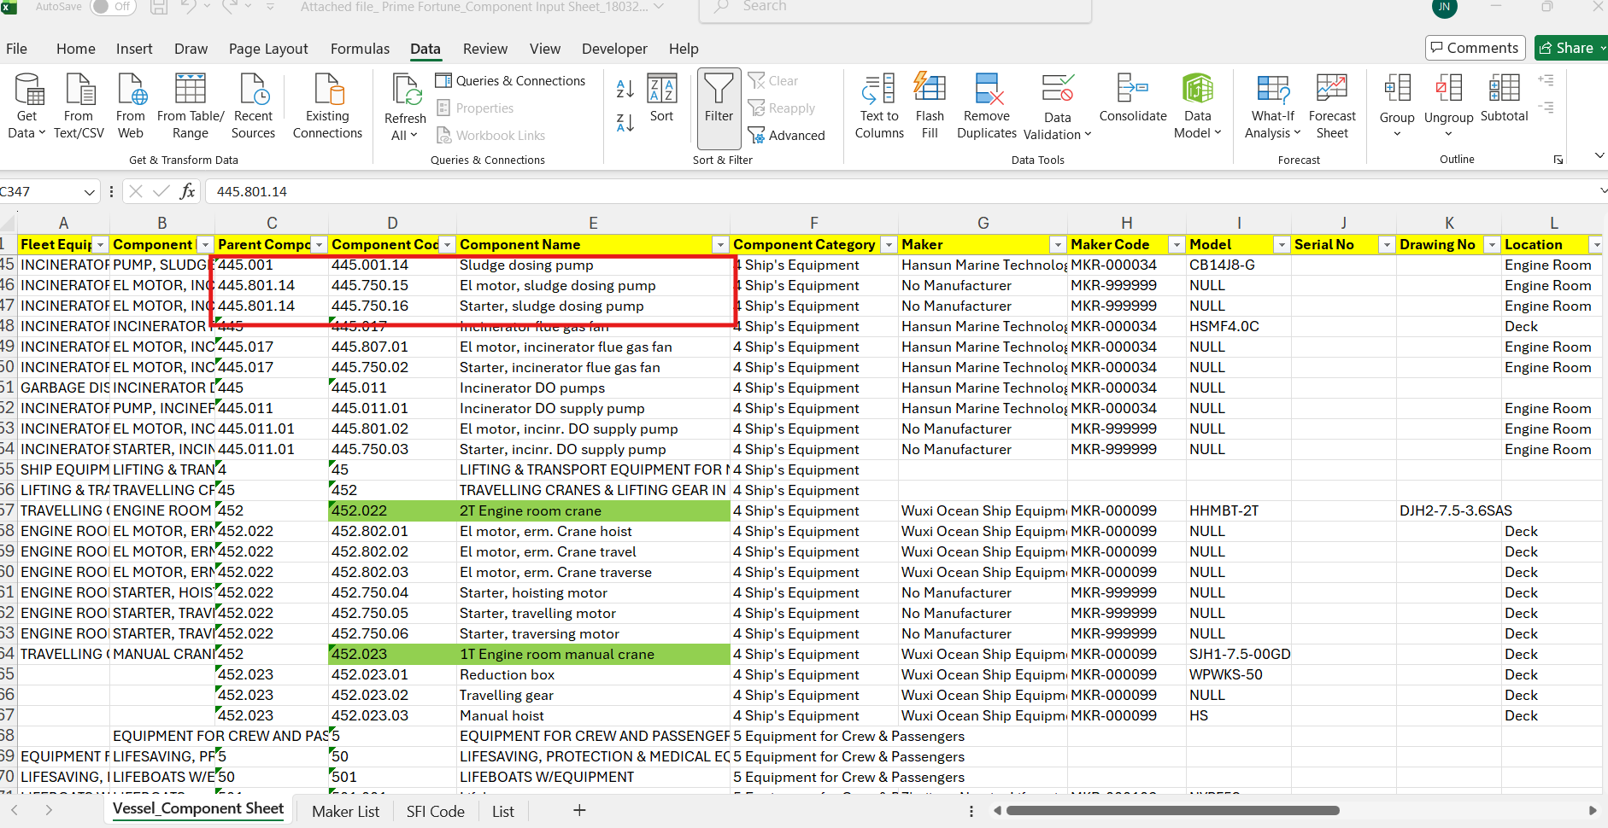

Example 10:
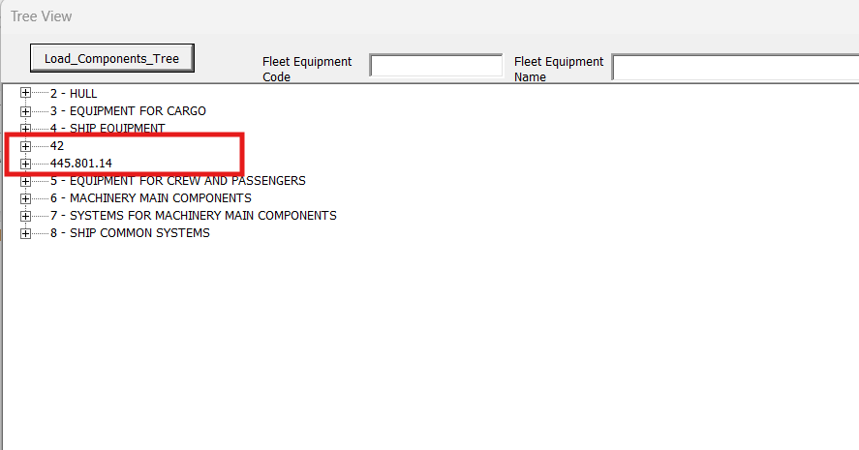

- In the Main Engine and Purifiers component structure, we have noticed that many small-scale components, parts, and tools have been created that do not have any planned maintenance or spares. Clarification is required on why these components have been created.
Example 11:
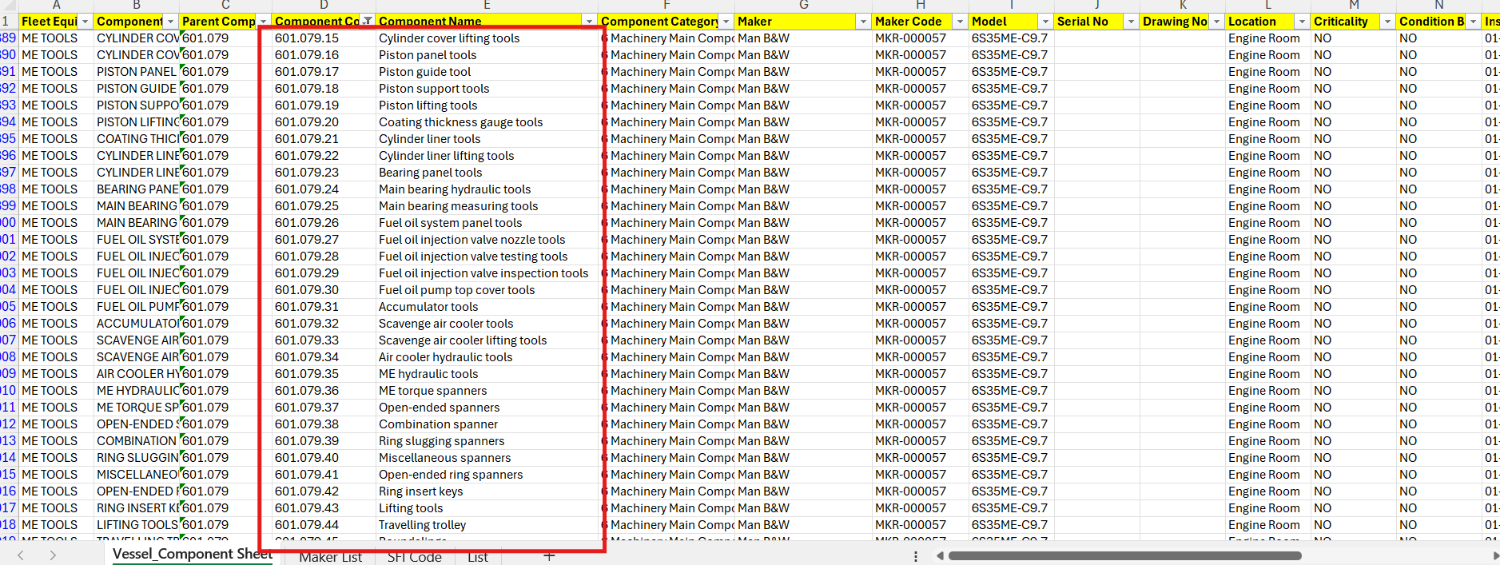

Example 12:
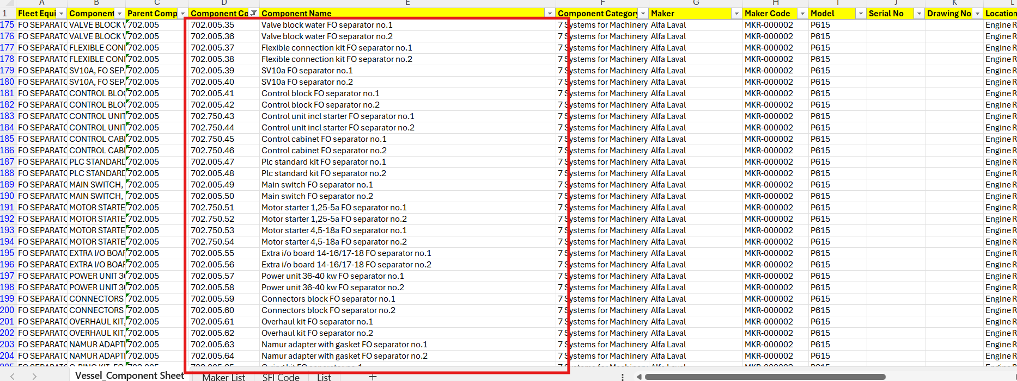

- We have noticed that, in the 2 Series, the tank details have not been created. Kindly request the team to provide the capacity plan and update the tank details accordingly.
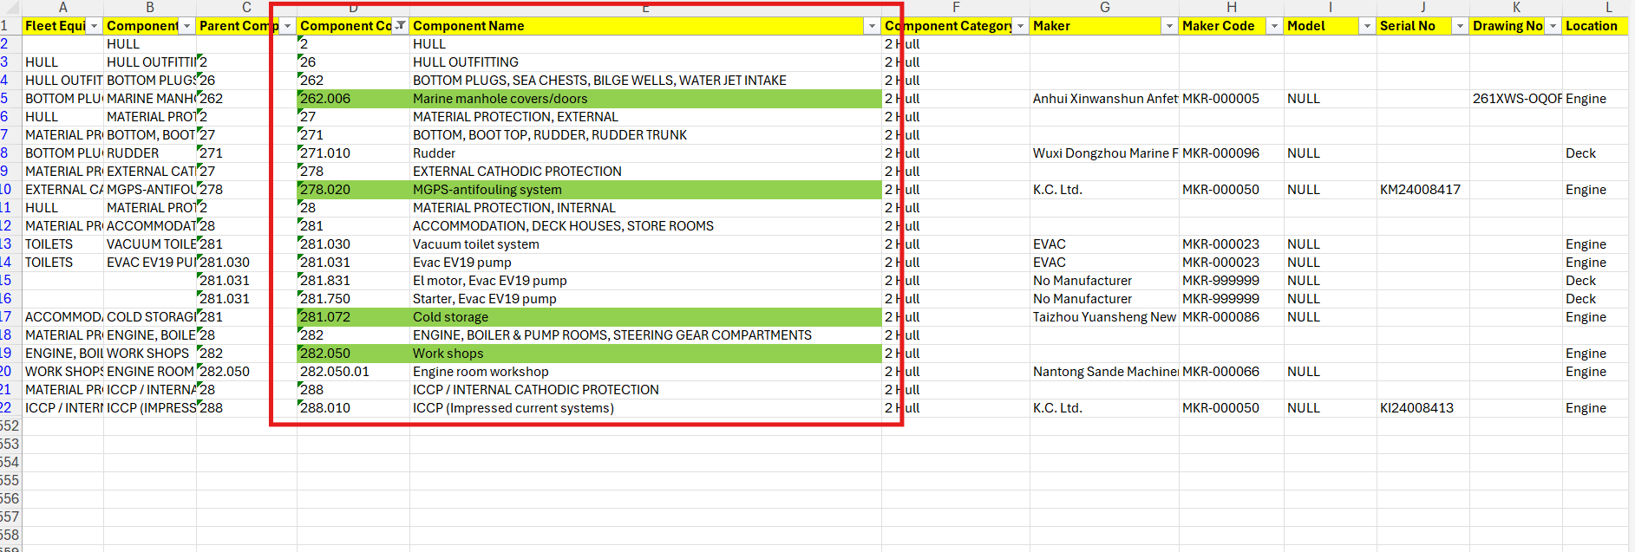

Clarification is required on whether the Main Engine T/C and Aux Blowers RH should be inherited from the Main Engine or have their own separate RH.
Example 13:
