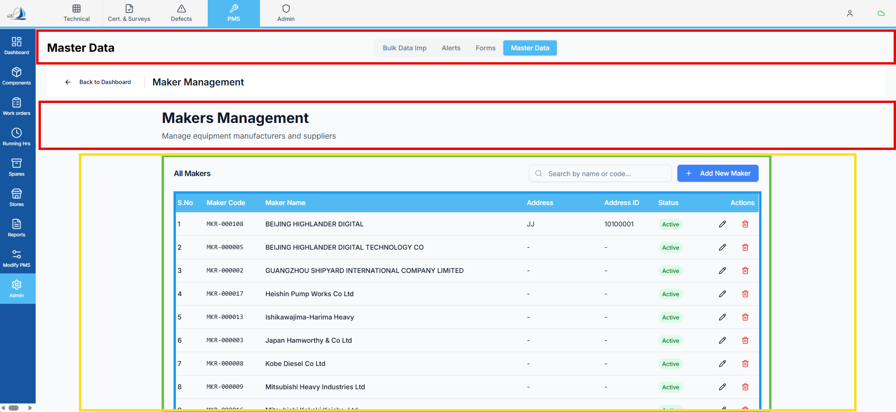

Raplit UI Change Prompt – Alpha
Module / Screen: Maker Management Screen
Change Type: UI Change Only
Change Name: Alpha
Scope: Applicable only to this screen

Context
This request is strictly for UI adjustment on the Maker Management screen.
No functional, logical, or data-level behavior must be changed.

UI Change Requirements (Alpha)
- Remove Red Highlighted Sections
  - Completely remove the red highlighted UI sections from this screen.
  - No hidden logic or replacement behavior is required.
- Expand “All Makers” Section
  - The All Makers section should be expanded.
  - Increase its size to be equal to the currently orange highlighted area.
  - Layout change only; no data or interaction logic changes.
- Blue Highlighted Area – Table Format
  - Convert the blue highlighted area into a table layout similar to Excel:
    - Row-based structure
    - Column headers
    - Grid-style alignment
  - Visual structure only; no sorting, editing, or functional enhancements.

Constraints (Strict)
- UI CHANGE ONLY
- NO functionality changes
- NO logic changes
- NO API changes
- NO data model changes
- NO impact on other screens
- Apply only to this screen
- Change name must be referenced as “Alpha”

Expected Result
- Cleaner UI layout with removed red sections
- Expanded All Makers area for better visibility
- Excel-style table presentation for the blue highlighted section
- Existing behavior remains fully unchanged

