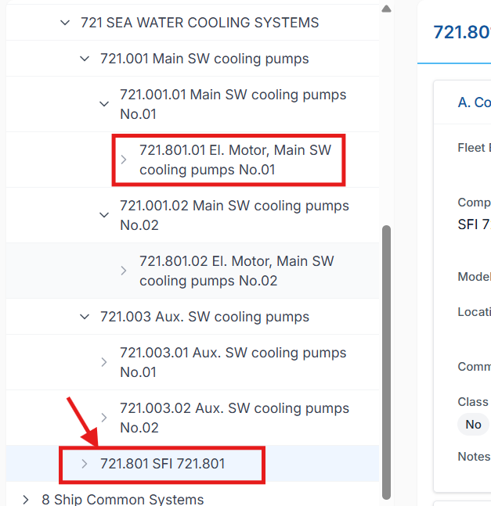

Replit Fix Prompt — Bulk Upload Creates Unwanted Default Parent Component
Context & Constraints
- This issue applies to Component bulk upload functionality in PMS
- Replit must:
  - Preserve all existing, correct functionality
  - Remove only the incorrect default-parent creation logic
- No code examples unless explicitly asked
- No database inspection
- Analysis and fix must be based on current logical flow
- Vessel-wise data handling rules remain unchanged

🎯 Issue Description (Exact Scenario)
During bulk upload of components, the following scenario occurs:
- Parent component code:
721.001.01 (fixed as per industrial coding standard)
- Child component code:
721.801.01
- In the Excel sheet:
  - Parent is correctly provided as 721.001.01
- System behavior:
  - Correctly links 721.801.01 under 721.001.01
  - Correctly displays the expected tree structure
  - ❌ Incorrectly creates an additional default parent component:
721.801
This default parent (721.801) is:
- NOT provided in Excel
- NOT part of business logic
- NOT required by industrial coding rules
- Created purely due to fallback/default logic

✅ Expected Business Behavior
- If a valid parent component code is explicitly provided in the bulk upload:
  - The system must use only that parent
  - The system must NOT auto-generate any intermediate or default parent
- Component hierarchy must be built strictly from Excel input, not inferred defaults

