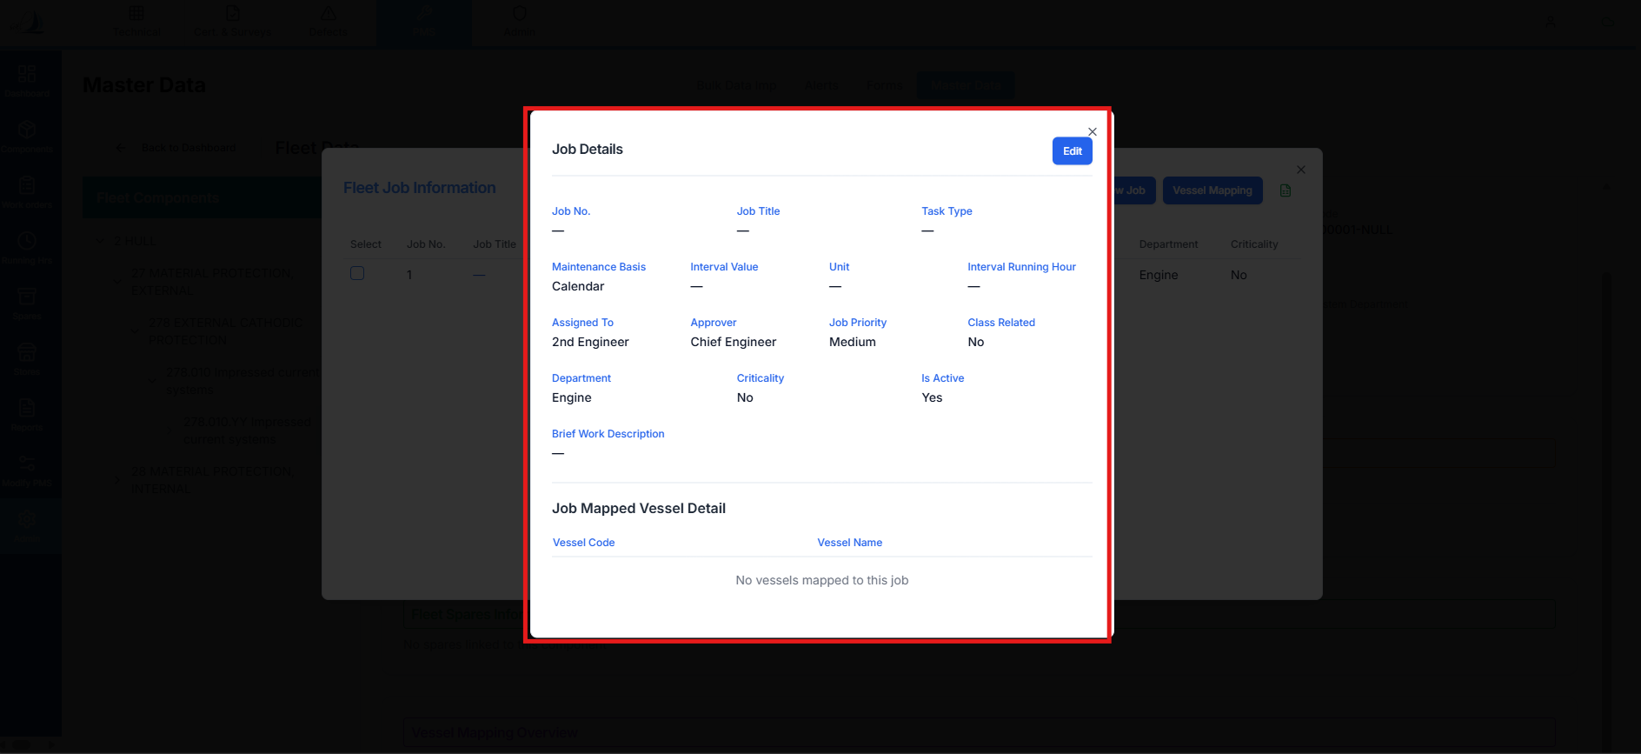

Raplit Analysis Prompt
Module: PMS → Fleet Jobs → Job Details View
Scope: Job Details Data Fetch & Display Consistency
Issue Type: Partial Data Display (Read-Only / Fetch Mapping Issue)

Context
In the Fleet Jobs – Job Details display screen, some fields are appearing blank, even though the corresponding data exists in the fleet_jobs table.
At the same time:
- Other job-related fields are displaying correctly
- This creates inconsistency and confusion in Job Details view
- Data integrity exists at database level, but UI does not reflect it fully

Observed Problem
- Certain fields show blank values
- Database (fleet_jobs table) contains valid data for these fields
- The UI is either:
  - Not fetching these fields
  - Fetching from an incorrect source
  - Incorrectly mapping field names

Analysis Questions (To Be Answered)
- Why are some Job Detail fields blank even though data exists in fleet_jobs?
- Is the Job Details screen fetching data from:
  - fleet_jobs table?
  - Or any other table/view?
- If data is fetched from another table:
  - Which table is it?
  - Why was that table chosen instead of fleet_jobs?
- What difficulty or limitation exists in fetching all required fields from fleet_jobs?
- Is there a mismatch between:
  - API response structure
  - UI field bindings
  - Database column names
- Why only selected fields are affected while others display correctly?

Correct Expected Method (Reference)
The Job Details display must fetch data only from the fleet_jobs table for the following fields:
Display Name | fleet_jobs Table Column
Job No. | job_code
Job Title | wo_title
Task Type | task_type
Interval Value | interval_value
Unit | unit
Brief Job Description | brief_job_description
Note: Remaining fields are already displaying correctly and are out of scope unless directly related.

Detailed Analysis Scope
1. Data Source Verification
- Identify the exact data source used by the Job Details screen
- Confirm whether:
  - fleet_jobs table is partially used
  - Or another table/view is being queried
2. API & Data Contract Analysis
- Analyse API response for Job Details:
  - Missing fields
  - Incorrect aliases
  - Field name mismatches
- Verify alignment between:
  - API keys
  - UI bindings
  - Table column names
3. UI Binding Analysis
- Check how Job Details UI maps:
  - Response fields → display fields
- Identify fields that are:
  - Not bound
  - Incorrectly bound
  - Conditionally rendered

Corrective Plan (Design-Level Only)
Step 1: Standardize Data Source
- Ensure Job Details fetches required fields directly from fleet_jobs
- Eliminate unnecessary dependency on alternate tables for these fields
Step 2: Field Mapping Alignment
- Align:
  - Display field names
  - API response keys
  - fleet_jobs column names
- Ensure all listed fields are included in the response
Step 3: Consistency Validation
- Cross-check fields that already display correctly
- Ensure no regression while correcting blank fields
Step 4: Error Prevention Strategy
- Define a clear data-fetch contract for Job Details view
- Avoid partial or mixed-source data fetching going forward

Expected Outcome
- All listed Job Detail fields display correctly
- Data is fetched consistently from fleet_jobs table
- No blank fields when data exists
- Job Details screen becomes predictable and reliable

Mandatory Constraints (Strict)
- ANALYSE & PLAN ONLY
- DO NOT implement logic
- DO NOT change database schema
- DO NOT impact other job screens
- DO NOT change UI layout
- Scope limited to Job Details data fetch
- WAIT for explicit PROCEED instruction

