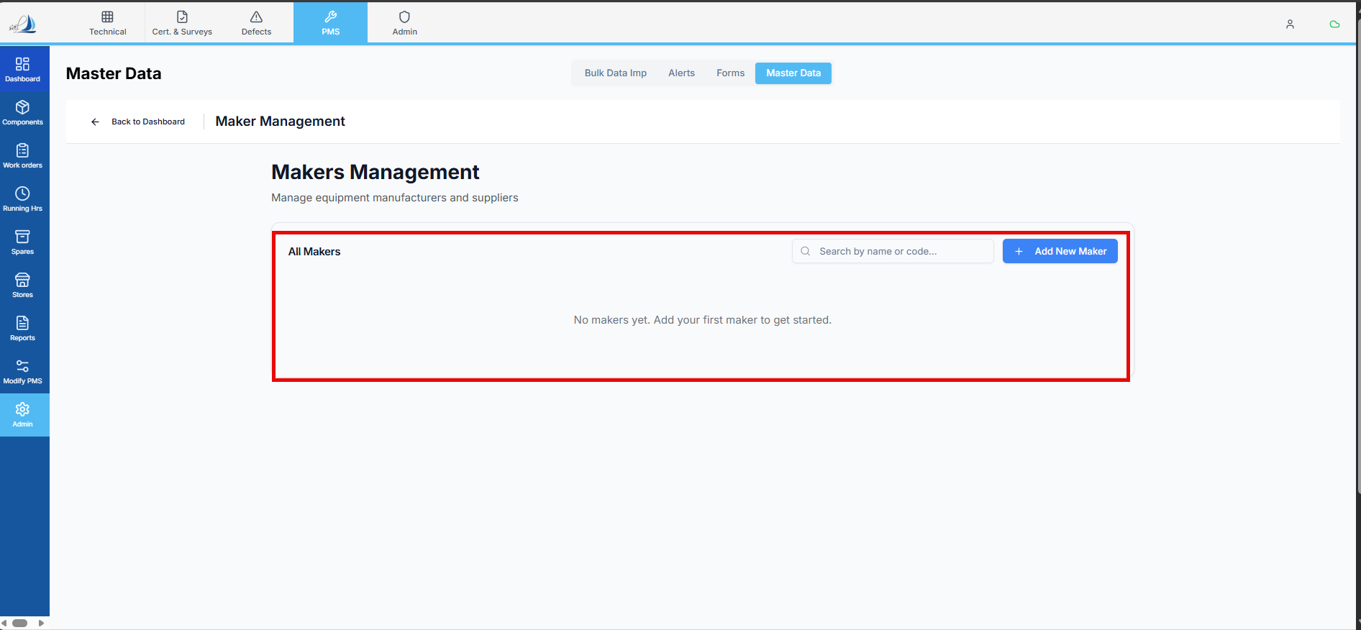

Raplit Prompt
Title: Fleet → Maker List Screen (Highlighted Section) – Data Source & Visibility Analysis
Purpose
Analyse the highlighted section of the Fleet → Maker List screen to clearly identify:
- What data is displayed
- From where the data is fetched
- Why imported Maker List records are not appearing
This prompt is analysis-only and strictly limited to this screen and issue.

Analysis Questions (Must Be Answered Explicitly)
1. Highlighted Section – What Data Is Shown
Analyse and document:
- What exact data is shown in the highlighted section
- Whether the data is:
  - Dynamically fetched from backend
  - Hardcoded / mock
  - Cached or derived
- Whether the data represents:
  - Maker master data
  - Any other lookup or legacy dataset

2. Data Source Identification
Identify precisely:
- Which API endpoint is used to populate this section
- Which backend service/controller handles the request
- Which database table or view is queried
Explicitly confirm:
- Is the data fetched from maker_list table? (Yes / No)
- If No, identify the actual table/view currently used

3. Screen Headers / Columns
List all headers currently visible in the highlighted section and identify for each:
- Screen column name (UI label)
- Frontend data key
- Backend response field (if applicable)
- Source table and column (if identifiable)

4. Root Cause – Why Imported Maker List Data Is Not Showing
Provide a detailed root-cause analysis covering:
- Whether imported Maker List data is:
  - Persisted in maker_list table
  - Stored in a different table
  - Not persisted at all
- Whether the screen:
  - Queries a different table than the import flow
  - Applies filters (status, active flag, fleet scope) that hide new records
- Any mismatch between:
  - Import storage vs screen query
  - Backend response vs UI expectation

Actual vs Planned Behavior
Actual (As-Is)
Document the current behavior clearly:
Highlighted Maker List Section
→ API: __________
→ Table/View: __________
→ Result: Imported Maker List data not visible

Planned (To-Be)
Define the correct plan:
- The highlighted section must fetch data only from maker_list table
- Imported Maker List records must be visible automatically
maker_list table
→ Maker List Screen API
→ Highlighted Section UI

Scope & Safety Constraints (Mandatory)
- Do not change or impact any other screen, module, or functionality
- Do not refactor shared components or APIs
- No changes outside this Maker List screen analysis
- No assumptions without verification
- Analysis only – no code changes
This prompt must focus exclusively on this issue.

Expected Outcome
After completing this analysis:
- There is absolute clarity on:
  - What data the highlighted section shows
  - From which table it is fetched
  - Why imported Maker List data is missing
- A safe, isolated plan exists to align the screen with the maker_list table
- Other Fleet / PMS functionality remains completely unaffected

