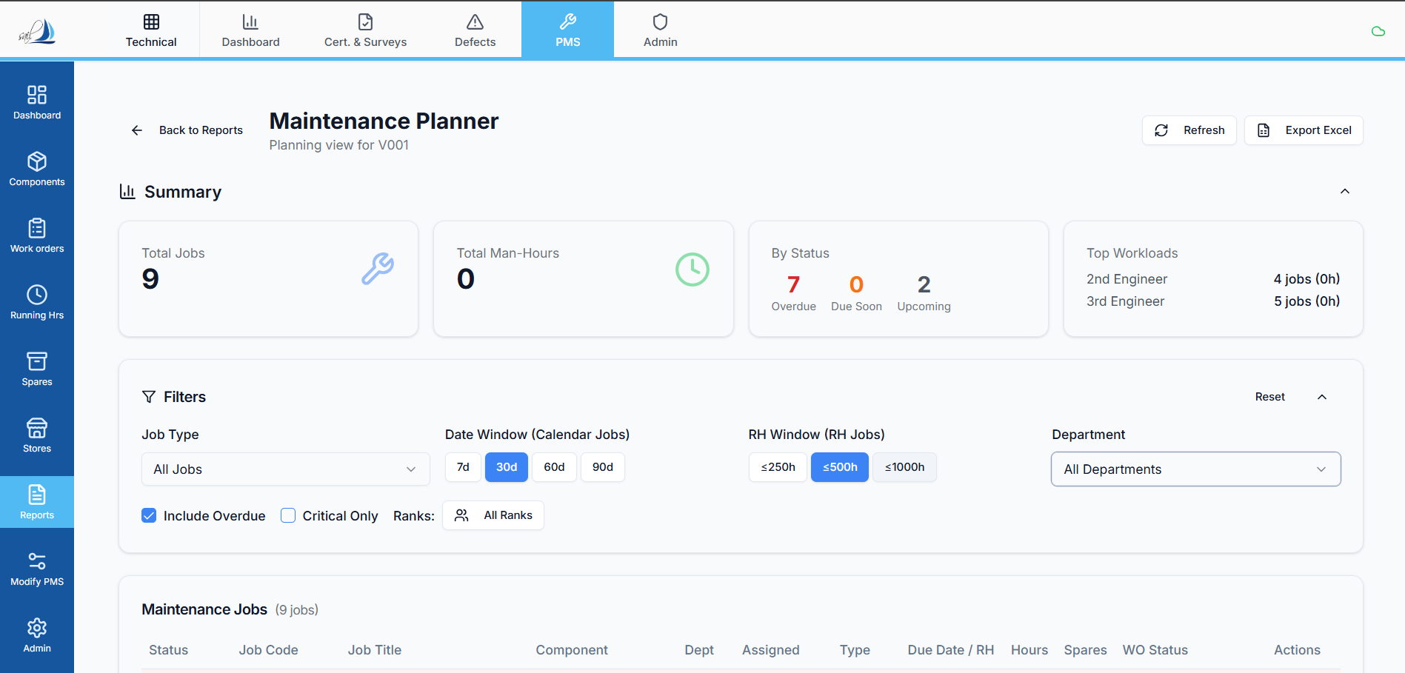

✅ Replit Analysis Prompt — Maintenance Planner Data Fetching & Table Usage (PMS)
Context & Mandatory Constraints
- This analysis applies only to the Maintenance Planner module
- Replit must perform deep logical analysis, not implementation
- Do NOT provide code
- Do NOT suggest database inspection, queries, or DB access
- Assume Replit cannot check the database
- Analysis must be based on:
  - Existing functional behavior
  - Data flow assumptions
  - Module interactions
- Vessel-wise data isolation rules must be respected

🎯 Objective
Perform a complete analysis of the Maintenance Planner’s data fetching logic, including:
- Which tables / data sources are being used logically
- How data is assembled, filtered, and grouped
- Whether the planner is fetching correct, vessel-scoped, and complete data

🔍 What Replit Must Analyse (Step-by-Step)
1. Entry Point Analysis
Analyse if vessel context is:
  - Mandatory
  - Optional
  - Implicitly assumed

2. Data Sources & Table Usage (Logical)
- Identify all logical data sources involved, such as:
  - Components
  - Jobs / Maintenance tasks
  - Running hours / counters
  - Work order table
- Analyse:
  - Why each data source is used
  - Whether any required source is missing
  - Whether any unnecessary source is being used

3. Data Joining & Relationship Logic
- Analyse how data is logically joined:
  - Component → Jobs
  - Jobs → Schedules
  - Jobs → Completion / History
- Identify whether joins:
  - Use correct identifiers
  - Include vessel context

4. Vessel-wise Data Isolation
- Verify whether:
  - All planner data is filtered by Vessel_ID
  - Cross-vessel data can leak into the planner
- Identify assumptions such as:
  - Job numbers being globally unique
  - Component codes reused across vessels
- Confirm whether planner logic violates vessel boundaries

🚫 What Replit Must NOT Do
- ❌ Do NOT propose fixes yet
- ❌ Do NOT write or suggest code
- ❌ Do NOT assume DB schema correctness
- ❌ Do NOT skip explaining logic gaps

📄 Expected Output
Replit must provide:
- End-to-end explanation of how Maintenance Planner data is currently fetched
- List of all logical tables / data sources involved
- Relationship and dependency map (conceptual)
- Identified gaps, inconsistencies, and incorrect assumptions
- Root causes for incorrect planner data (if any)
- Pre-fix analysis summary describing:
  - What is working
  - What is broken
  - Why it is broken

🧠 Final Instruction (Critical)
First understand and explain the Maintenance Planner’s current data flow completely,
then stop.
Do NOT jump into solutions unless explicitly asked.

